Name: Preyash

Registration Number: 20BPS1022 Date: February 10, 2022

**LAB-03**

**CSE2021**

**DISTRIBUTED REAL-TIME SYSTEMS**

**Tools Used: Ptolemy**

**Task: Extended State machine model of a traffic light controller the track the passage of time, at regular intervals.**

**Circuit:**

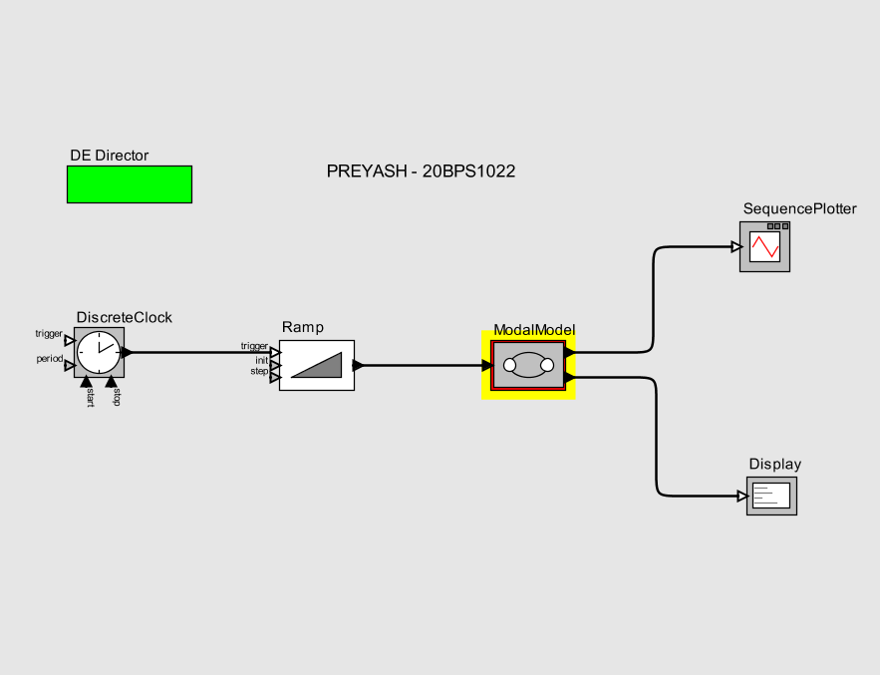

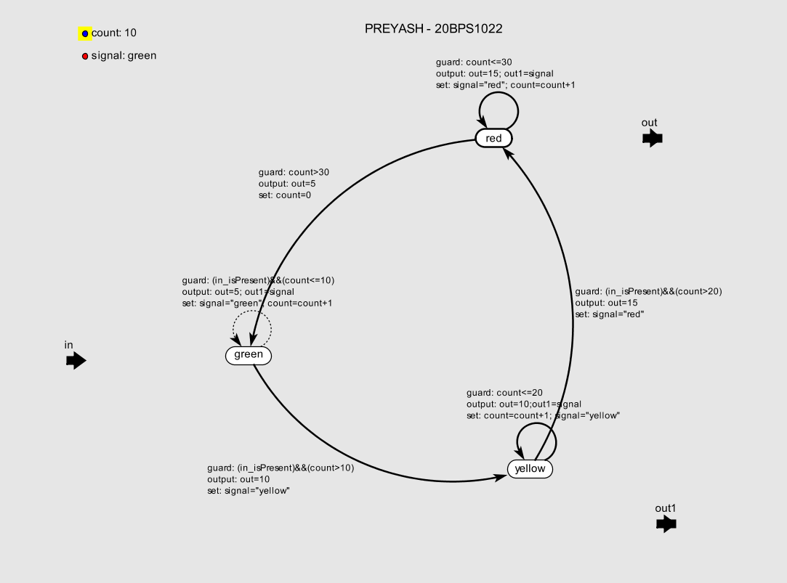

**Output:**

