Name: Preyash

Registration Number: 20BPS1022 Date: February 24, 2022

**LAB-04**

**CSE2021**

**DISTRIBUTED REAL-TIME SYSTEMS**

**Tools Used: Ptolemy**

**Task: Implement various task scheduling algorithms in Real Time Systems**

**Circuit:**

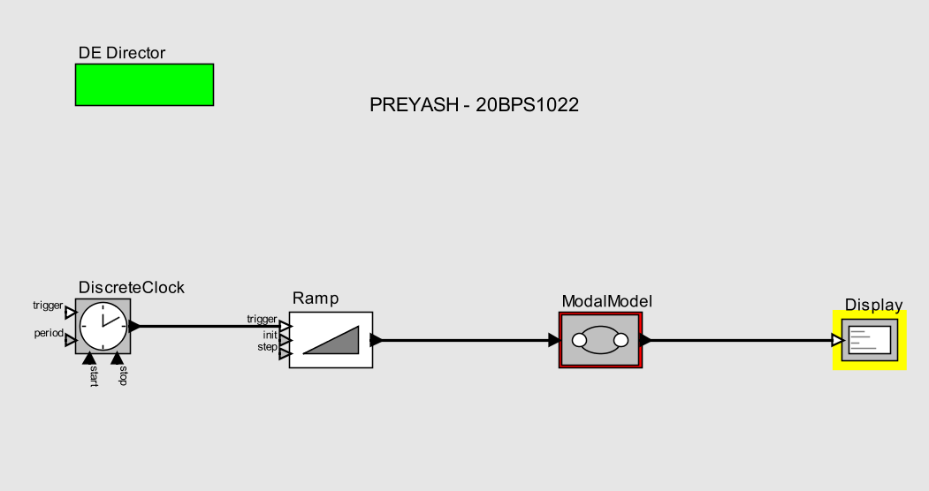

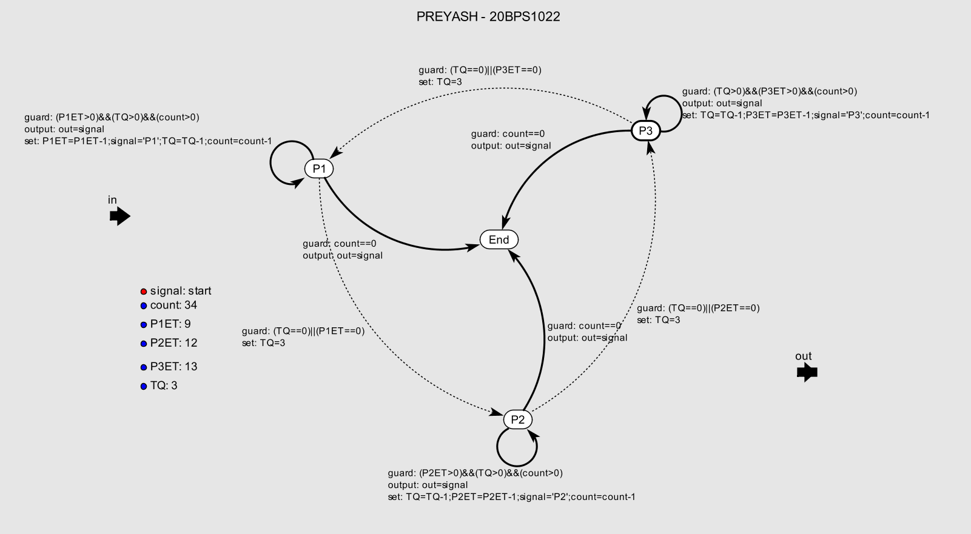

**Output:**

