**LAB-05**

**CSE2021**

**DISTRIBUTED REAL-TIME SYSTEMS**

**Name: Disha Gupta**

**Registration Number: 20BPS1078 Date: 03 March, 2022**

**Tools Used: Ptolemy**

**Task: Creating cyclic scheduling using Finite State Machine (FSM).**

**Question:**

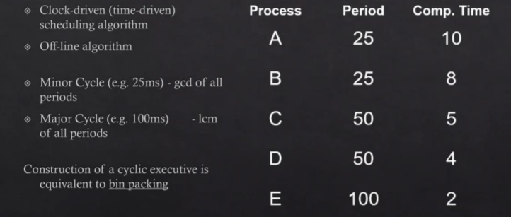

**Schedule:**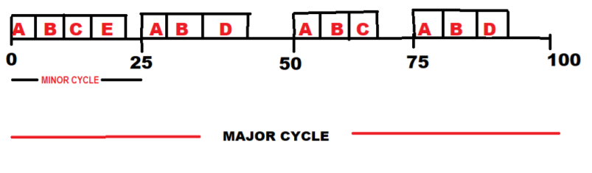

**Circuit:**

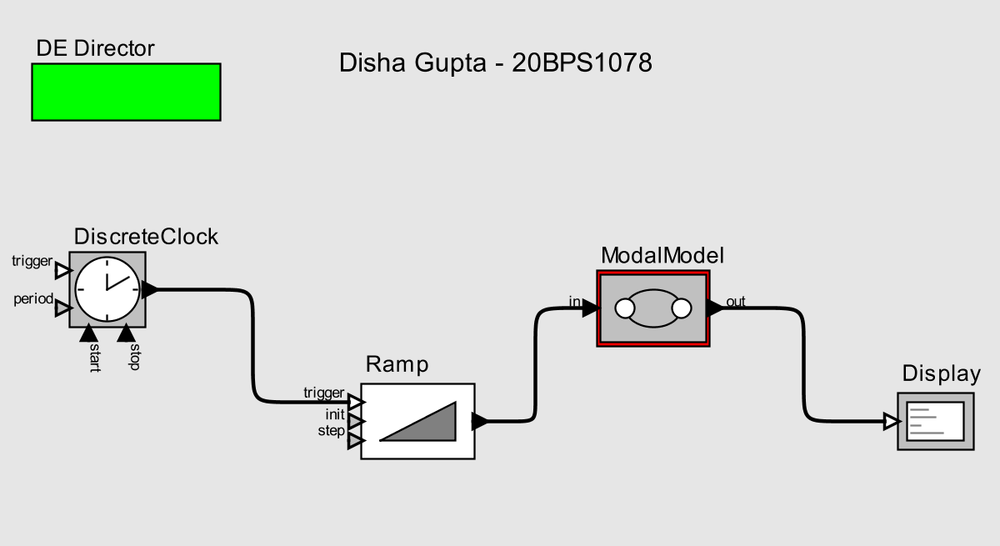

**FSM:**

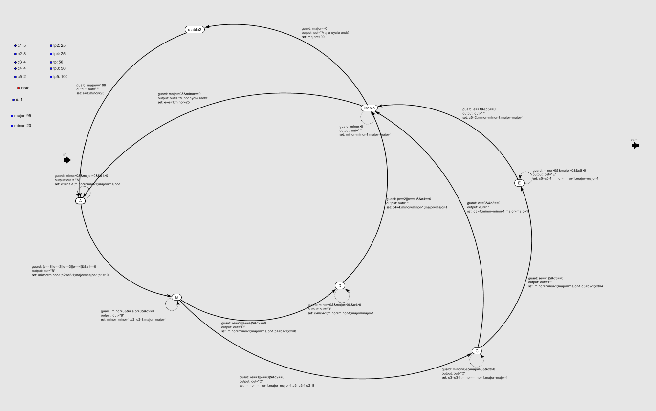

**Closer view:**

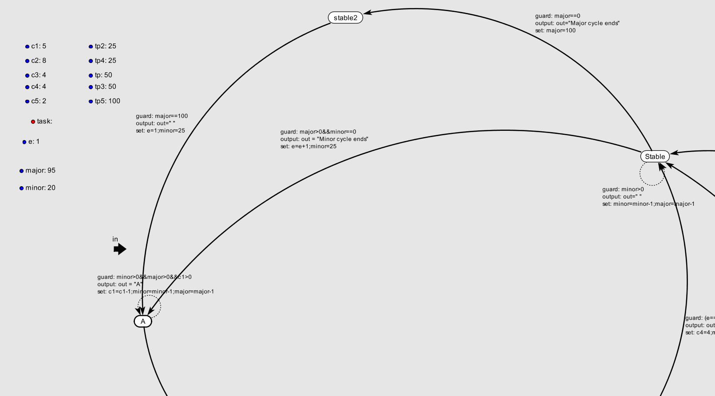

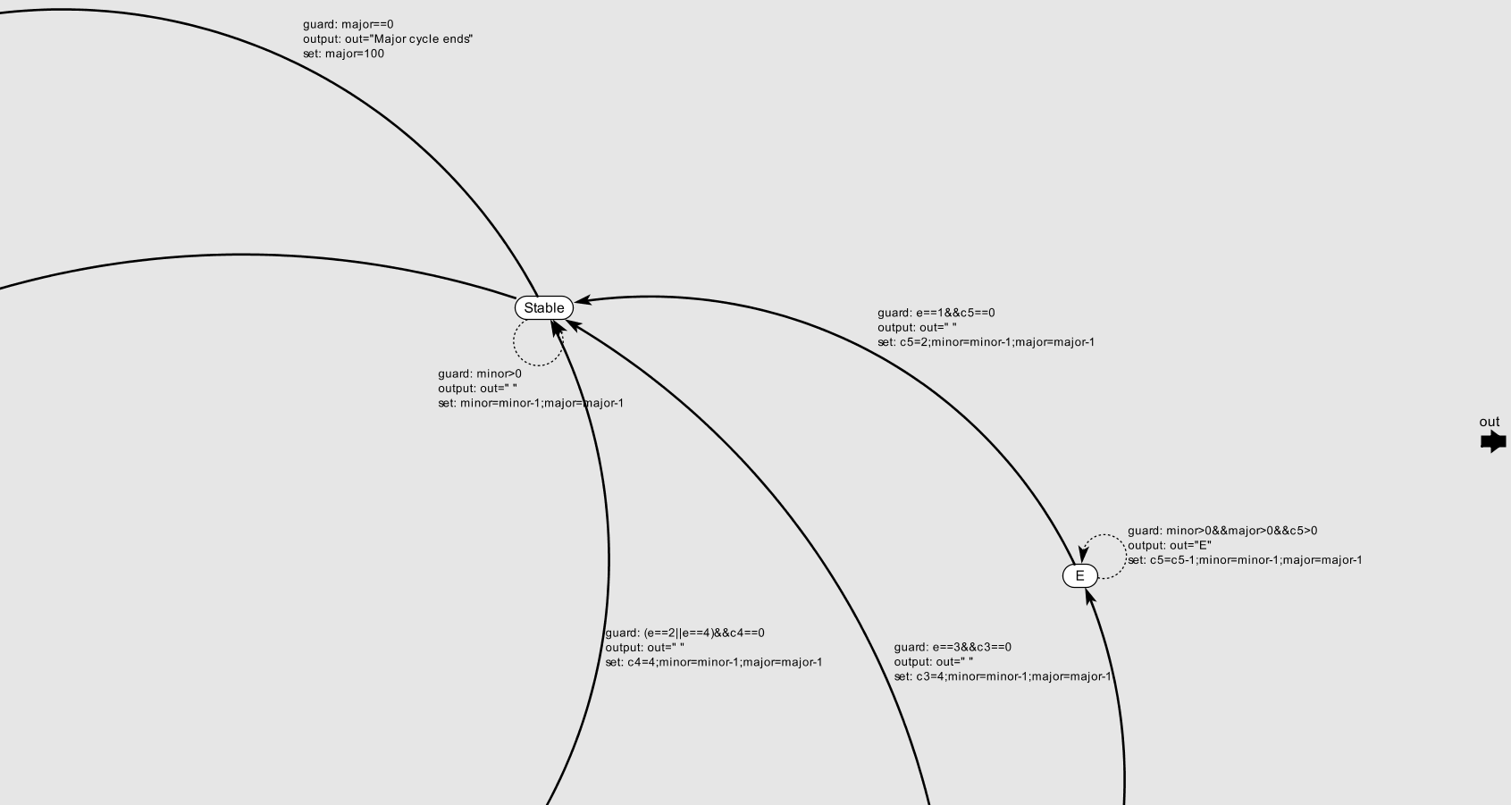

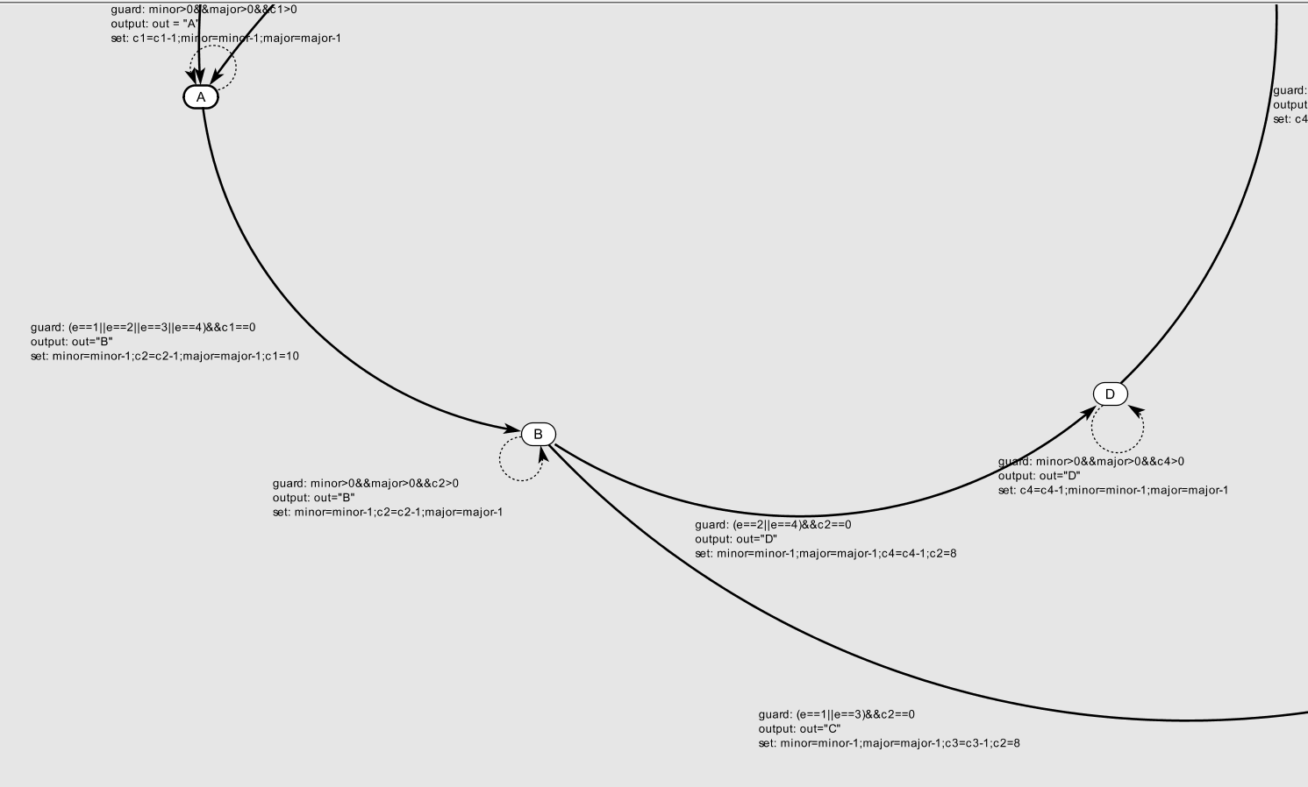

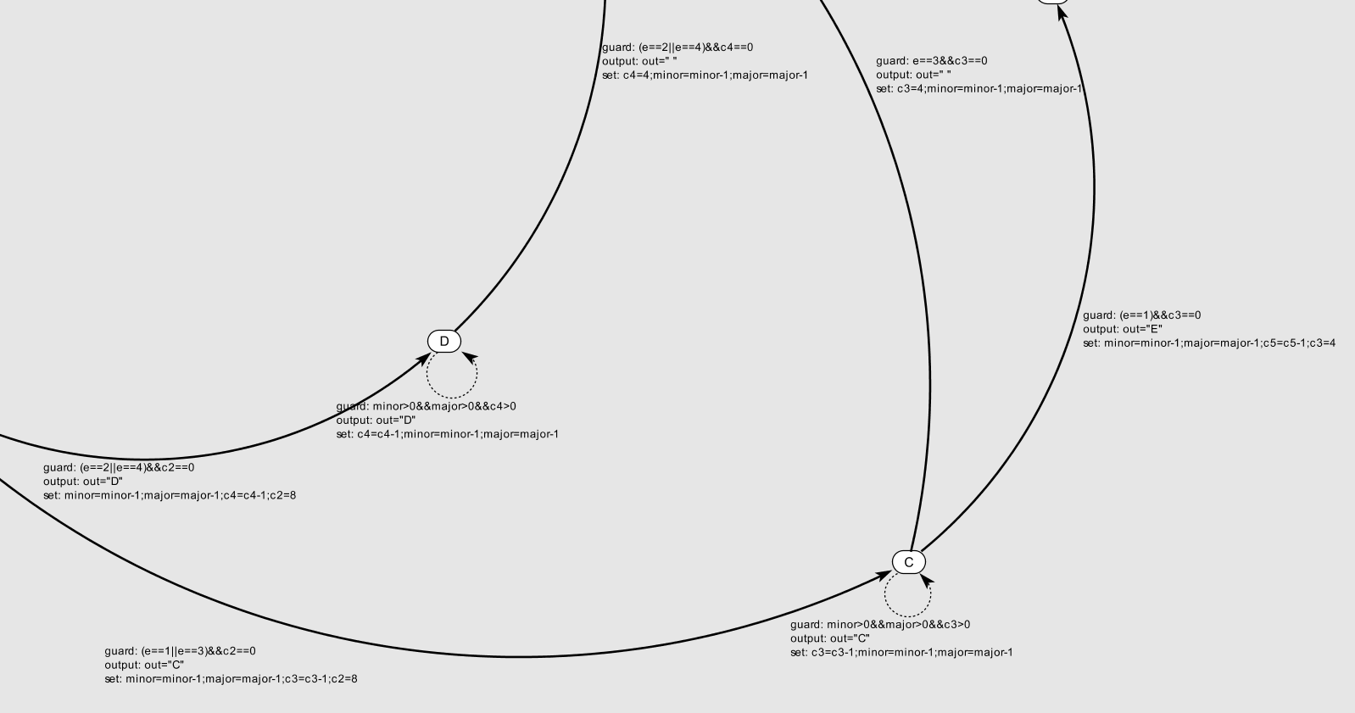

**Output:**

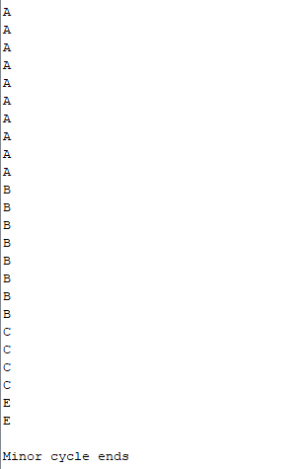

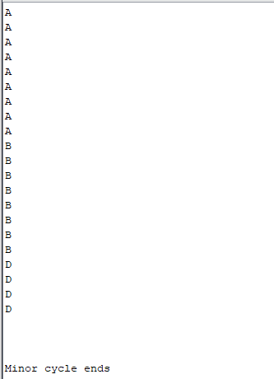

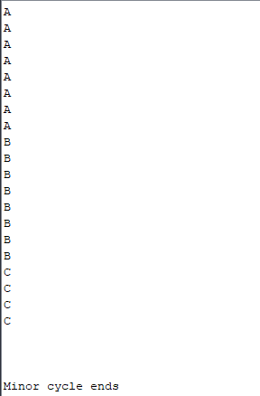

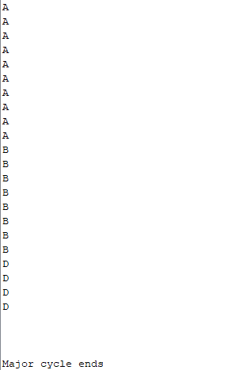

**Note:** The Program will keep on running for every major cycle in similar way.