**Control System Introduction**

**Experiment Number: 01**

Name: Preyash

Registration Number: 20BPS1022 Date: 28/01/2022

**Aim:**

The goal of this session is to do the following:

1. Visualize discrete time signals.

2. Recognize the Sampling Theorem.

3. Identifying and solving differential equations.

4. Determine the step response and impulse.

As illustrated in an example, code, execute, and obtain plots for each of the following.

**Q1. Write a code in MATLAB to plot a 3cycles of a sine and cosine wave of 50 Hz frequency.**

**Code:**

%create a cosine/sine wave with f = 50 Hz

clc

clear all

f=50; tp=1/f;

fs=1000; ts=1/fs ;

% signal frequency in continuous time

% time period

% sampling frequency

% sampling Time

t=0:ts:3*tp;

x=cos(2*pi*f*t)

subplot(2,1,1)

plot(t,x)

title('50 Hz Cosine Wave')

xlabel('Time (s)');

ylabel('Voltage (V)');

t=0:ts:3*tp;

x=sin(2*pi*f*t)

title('50 Hz Sine Wave')

subplot(2,1,2)

stem(t,x)

xlabel('Time (s)');

ylabel('Voltage (V)');

grid on

**Output:**

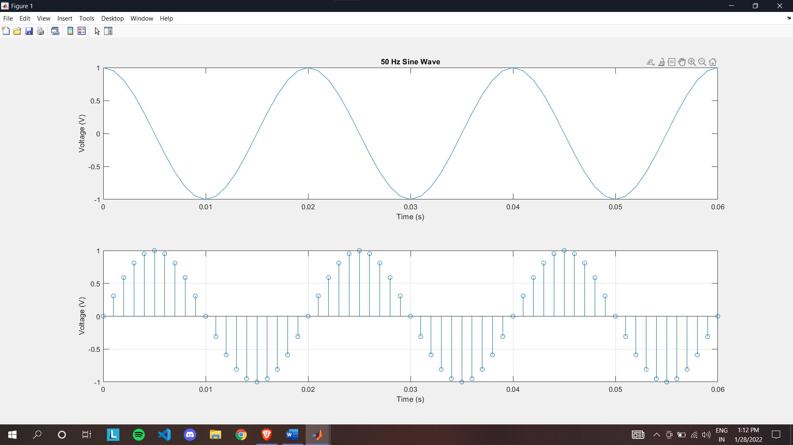

**Q2. Plot the signals.**

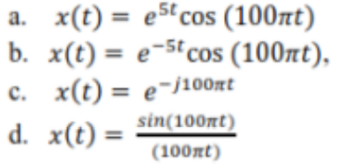

**Code:**

For a and b:

%%

clear all

f=50;

tp=1/f;

samples=20;

t=0:tp/samples:5*tp;

a=10

x=exp(a*t).*cos(2*pi*f*t)

subplot(2,1,1)

plot(t,x)

title('Growing Exponential')

xlabel('Time (s)');

ylabel('Voltage (V)');

x=exp(-a*t).*cos(2*pi*f*t)

subplot(2,1,2)

stem(t,x)

title('Decaying Exponential')

xlabel('Time (s)');

ylabel('Voltage (V)');

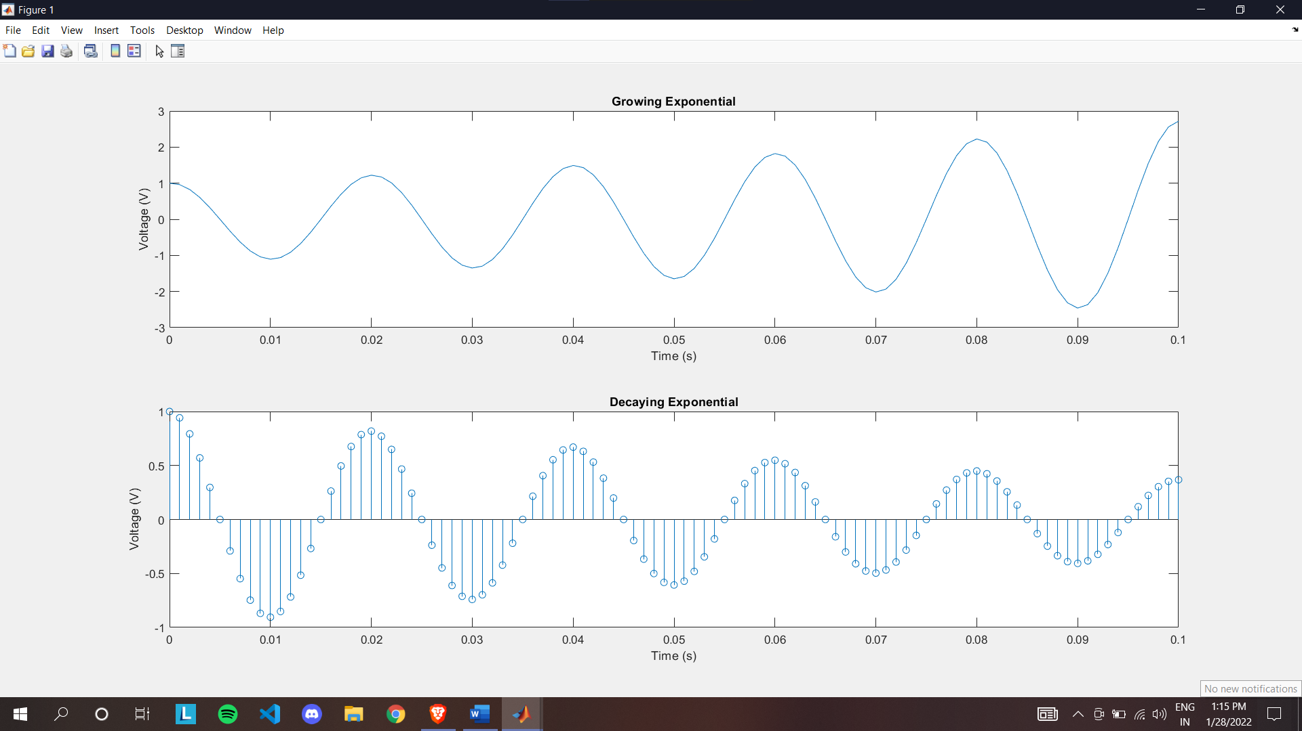

For c:

%%

clear all

clc

f = 50; tp = 1 / f; %freq and time period

fs = 1000; ts = 1 / fs; %sampling freq and time

period

t = 0:ts:10*tp;

x = exp(-i*2*pi*f*t)

plot(t,x)

title('Exponential Function')

xlabel('Time period')

ylabel('Voltage')

grid on

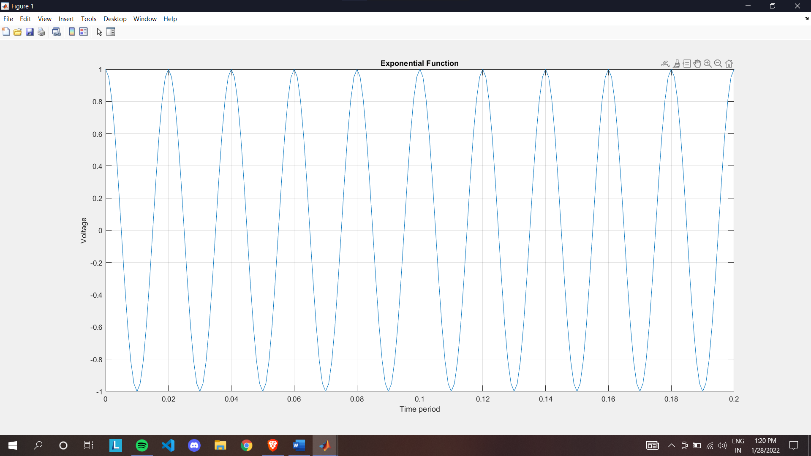

For d:

clear all

clc

f = 50; tp = 1 / f;

samples = 20;

t = 0:tp/samples:5*tp;

x = sin(2*pi*f*t) ./ (2*pi*f*t)

subplot(2,1,1)

plot(t,x)

stem(t,x)

title('Sine Function')

xlabel('Time period')

ylabel('Voltage')

grid on

x = cos(2*pi*f*t) ./ (2*pi*f*t)

subplot(2,1,2)

plot(t,x)

stem(t,x)

title('Cos Function')

xlabel('Time period')

ylabel('Voltage')

grid on

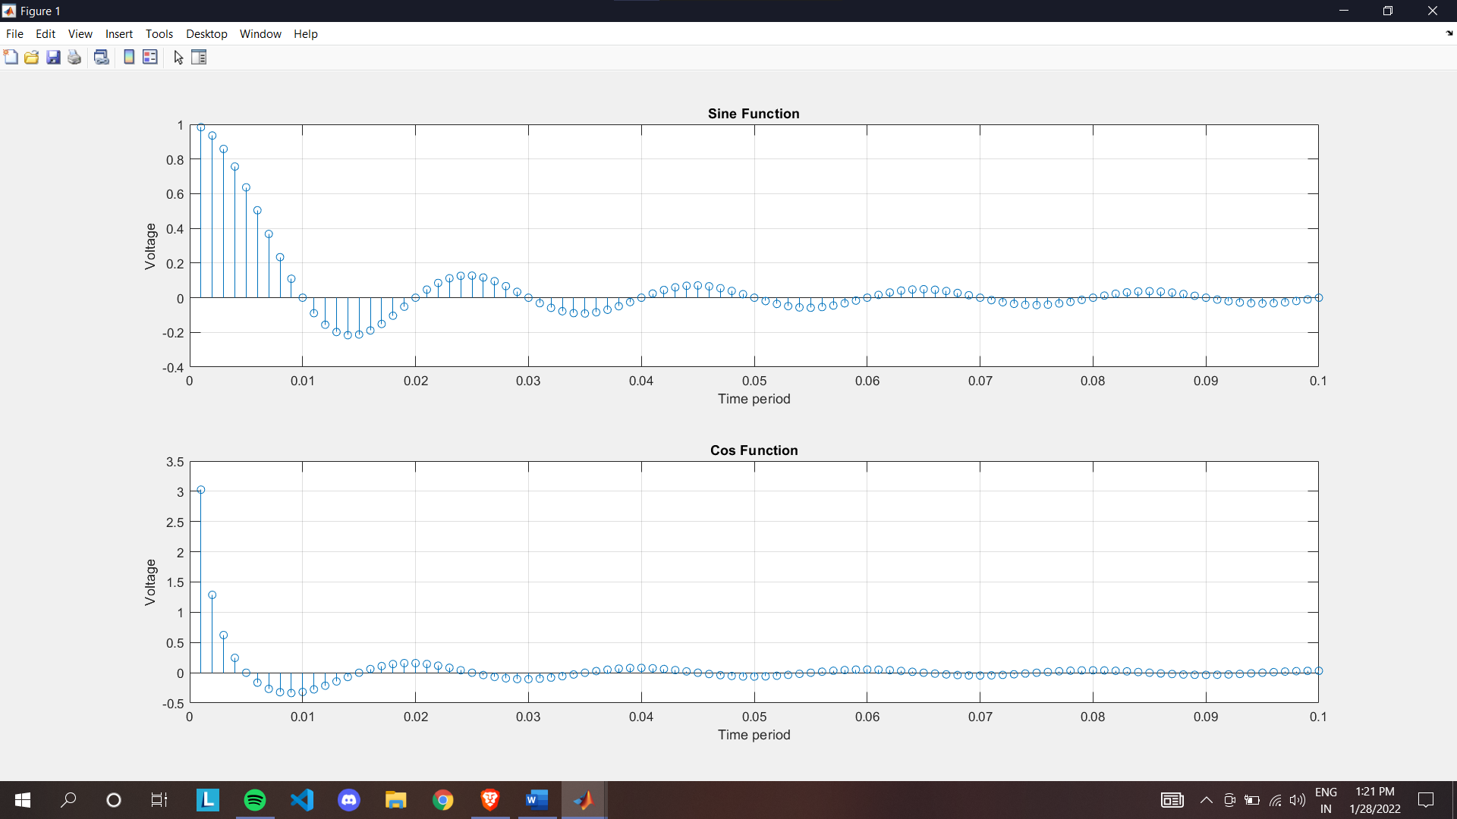

#Sine Cos function in x, y, z axis

%sine & wave figure

f = 50;

tp = 1 / f;

samples = 20;

t = 0:tp/samples:5*tp;

x = cos(2*pi*f*t);

y = sin(2*pi*f*t);

plot3(t,x,y)

title('Sine & Cos')

xlabel('Time (s)')

ylabel('Cos')

zlabel('Sin')

grid on

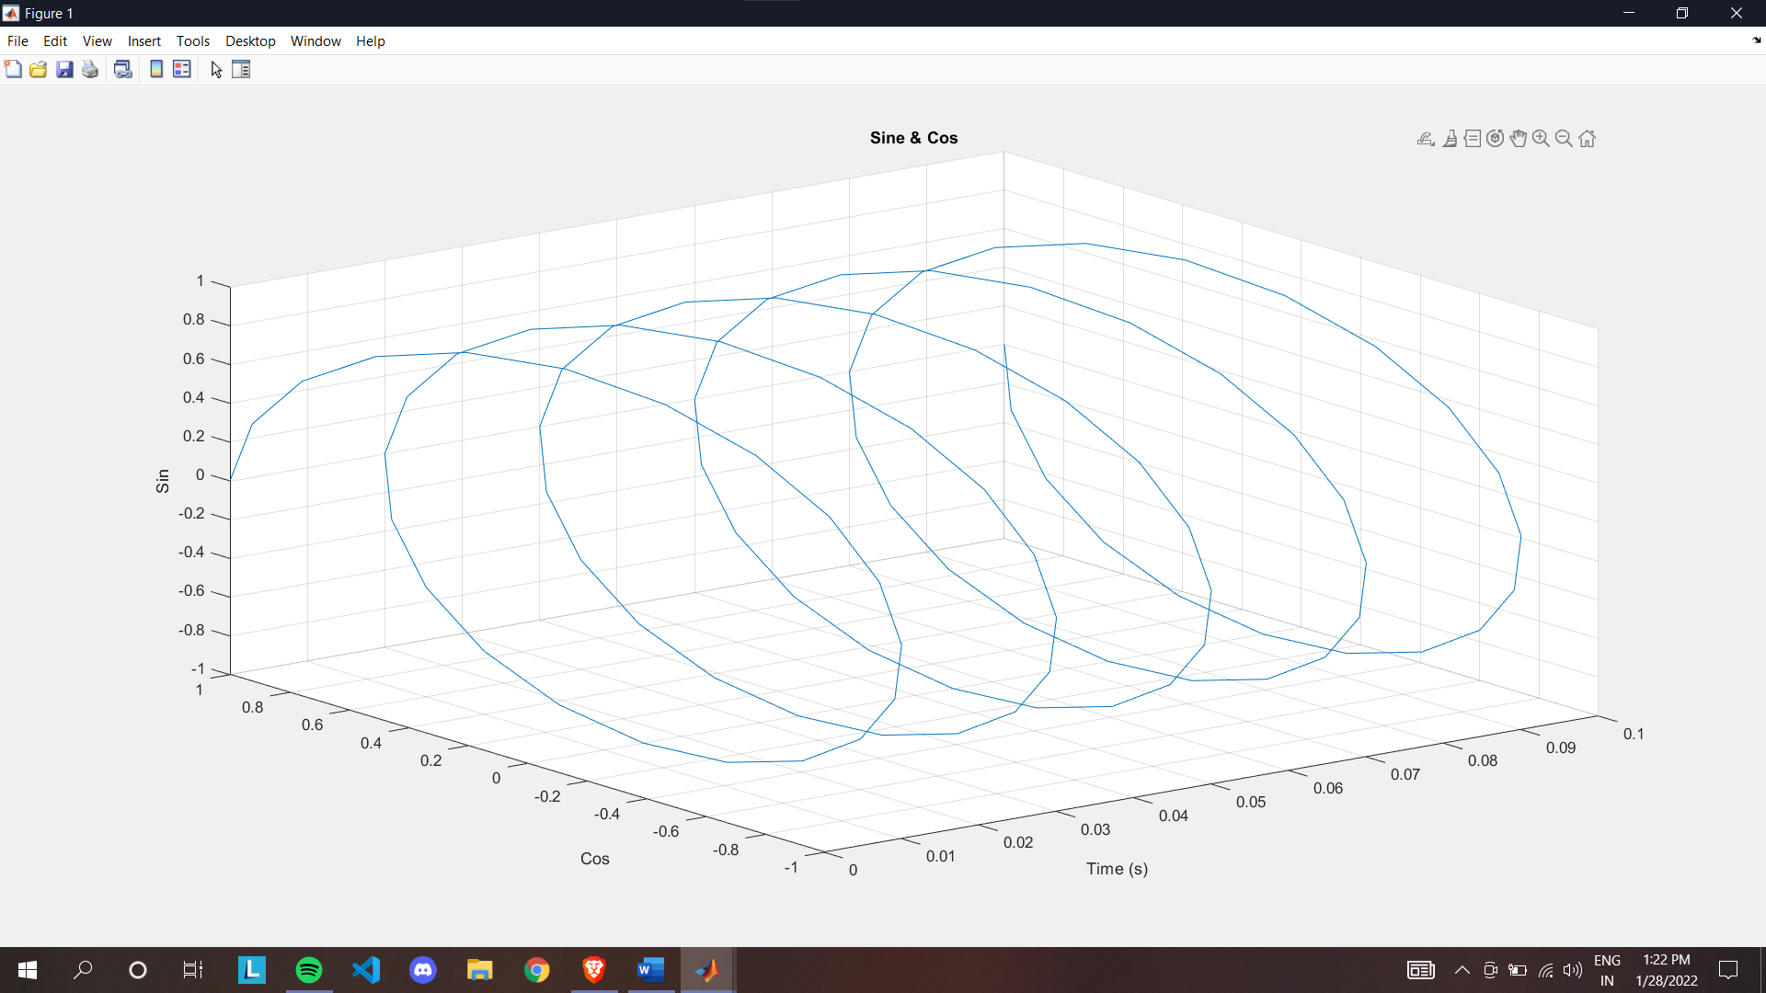

**Q3. Two continuous time signals of frequency fc1 and fc2 are sampled with a sampling frequency of fs=1 kHz. Find the frequencies for which the discrete time signals that will be identical. Plot the signals for the same time scale.**

**Code:**

clear all

clc

%sampling theorem is verified (fs > 2f)

f = 40; tp = 1 / f; %freq and time period

fs = 100; ts = 1 / fs; %sampling freq and time period

t = 0:ts:10*tp;

x = sin(2*pi*f*t)

subplot(2,1,1)

stem(t,x)

plot(t,x)

title('Sine Function (Sampling Theorem Verified)')

xlabel('Time period')

ylabel('Voltage')

grid on

%sampling theorem is not verified (fs < 2f)

f = 140; tp = 1 / f; %freq and time period

fs = 100; ts = 1 / fs; %sampling freq and time period

t = 0:ts:30*tp;

x = sin(2*pi*f*t)

subplot(2,1,2)

stem(t,x)

plot(t,x)

title('Sine Function (Sampling Theorem not Verified)')

xlabel('Time period')

ylabel('Voltage')

grid on

**Output:**

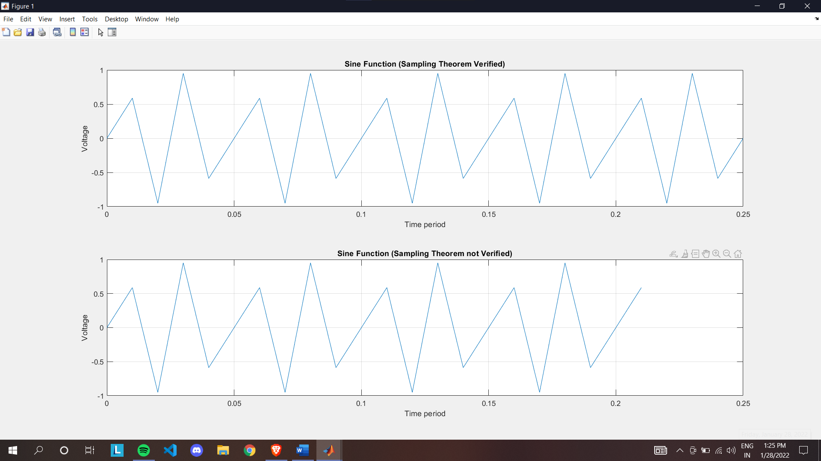

**Q4. Find the solution of the differential equations.**

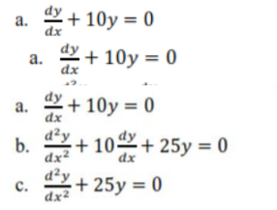

**Code:**

clc

clear all

x=dsolve('Dx=-10*x')

x=dsolve('D2x=-25*x', 'x(0)=5','Dx(0)=0')

x=dsolve('D2x=-10*Dx-25*x', 'x(0)=5','Dx(0)=0')

**Output:**

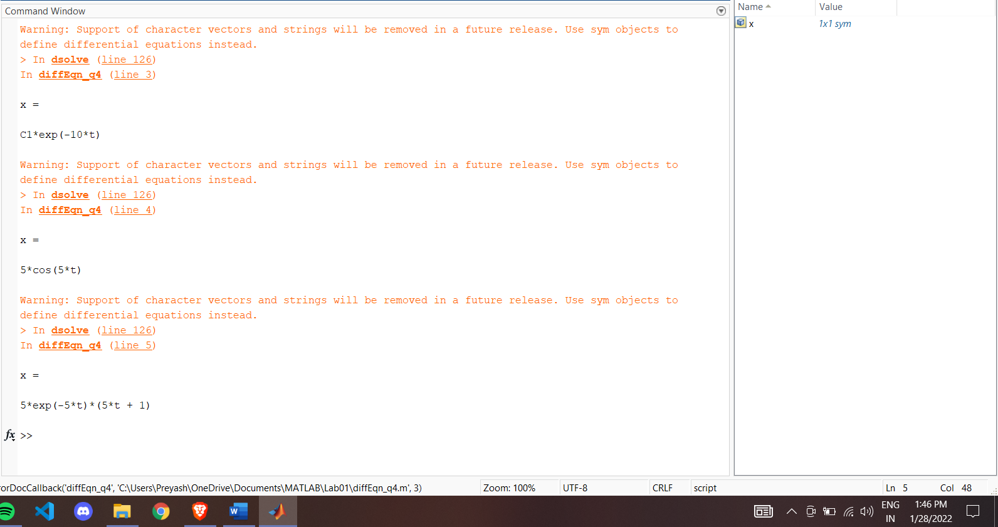

**Q5. Find the step and impulse response of the system with transfer functions.**

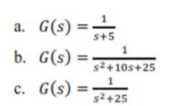

**Code:**

For a

clear all

clc

num = [1]

denom = [1,5]

f = tf(num,denom)

subplot(2,1,1)

impulse(f)

title('Impulse Graph')

subplot(2,1,2)

step(f)

title('Step Graph')

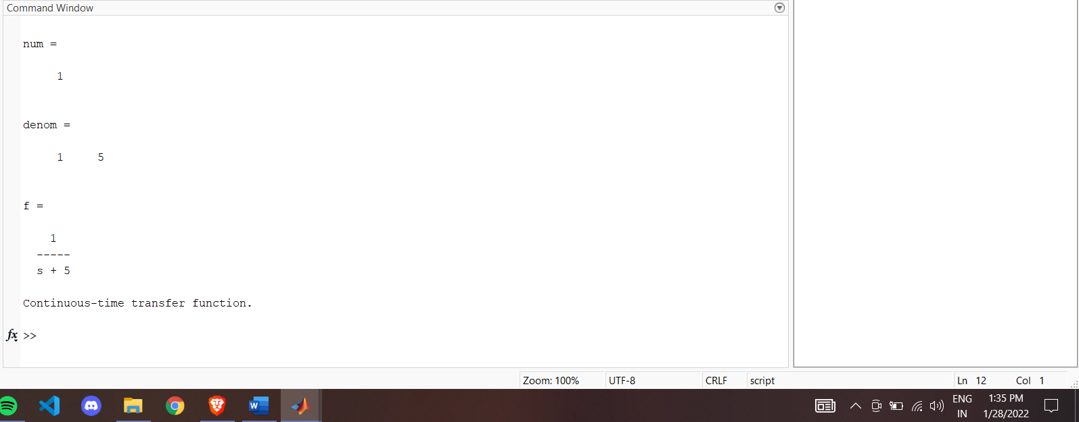

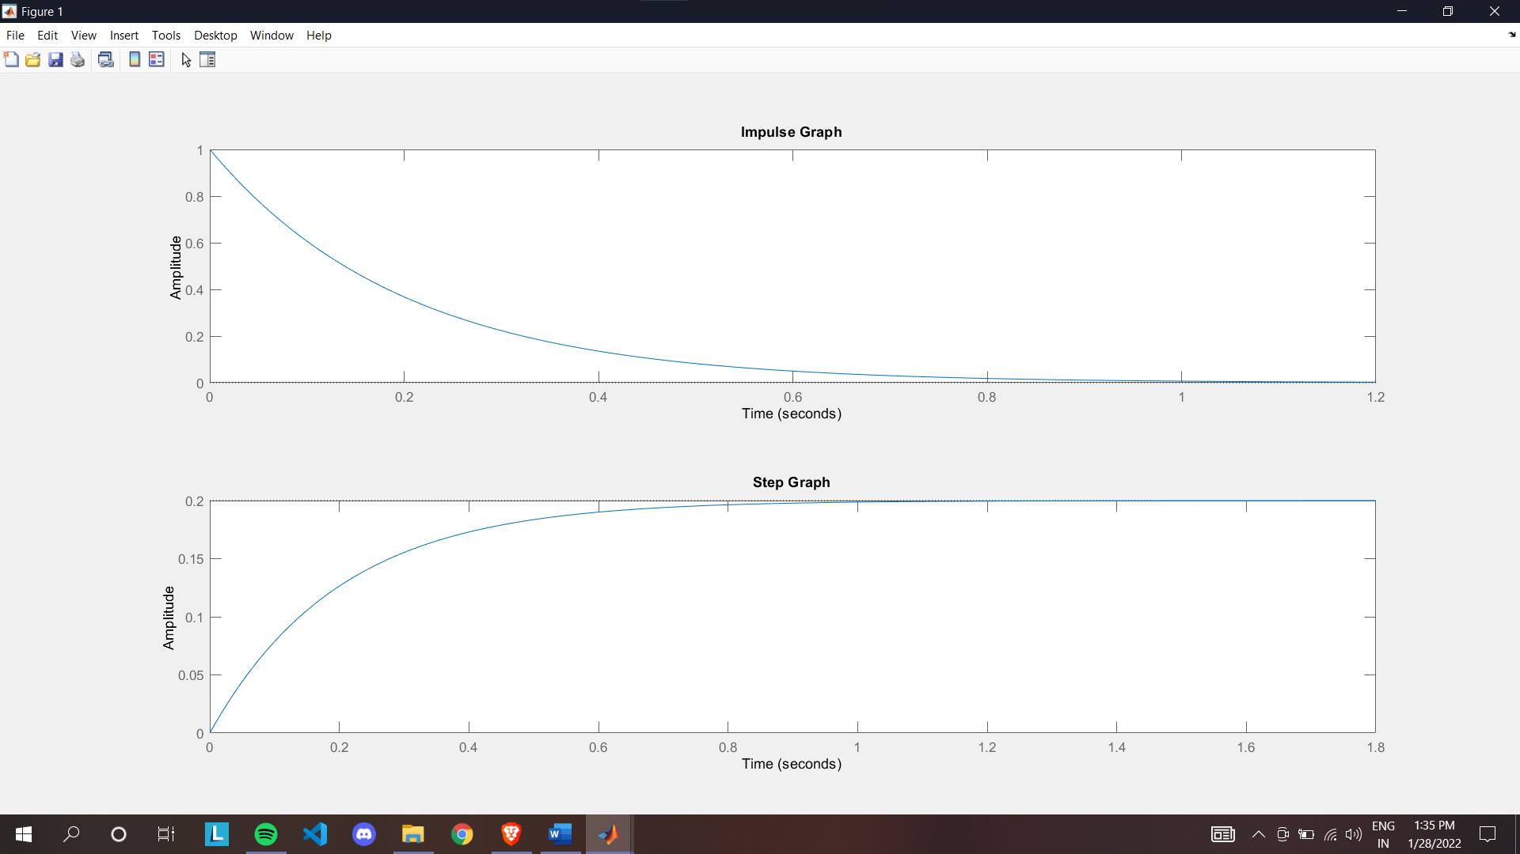

For b

%%

clear all

clc

num = [1]

denom = [1,10,25]

f = tf(num,denom)

subplot(2,1,1)

impulse(f)

title('Impulse Graph')

subplot(2,1,2)

step(f)

title('Step Graph')

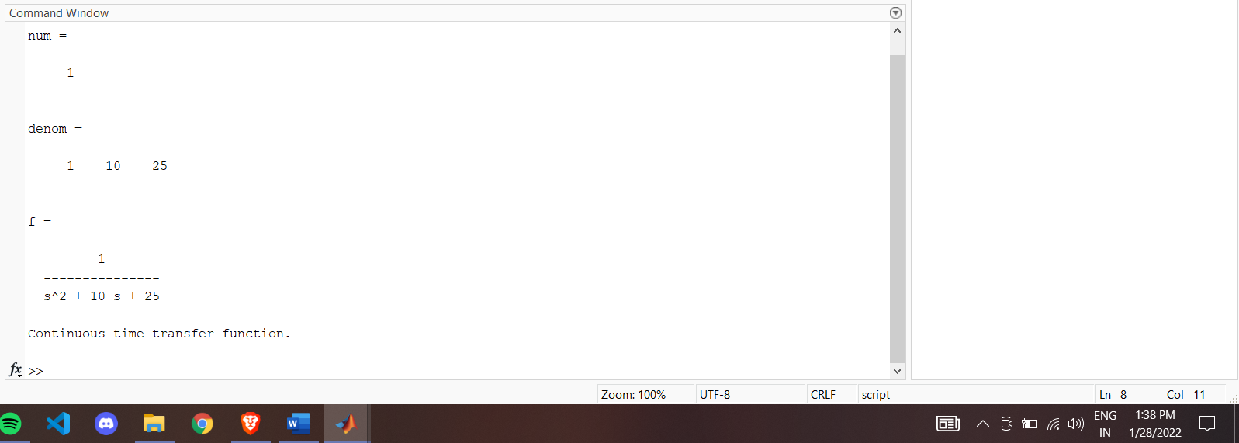

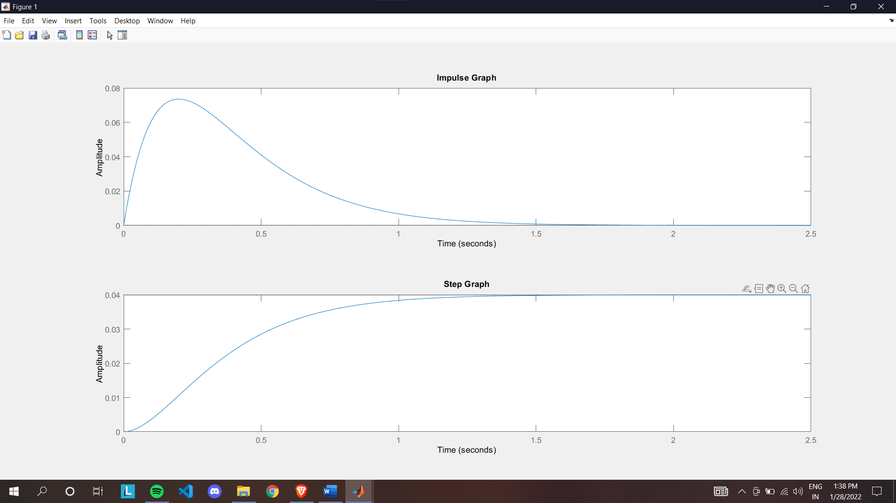

For c:

%%

clear all

clc

num = [1]

denom = [1,0,25]

f = tf(num,denom)

subplot(2,1,1)

impulse(f)

title('Impulse Graph')

subplot(2,1,2)

step(f)

title('Step Graph')

