**Understanding Systems with MATLAB**

**Experiment Number: 02**

Name: Preyash

Registration Number: 20BPS1022 Date: 04/02/2022

**Aim:**

The goal of this exercise is:

1. To learn the general shape of a second order system's transfer function.

2. The response of the second order system when the damping ratio varies.

3. System pole positioning owing to a change in damping ratio.

4. Find a first-order and a second-order system with the same step response.

**Draw the locus of roots of the system as the damping ratio changes increases. Write a MATLAB code to do plot the locus.**

1. Undamped System

**Code:**

clear all

clc

% undamped system

sys = tf([25],[1 0 25])

subplot(3,1,1)

impulse(sys)

subplot(3,1,2)

step(sys)

subplot(3,1,3)

pzmap(sys)

**Output:**

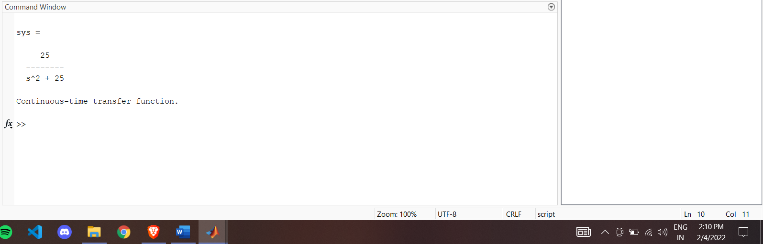

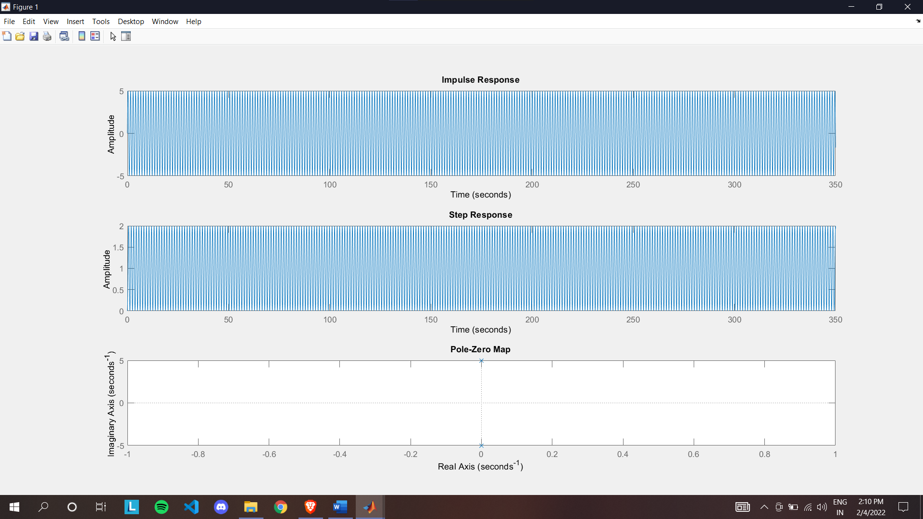

1. Underdamped System

**Code:**

% underdamped system

clear all

clc

sys = tf([25],[1 5 25])

subplot(3,1,1)

impulse(sys)

subplot(3,1,2)

step(sys)

subplot(3,1,3)

pzmap(sys)

**Output:**

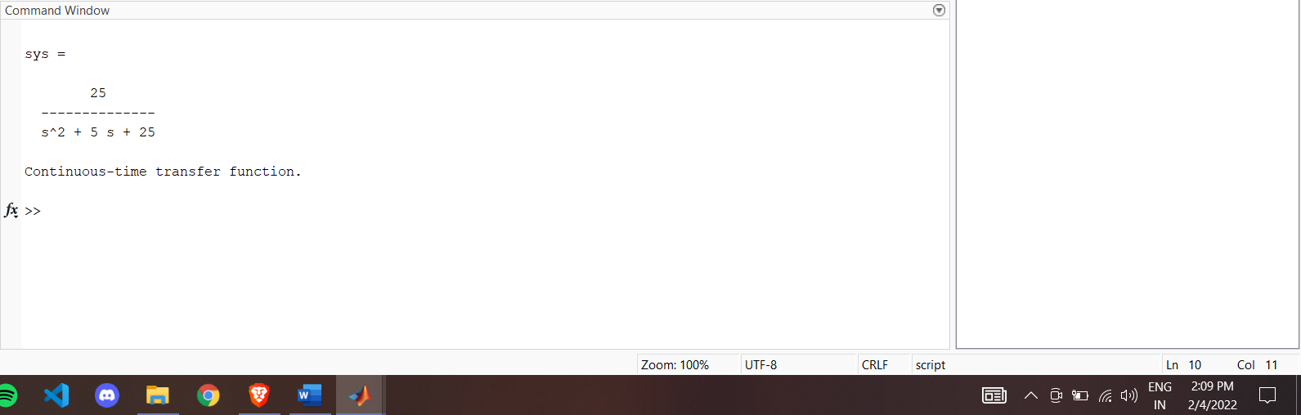

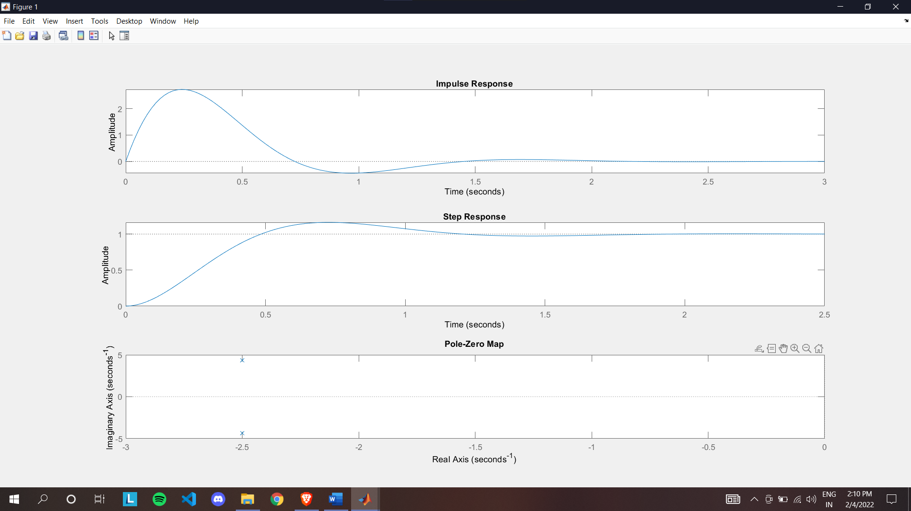

1. Critically Damped System

**Code:**

%critically damped

clear all

clc

sys = tf([25],[1 10 25])

subplot(3,1,1)

impulse(sys)

subplot(3,1,2)

step(sys)

subplot(3,1,3)

pzmap(sys)

**Output:**

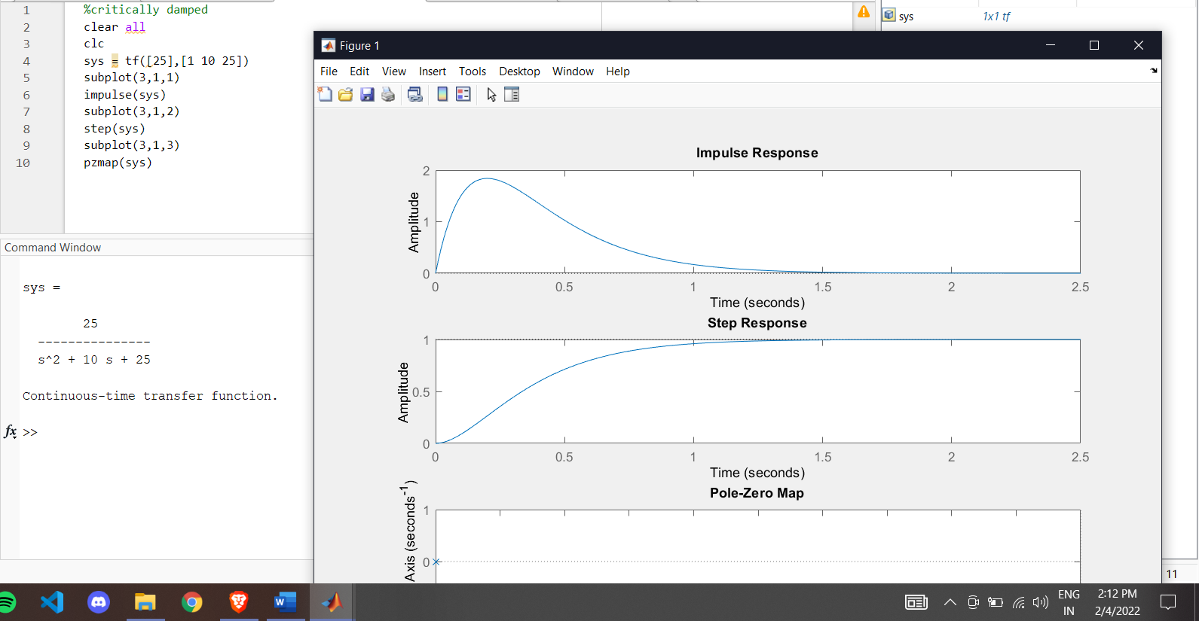

1. Overdamped System

**Code:**

%overdamped

clear all

clc

sys = tf([25],[1 100 25])

subplot(3,1,1)

impulse(sys)

subplot(3,1,2)

step(sys)

subplot(3,1,3)

pzmap(sys)

**Output:**

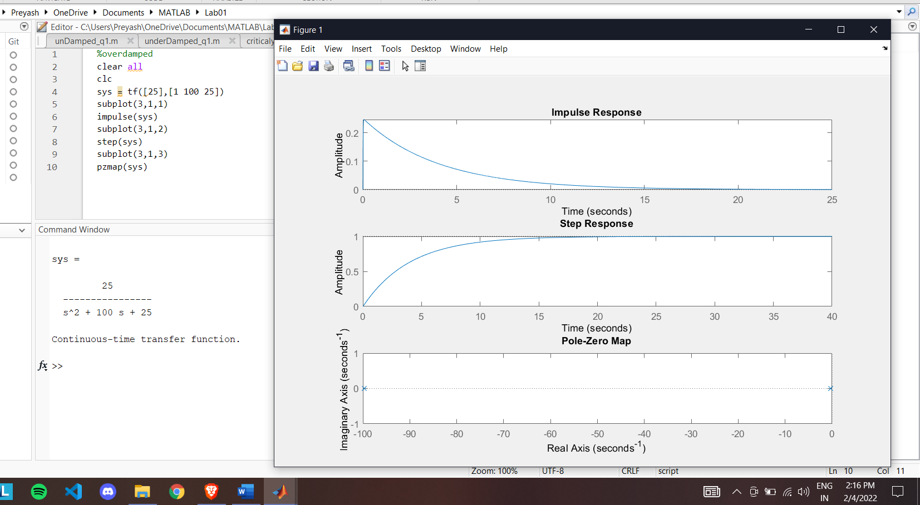

1. First Order System

**Code:**

%first order system

clear all

clc

sys = tf([0.2506],[1 0.2506])

subplot(3,1,1)

impulse(sys)

subplot(3,1,2)

step(sys)

subplot(3,1,3)

pzmap(sys)

**Output:**

