**Time Domain Specifications of a Second Order System**

**Experiment Number: 03**

Name: Preyash

Registration Number: 20BPS1022 Date: 11/02/2022

**Aim:**

The objective of this exercise is to

1. Understand the step response (transient and steady state) of a second order system.

2. Know the time domain specifications like peak overshoot, rise time, settling time and steady state error.

3. Analyze the effect of additional poles and zeros on a second order system.

**PRACTICE:**

Commands Used

#sys1= tf ([num],[den1 coefficients])

#ltiview(sys)

#pole(sys)

#zero(sys)

#r=roots(sys)

#poly(-a1; r)

#sys2= tf ([num],[den2 coefficients])

#sys3= tf ([num],[den3 coefficients])

#ltiview(sys1,sys2,sys3)

**System #1**

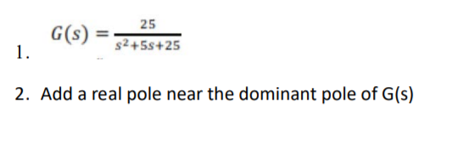

3. Add a real pole away the dominant pole of G(s)

**CODE:**

clc;

clear all;

num=[25]

den=[1 5 25]

sys1=tf(num,den)

P1 = pole(sys1)

Z1 = zero(sys1)

r=roots(den)

ltiview(sys1)

a=poly([-2;r])

num1=num/1

sys2= tf(num1,a)

P2 = pole(sys2)

ltiview(sys2)

num2=num/1

a1=poly([-4;r])

sys3=tf(num2,a1)

P3 = pole(sys3)

ltiview(sys3)

ltiview(sys1,sys2,sys3)

**OUTPUT:**

**System G(S)**

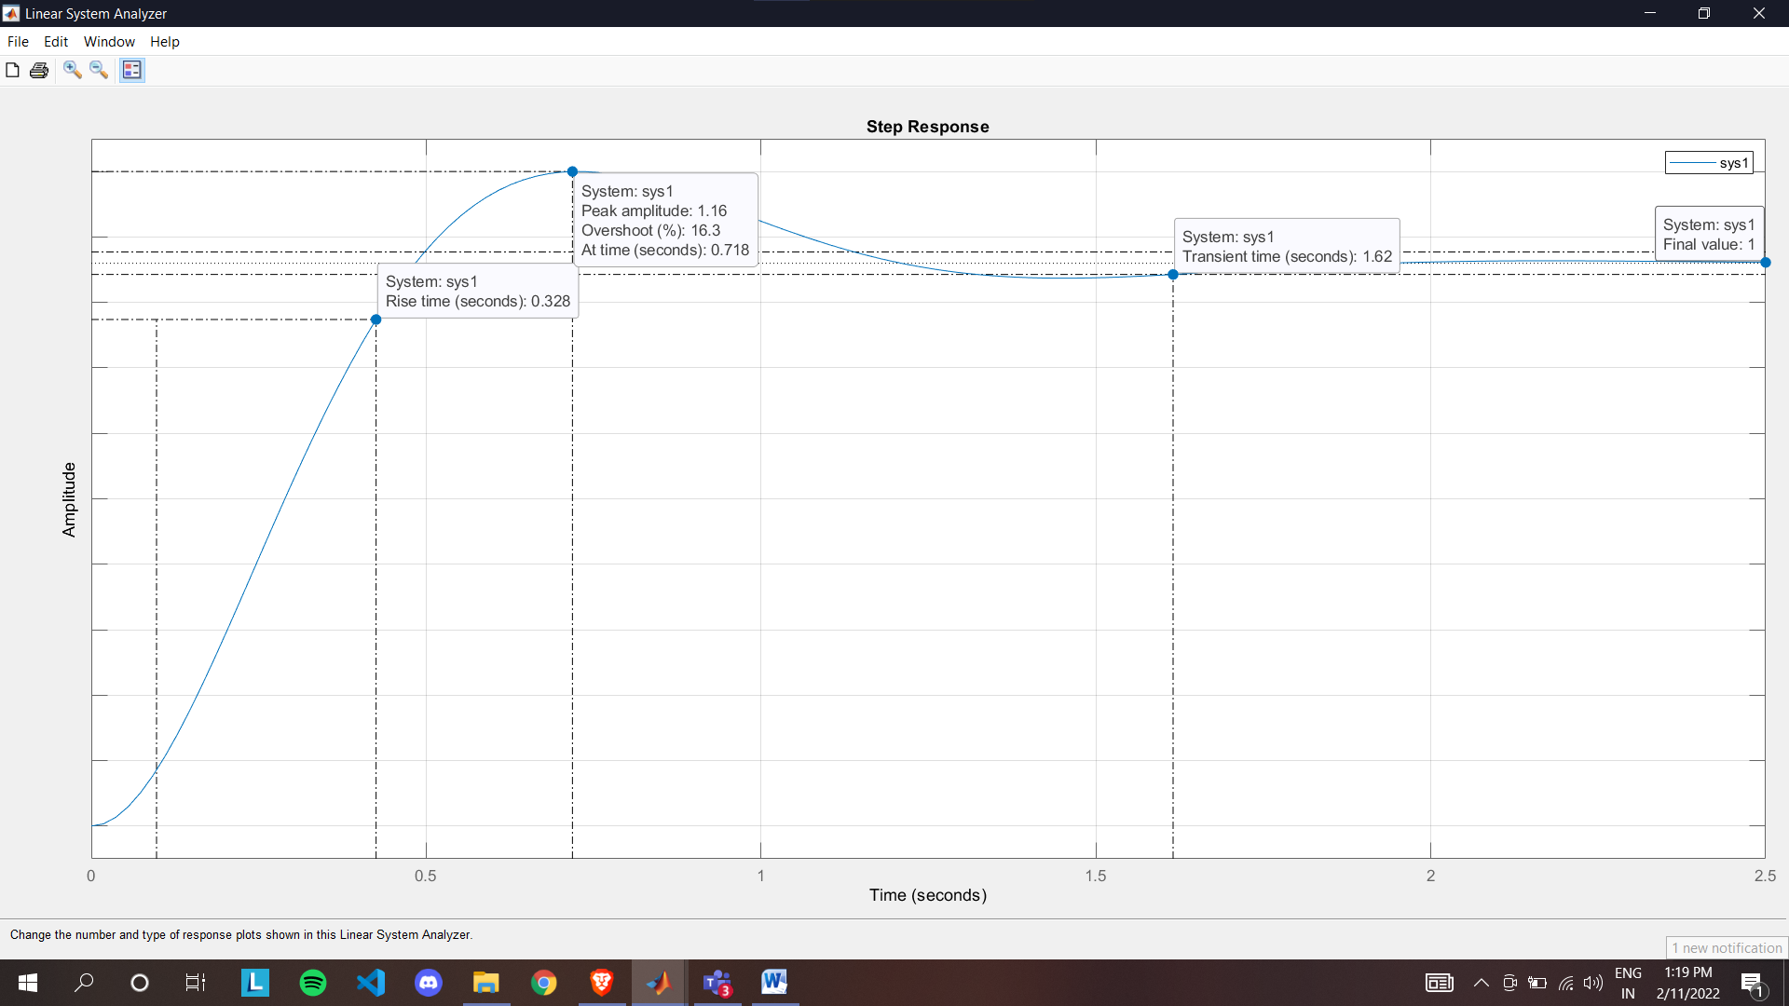

**Add a real pole near the dominant pole of G(s)**

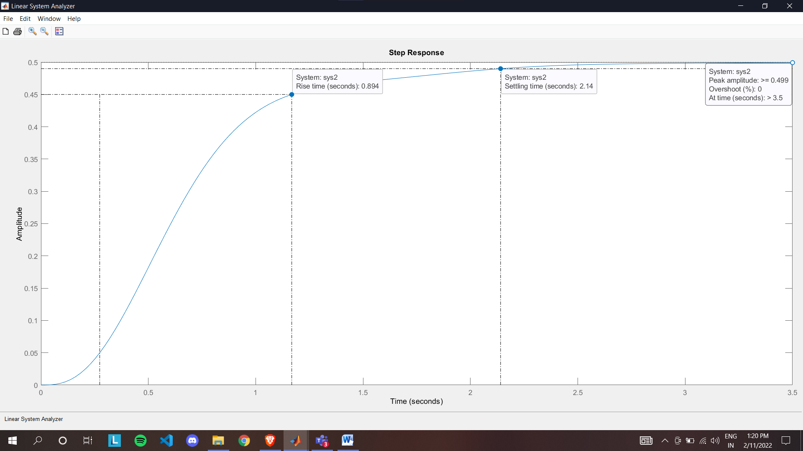

**Add a real pole away the dominant pole of G(s)**

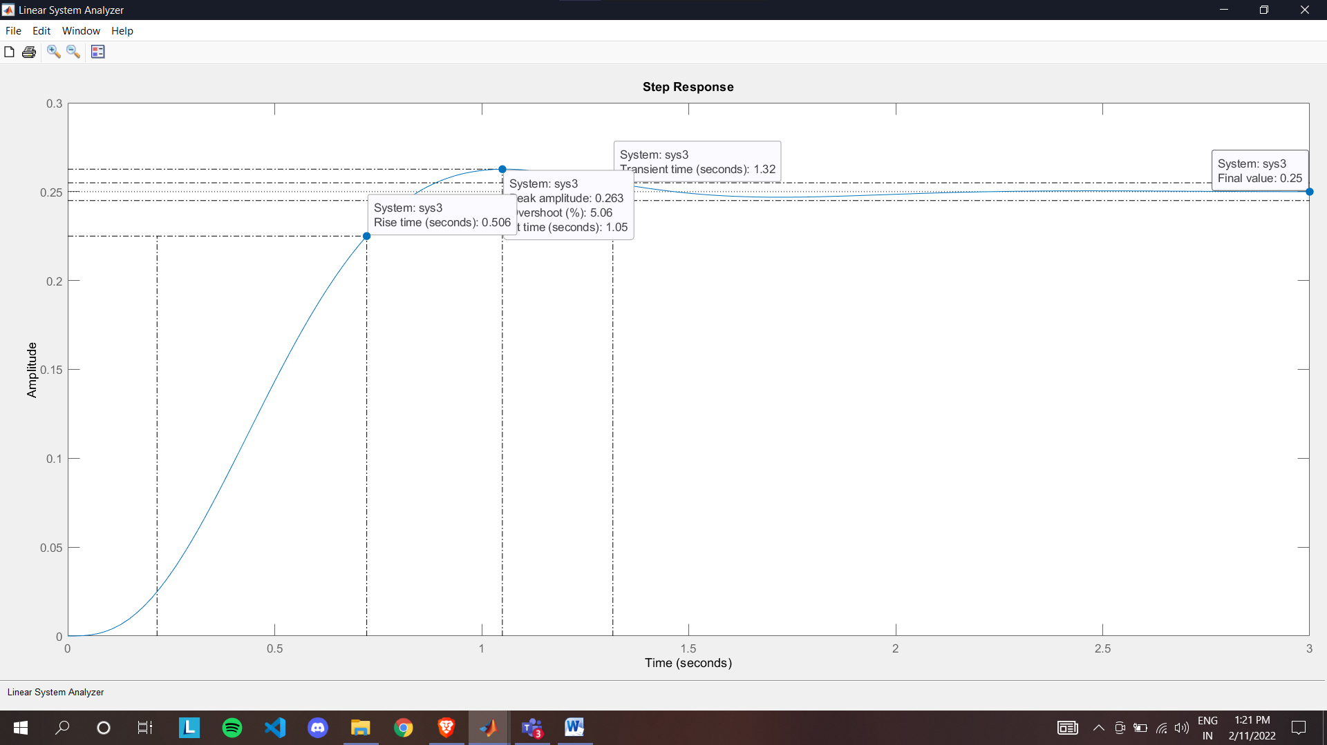

**LTI View of all three system**

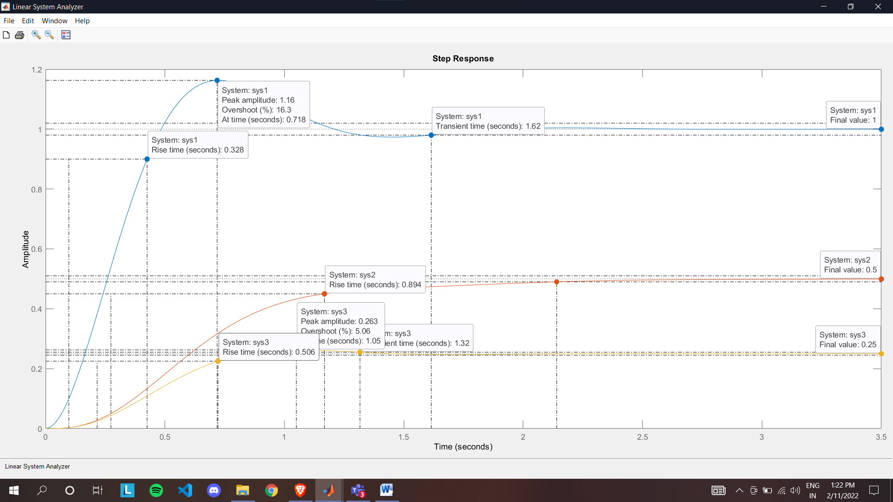

**CODE:**

clc;

clear all;

num=[25]

den=[1 5 25]

sys1=tf(num,den)

P1= pole(sys1)

Z1= zero(sys1)

r=roots(den)

ltiview(sys1)

num1=[25 50]

sys2= tf(num1,den)

Z2 = zero(sys2)

ltiview(sys2)

num2=[25 100]

sys3=tf(num2,den)

Z3 = zero(sys3)

ltiview(sys3)

ltiview(sys1,sys2,sys3)

**OUTPUT:**

**System G(S)**

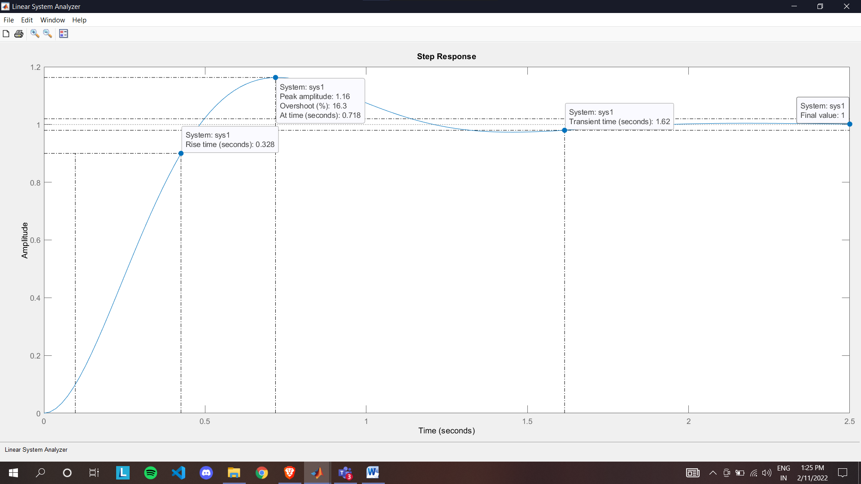

**Add a real zero near the dominant zero of G(s)**

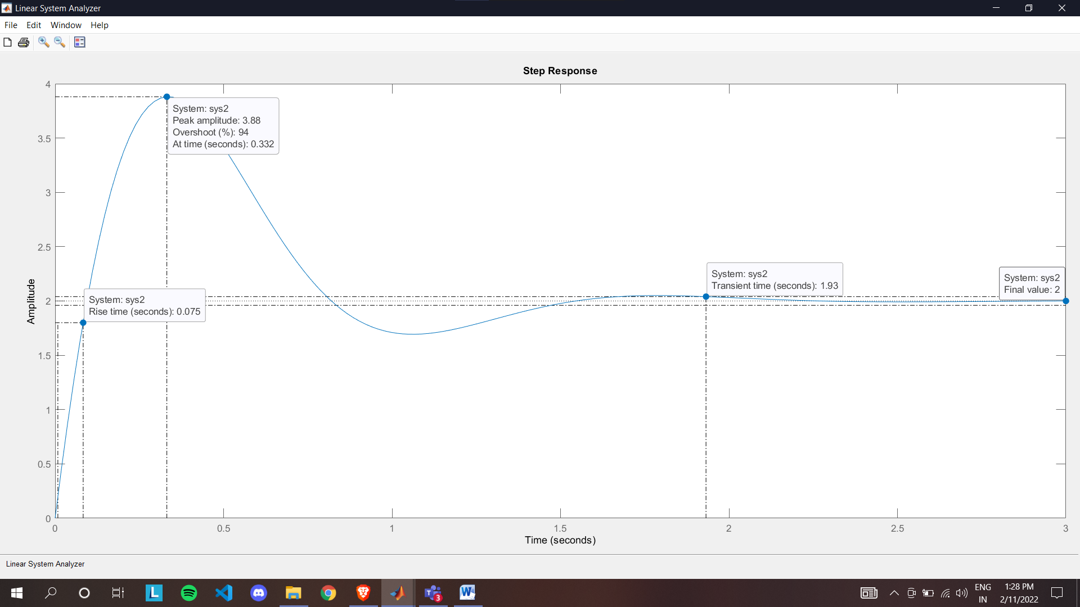

**Add a real zero away the dominant zero of G(s)**

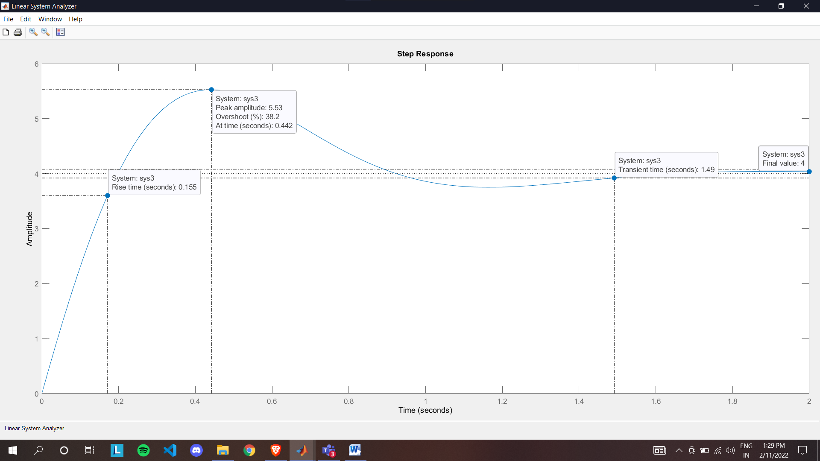

**LTI View of all three systems**

