**BLOCK DIAGRAM REDUCTION**

**Experiment Number: 04**

Name: Preyash

Registration Number: 20BPS1022 Date: 25/02/2022

**Aim:**

The goal of this exercise is to learn block diagram reduction in MATLAB

**Block Diagram Reduction - MATLAB Commands Used**

#tf(G1, G2)

#series(G1, G2)

#parallel(G1, G2)

#feedback(G1,G2)

#append(G1, G2)

#connect(sys, Q, input, output)

#tf2ss (num,den)

1. **Blocks connected in series:**

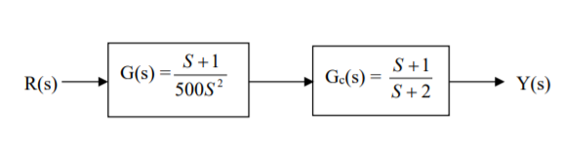

**Code:**

clc

clear all

numg=[1 1];

deng = [500 0 0];

numh=[1 1];

denh = [1 2]

[num, den]= series(numg,deng,numh,denh);

disp("Blocks Connected in series")

printsys (num,den)

**Output:**

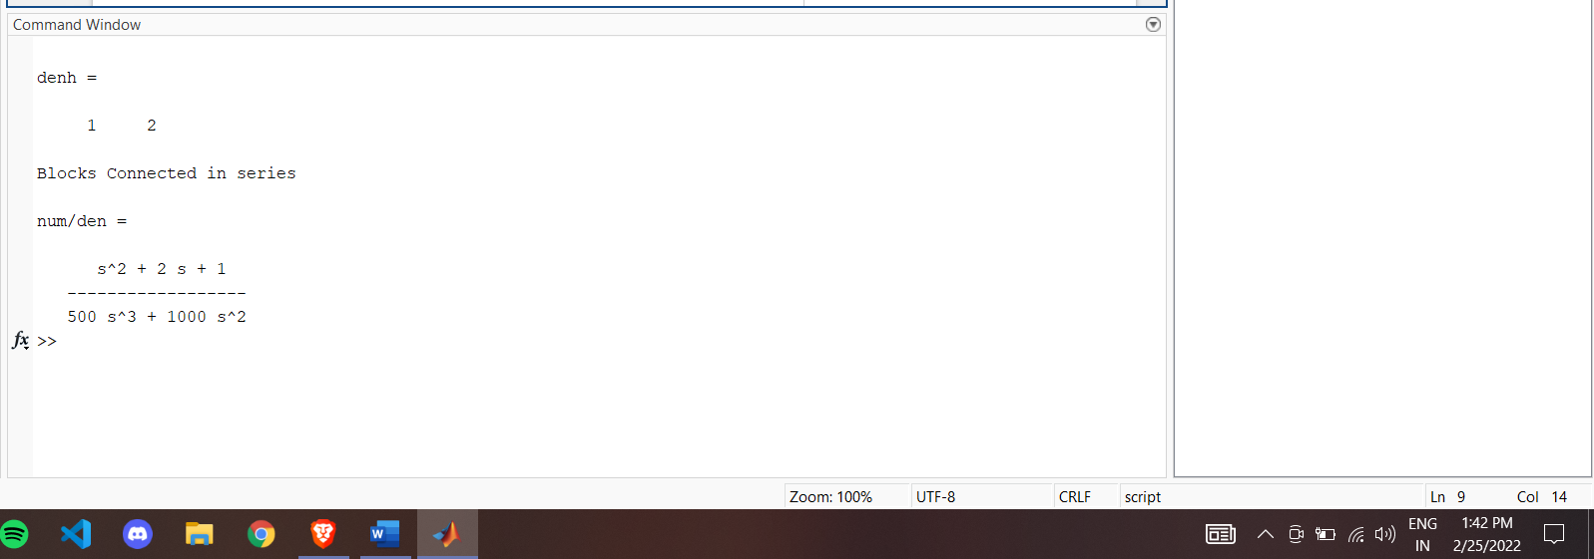

1. **Blocks connected in parallel:**

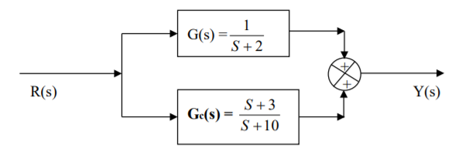

**Code:**

%Blocks connected in parallel

clc

clear all

num1 = 1;

den1 =[1 2];

num2 =[1 3];

den2 =[1 10];

[nump, denp] = parallel(num1, den1, num2, den2);

disp("Blocks connected in parallel")

printsys(nump, denp);

**Output:**

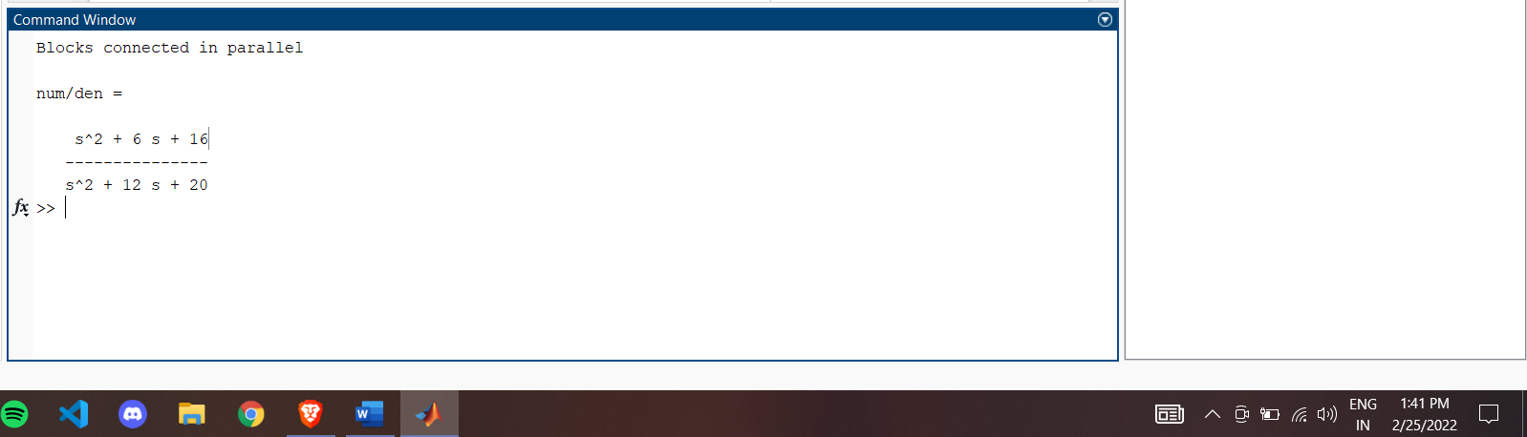

1. **Feedback function:**

command : [num, den] = feedback(num1, den1, num2, den2, sign)

Single loop

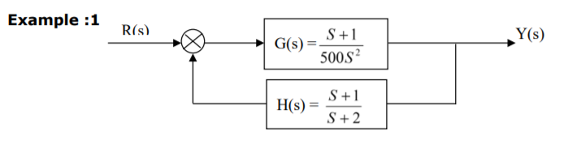

**Code:**

%Negative feedback system

clc

clear all

numg = [1 1] ; deng = [500 0 0];

numh = [1 1] ; denh = [ 1 2 ];

[num, den] = feedback(numg,deng,numh,denh,-1);

disp("Blocks connected with negative feedback loop")

printsys(num, den)

**Output:**

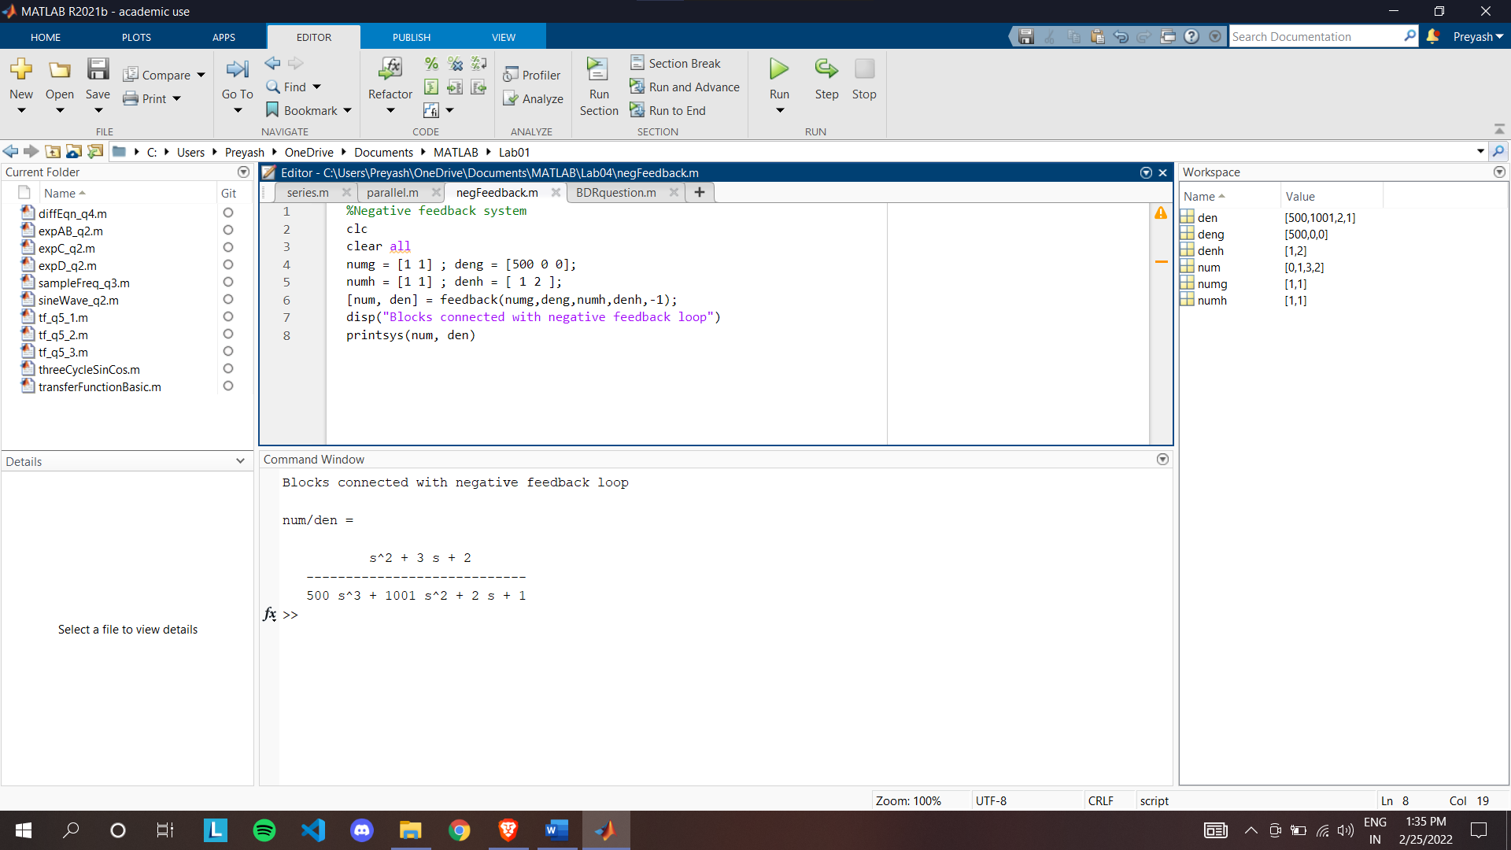

**Question: Write a code to reduce the block diagram and obtain the transfer function.**

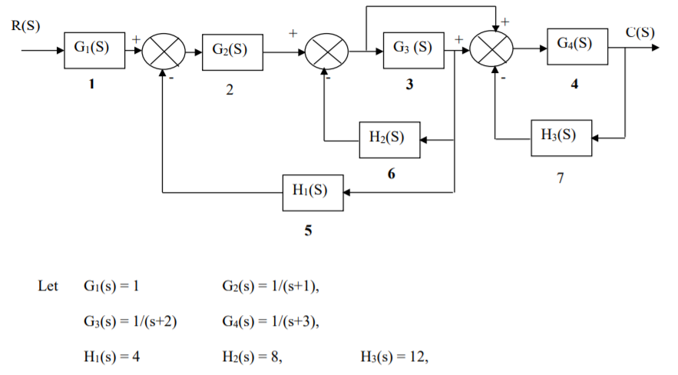

**Code:**

%Block diagram reduction question

clc

clear all

n1=1;d1=1;

n2=1;d2=[1 1];

n3=1;d3=[1 2];

n4=1;d4=[1 3];

n5=4;d5=1;

n6=8;d6=1;

n7=12;d7=1;

nblocks=7;

blkbuild

q = [ 1 0 0 0 0

2 1 -5 0 0

3 2 -6 0 0

4 2 -6 3 -7

5 3 0 0 0

6 3 0 0 0

7 4 0 0 0 ]

iu = 1;

iy = 4;

[A,B,C,D]=connect(a,b,c,d,q,iu,iy);

sys=ss(A,B,C,D);

sys=tf (sys)

**Output:**

