**SIMULATION OF FIRST & SECOND ORDER SYSTEMS**

**Experiment Number: 05**

Name: Preyash

Registration Number: 20BPS1022 Date: 26/02/2022

**Aim:** To digitally simulate the time response characteristics of a linear system without non- linearities and to verify it manually.

**FIRST-ORDER SYSTEM:**

BLOCK-DIAGRAM:

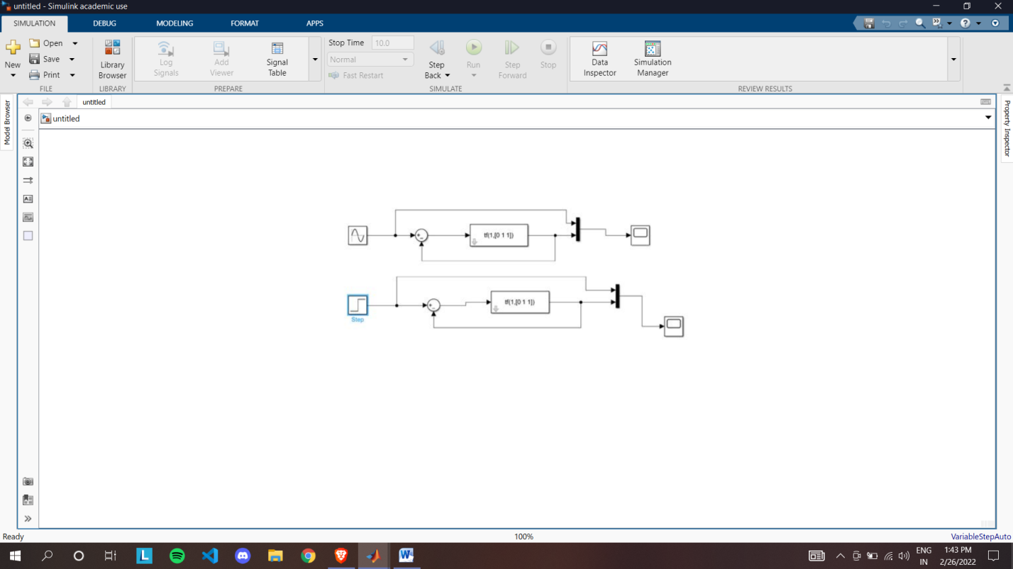

OUTPUT:

SINE RESPONSE:

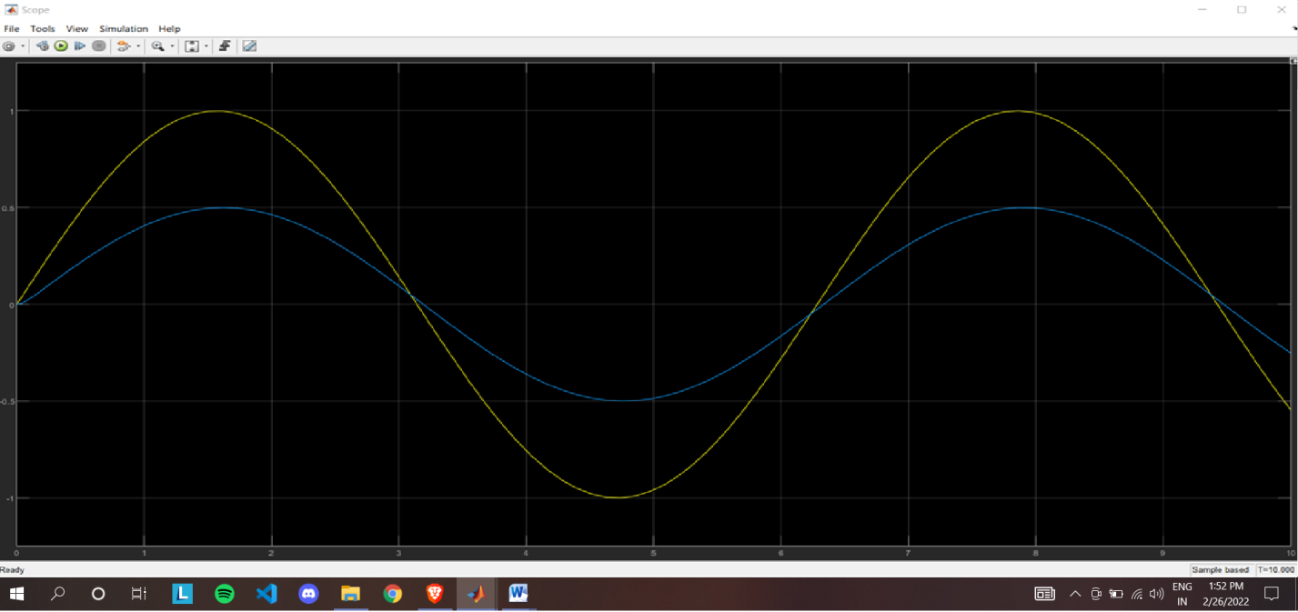

STEP RESPONSE:

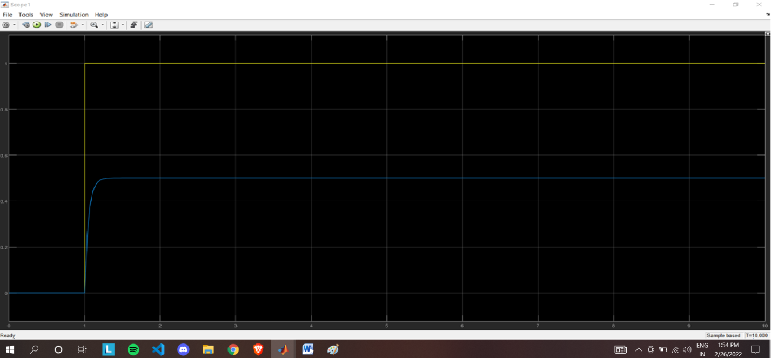

**SECOND-ORDER SYSTEM:**

BLOCK-DIAGRAM:

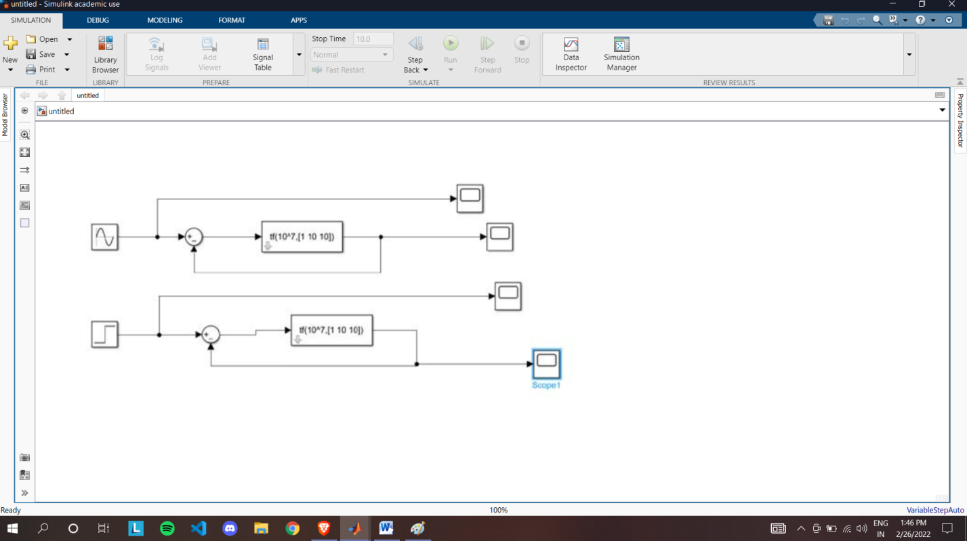

OUTPUT:

SINE INPUT:

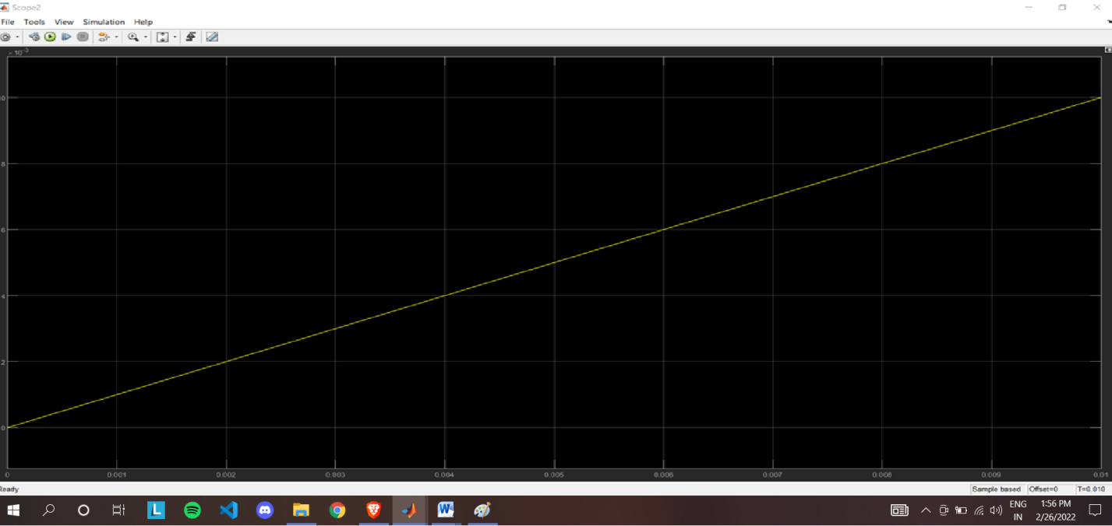

SINE RESPONSE:

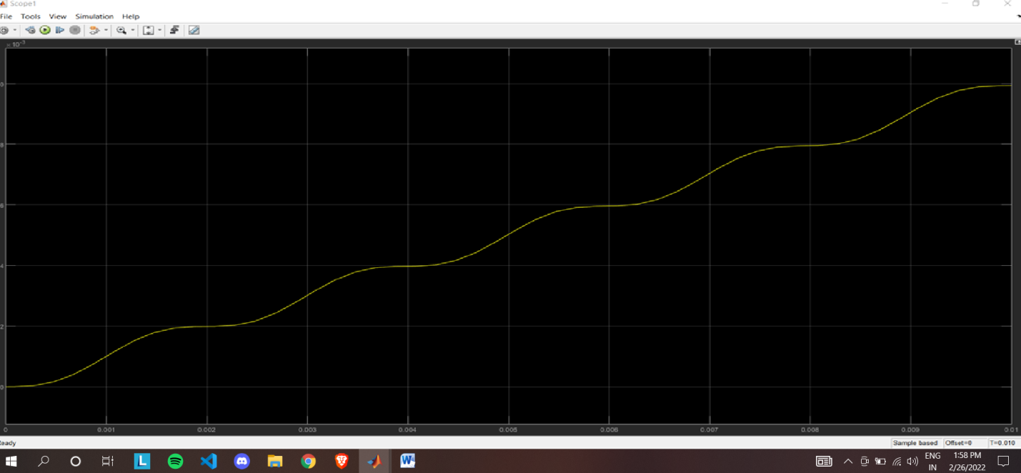

STEP INPUT:

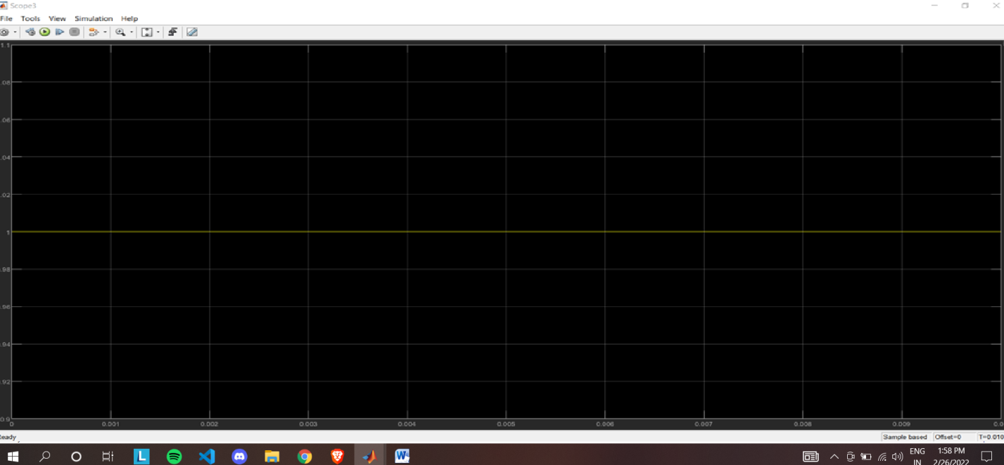

STEP RESPONSE:

