**Static Error Constants and Steady State Error**

**Name: Preyash**

**Reg No. 20BPS1022 Date: 04/03/2022**

# Aim:

The objective of this exercise is to

1. Introduce type of a system
2. Understand steady state error in systems of different types
3. Define static error constants and estimate steady state error from error constants

# Practice:

Identify the type of systems given below with

1. Poles at (-8, -9, -12), zeros at (-2, -3) and gain of 100

2. Poles at (0, -8, -9, -12), zeros at (-2, -3) and gain of 100

3. Poles at (0, 0, -8, -9, -12), zeros at (-2, -3) and gain of 100

Find the static error constants, the steady state error and plot the response of the systems for step, ramp and parabolic inputs

# MATLAB code:

%steady state error

clc

clear all

% Type ZERO System

Gp0 = zpk([-2 -3],[-8 -9 -12],100)

Kp0 = dcgain(Gp0)

ssr_steps0 = 1/(1+Kp0)

Gv0 = zpk([0 -2 -3],[-8 -9 -12],100)

Kv0 = dcgain(Gv0)

ssr_ramp0 = 1/Kv0

Ga0 = zpk([0 0 -2 -3],[-8 -9 -12],100)

Ka0 = dcgain(Ga0)

ssr_parabolic0 = 1/Ka0

% Type ONE System

Gp1 = zpk([-2-3],[0-8-9-12],100)

Kp1 = dcgain(Gp1)

ssr_steps1 = 1/(1+Kp1)

Gv1 = zpk([0 -2 -3],[0 -8 -9 -12],100)

Kv1 = dcgain(Gv1)

ssr_ramp1 = 1/Kv1

Ga1 = zpk([0 0 -2 -3],[0 -8 -9 -12],100)

Ka1 = dcgain(Ga1)

ssr_parabolic1 = 1/Ka1

% Type TWO System

Gp2 = zpk([ -2-3],[0 0-8-9-12],100)

Kp2 = dcgain(Gp2)

ssr_steps2 = 1/(1+Kp2)

Gv2 = zpk([0-2-3],[0 0-8-9-12],100)

Kv2 = dcgain(Gv2)

ssr_ramp2 = 1/Kv2

Ga2 = zpk([0 0-2-3],[0 0-8-9-12],100)

Ka2 = dcgain(Ga2)

ssr_parabolic2 = 1/Ka2

%PLOT RESPONSES

G0=zpk( [ -2 -3], [ -8 -9 -12], 100)

G1=zpk( [-2 -3], [0 -8 -9 -12], 100)

G2=zpk( [ -2-3], [0 0-8-9 -12], 100)

%Figure

%%

% Type 0 system

sys0=feedback(tf(G0),1) ;

% step input

subplot (3, 3, 1) ;

t=0.0001:0.01:5;

u=t./t;

lsim(sys0,u,t);

% Ramp input

subplot(3,3,2);

t=0.0001:0.01:5;

u=t;

u(1:100)=0;

lsim(sys0,u,t);

% acceleration input

subplot(3,3,3);

t=0.0001:0.01:5;

u=t.*t/2;

u(1:100)=0;

lsim(sys0,u,t);

%%

% Type 1 system

sys1=feedback(tf(G1),1);

% step input

subplot(3,3,4);

t=0.0001:0.01:5;

u=t./t;u(1:100)=0;

lsim(sys1,u,t);

% Ramp input

subplot(3,3,5);

t=0.0001:0.01:5;

u=t;

lsim(sys1,u,t);

% acceleration input

subplot(3,3,6);

t=0.0001:0.01:5;

u=t.*t/2;

lsim(sys1,u,t);

%%

% Type 2 system

sys2=feedback(tf(G2),1);

% step input

subplot(3,3,7);

t=0.0001:0.01:5;

u=t./t;

u(1:100)=0;

lsim(sys2,u,t);

% Ramp input

subplot(3,3,8);

t=0.0001:0.01:5;

u=t;

u(1:100)=0;

lsim(sys2,u,t);

% acceleration input

subplot(3,3,9);

t=0.0001:0.01:5;

u=t.*t/2;

lsim(sys2, u,t)

**Output :**

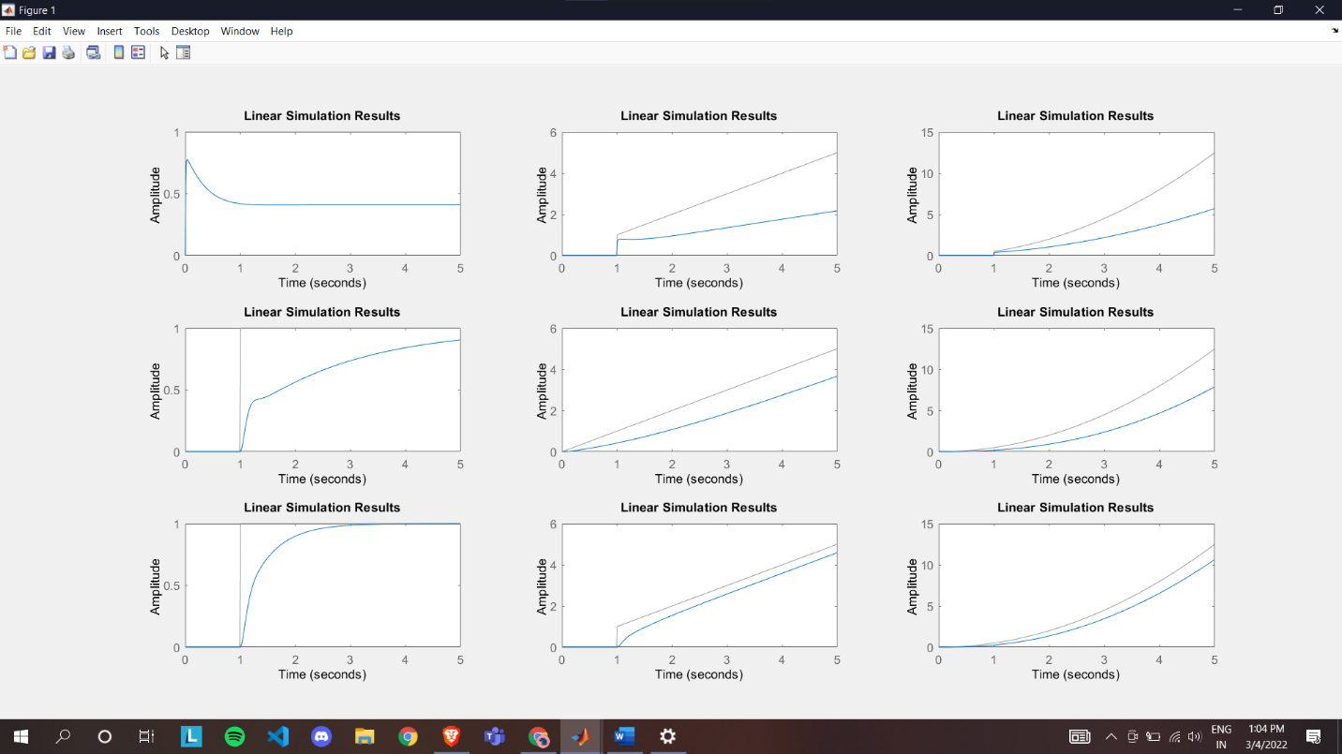

**Give the result as a table and the response plot**

# Results:

|  |  |  |  |  |
| --- | --- | --- | --- | --- |
| Systems | Input | Static error constants | Steady state error | Plot responses |
| Poles at (-8, -9, -12)  Zeros at (-2, -3) Gain of  100 | Step | 0.6944 | 0.5902 |  |
| Ramp | 0 | infinity |  |
| Parabolic | 0 | infinity |  |
| Poles at (0, -8, -9, -12)  Zeros at (-2, -3) Gain of  100 | Step | infinity | 0 |  |
| Ramp | 0.6944 | 1.4400 |  |
| Parabolic | 0 | infinity |  |
| Poles at (0, 0, -8, -9, -12)  Zeros at (-2, -3) | Step | infinity | 0 |  |
| Ramp | infinity | 0 |  |
| Parabolic | 0.6944 | 1.4400 |  |