Name: **Preyash**

Registration Number: **20BPS1022**

**L37-38**

**MAT2001**

**Lab Assignment-01**

**Introduction to R Studio (Basic syntax and commands)**

**“>” this symbol is called prompt**

**Arithmetic Operations:**

Addition



Subtraction



Multiplication



Division



Exponent (2 ways)

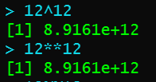

Modulus



Integer division



Some exceptions:









Some more basic calculations

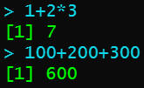

**Logical Operations:**

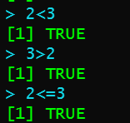

**Working with vectors**

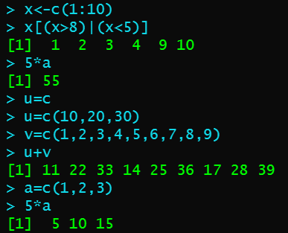

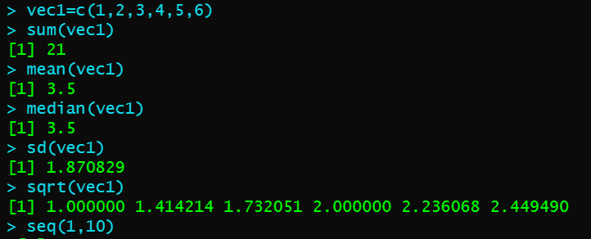

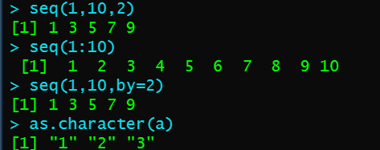

**String operation**

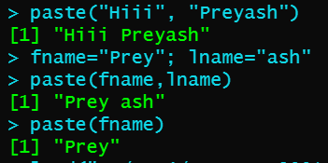

**Importing the CSV File.**

