

**Activity 2 – Graphs & Charts**

**Name: Preyash Date: 11/01/2022**

**Registration Number: 20BPS1022**

* Prepare a questionnaire and conduct an online survey on your topic (Preferably the current situation) with minimum 50 responses. (or) Secondary date can be used.
* Present the dataset in a Graphs & Charts include table wherever necessary.

**Online Learning in VIT**

**CSV (collected responses)**

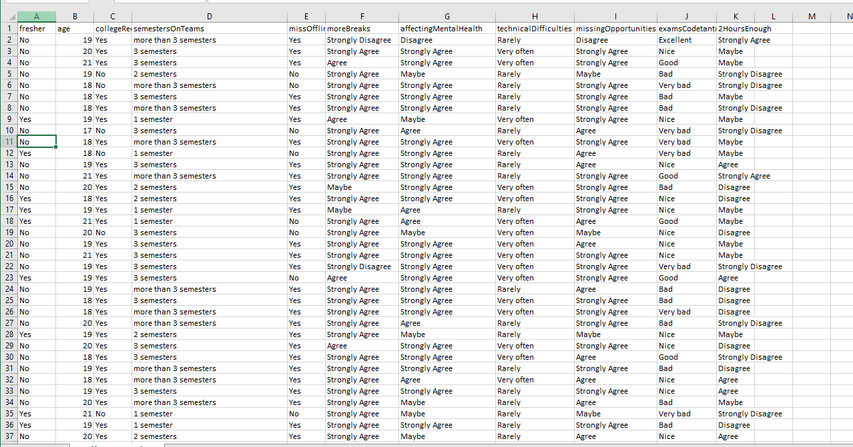

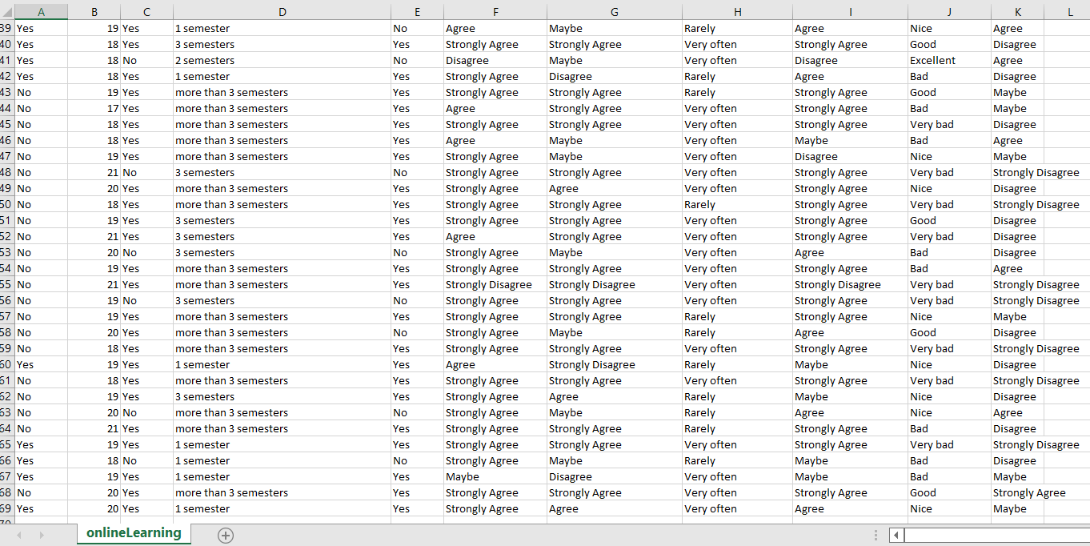

**Importing the CSV**

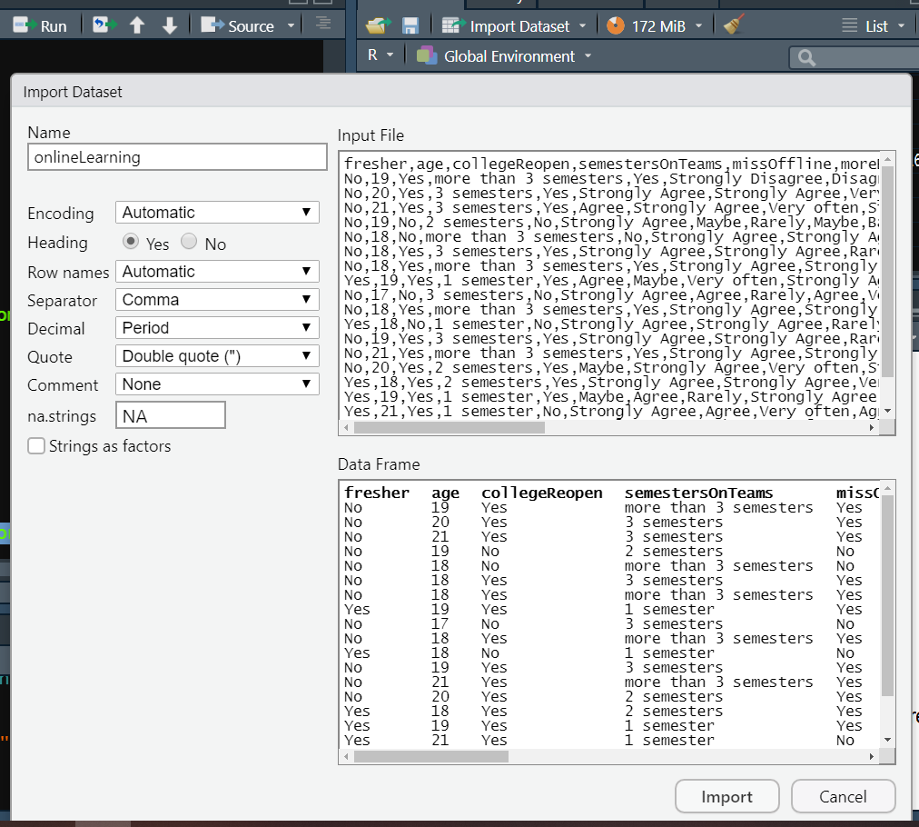

**Q1.) What is your age?**

plot(onlineLearning$age,type="l",main="age",xlab="responses",ylab="age in years",col="blue")

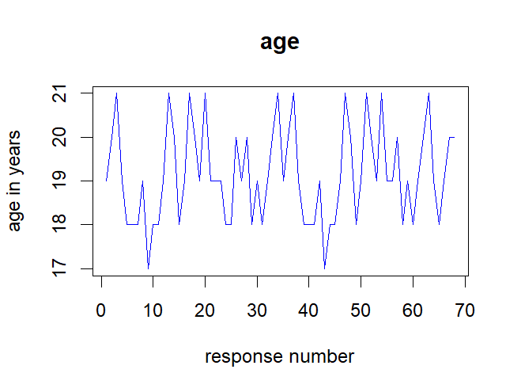

**Q2.) Are you a fresher?**

tableFresher=table(onlineLearning$fresher)

pie(tableFresher,col=c("blue","red"))

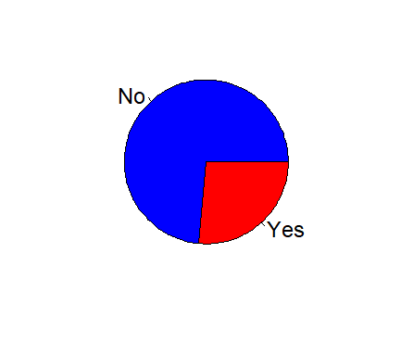

**Q3.) Do you want the college to reopen?**

tableReopen=table(onlineLearning$collegeReopen)

barplot(tableReopen,beside=T,xlim=c(0,8),ylim=c(0,80),col=c("cyan","yellow"))

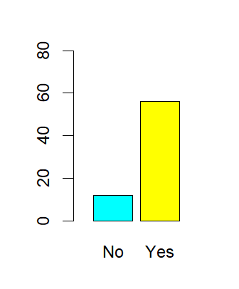

**Q4.) How many semesters have you spent on MS Teams?**

tableMSteams=table(onlineLearning$semestersOnTeams)

pie(tableMSteams,col=c("red","blue","yellow","green"))

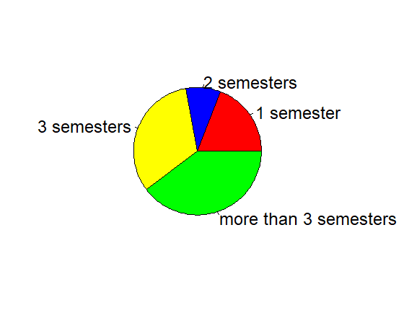

**Q5.) Do you miss offline classes?**

tableMiss=table(onlineLearning$missOffline)

barplot(tableMiss,beside=T,xlim=c(0,8),ylim=c(0,80),col=c("red","blue"))

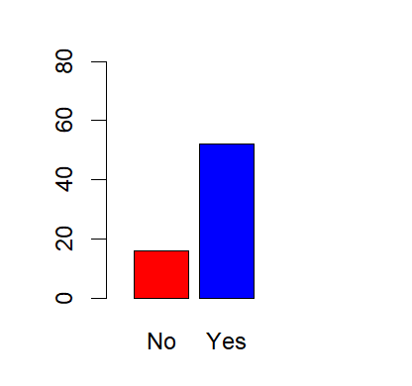

**Q6.) Do you think we should get more holidays/semester breaks?**

tableBreaks=table(onlineLearning$moreBreaks)

pie(tableBreaks,col=c("blue","red","yellow","green","pink"))

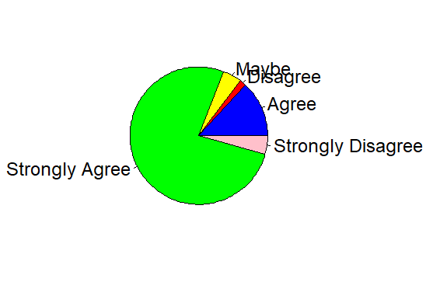

**Q7.) Do you think online classes are affecting our mental health?**

tableAffectingMentally=table(onlineLearning$affectingMentalHealth)

barplot(tableAffectingMentally,beside=T,xlim=c(0,5),ylim=c(0,50),col=c("red","blue","cyan","yellow","green"),ylab="No. of Responses")

legend("topright",legend=rownames(tableBreaks),fill=c('red','blue','cyan','yellow','green'),bty="n")

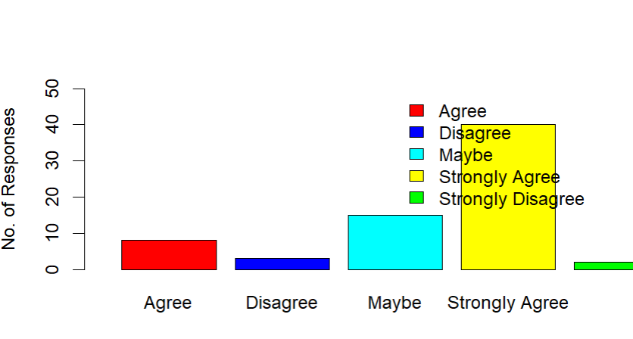

**Q8.) Do you think we are missing a lot of learning opportunities because of these online classes?**

tableOppo=table(onlineLearning$missingOpportunities)

pie(tableOppo,col=c("red","blue","cyan","yellow","green"),xlab="Are you missing opportunities?")

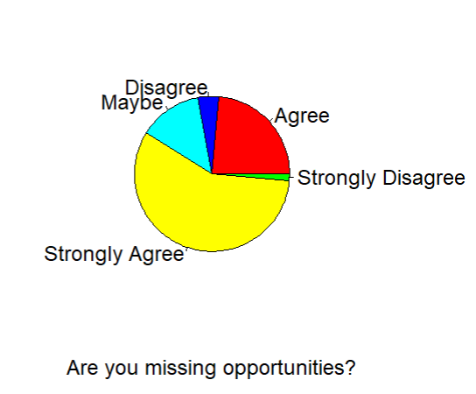

**Q9.) How was your experience of exams conducted on Codetantra?**

tableExp=table(onlineLearning$examsCodetantra)

pie(tableExp,col=c("red","blue","cyan","yellow","green"))

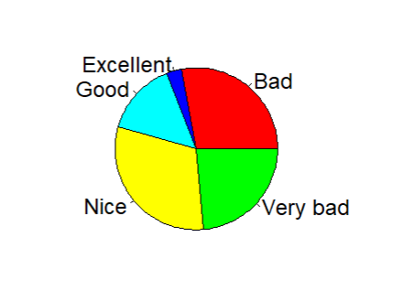

**Q10.) Do you think 2 hours are enough for solving the FAT questions?**

boxplot(onlineLearning$age~onlineLearning$X2HoursEnough,col=c("red","blue","cyan","yellow","green"),xlab="Are 2 hours enough for FAT questions.",ylab="age")

