

**Activity 3: Measures of Central Tendency & Dispersion**

**Name: Preyash Date: 25/01/2022**

**Registration Number: 20BPS1022**

**Aim:** To get comfortable with solving questions related with the measure of central tendency on R Studio.

**Tools Used:** R Studio

**Syntax/ Commands used:**

length() 🡪 gives the length of the vector

mean() 🡪 gives the mean of the vector

sum() 🡪 gives the sum of the vector

sqrt() 🡪 gives the square root

**Questions:**

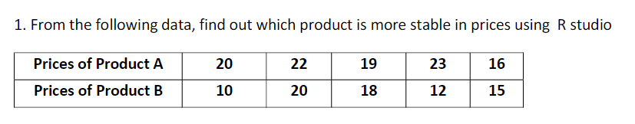

**Code:**

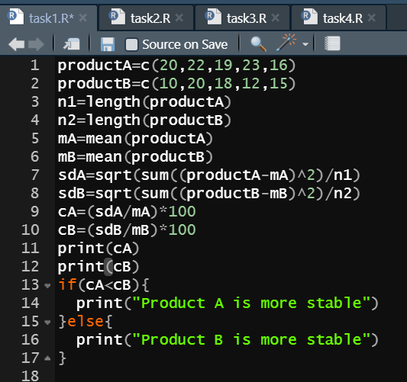

**Output:**

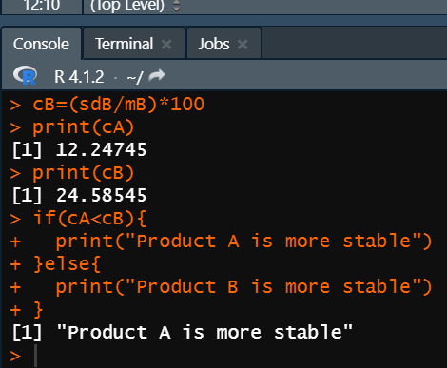



**Code:**

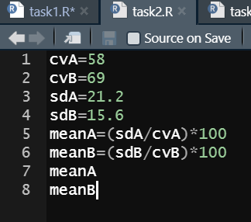

**Output:**

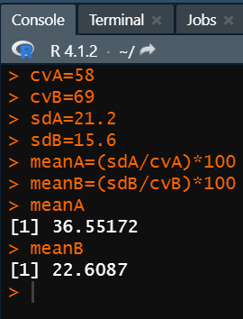



**Code:**

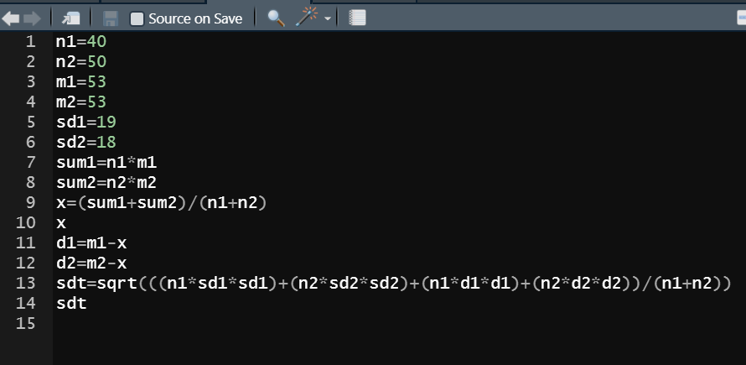

**Output:**

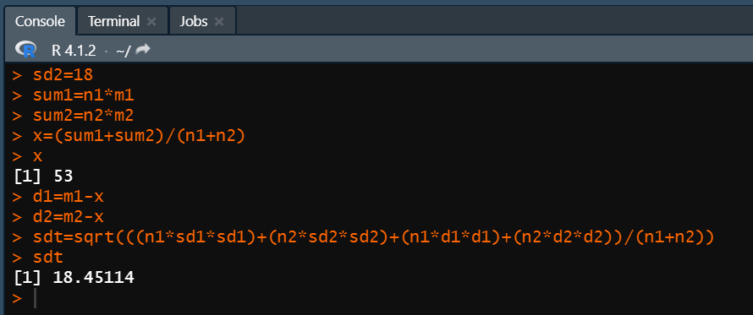

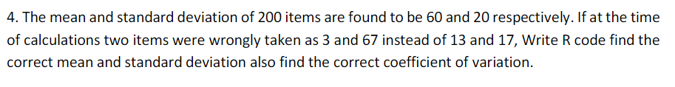

**Code:**

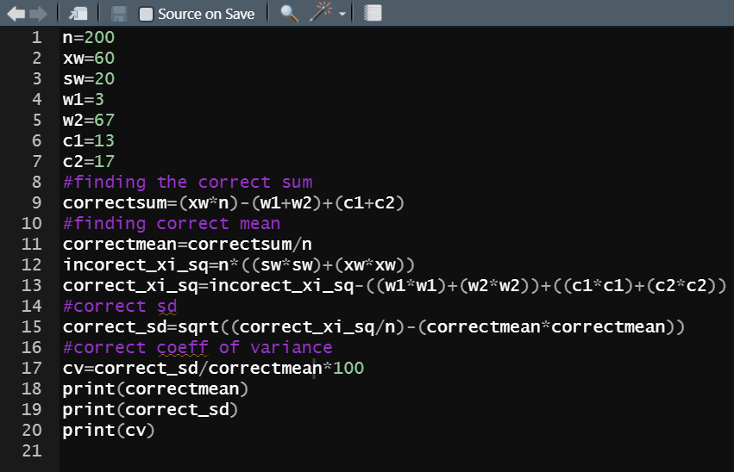

**Output:**

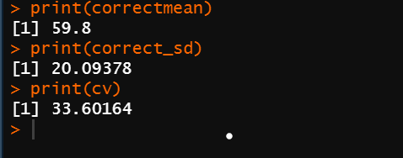

Result: We successfully solved all the questions.