

**Activity 4:**

**Name: Preyash Date: 01/02/2022**

**Registration Number: 20BPS1022**

**Aim:** Using R Studio to study correlation and moments

**Tools Used:** R Studio

**Syntax/ Commands used:**

We are using a special library available in R Studio which is moments. It has routines for calculating moments, Pearson's kurtosis, Geary's kurtosis, and skewness, as well as tests relating to these concepts.

We majorly used:

**all.moments():** This function computes all the sample moments of the chosen type up to a given order

**kurtosis():** This function computes the estimator of Pearson's measure of kurtosis.

**cor():** Cor computes the variance of x and the covariance or correlation of x and y

**Installing packages:**

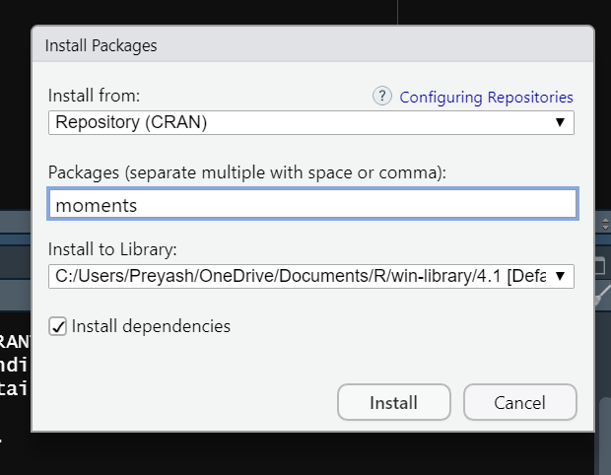

**Questions:**

**Task 1:** **Code:**

library(moments)

dataset=c(4,8,12,20,6,7,3)

datasetLen=length(dataset)

mean=sum(dataset)/datasetLen

mom1=sum(dataset-mean)/datasetLen

mom2=sum((dataset-mean)^2)/datasetLen

mom3=sum((dataset-mean)^3)/datasetLen

mom4=sum((dataset-mean)^4)/datasetLen

momr1=sum(dataset)/datasetLen

momr2=sum((dataset)^2)/datasetLen

momr3=sum((dataset)^3)/datasetLen

momr4=sum((dataset)^4)/datasetLen

print("raw")

print("package")

all.moments(dataset,order.max=4,absolute = TRUE)

print("manual")

momr1

momr2

momr3

momr4

print("central")

print("package")

all.moments(dataset,order.max=4,central = TRUE, absolute = FALSE)

print("manual")

mom1

mom2

mom3

mom4

**Output:**

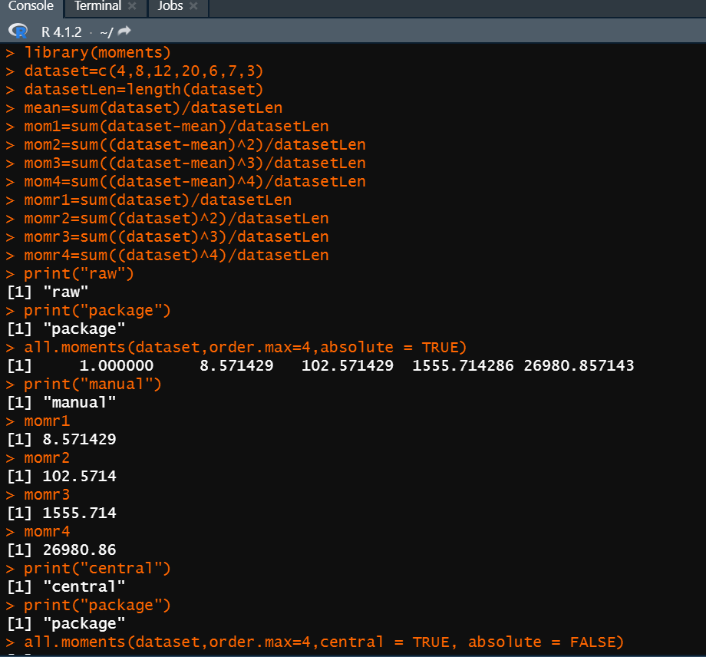

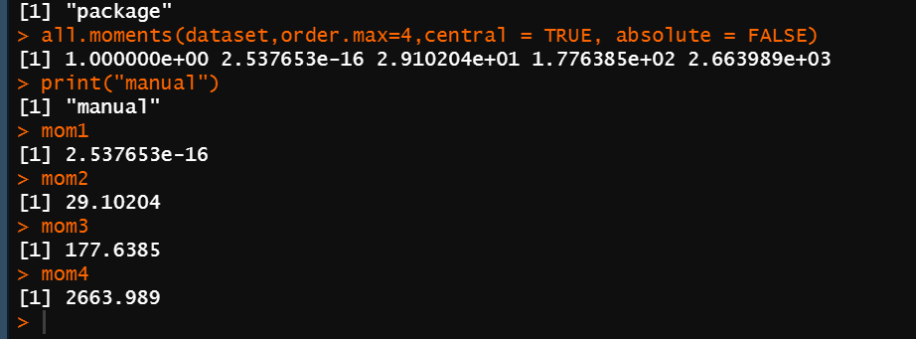

**Task 2:**

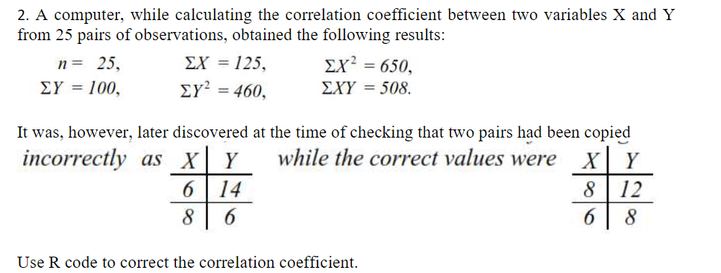

**Code:**

n=25

isigx=125

isigxx=650

isigy=100

isigyy=460

isigxy=508

ip1x=6

ip1y=14

ip2x=8

ip2y=6

p1x=8

p1y=12

p2x=6

p2y=8

sigx=isigx-ip1x-ip2x+p1x+p2x

sigy=isigy-ip1y-ip2y+p1y+p2y

sigxx=isigxx-(ip1x*ip1x)-(ip2x*ip2x)+(p1x*p1x)+(p2x*p2x)

sigyy=isigyy-(ip1y*ip1y)-(ip2y*ip2y)+(p1y*p1y)+(p2y*p2y)

sigxy=isigxy-(ip1x*ip1y)-(ip2x*ip2y)+(p1x*p1y)+(p2x*p2y)

numerator=(n*sigxy)-(sigx*sigy)

denominator=sqrt(((n*sigxx)-(sigx^2))*((n*sigyy)-(sigy^2)))

cor=numerator/denominator

cor

**Output:**

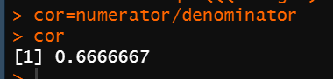

**Task 3:**

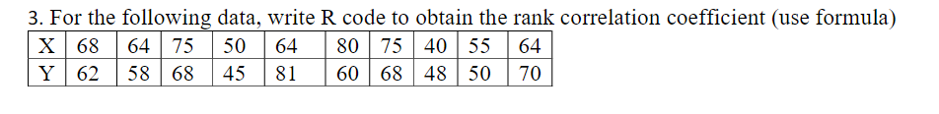

**Code:**

d1=c(68,64,75,50,64,80,75,40,55,64)

d2=c(62,58,68,45,81,60,68,48,50,70)

d1=rank(d1)

d2=rank(d2)

count=10

d=(d1-d2)^2

cf2=(2*((2^2)-1))/12

cf3=(3*((3^2)-1))/12

cfd1=cf2+cf3

cfd2=cf2

rankCorCoeff=1-(6*((sum(d)+cfd1+cfd2))/((count^3)-count))

rankCorCoeff

**Output:**

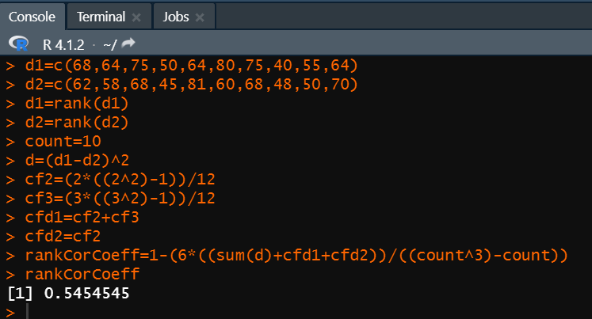

**Task 4 :**

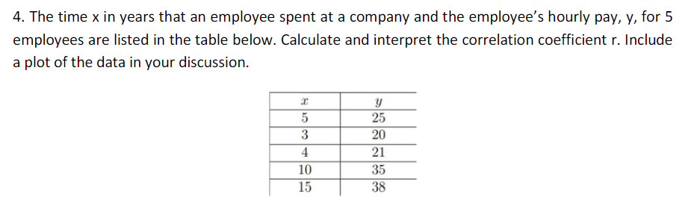

**Code:**

d1=c(5,3,4,10,15)

d2=c(25,20,21,35,38)

count=5

cor.test(d1,d2)

plot(d1,d2,type="o",d1lab ="d1",d2lab = "d2", main = "Correlation",col="blue")

**Output:**

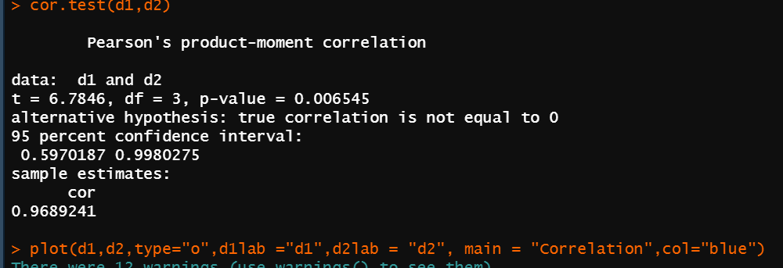

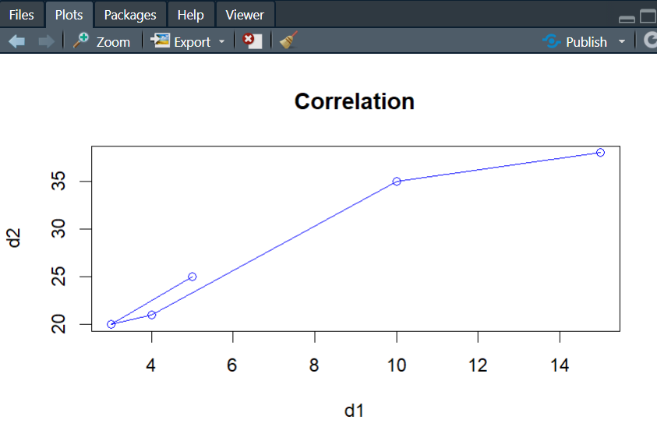

**Task 5:**

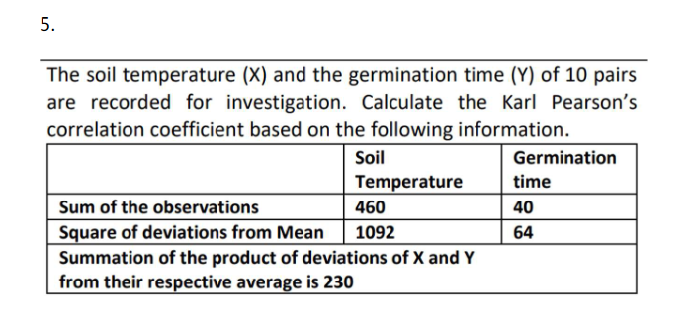

**Code:**

sigx=460

sigy=40

count=10

sigdxx=1092

sigdyy=64

sigdxy=230

rel=sigdxy/(sqrt(sigdxx*sigdyy))

rel

**Output:**

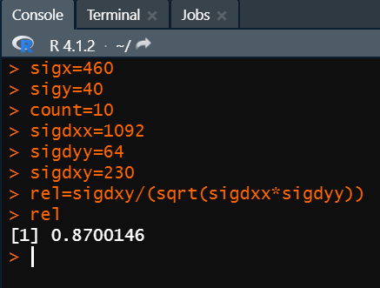

**Result:** We successfully solved all the questions and they were verified manually.