

**Activity 5:**

**Name: Preyash Date: 08/02/2022**

**Registration Number: 20BPS1022**

**Aim:** To use R to study regression

**Tools Used:** R Studio

**Syntax/ Commands Used:**

* **lm()** - In R, the lm(), or “linear model,” function can be used to create a simple regression model.
* **abline()** - The R function abline() can be used to add vertical, horizontal or regression lines to a graph.
* **pch :** numeric values (from 0 to 25) or character symbols (“+”, “.”, “;”, etc) specifying the point symbols (or shapes).
* **cex :** numeric values indicating the point size.

**Questions:**

**Task 1:**

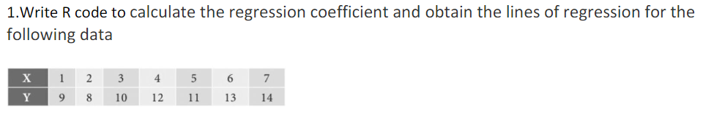

**Code:**

x<-c(1,2,3,4,5,6,7)

y<-c(9,8,10,12,11,13,14)

model<-lm(x~y)

summary(model)

plot(y, x, col = "red", main = "X & Y Regression", abline(lm(x~y)), cex = 1.3, pch = 16, xlab =

"X", ylab = "Y")

model=lm(y~x)

summary(model)

plot(x, y, col = "blue", main = "X & Y Regression", abline(lm(y~x)), cex = 1.3, pch = 16, xlab =

"X", ylab = "Y")

**Output:**

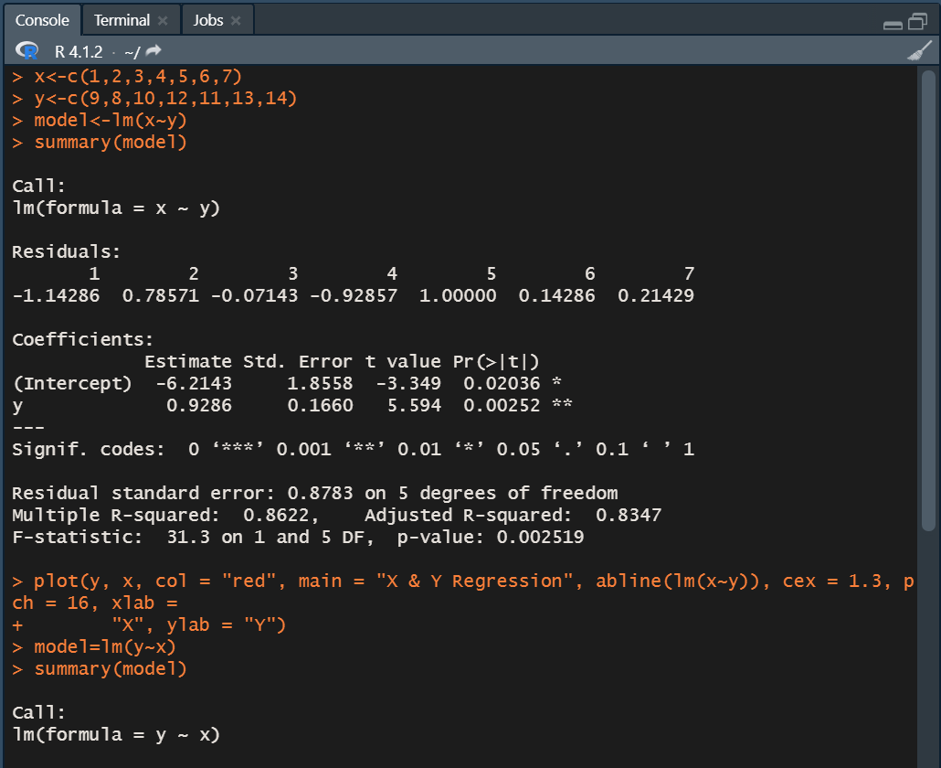

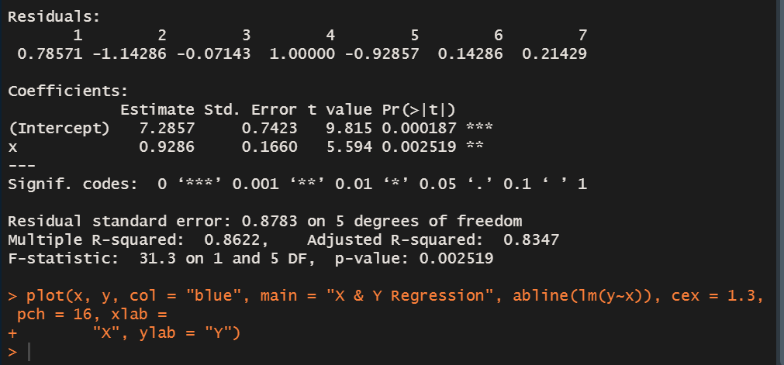

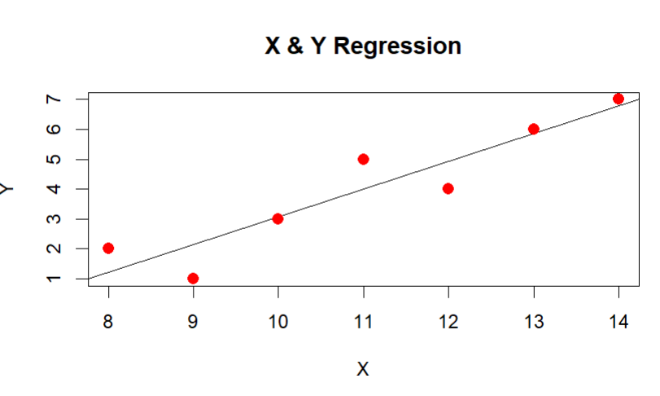

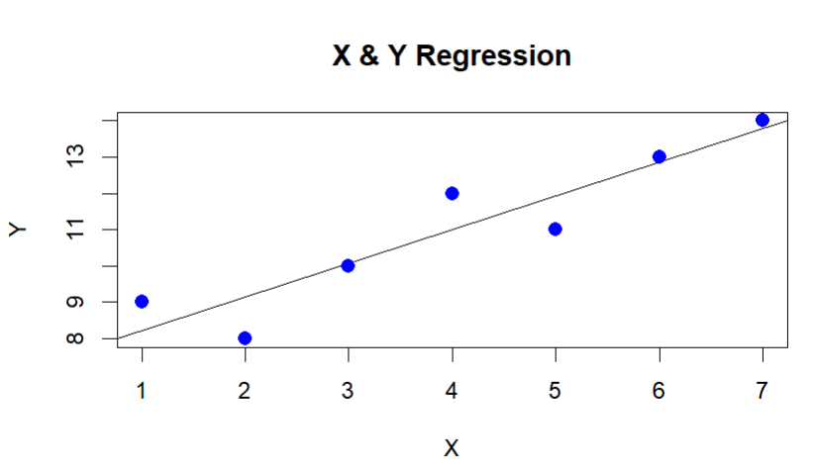

**Task 2:**

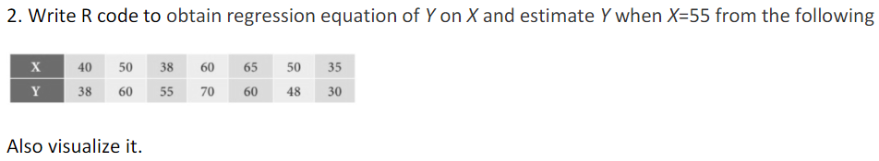

**Code:**

x<-c(40,50,38,60,65,50,35)

y<-c(38,60,55,70,60,48,30)

model<-lm(y~x)

plot(y,x,col = "red",main = "X & Y",abline(lm(y~x)),cex = 1.3,pch = 16,xlab = "X",ylab = "Y")

a<-data.frame(x=55)

result<-predict(model,a)

print(result)

**Output:**

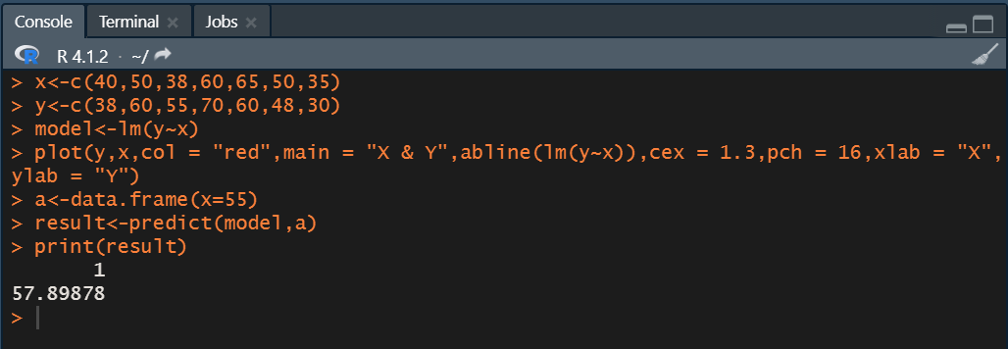

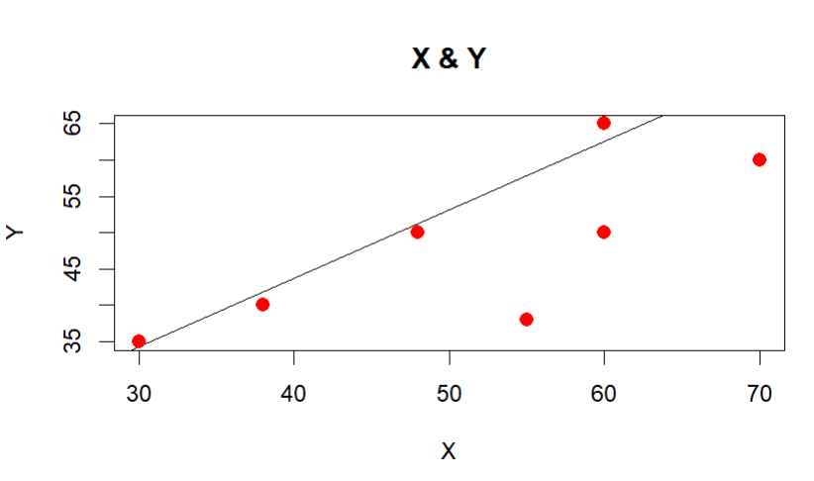

**Task 3:**

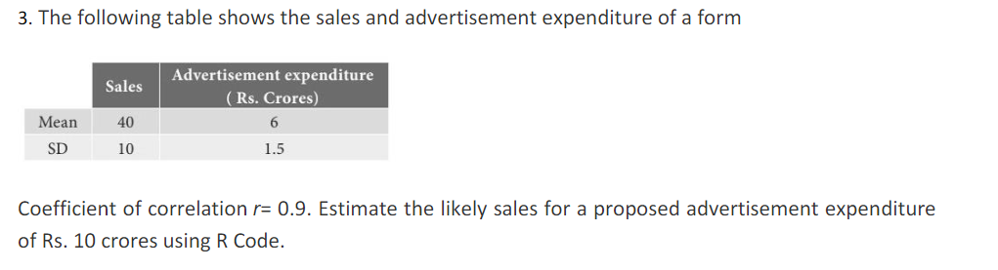

**Code:**

meanx=40

meany=6

SDx=10

SDy=1.5

r=0.9

Bxy=r*(SDx/SDy)

result=((10-mean)*Bxy)+meanx

print(result)

**Output:**

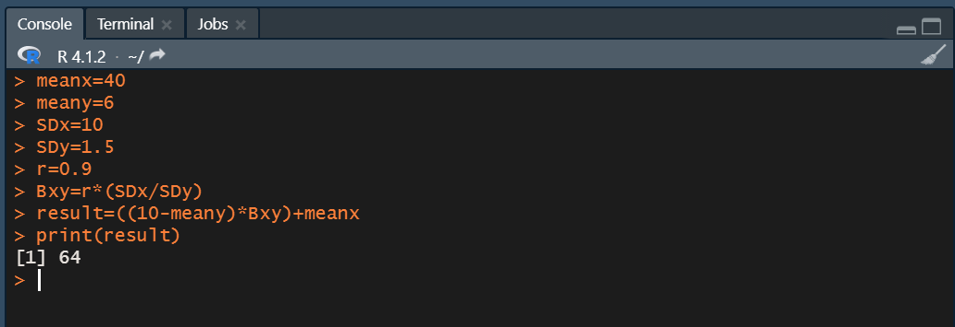

**Task 4 :**

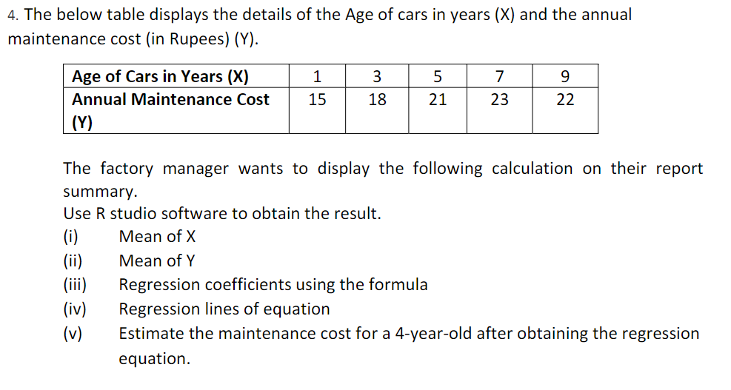

**Code:**

x=c(1,3,5,7,9)

y=c(15,18,21,23,22)

meanx=sum(x)/5

meany=sum(y)/5

SDx=sd(x)

SDy=sd(y)

r=cor(x,y)

Bxy=r*(SDx/SDy)

Byx=r*(SDy/SDx)

result=(Byx*(4-meanx))+meany

print(meanx)

print(meany)

print(Bxy)

print(Byx)

paste("x-",meanx,"=",Bxy,"(y-",meany,")")

paste("y-",meany,"=",Byx,"(x-",meanx,")")

print(result)

**Output:**

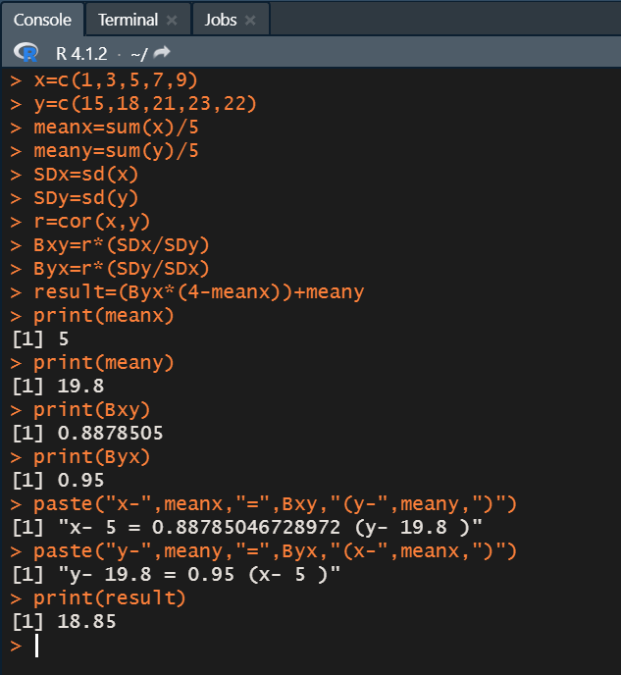

**Result:** We successfully used R to study regression.