

**Activity 6:**

**Name: Preyash Date: 08/03/2022**

**Registration Number: 20BPS1022**

**Aim:** To get used to distribution syntax.

**Tools Used:** R Studio

**Syntax/ Commands Used:**

* **dbinom(x,size,prob)->** To find binomial distribution at value x
* **pbinom(x,size,prob)->** To find binomial distribution at value less than or equal to x
* **dpois(x,lambda)->** To find Possion distribution at value x
* **ppois(x,lambda,lower.tail)->** To find Possion distribution at value less than equal to x

**Questions:**

**Task 1:**

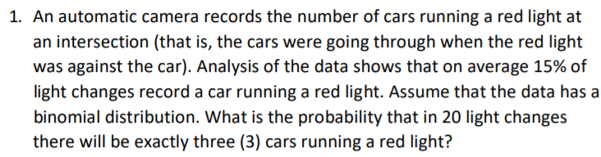

**Code:**

**dbinom(x=3,size=20,prob=0.15)**

**Output:**

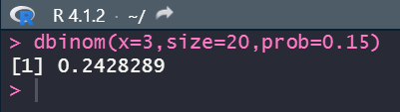

**Task 2:**

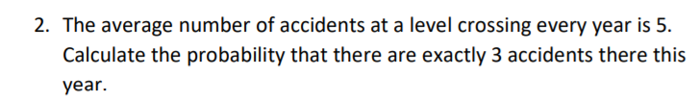

**Code:**

**dpois(x=3,lambda=5)**

**Output:**

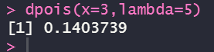

**Task 3:**

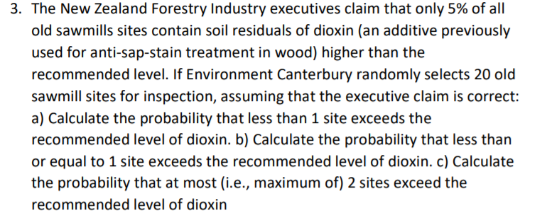

**Code:**

**a)**

**probs=dbinom(0,size=20,prob=0.05)**

**round(probs,4)**

**b)**

**probs=pbinom(1,size=20,prob=0.05)**

**round(probs,4)**

**c)**

**probs=pbinom(2,size=20,prob=0.05)**

**round(probs,4)**

**Output:**

a)

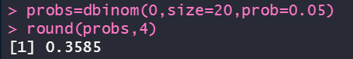

b)

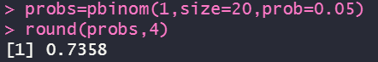

c)

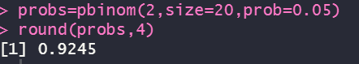

**Task 4:**

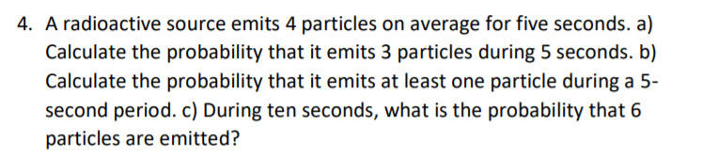

**Code:**

1. **dpois(x=3, lambda=4)**

**b ) ppois(q=1, lambda=4, lower.tail= FALSE)+ dpois(1,lambda=4)**

**c) dpois(x=6, lambda=8)**

**Output:**

**a)**



**b)**

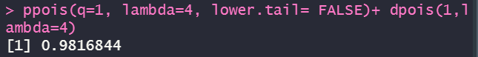

**c)**

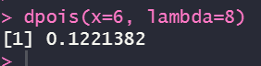

**Task 5:**

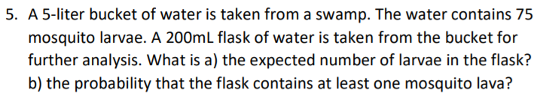

**Code:**

**a)** ) Expected number is of larvae is 3 (as 75 mosquito 5L )

**b) 1-dpois(x=0, lambda=3)**

**Output:**



**Result:** We successfully used distribution syntax in R.