Name: Preyash

Registration Number: 20BPS1022



**WINTER SEMESTER 2021-2022**

**Activity Sheet -7**

**Normal Distribution**

**Answer to be presented below each question   - 10 Marks**

**Time – 15 Minutes**

**Write R- Code with Visualisation**

1. The local authority in a certain city installed 20,000 sodium lamps in the main street of the city. The life of the lamp is assumed to follow a normal distribution with a mean life of 1350 burning hours with a standard deviation of 300 burning hours. Find (a) The number of lamps expected to fail in first 900 hours (b) The number of lamps expected to have a life of 900 to 1200 burning hours          [6 Marks]

a)

Code:

x=seq(-5000,5000, length = 200)

y=dnorm(x, mean=1350, sd=300)

plot(x,y,type="l")

x=seq(900,5000,length=100)

y=dnorm(x,mean=1350,sd=300)

polygon(c(900,x,1200), c(0,y,0), col="red")

pnorm(1200,mean=1350,sd=300)-pnorm(900,mean=1350,sd=300)

Output:

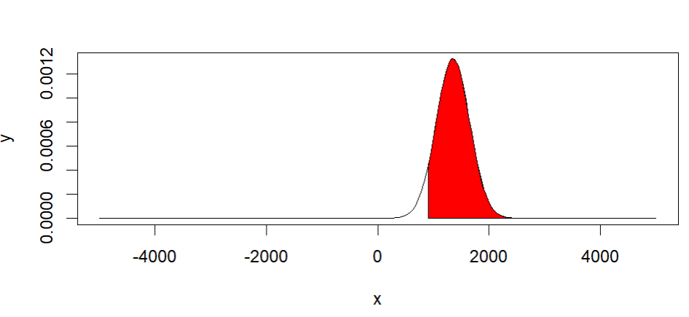

b)

code:

x=seq(-5000,5000, length = 200)

y=dnorm(x, mean=1350, sd=300)

plot(x,y,type="l")

x=seq(900,1200,length=100)

y=dnorm(x,mean=1350,sd=300)

polygon(c(900,x,1200), c(0,y,0), col="red")

pnorm(1200,mean=1350,sd=300)-pnorm(900,mean=1350,sd=300)

Output:

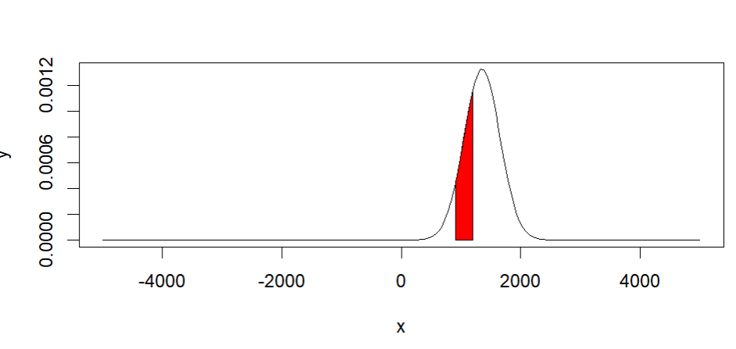

2. The marks obtained by the students in Statistics, English and Biology in an examination are normally distributed with the means 52,50 and 48 and with the standard deviation 10,8,6 respectively. Find the probability that a student selected at random has secured a total of (a) 180 or above (b) 135 or less                                                                                                                         [4 Marks]

Q.) To find the area to the left of 1.

Q.) If Z is norm(mean =0; sd=1), find

(i) P [Z>1]

(ii) P[0<Z<1.74]

(iii) P[Z>-1.39]

(iv) P[Z<-1.24]