

**ASSESSMENT – 8**

Name: Preyash Reg No.: 20BPS1022

**LARGE SAMPLE TEST**

**Syntax:**

* **qnorm:** The function qnorm() aims to find the boundary value, A in P(X < A) , given the probability P.
* **abs:** computes the absolute value of numeric data.
* **sqrt:** The R sqrt method is one of the R Math functions, which is useful to find the square root in R for an individual number or an expression.
* **print:** Using [print()](https://www.geeksforgeeks.org/print-the-argument-to-the-screen-in-r-programming-print-function/) function to print output is the most common method in R.

1.In a sample of 400 parts manufactured by a factory, the number of defective​ parts was found to be 30. The company, however, claimed that only 5% of their​ product is defective. Is the claim tenable? ​

**Code:**

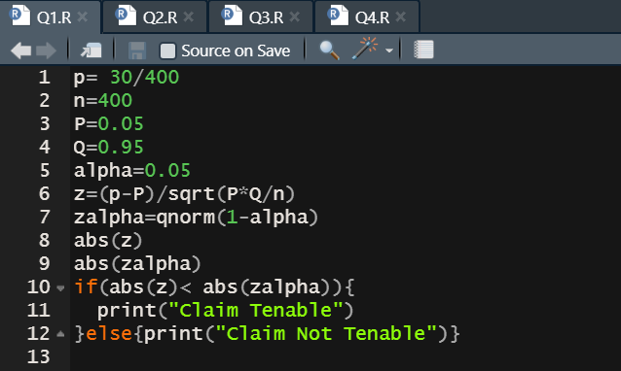

**Output:**

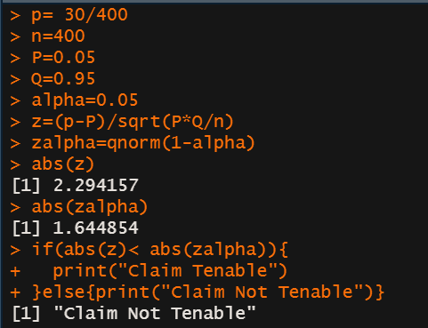

​2. Random samples of 400 men and 600 women were asked whether they would​ like to have a flyover near their residence. 200 men and 325 women were in favor ​of the proposal. Test the hypothesis that proportions of men and women in favor of​ the proposal are same, at 5% level.

**Code:**

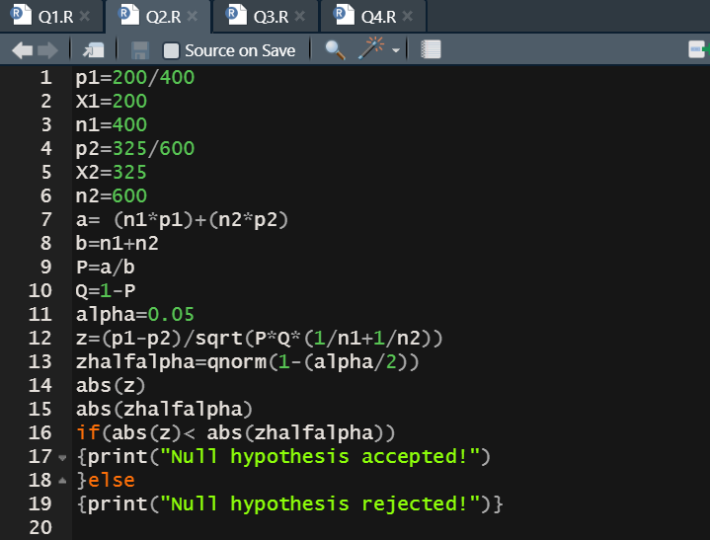

**Output:**

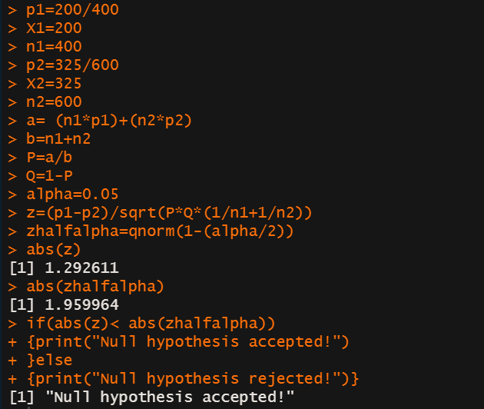

3.A sample of 900 members has a mean of 3.4 cms and S.D 2.61 cms. Is the sample from a large population of mean 3.25 cm and S.D 2.61 cms. If the population is normal and its mean is unknown find the 95% fiducial limits of true mean.

**Code:**

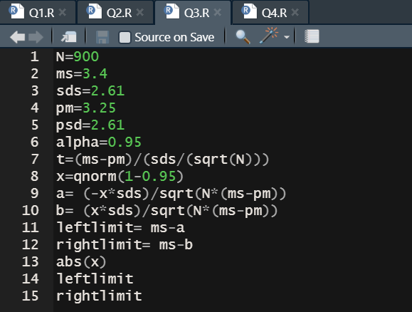

**Output:**

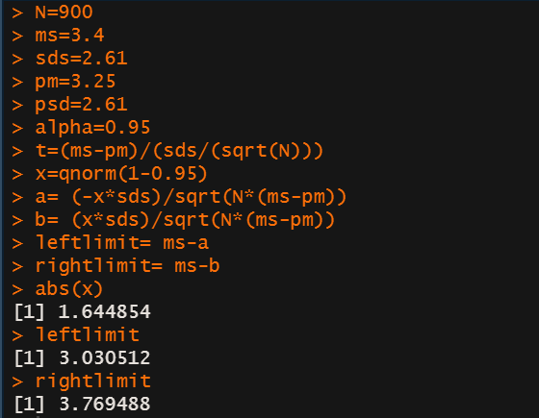

4.The means of 2 large samples 1000 and 2000 members are 67.5 inches and 68 inches respectively. Can the samples regarded as drawn from the same population of S.D 2.5 inches.

**Code:**

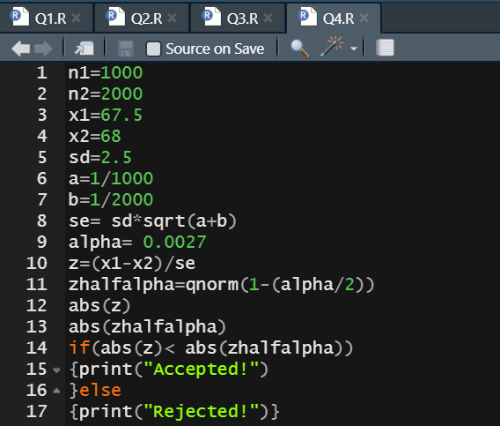

**Output:**

