

**ASSESSMENT – 9**

Name: Preyash Reg. No.: 20BPS1022

**SMALL SAMPLE TEST**

**Aim:** Exploring and visualizing the small sample tests (t-test, chi square test, F test) using R code

**Syntax:**

* **t.test() :** To Do the t- test for a small sample data
* **var.test() :** To Do the f- test for a small sample data
* **chi.test() :** To Do the chi squared- test for a small sample data

**Questions:**

**Q1.)**

**Code:**

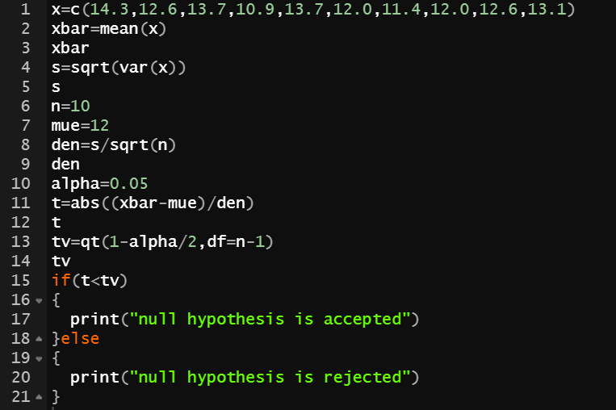

**Output:**

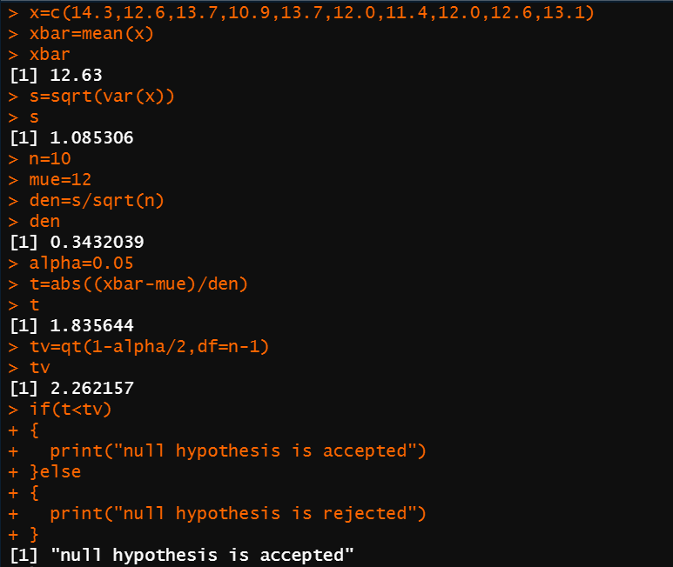

**Inference:**

We estimate that the new green gramme variety will yield 12 quintals per acre on average.

**Q2)**

**Code:**

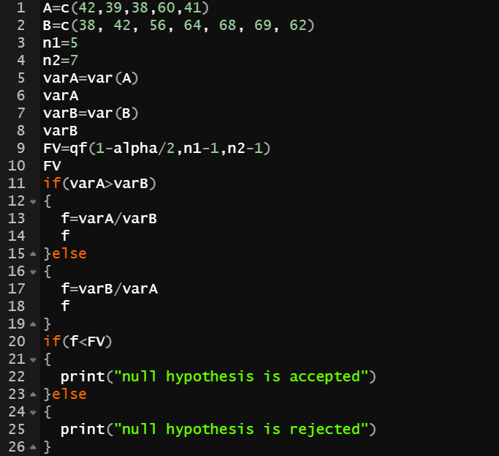

**Output:**

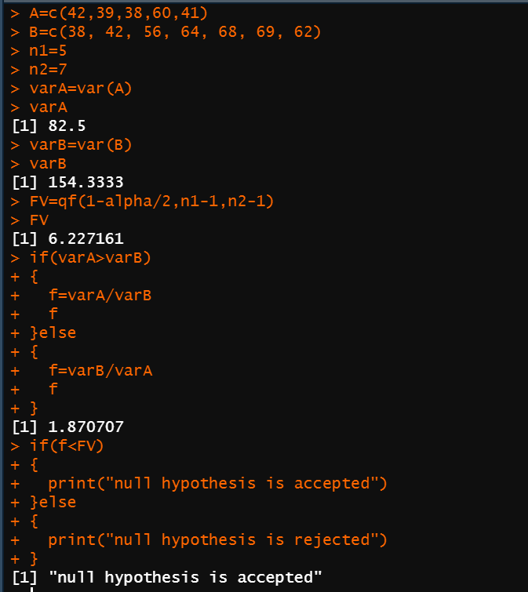

**Inference:**

The medicines A and B do not vary appreciably, we conclude.

**Q3)**

**Code:**

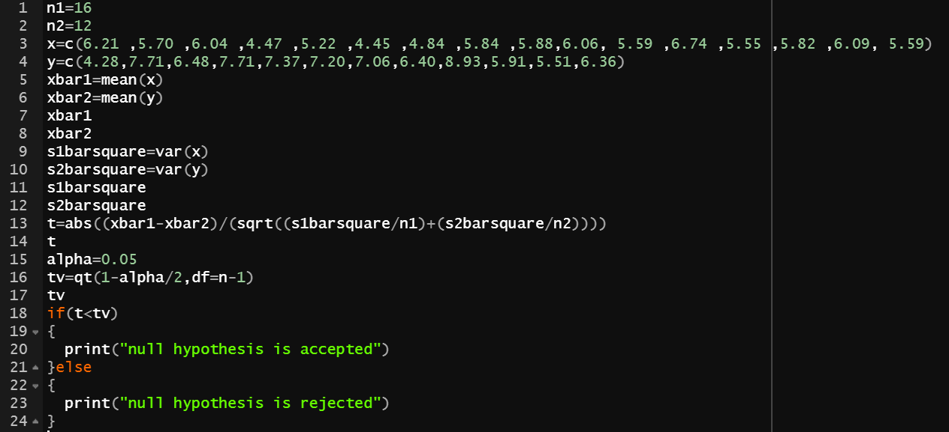

**Output:**

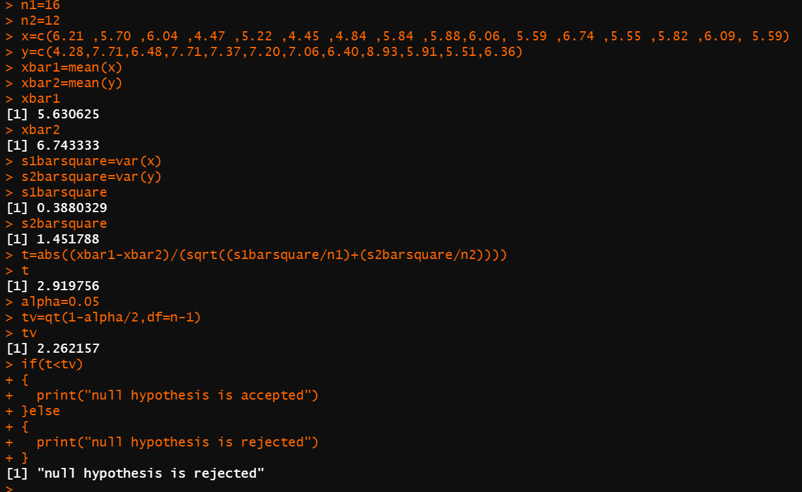

**Inference**

We reject the null hypothesis H0 (i.e., that the two rubber plants are significantly different).

**Q4)**

**Code:**

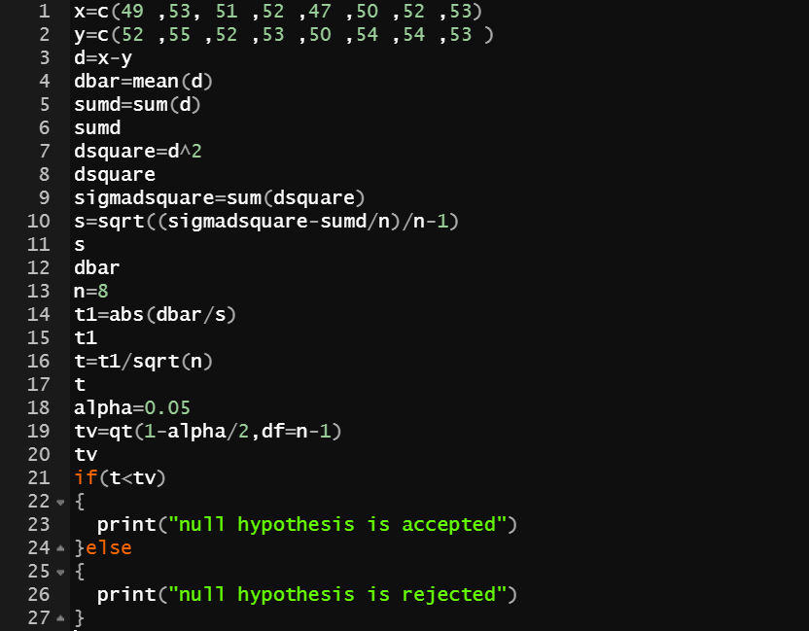

**Output:**

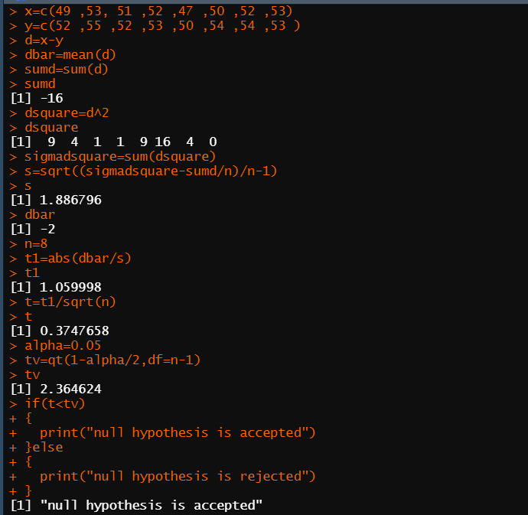

**Inference:**

The null hypothesis H0 (i.e., there is no substantial difference between the two meals A and B) is accepted.

**Q5)**

**Code:**

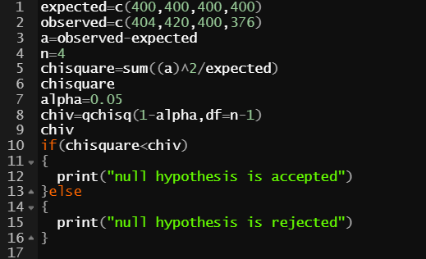

**Output:**

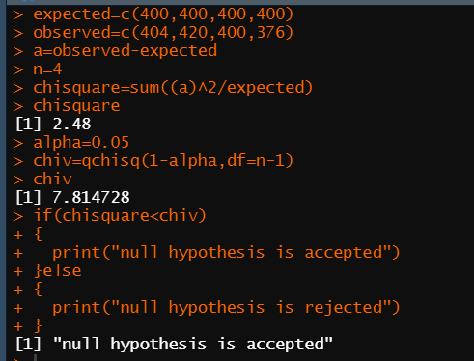

**Inference:**

As a result, both suits are equally likely.