Name: Preyash

Reg. No. 20BPS1022 Date: April 19, 2022

**ASSESSMENT-10**

**ANOVA**

**Syntax Used:**

(i) aov(formula, data = NULL, projections = FALSE, qr = TRUE,

contrasts = NULL, ...), used to fit an analysis of variance model by a call to lm for each stratum.

(ii) data.frame(cbind(grp1, …, grpn)), used to make a matrix compromising all the groups as columns

(iii) stack(group), Stacking vectors concatenate multiple vectors into a single vector along with a factor indicating where each observation originated.

(iv) summary (…), a generic function used to produce result summaries of the results of various model fitting functions.

(v)boxplot (x,…) , produce box-and-whisker plot(s) of the given (grouped) values.

(vi) read.table(file, header = TRUE), Reads a file in table format and creates a data frame from it, with cases corresponding to lines and variables to fields in the file.

(vii) as.matrix(), attempts to turn its argument into a matrix.

(viii) ncol(), nrow(), returns the number of columns and rows.

(ix) gl(n, k, length = n*k, labels = seq_len(n), ordered = FALSE), generate factors by specifying the pattern of their levels.

(x) interaction.plot(x.factor, trace.factor, …), plots the mean (or other summary) of the response for two-way combinations of factors, thereby illustrating possible interactions

**Problem:**

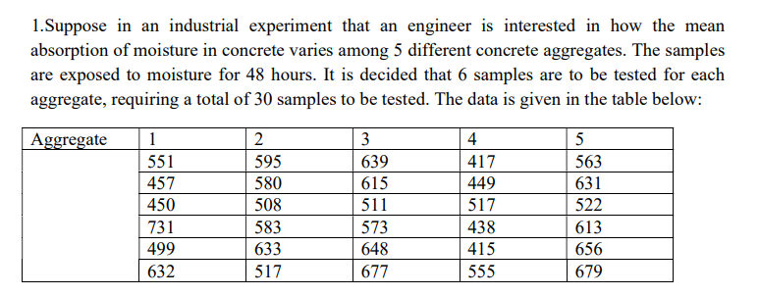

**Code:**

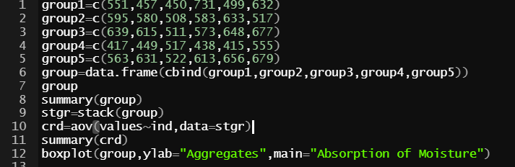

**Output:**

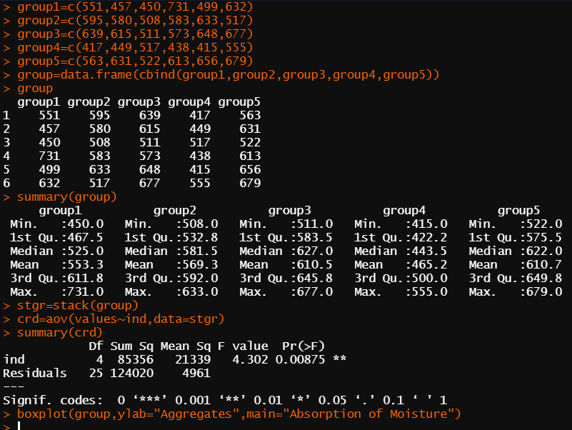

**Plot:**

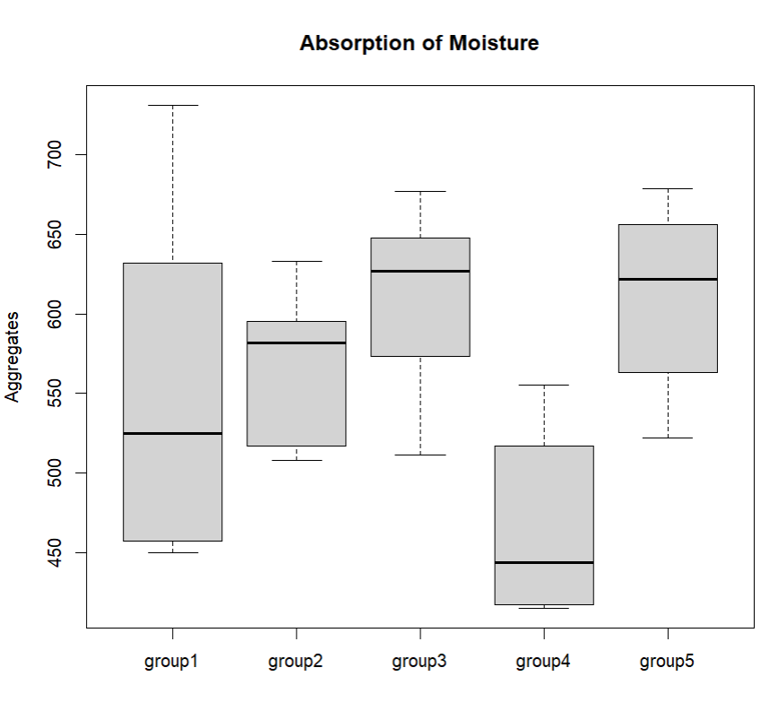

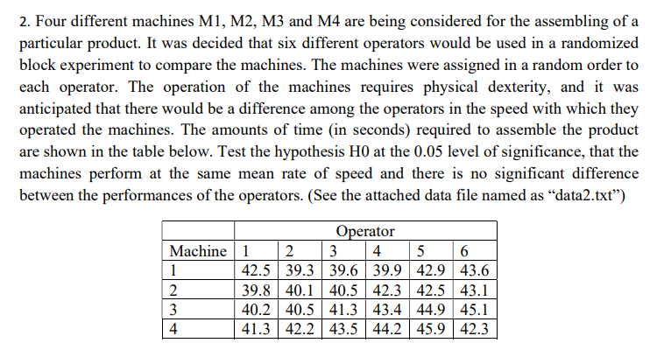

**Code:**

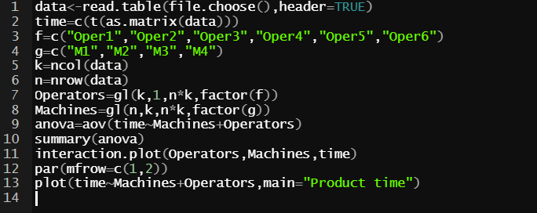

**Output:**

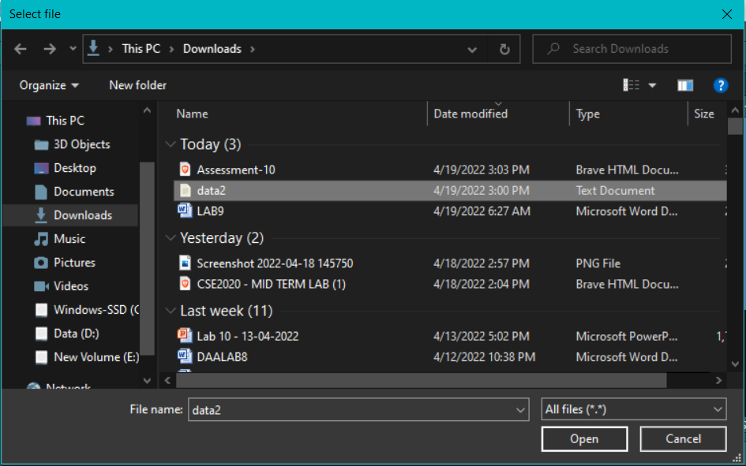

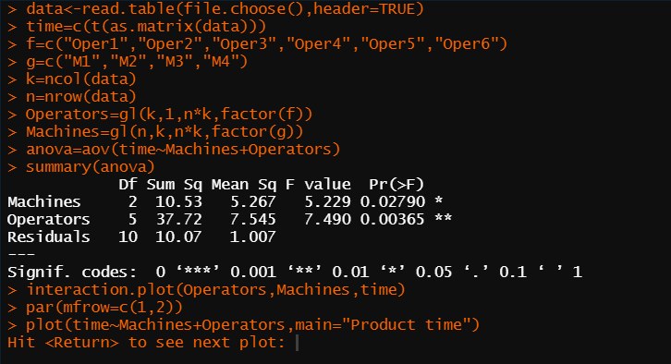

**Plot:**

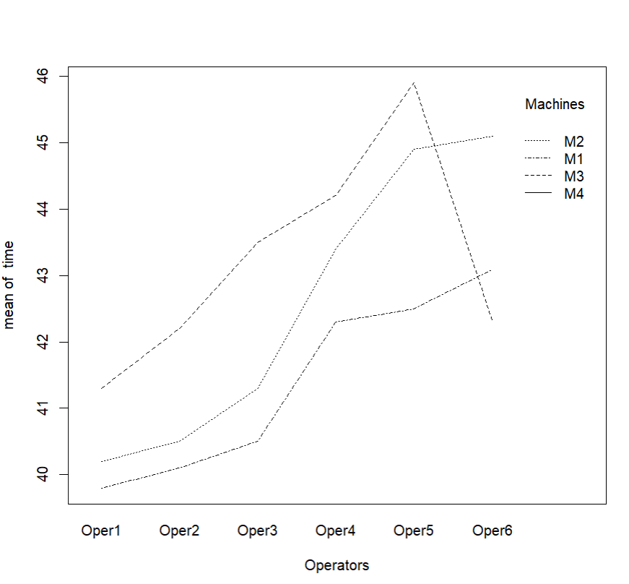

**Result:** All the classifications were plotted and visulaised.