Preyasi Gaur

705704939

**Computer Science 161**

**Homework 8**

**Question 1**

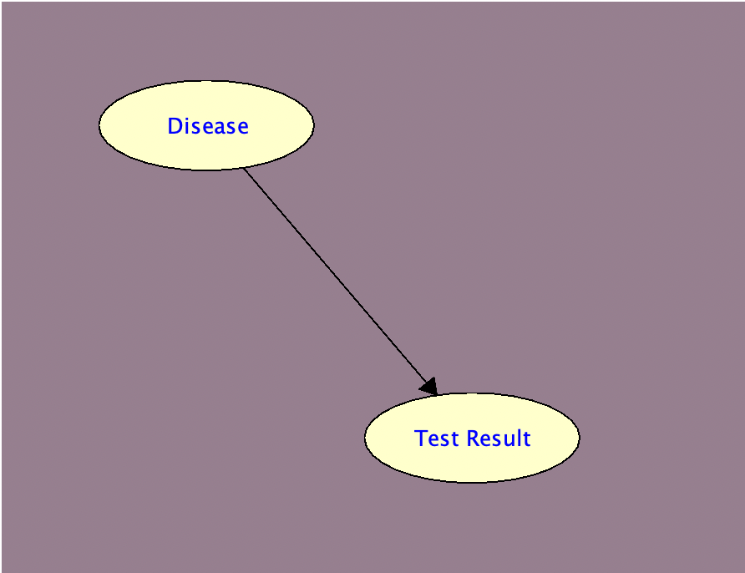

**A constraint on each of the following, which is sufficient to ensure that Pr(D|T) ≥ 0.3: The prior probability of having the disease, the false positive for the test, and the false negative for the test.**  
  
Using the Single-Parameter Values, we get the following,

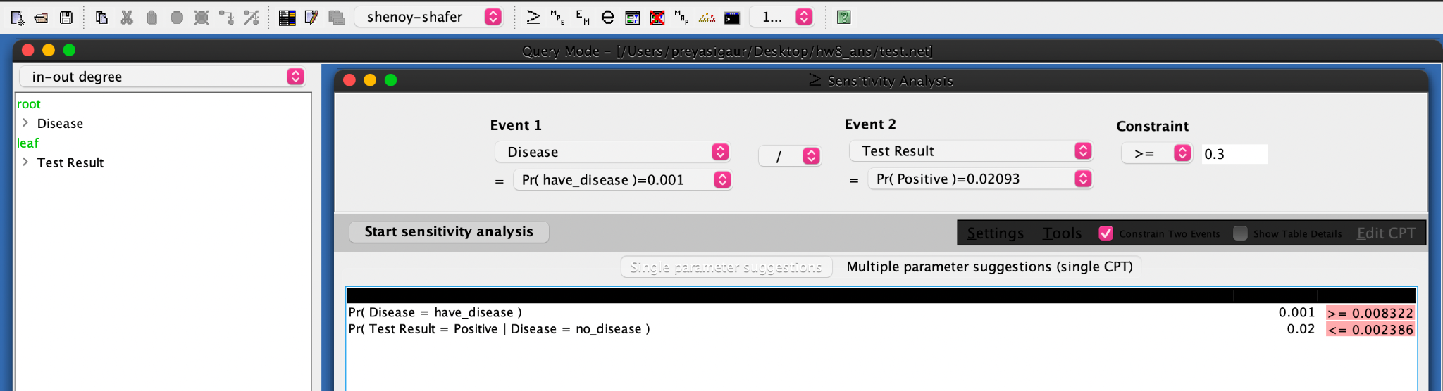

Through this we get that P(Disease) 0.008322

P(TestResult = Positive | Disease = No) 0.00236

In other words,  
probability of disease must be at least 0.008322,

probability of a false positive must be at most 0.00236,

probability of a false negative cannot be constrained to achieve P(D|T) 0.3

**Question 2**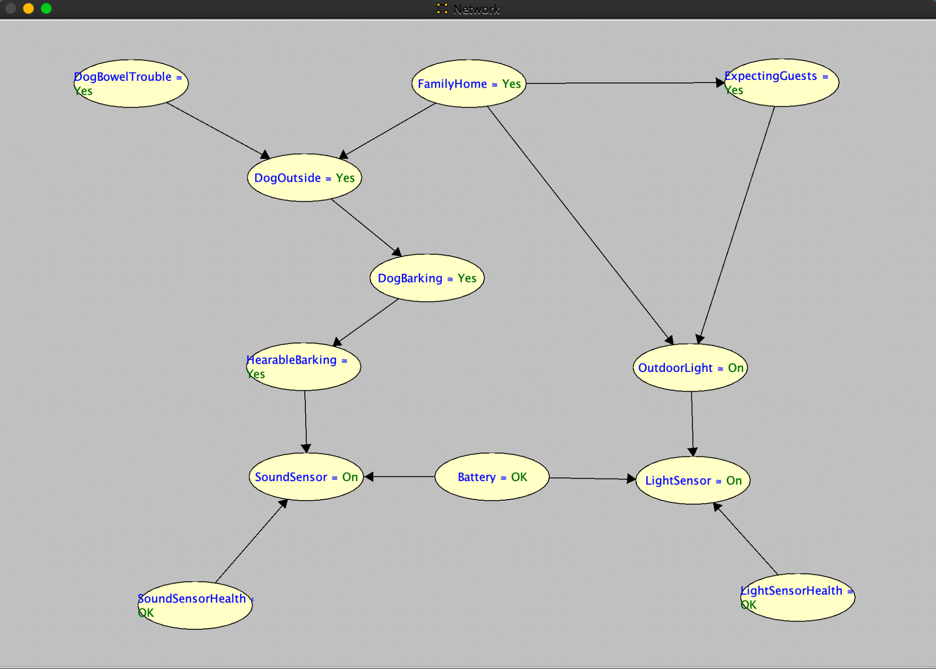

* **The most likely instantiation of all variables given that Sambot has sensed the lights to be on, but has sensed no bark. Explain how you obtained this answer (for partial credit in case you get the wrong answer). Screenshot the results from SamIam and attach the pictures in the report.**

I set the LightSensor parameter to be On, and the SoundSensor to be Off and ran MPE to get the tabulated results for the most likely instantiations.

P(mpe,e) = 0.1526329476868096

P(mpe | e) = 0.35708904974782174

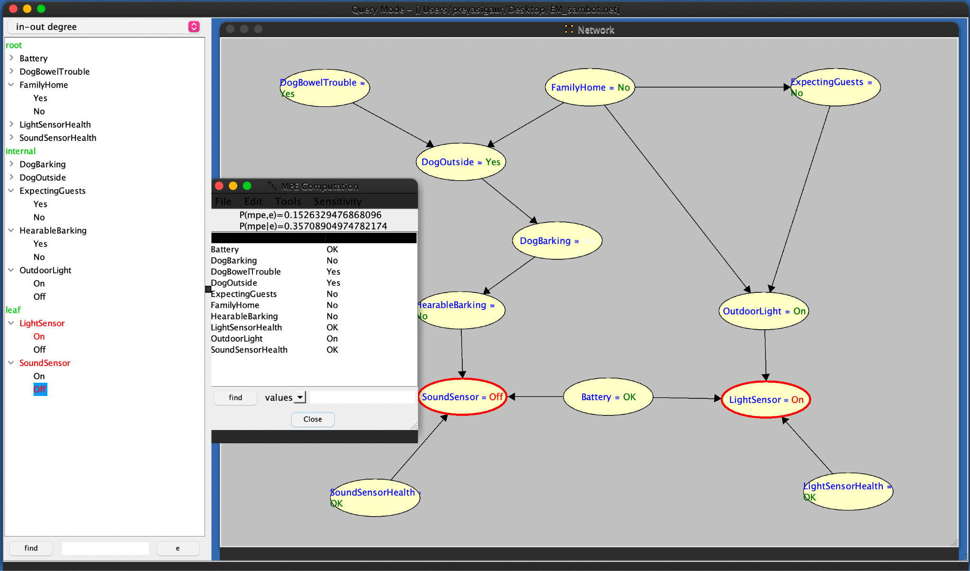

* **The most likely instantiation of the sensors given that the family is home and no guests are expected. Explain how you obtained this answer (for partial credit in case you get the wrong answer). Screenshot the results from SamIam and attach the pictures in the report.**

I set the FamilyHome parameter to be Yes, and the ExpectingGuests to be No and ran MPE to get the tabulated results for the most likely instantiations.

P(mpe,e)=0.030139232059155238

P(mpe | e)=0.15668953500990498

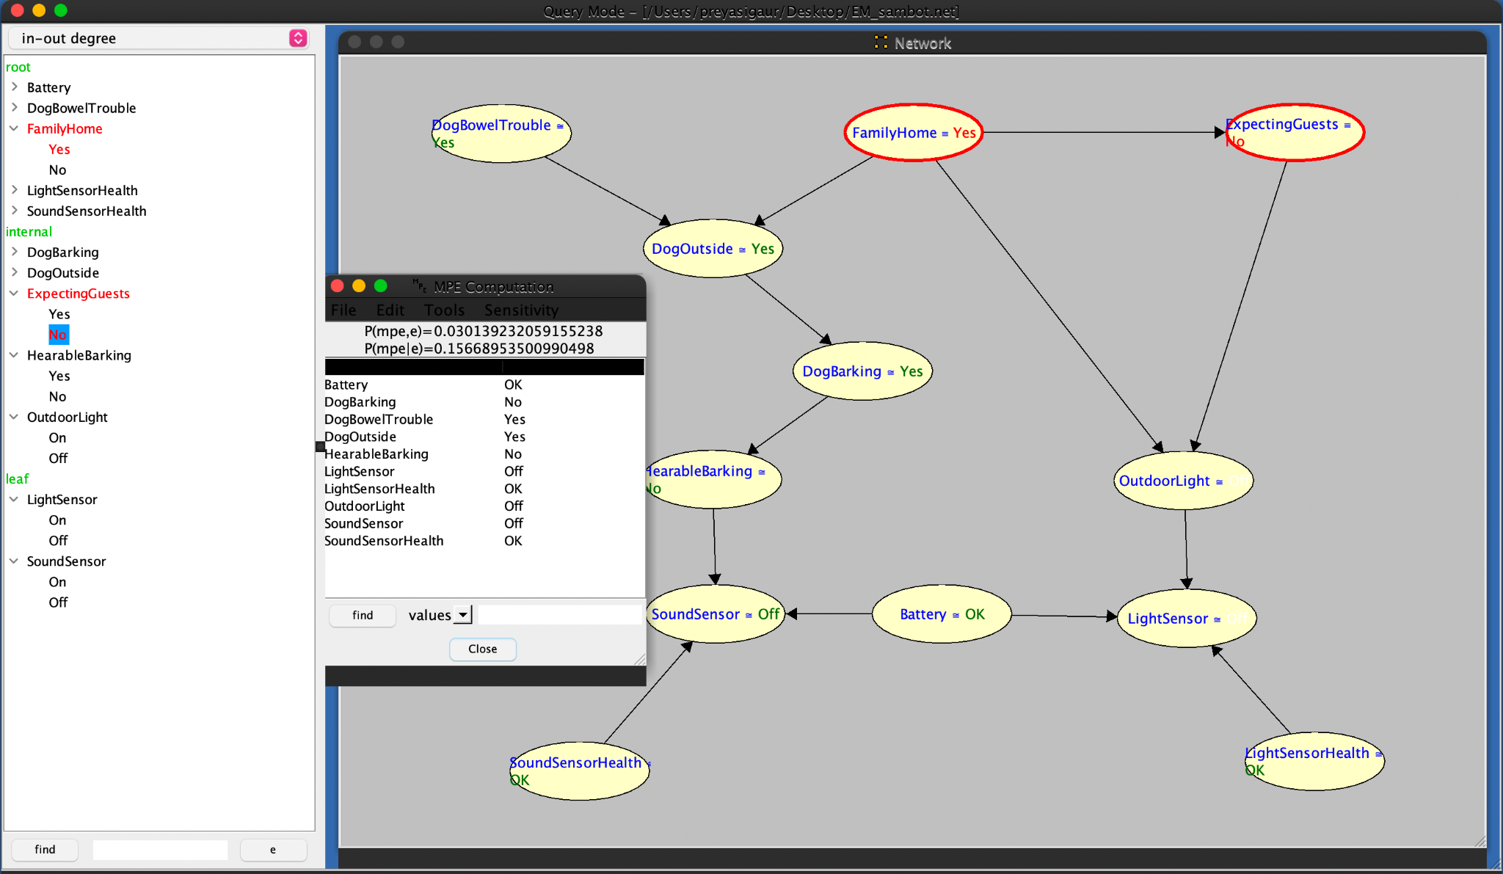

* **The smallest set of variables Z in your network such that the two sensors are independent given Z. Justify your answer based on d-separation.**

The correct smallest set of variables 𝑍 such that LightSensor and SoundSensor are independent given 𝑍 are: DogOutside, Battery

DogOutside blocks the indirect paths through OutdoorLight and DogBarking, while Battery blocks the path through SoundSensorHealth, ensuring that LightSensor and SoundSensor are d-separated and thus independent given these variables.

* **The type of network you constructed: tree, polytree (singly-connected network), or multiply-connected network.**multiply-connected network