**EXERCISE NO:**1

**REGISTERNO:**1518102103

**AIM:**

To print the calendar of a given month and year.

**PROGRAM:**

import calendar

year=int(input())

month=int(input())

if(year<10000 and year>999 and month < 13 and month>0):

print(calendar.month(year,month))

else:

print("Invalid input")

**LINK:**

[**http://103.53.53.18/mod/vpl/forms/edit.php?id=229&userid=1707**](http://103.53.53.18/mod/vpl/forms/edit.php?id=229&userid=1707)

**OUTPUT:**

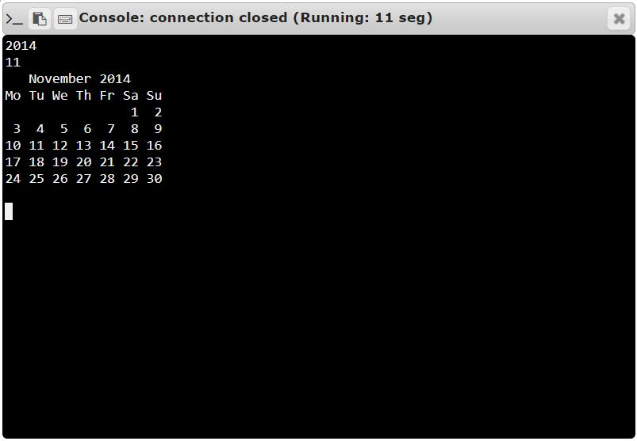

**RESULT:**

Thus, the code has been successfully executed and output is verified. ­­­­­