**EXERCISE NO:**2

**REGISTER NO:1518102103**

**AIM:**

To print the count number x in a given list of numbers.

**PROGRAM:**

def countX(lst,x):

c=0

for i in range(len(lst)):

if (lst[i]==x):

c+=1

return c

lst=[]

n=int(input())

for i in range(n):

ele=int(input())

lst.append(ele)

x=int(input())

c=countX(lst,x)

print(c)

**LINK:**

[**http://103.53.53.18/mod/vpl/forms/edit.php?id=230&userid=1707**](http://103.53.53.18/mod/vpl/forms/edit.php?id=230&userid=1707)

**OUTPUT:**

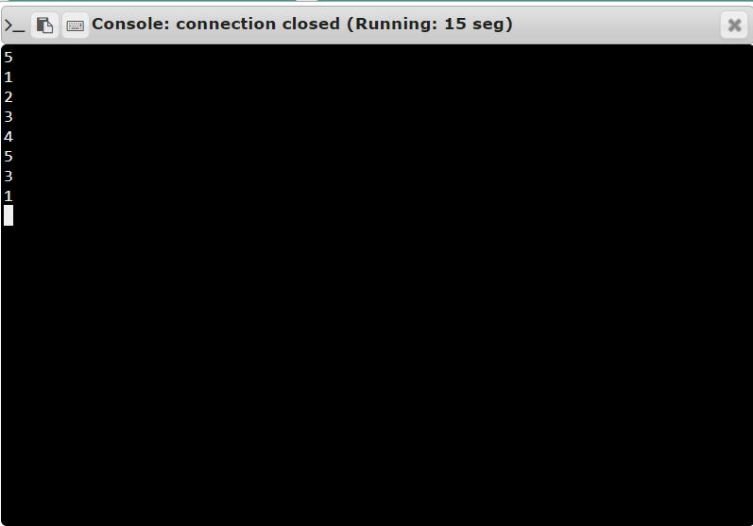

**RESULT:**

Thus, the code has been successfully executed and output is verified. ­­­­­