**EXERCISE NO:**5

REGISTER NO:1518102103

**AIM:**

To print the missing characters to make string pangram.

**PROGRAM:**

a=input()

a=set(a.strip())

a.remove(chr(32))

b="abcdefghijklmnopqrstuvwxyz"

b=set(b)

b=b.difference(a)

b=list(b)

b.sort()

print("".join(b))

**LINK:** [**http://103.53.53.18/mod/vpl/forms/edit.php?id=235&userid=1707**](http://103.53.53.18/mod/vpl/forms/edit.php?id=235&userid=1707)

**OUTPUT:**

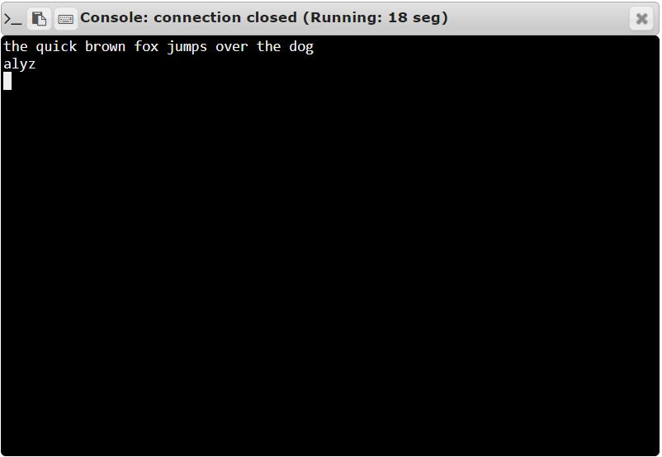

**RESULT:**

Thus, the code has been successfully executed and output is verified. ­­­­­