Solution

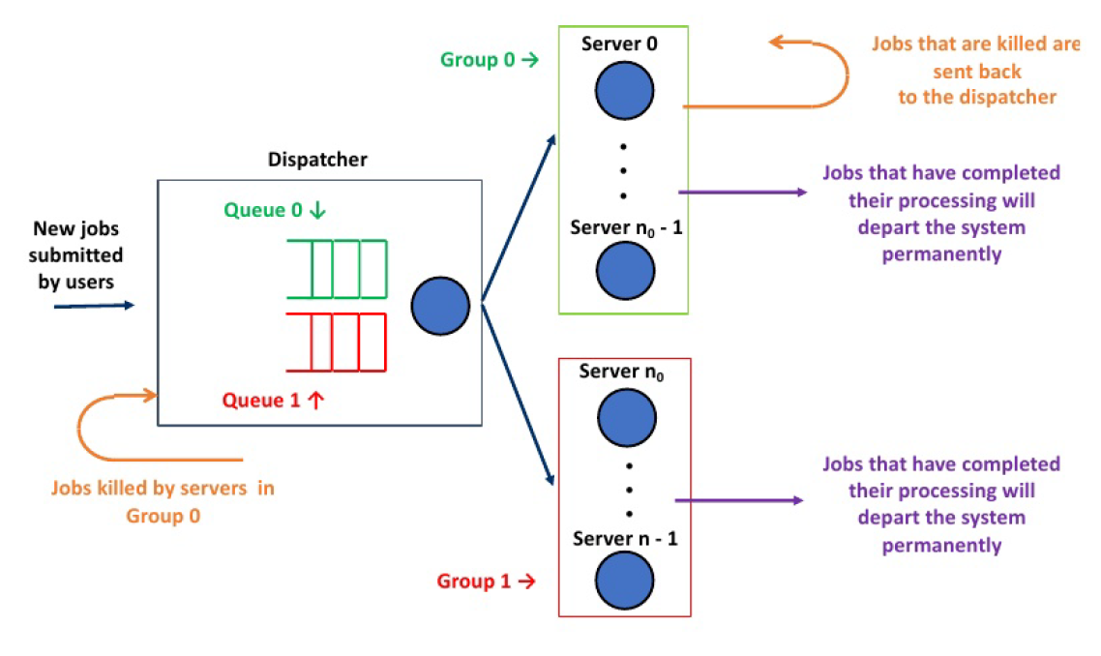

E.g. Input: *n=3* (*n0 = 1*, *n1=2*) and *t_limit = 3*

|  |  |  |  |  |  |  |  |  |
| --- | --- | --- | --- | --- | --- | --- | --- | --- |
| Master clock | Event type | Next arrival time | Server 0  Group 0 | Server 1  Group 1 | Server 2  Group 1 | Queue 0 | Queue 1 | Notes |
| 0 |  | 2 | Idle, Inf | Idle, Inf | Idle, Inf |  |  | the start of the simulation |
| 2 | Arrival | 10 | Idle, Inf | Busy, (2,7) | Idle, Inf |  |  |  |
| 7 | Departure | 10 | Idle, Inf | Idle, Inf | Idle, Inf |  |  |  |
| 10 | Arrival | 11 | Busy,(10,13,4) | Idle, Inf | Idle, Inf |  |  | 三元组含义:(arrival time, departure time, service time) |
| 11 | Arrival | 12 | Busy,(10,13,4) | Idle, Inf | Idle, Inf | (11,9) |  |  |
| 12 | Arrival | 14 | Busy,(10,13,4) | Idle, Inf | Idle, Inf | (11,9),(12,2) |  |  |
| 13 | Departure | 14 | Busy,(11,16,9) | Busy  (10,17) | Idle, Inf | (12,2) |  |  |
| 14 | Arrival | 15 | Busy,(11,16,9) | Busy  (10,17) | Busy (14,22) | (12,2) |  |  |
| 15 | Arrival | 19 | Busy,(11,16,9) | Busy  (10,17) | Busy (14,22) | (12,2),(15,5) |  |  |
| 16 | Departure | 19 | Busy,(12,18) | Busy  (10,17) | Busy (14,22) | (15,5) | (11,9) |  |
| 17 | Departure | 19 | Busy,(12,18) | Busy  (11,26) | Busy (14,22) | (15,5) |  |  |
| 18 | Departure | 19 | Busy,(15,21,5) | Busy  (11,26) | Busy (14,22) |  |  |  |
| 19 | Arrival | 20 | Busy,(15,21,5) | Busy  (11,26) | Busy (14,22) | (19,3) |  |  |
| 20 | Arrival | Inf | Busy,(15,21,5) | Busy  (11,26) | Busy (14,22) | (19,3) | (20,6) |  |
| 21 | Departure | Inf | Busy,(19,24) | Busy  (11,26) | Busy (14,22) |  | (20,6),(15,5) |  |
| 22 | Departure | Inf | Busy,(19,24) | Busy  (11,26) | Busy (20,28) |  | (15,5) |  |
| 24 | Departure | Inf | Idle, Inf | Busy  (11,26) | Busy (20,28) |  | (15,5) |  |
| 26 | Departure | Inf | Idle, Inf | Busy  (15,31) | Busy (20,28) |  |  |  |
| 28 | Departure | Inf | Idle, Inf | Busy  (15,31) | Idle, Inf |  |  |  |
| 31 | Departure | Inf | Idle, Inf | Idle, Inf | Idle, Inf |  |  |  |