Homework 1 STAT651

Patricia Reynoso

October 22nd, 2018

library(macleish)  
library(ggplot2)  
glimpse(whately_2015)

## Rows: 52,560  
## Columns: 8  
## $ when <dttm> 2015-01-01 00:00:00, 2015-01-01 00:10:00, 2015-01-...  
## $ temperature <dbl> -9.32, -9.46, -9.44, -9.30, -9.32, -9.34, -9.30, -9...  
## $ wind_speed <dbl> 1.399, 1.506, 1.620, 1.141, 1.223, 1.090, 1.168, 1....  
## $ wind_dir <dbl> 225.4, 248.2, 258.3, 243.8, 238.4, 241.7, 242.3, 24...  
## $ rel_humidity <dbl> 54.55, 55.38, 56.18, 56.41, 56.87, 57.25, 57.71, 58...  
## $ pressure <int> 985, 985, 985, 985, 984, 984, 984, 984, 984, 984, 9...  
## $ solar_radiation <dbl> 0, 0, 0, 0, 0, 0, 0, 0, 0, 0, 0, 0, 0, 0, 0, 0, 0, ...  
## $ rainfall <int> 0, 0, 0, 0, 0, 0, 0, 0, 0, 0, 0, 0, 0, 0, 0, 0, 0, ...

whately_2015%>%  
 ggplot(aes(x = when, y = temperature)) + geom_point(size = 0.001, color = "gray")+geom_smooth() + ggtitle("Average temperature in Whately Massachussets 2015") + xlab("Date")

## `geom_smooth()` using method = 'gam' and formula 'y ~ s(x, bs = "cs")'

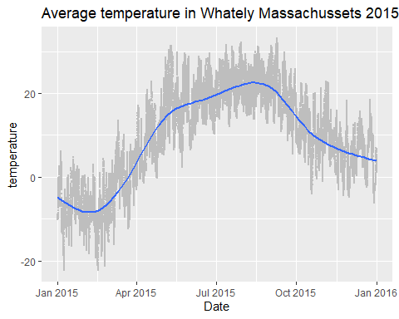

library(nasaweather)  
glimpse(storms)

## Rows: 2,747  
## Columns: 11  
## $ name <chr> "Allison", "Allison", "Allison", "Allison", "Allison", "Al...  
## $ year <int> 1995, 1995, 1995, 1995, 1995, 1995, 1995, 1995, 1995, 1995...  
## $ month <int> 6, 6, 6, 6, 6, 6, 6, 6, 6, 6, 6, 6, 6, 6, 6, 6, 6, 6, 6, 6...  
## $ day <int> 3, 3, 3, 3, 4, 4, 4, 4, 5, 5, 5, 5, 6, 6, 6, 6, 7, 7, 7, 7...  
## $ hour <int> 0, 6, 12, 18, 0, 6, 12, 18, 0, 6, 12, 18, 0, 6, 12, 18, 0,...  
## $ lat <dbl> 17.4, 18.3, 19.3, 20.6, 22.0, 23.3, 24.7, 26.2, 27.6, 28.5...  
## $ long <dbl> -84.3, -84.9, -85.7, -85.8, -86.0, -86.3, -86.2, -86.2, -8...  
## $ pressure <int> 1005, 1004, 1003, 1001, 997, 995, 987, 988, 988, 990, 990,...  
## $ wind <int> 30, 30, 35, 40, 50, 60, 65, 65, 65, 60, 60, 45, 30, 35, 35...  
## $ type <chr> "Tropical Depression", "Tropical Depression", "Tropical St...  
## $ seasday <int> 3, 3, 3, 3, 4, 4, 4, 4, 5, 5, 5, 5, 6, 6, 6, 6, 7, 7, 7, 7...

storms%>%  
 ggplot(aes(x = pressure, y = wind, color = type)) + geom_point(size = 1) + ggtitle("Wind vs Pressure by Type of Storm")

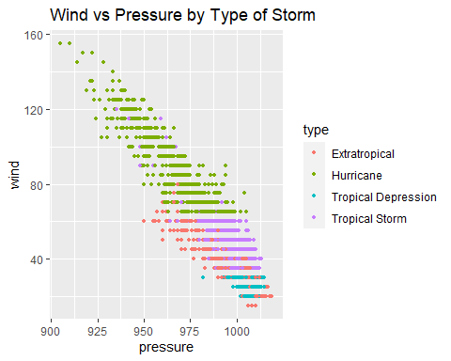

library(nasaweather)  
bbox <- storms %>%  
select(lat, long) %>%  
apply(MARGIN = 2, range) %>%  
as.data.frame()  
bbox

## lat long  
## 1 8.3 -107.3  
## 2 70.7 1.0

base_map <- ggplot(data = map_data("world"), aes(x = long, y = lat))+  
geom_path(aes(group = group), color = "black", size = 0.1)+  
lims(x = bbox$long, y = bbox$lat)  
base_map

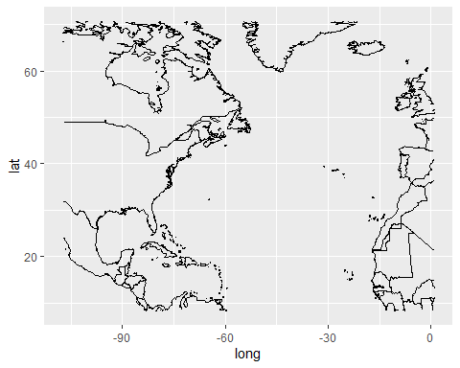

storms <- storms %>%  
mutate(the_date = lubridate::ymd(paste(year, month, day)))

base_map +  
geom_path(data = storms, aes(color = name, alpha = 0.1, size = wind),  
arrow = arrow(length = unit(0.1, "inches")))+  
facet_wrap(~year)+  
theme(legend.position = "none")

