3b
1.
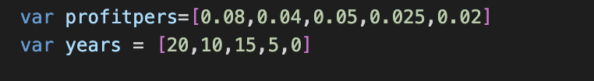
2.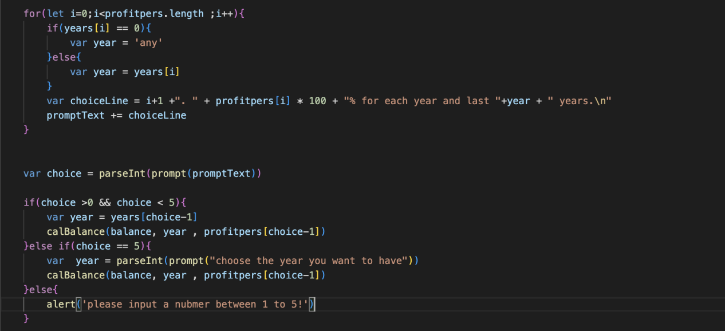

- profitpers, years
- In the list profitpers, the value contained is about interest rate. And in the list years, the value contained is about years that interest choice has.
- If I choose not to use a list of years, I will need to write the same line of code repeatedly for every year in order to calculate certain values. However, by utilizing a list of years, I can avoid having to write this repetitive code and instead can reuse the same code block to calculate the necessary values for each individual year. Similarly, when it comes to the profitpers list, if I decide not to use it, I will be required to write out the same code repeatedly for each choice that a user makes in order to calculate the profit they earn. However, if I take advantage of the profitpers list, I can reuse the same code block to calculate the profits for each choice, based on the values in the list, thereby avoiding the need for repetitive coding.

