3c
1.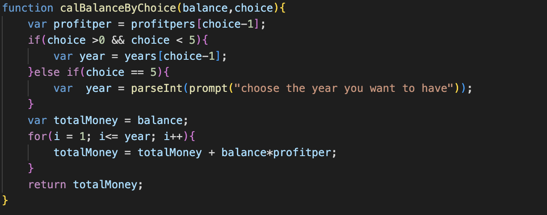

2.
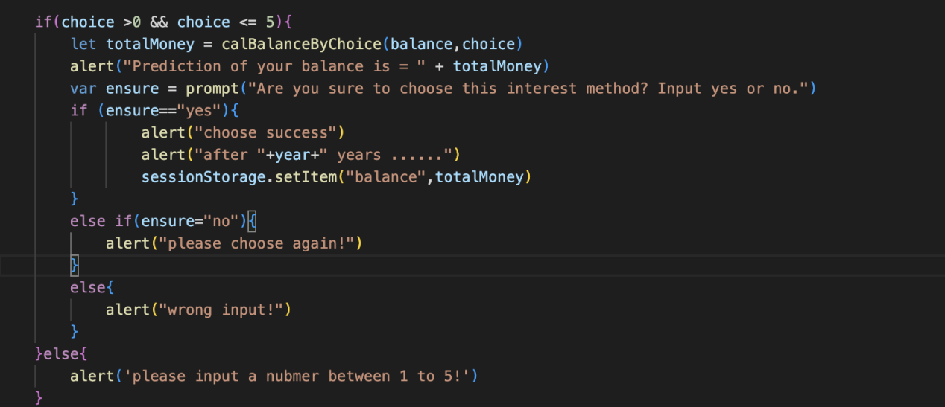

- The calBalance function is a crucial aspect of the program, serving as a calculation process for determining the profit that users can earn based on their chosen interest rates. By consolidating this calculation process within a single function, the overall functionality of the program is significantly improved. This not only simplifies the code, but also minimizes the need for repetitive sentences throughout the program. As a result, the code becomes easier to read and more convenient to write, ultimately helping to achieve the program's primary goal of calculating the profit that users can expect to earn.
- In this function, the parameters 'balance’ and ‘choice’ are retrieved from the preceding code. According to the choice that users choose, the different profit per year and year will be define. If the choice is 5 which is the current profit, the year would be defined by users’ inputs. And there is a new variable called totalMoney which is equal to the balance that stored in the system. And there is a for loop and a formula to calculate the total money that the user can have after the calculation. And the function will return this total money as totalMoney

