**MAPPING TWEETS AND ANALYZING TWITER TRENDS:**

In this project, I analyzed data taken from Twitter. The goal was to produce a map that shows how popular tweets about a given topic are in each state. In order to create maps like the one below, which shows how frequently people in each state are posting tweets containing the word “beach”, with darker blues representing more tweets (per capita), download the trends.py file located inside ProjectTwitter folder and at the very last line type your desired query item inside the draw_map_for_query(make_searcher(‘#Your desired search query’)) function.

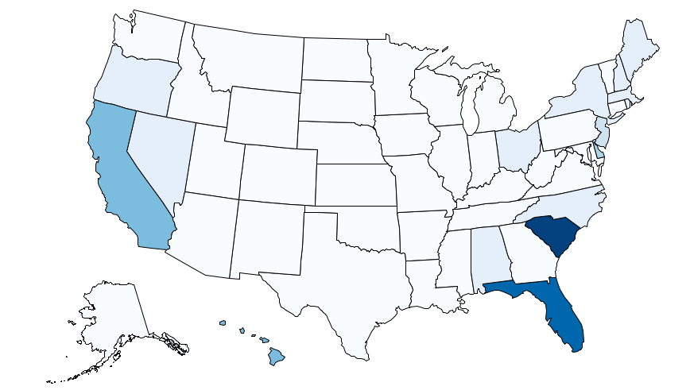

|  |  |
| --- | --- |
| **trends.py** | A framework for implementing the data analysis. |
| **geo.py** | A data abstraction for geographic positions, as well as functions for map projections and other useful geometric calculations. |
| **maps.py** | Functions for drawing maps. |
| **data.py** | Functions for loading Twitter data from files. |
| **graphics.py** | A simple Python graphics library. |