Exercise: Perspective Projection, 2D

Write some code that simulates the projection of a line segment defined by two points (-5,Z) and (5,Z), where Z ranges from 10 to 1000, and assuming a camera focal length of f=1.

For each distance Z, project the two points into a 1-D sensor under perspective projection, and compute the length of the segment.

Plot this length as a function of distance Z to see how size changes as a function of distance to the camera.

Exercise: Perspective Projection, 3D
Write some code that simulates the projection of a 3-D cube under perspective projection. The eight corners of the cube are:

[0,0,0], [1,0,0], [1,1,0], [0,1,0], [0,0,1], [1,0,1], [1,1,1], [0,1,1]

Specify the translation and rotation around the x-, y-, and z-axis and build the 3x4 extrinsic matrix M. Specify the focal length and camera center, and build the 3x3 intrinsic matrix K.

Project under perspective projection using the projection matrix formulation:
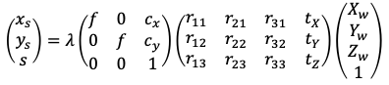
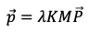

Draw the resulting "image."

