**Problem 1 – ML Libraries**

Build a recommendation engine which will skim through list of features and suggest common features in the data. The engine should also return different products the feature is used in.

Engine should be able to identify the intent of the feature and group similar features.

For example in the sample excel attached

One of the outcome should be **Notification functionality** as there are multiple features related to Notification in Prodcut A,B &C

**Solution:**

**Tools and Environments.**

1. Visual Studio Code
2. DotNet Core 3.0
3. C#
4. Packages - Microsoft.ML, Microsoft.ML.Data;

**Note:** This is Console application created for POC only. It can be more optimized and modularized.

**Solution Output:**

1. User can select top 10, top 20, top n record.
2. User can filter based on product type like all records of ProductA, or All records of ProductB
3. User need to pass input type like Payment, Financials, DeploymentActivities, HumanCapitalManagement so the output will return only related record to feature types.

**Logical Flow:**

Financials  
Payment

DeploymentActivities  
CI/CD  
Docker  
Container

Notification  
Email  
smscall

Features

Add / Update feature text

Is more filter text added

Desired Output

Query

Algorithm

Model

Training Data

Input file is CSV.

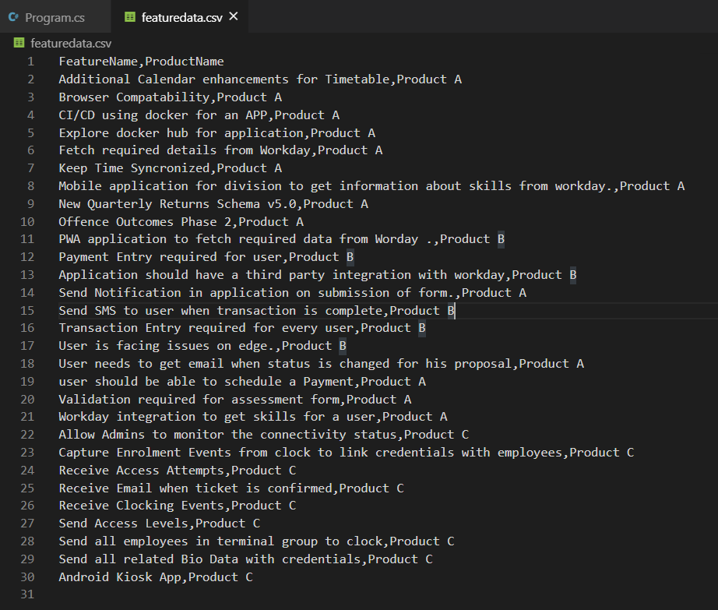

1. Get the data based on Product.

**Input = >** Product A  
**O/p**  
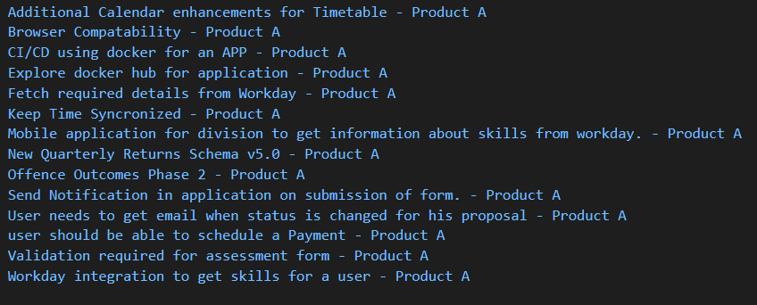

**Logic**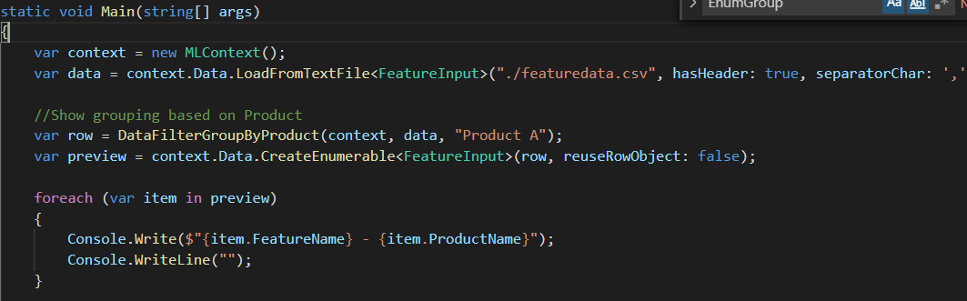

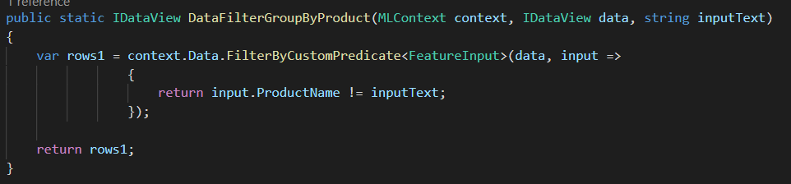

1. **Group the data base on Feature types.**

**Input -** HumanCapitalManagement

**O/P**

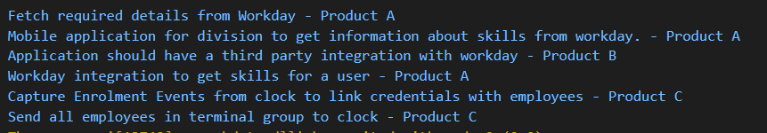

**Input –** DeploymentActivities

**O/P**  


**Logic**

