***C0558 “LA Budget Remaining” Column on Customer Order Line and Calculation for LAC Orders***

|  |  |  |  |  |
| --- | --- | --- | --- | --- |
| **Ver** | **Date** | **Author** | **Comments** | **Reviewed by** |
| 1 | 05/03/2020 | Linzi Evans |  | TBC |
| 1.1 | 19/07/21 | Linzi Evans | Added amendments following testing |  |

Requirements 2

Prerequisites 2

Solution Overview 2

Solution Details 2

Security 3

Companies 3

Data Migration 3

Test Steps 3

Technical Implementation 3

Requirements

* New custom column required on Customer Order Line Column: LA Remaining Budget.

A customer can pay funds upfront and call off from this payment with subsequent order lines.

Non Inventory Sales Part : BUDGET will be added to the customer order.

* If this part is added, the value will be added to Price/Curr field.

The new custom field (Remaining Budget) will be populated with this value.

* Subsequent Order lines will be added.

When an order line is added, the value of the discount amount PER LINE should be deducted from the value in the remaining budget field on the BUDGET order line.

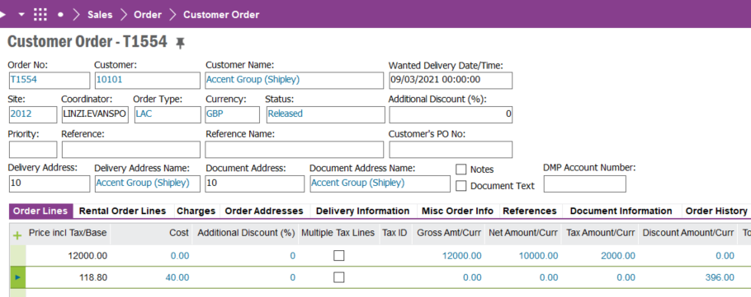

Solution Details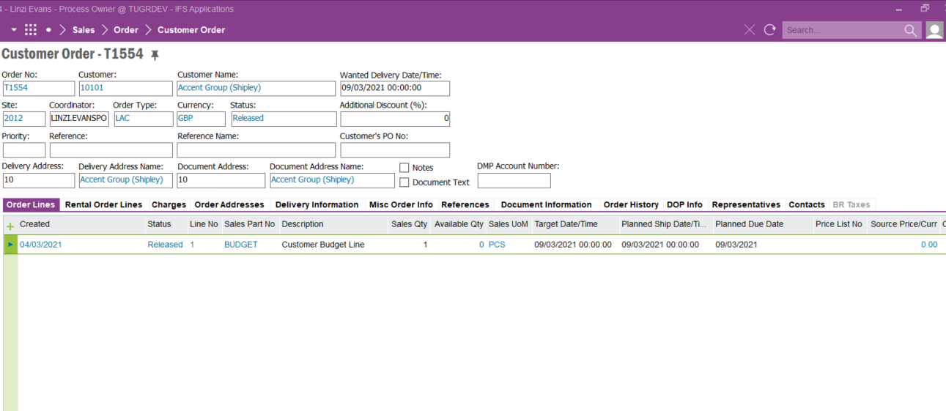

**Field Definitions**

TO READ: LA REMAINING BUDGET

CALCULATION: Order Line 1: Budget Price/Curr MINUS Order Line 2/3/4/5 etc Discount Amount

**19/07/21**

**This calculation is NOT valid for order lines in a “CANCELLED” Status. Cancelled order lines should not be deducted from the LA Remaining Budget figure.**

**Also, if a line is deleted (due to input error), the LA remaining budget figure should revert to valid line discount amounts only.**

**Also: Custom Event Required:**

**LA Remaining Budget must NOT become a negative number. A pop-up error message should appear when the value will fall below 0. “Unable to add order line due to remaining budget”.**

<New Field/CLU Definition>

|  |  |  |  |  |  |  |
| --- | --- | --- | --- | --- | --- | --- |
| New DB Object Name | DB Object Item/Field Names | Item Description | Item Data Type | Item Syntax | Calculation Spec, if Derived | LOVs/Enums/Is Mandatory? |
|  |  |  |  |  |  |  |
|  |  |  |  |  |  |  |
|  |  |  |  |  |  |  |
|  |  |  |  |  |  |  |
|  |  |  |  |  |  |  |
|  |  |  |  |  |  |  |
|  |  |  |  |  |  |  |
|  |  |  |  |  |  |  |
|  |  |  |  |  |  |  |
|  |  |  |  |  |  |  |
|  |  |  |  |  |  |  |
|  |  |  |  |  |  |  |

Security

All users with access to Customer Orders can access / view and edit this field.

Companies

Applies to the following companies

|  |  |
| --- | --- |
| **Company** | **Required (Y/N)** |
| 1201 | Y |
|  |  |
|  |  |

Data Migration

N/A

Test Steps

<Steps that needs to be taken to test this change. Please provide expected results>

|  |  |  |
| --- | --- | --- |
| **No** | **Script\Test Steps** | **Expected Result** |
| 1 |  |  |
|  |  |  |
|  |  |  |
|  |  |  |
|  |  |  |
|  |  |  |

Technical Implementation

1. Custom Field – La Remaining Budget

Note – If the custom field is not available in the Customer Order – Lines Tab, RMB on the Column header, Column Chooser, set the “LA REMAINING BUDGET” field to visible

1. Custom Events

* SET_REMAINING_BUDGET

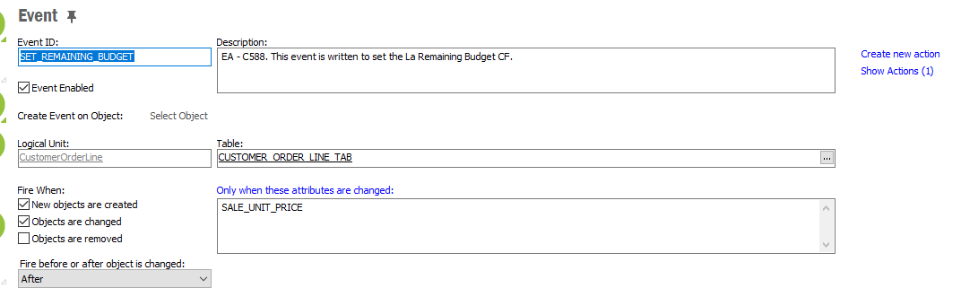

* UPDATE_REMAINING_BUDGET

**CUSTOM EVENT -** LA Remaining Budget must NOT become a negative number. A pop-up error message should appear when the value will fall below 0. “Unable to add order line due to remaining budget”.

Due to some technical limitations an error message cannot be popped up in the Client application as the task is based on a background job. However, there is a work around for this, I have added it as a Stream Message. Thus, it will pop-up in the Streams Section as follows.

When the user clicks on it, the message can be seen as follows,

Delivery Notes

* PACKAGE - EA_COM
* Permissions granted – IFS_ALL (Users who have access to the Customer Order Window)