**Document Signatures**

|  |  |  |  |  |
| --- | --- | --- | --- | --- |
| **Ver** | **Date** | **Author** | **Comments** | **Reviewed by** |
| 1 | 19/05/2021 | Tom Bell | CRIM 0678 | TBC |
|  |  |  |  |  |

Requirements 2

Prerequisites 2

Solution Overview 2

Solution Details 2

Security 3

Companies 3

Data Migration 3

Test Steps 3

Technical Implementation 3

Requirements

HR require a user to sign a document in IFS by typing their name into a dialogue box.

Solution Overview

In the My Incoming Documents screen in AURENA changes are required to enable a user to digitally sign a document.

* Rename Unattended section title to “Requires Signature”
* Remove the entire “Mark as Read” section and button on screen.
* Move out of box logic from “Approve” button.
* Rename Approved section title “My Signed Documents”.
* Document Signature Dialogue Box
* Error handling to ensure the user has input their name.

Solution Details

# My Incoming Documents screen Amendments

* Rename Unattended to “Requires Signature” in red
* Remove the entire “Mark as Read” section in blue.
* Rename Approved “My Signed Documents” in yellow.

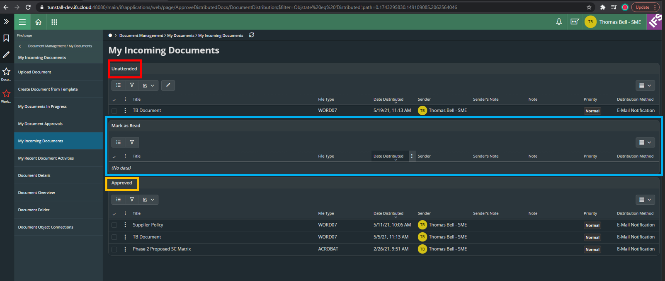

# Button Amendments

Remove the “Mark as Read” button from this screen (marked in red box).

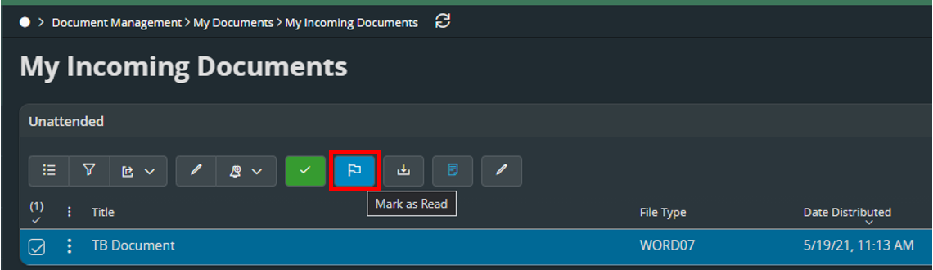

Change the text that appear when the cursor is placed over the Approve button (marked in yellow below) to “Sign Document” Currently this button changes the status of the document to “Approved”

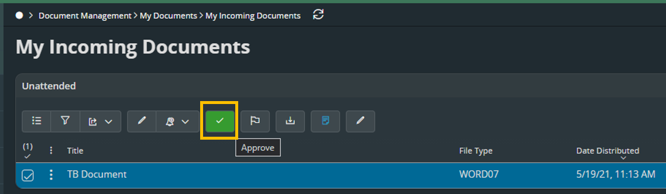

# Dialogue Box Trigger

When the Approve button is clicked (in yellow below), a dialogue box must open. This will be discussed in more detail below.



The below screenshot shows the effect of the current functionality of the green button (marked in yellow) above. The status of the Document Distribution is changed to “Approved” (see red in below screenshot) which also moves the document into the “Approved” section of the My Incoming Documents screen.

**This button needs to not trigger this functionality, the button must only open the dialogue box.**

This will instead be triggered from the dialogue box’s “Sign Document” button discussed in the next section.

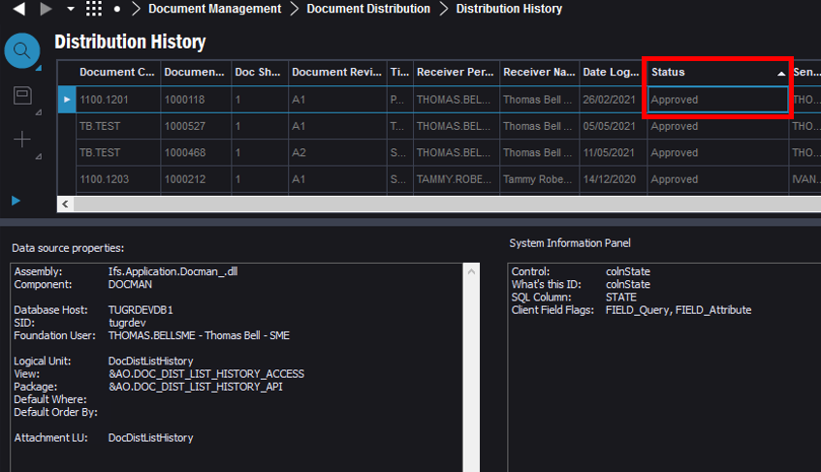

# Document Signature Dialogue Box

The below shows a wireframe of a dialogue box. The dialogue box must resemble the wireframe below The below section will breakdown the contents.

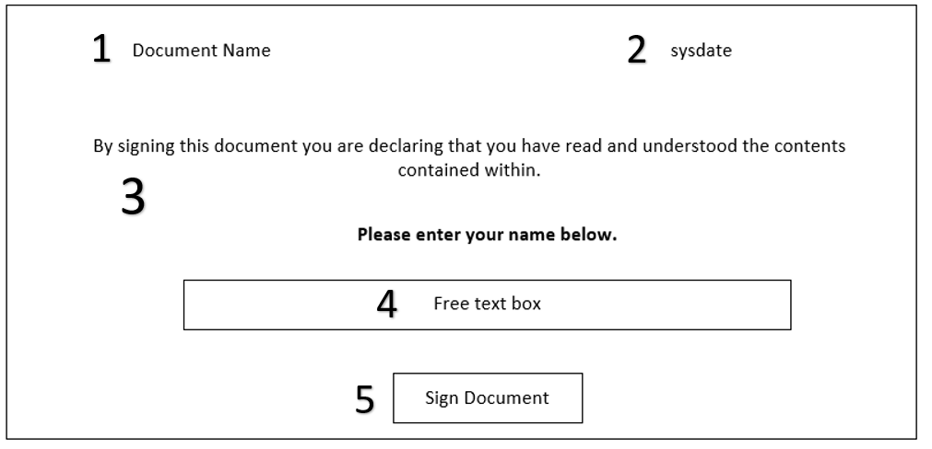

1. Name of the document that was selected to be signed/approved.
2. Current data and time
3. Hard coded text
4. Free text field. User must enter their name here.
5. Button - that if clicked and the text box contains more than 2 characters, closes the dialogue box, **AND changes the Distribution Status to “Approved”. This will move the document to the Approved/Signed Document section of the My Incoming Document screen (as per the above section).** This button requires the same logic AS IS logic the “Approve” button has.

# Error Handling

If the Sign Document button is clicked and the text box contains 2 or less characters, a new dialogue box must open that states the following.

*“Please enter your name and then click the “Sign Document” button”.*

This will prompt the user to input their name.

**Technical.**

Field Definitions.

<New Field/CLU Definition>

|  |  |  |  |  |  |  |
| --- | --- | --- | --- | --- | --- | --- |
| New DB Object Name | DB Object Item/Field Names | Item Description | Item Data Type | Item Syntax | Calculation Spec, if Derived | LOVs/Enums/Is Mandatory? |
|  |  |  |  |  |  |  |
|  |  |  |  |  |  |  |
|  |  |  |  |  |  |  |
|  |  |  |  |  |  |  |
|  |  |  |  |  |  |  |
|  |  |  |  |  |  |  |
|  |  |  |  |  |  |  |
|  |  |  |  |  |  |  |
|  |  |  |  |  |  |  |
|  |  |  |  |  |  |  |
|  |  |  |  |  |  |  |
|  |  |  |  |  |  |  |

Security

<Define security controls> (Who needs access to this and will it be restricted from any other users etc)

All users have access to this transaction. But will only be able to see documents that have been distributed to their own user.

Companies

Applies to the following companies. All.

|  |  |
| --- | --- |
| **Company** | **Required (Y/N)** |
| 1201 | Y |
| TBC |  |
|  |  |

Data Migration

<Describe any data migration impacts this development may have – i.e additional data to be migrated>

Test Steps

<Steps that needs to be taken to test this change. Please provide expected results> Updated post solution.

|  |  |  |
| --- | --- | --- |
| **No** | **Script\Test Steps** | **Expected Result** |
| 1 |  | See changes to My Incoming Documents screen |
| 2 | Approve/Sign a document | See dialogue box as shown with correct error handling message. |
| 3 |  |  |
| 4 |  |  |
|  |  |  |
|  |  |  |

Technical Implementation

‘Sign Document’ dialog functionality is changed after discussion with Tusntall due to a feasibility issue.

(Configured dialog box is not feasible in Aurena)

New solution :

The custom Action ‘Sign Document’ and custom field ‘Signer’ is configured in My Incoming document - > Requires Signature section. When the user clicks on the ‘Sign Document’ command, it will check whether the ‘Signer’ column is filled with more than two characters.

If not it will trigger an error. If yes, the document will move in to ‘My Signed documents’ section.

Amendments after initial testing

Tunstall : Amend the status options in the Distribution History to match the ones changed in the My Incoming Documents – ‘Requires Signature’ and ‘Signed Documents’

Darshika : It’s not possible to change the existing Status column in the Dustribution History window. Instead, we can introduce a new custom field with the following status mappings.

Requires Signature – If the actual status is ‘Approved’

Signed Documents – If the actual status is ‘Distributed’.

No Value – If the actual status is ‘Read’ or ‘Hardcopy Distribution’

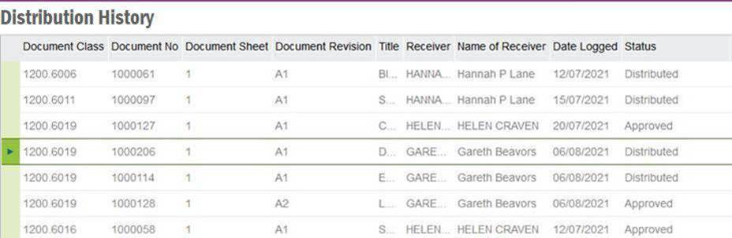

Tunstall : The HR Team would also need an additional custom field in the distribution history data screen to show the date and time the status of the document was changed from requires signature to signed document

Darshika : This is possible

Tunstall : The mark as read option in the icon at the top of the page and in the 3 dot picker options needs also to be removed from these options – when this is selected the documents disappears from the current view altogether as this option box has been removed from site.

Darshika : This is possible

Application Configuration Package: EA_DOCMAN

Steps:

1. Import the ACP. Go to ACP and publish if it’s not published.
2. Open IEE application, go to ‘Distributed Documents’ and RMB custom field overview.
3. Publish/ Synchronize the custom fields.
4. ‘Distributed Documents’ - Reload Configuration
5. ‘Distributed Documents’ - select the custom fields using ‘Column Chooser’.
6. Open Aurena application and go to ‘My Incoming Documents’ window.
7. Go to page designer.

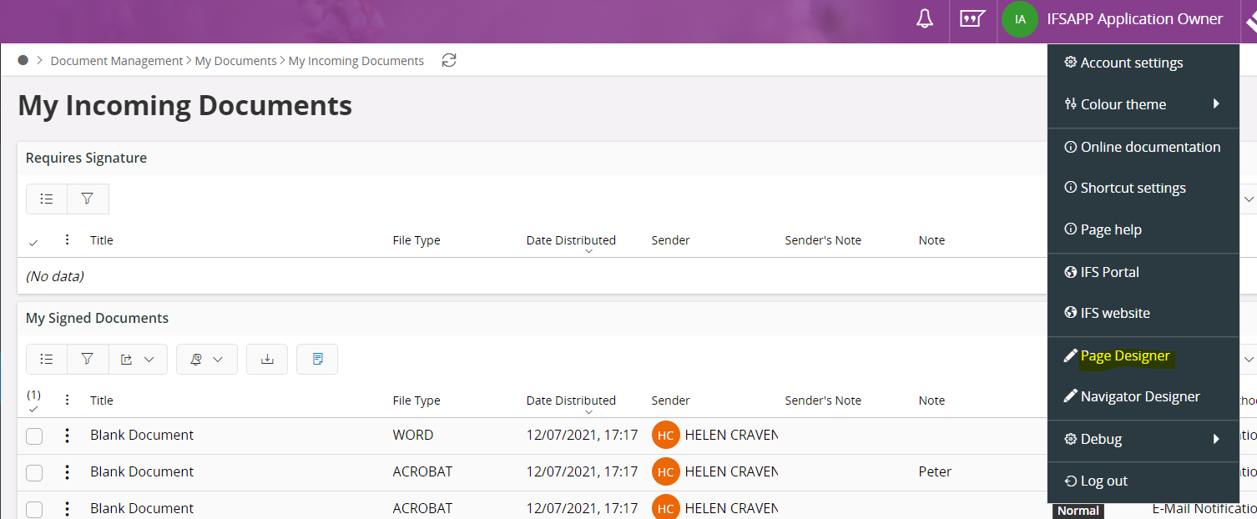



1. Publish the configurations if it’s not published.

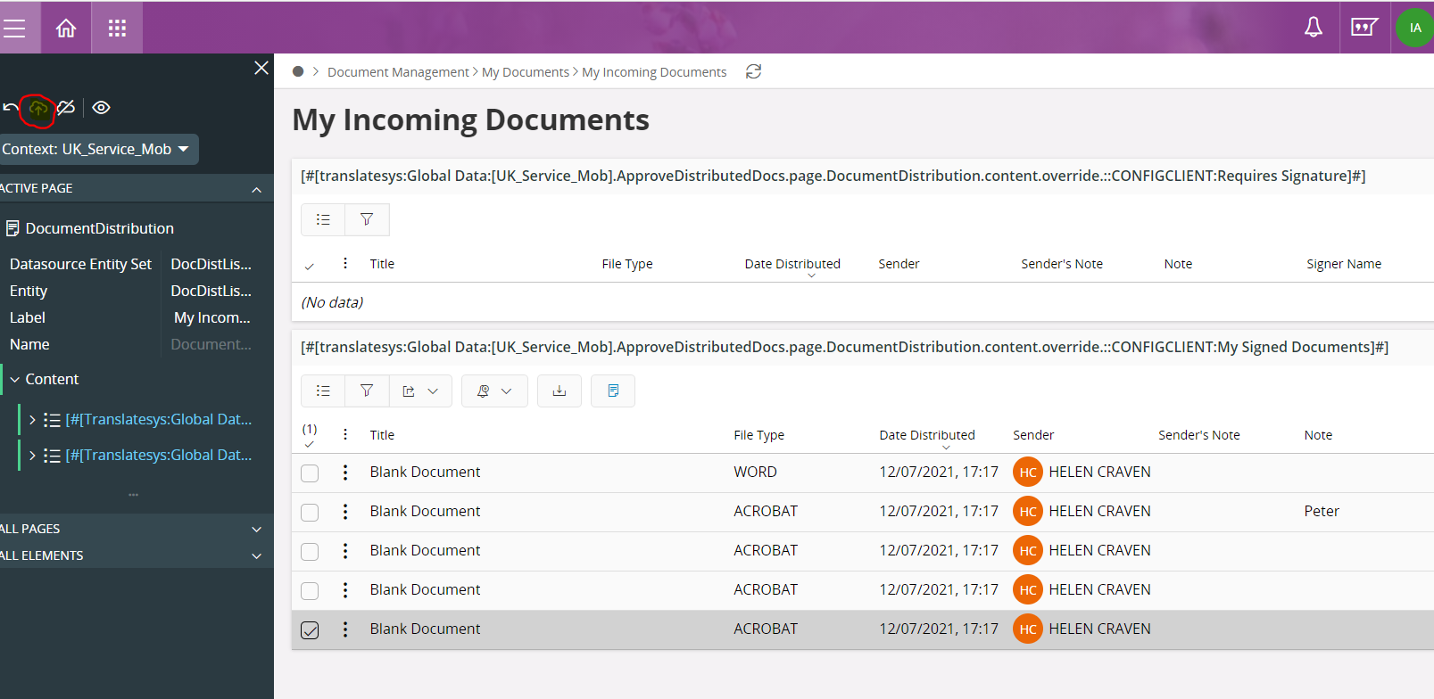



1. Go to Distribution History window in Aurena application.
2. Go to page designer and publish the configuration is it’s not published.

Database Logic is written in C_EA_Customization_Util_API.Approve_Incoming_Docs. So please make sure this Is deployed.