**CRIM 0692 – Instant Auth - Credit Note Check Box**

|  |  |  |  |  |
| --- | --- | --- | --- | --- |
| **Ver** | **Date** | **Author** | **Comments** | **Reviewed by** |
| 1 | 14/06/2021 | Tom Bell | CRIM 0692 | TBC |
|  |  |  |  |  |

Requirements 2

Prerequisites 2

Solution Overview 2

Solution Details 2

Security 3

Companies 3

Data Migration 3

Test Steps 3

Technical Implementation 3

Requirements

A custom field is required on the Instant Authorisation screen to let AP know that an Invoice requires a Credit Note.

Prerequisites

<Describe any pre-requisites that this development may rely upon, data configuration or other developments>

Solution Overview

* Custom checkbox called “Hold for Credit” on Instant Authorisation screen that if marked true, will trigger event when an Instant Authorisation is Authorised.
* Add column with containing “Hold for Credit” on Posting Proposal screen with associated invoice.

To navigate to the Instant Authorisation screen, go to the screen below.

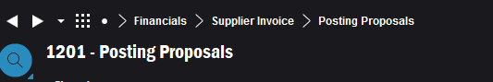

Then RMB a link in the Posting Proposal screen.

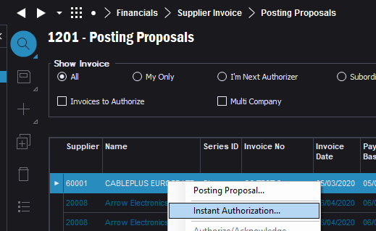

Solution Details

# Custom Check Box Location

A check box is required on the header of the Instant Authorisation screen called “Hold for Credit Note”.

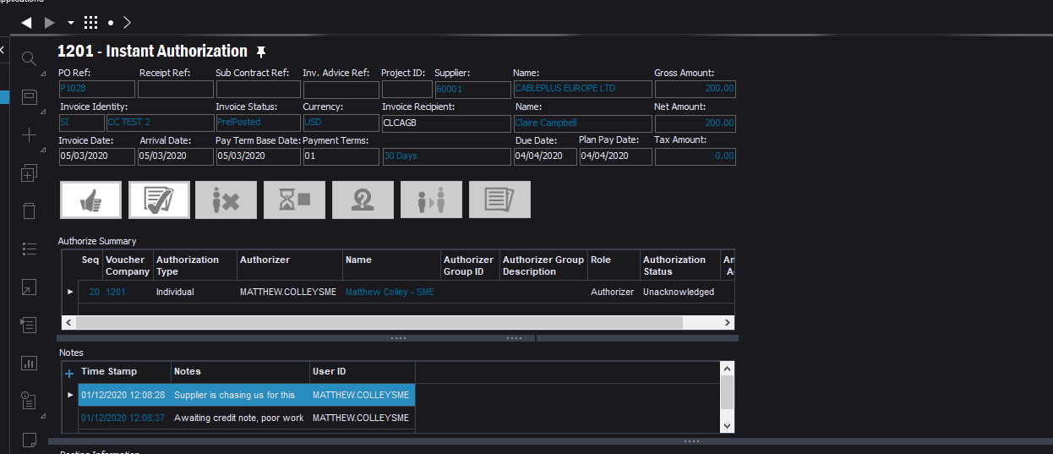

# Custom Event

**Trigger**

If the “Hold for Credit” checkbox is marked TRUE and the Instant Authorisation is set to “Authorised”

The below screenshot shows the button that will trigger the event.

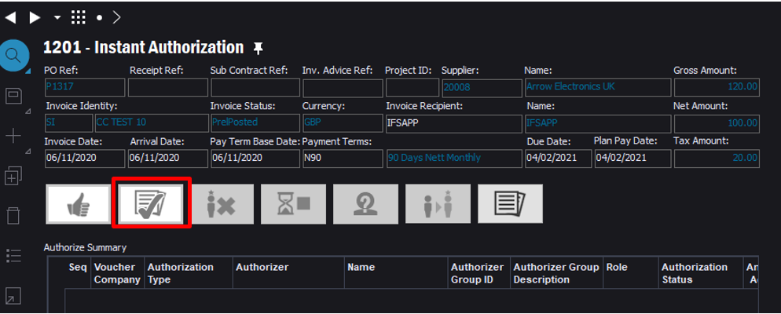

**Logic**

Dialogue box pop up will appear with the following text with Yes and No buttons “*Hold for credit note box will be removed when Authorised - are you sure you want to authorise?*”.

If “No” is selected, the Authorisation is aborted, and the Hold for Credit checkbox is unchanged (TRUE).

If “Yes” is selected, the Authorisation is complete, and the Hold for Credit Checkbox is marked FALSE.

# Custom Column – Posting Proposals screen

Require a custom column on the Posting Proposals screen that contains the “Hold for Credit” custom field from the above section of this spec.

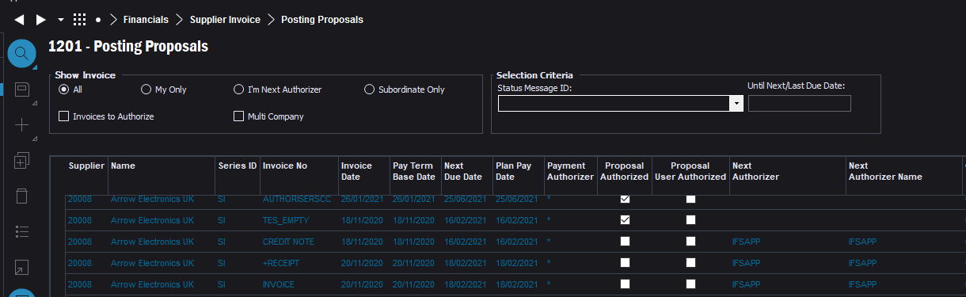

**Technical.**

Field Definitions.

<New Field/CLU Definition>

|  |  |  |  |  |  |  |
| --- | --- | --- | --- | --- | --- | --- |
| New DB Object Name | DB Object Item/Field Names | Item Description | Item Data Type | Item Syntax | Calculation Spec, if Derived | LOVs/Enums/Is Mandatory? |
|  |  |  |  |  |  |  |
|  |  |  |  |  |  |  |
|  |  |  |  |  |  |  |
|  |  |  |  |  |  |  |
|  |  |  |  |  |  |  |
|  |  |  |  |  |  |  |
|  |  |  |  |  |  |  |
|  |  |  |  |  |  |  |
|  |  |  |  |  |  |  |
|  |  |  |  |  |  |  |
|  |  |  |  |  |  |  |
|  |  |  |  |  |  |  |

Security

<Define security controls> (Who needs access to this and will it be restricted from any other users

Companies

Applies to the following companies. All.

|  |  |
| --- | --- |
| **Company** | **Required (Y/N)** |
| 1201 | Y |
| TBC |  |
|  |  |

Data Migration

<Describe any data migration impacts this development may have – i.e additional data to be migrated>

Test Steps

<Steps that needs to be taken to test this change. Please provide expected results> Updated post solution.

|  |  |  |
| --- | --- | --- |
| **No** | **Script\Test Steps** | **Expected Result** |
| 1 |  |  |
| 2 |  |  |

Technical Implementation

<Completed by the technical developer - Technical solution, list packages, functions, Custom menus created etc >

1. Agreed to trigger an error message instead of a warning/information message – This error message will act as a flow stopper.

New Error Message is as follows,  
   
 “Hold for credit note box is checked so cannot proceed with authorisation”

Delivery Notes

**PACKAGE** – EA_FINANCE

**Permission Granted** – IFS_ALL

**Custom Field**

1. Posting Proposal

Note – In case the Hold for Credit custom field (column) is not available in the Posting Proposals Window, RMB of a column, Column Chooser, Add the Hold for Credit.

1. Instant Authorization

Note – In case the Hold for Credit custom field (column) is not available in the Instant Authorization Window, RMB on the header, Properties, Layout and add the custom field.

**Custom Events**

