**Information**

|  |  |  |
| --- | --- | --- |
| **CRIM ID** | **Title** | **Workstream** |
| C0706 | Display next object ID in the sequence– v0.1 | Service Management |

**Revision History**

|  |  |  |  |
| --- | --- | --- | --- |
| **Revision** | **Date** | **By** | **Remarks** |
| 0.1 | 20/07/2021 | Erika Sukevic | Base spec |
| 1.0 |  |  |  |
| 1.1 |  |  |  |
| 1.2 |  |  |  |

# CRIM Narrative

We need a custom field which calculates what is the next object ID in the sequence. The field need to identify which objects on the specific object level belongs to the selected structure and calculate ID based on it.

The new field should be placed on the Equipment Object Navigator screen and Functional Object screen.

The logic should find the object ID where Object level = 210_MS_CONTRACT or 200_CONTRACT

Then the logic should find all object IDs which

* belongs to the object id with object level 210_MS_CONTRACT or 200_CONTRACT and
* has object level 355_DWELLING or 340_SCHEME

The first part of the 355_DWELLING or 340_SCHEME object id is always the number of the object where level is 210_MS_CONTRACT or 200_CONTRACT. Then it follows with underscore and minimum of 4-digit number. For example, if object id for 210_MS_CONTRACT object is 1 then the first 210_MS_CONTRACT object id will be 1_0001.

The field should find the highest number in the structure and display the next number in the sequence. For example, if the highest number is 1_20014 then field should display 1_20015.

# Implementation

Two custom fields were added to ‘EquipmentObject’ and ‘EquipmentFunctional’ logical units with the name ‘C_NEXT_OBJECT’. Custom field in ‘EquipmentObject’ will do the actual calculation of the next object id and field in ‘EquipmentFunctional’ is referring to the custom field in ‘EquipmentObject’

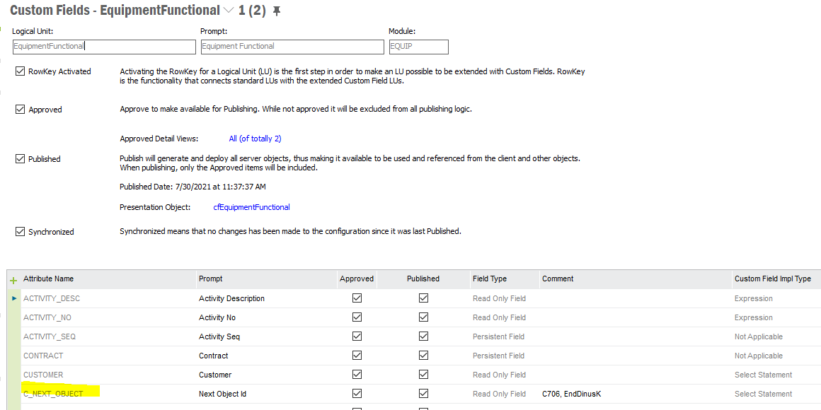

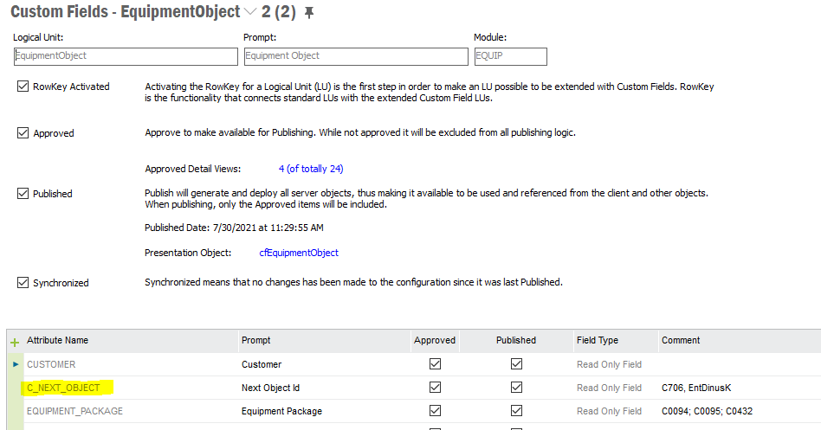

And added them in them in the window layout for ifsapp user.

