

C0618 MRB Custom RMB – Business Requirement Specification

This document has been approved by

|  |  |
| --- | --- |
|  |  |
| Business consultant | Solution owner or accountable role |
|  |  |
| Date | Date |

Document Revision History

|  |  |  |  |
| --- | --- | --- | --- |
| Revision | Date | Author | Remarks |
| A1 | 2021-04-13 | BTIMBERLAKE | First Revision |
| A2 | 2021-05-06 | BTIMBERLAKE | Revisions made to section 4.3 MRB Object Connection |
| B1 | 2021-07-30 | BTIMBERLAKE | Revisions added for further functionality  Additional text will be in yellow highlight. |
|  |  |  |  |
|  |  |  |  |
|  |  |  |  |

Table of Contents

1 Purpose and Guideance 4

2 Open Issues/Decisions Required 5

3 Business Requirements and References 6

3.1 Business Requirements 6

3.2 Sources and Dependencies 6

4 Solution Description 7

4.1 Process Description 7

4.2 NCR Creation Data Mapping 8

4.3 NCR RMB Create Corrective Action 9

4.4 CAPA Creation Data Mapping 9

4.5 MRB & CAPA Object Connection 9

5 Delimitations 12

6 Glossary/Acronyms 13

7 Change log 14

7.1 Change log for revision XX 14

# Purpose and Guideance

This document specifies how the defined functions shall be developed or how the application shall be customized to solve the business requirements.

The Section 4 defines whatwill be delivered. The solution is matched against the requirements described in Section 3. Section 5 Delimitations describe what is explicitly not covered by this customization. Together with the Section 4, these delimit the extent of the functional addition agreed for implementation.

# Open Issues/Decisions Required

This specification cannot be completed until the following issues/decisions have been resolved:

|  |  |
| --- | --- |
| Issue/Decision | Responsible |
|  |  |
|  |  |

# Business Requirements and References

## Business Requirements

Tunstall recognize the benefits of using the MRB process to inspect materials and identify where the buyers and/or quality team need to interact with suppliers around issues found either upon arrival or when in inventory.

What is also noted is that in creating the NCR and CAPA after the MRB is processed appears to bring with it a large amount of duplication around data and information input. Here Tunstall require a way to have the information from the MRB to automatically transfer to the NCR and CAPA upon creation.

## Sources and Dependencies

|  |  |  |
| --- | --- | --- |
| Case, Document or Customization ID | Title or Description | Comments |
|  |  |  |
|  |  |  |

# Solution Description

## Process Description

Tunstall require a custom right mouse button (RMB) on the MRB Case screen (Logical Unit: MrbHead) that they can action to create an NCR and CAPA automatically. This RMB needs to take data from the MRB screen, combine it with some hardcoded data and create a brand-new NCR which it turns then creates a CAPA. It also then needs to attach the MRB to the NCR and CAPA as an object.

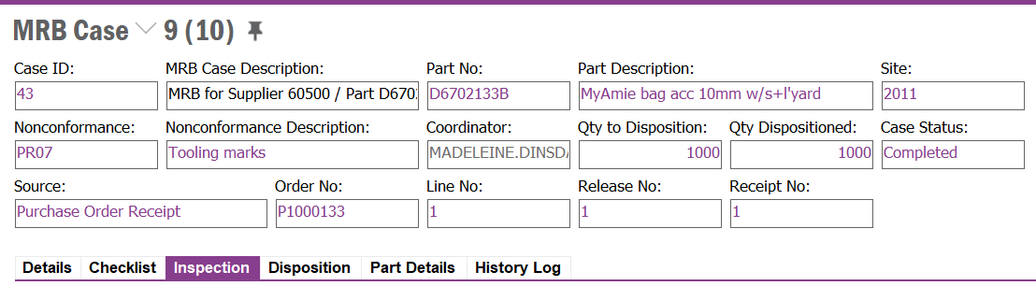

To do this the below mappings have been detailed which incorporate the mandatory and commonly used fields on the NCR screen when creating a new record. These are also the fields that can be/are required to be completed via the Create NCR Assistant screen. The solution is to skip this manual raising process by having the custom RMB do this for the user.

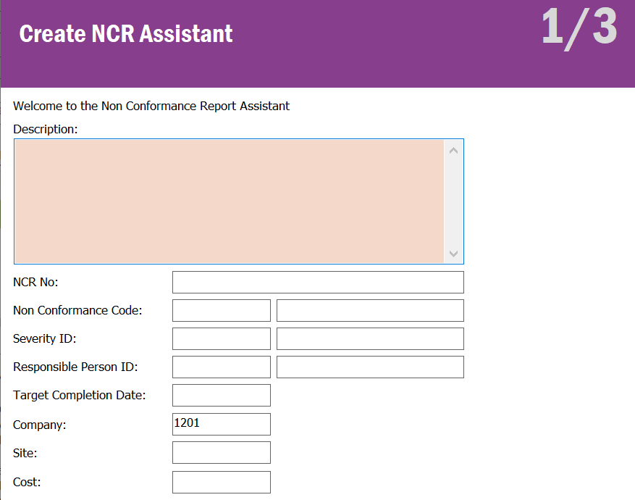

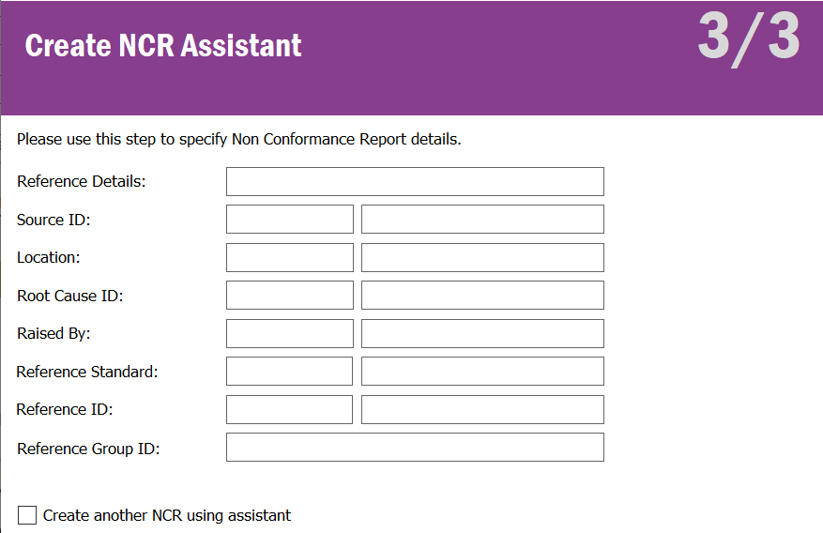

Once the RMB has triggered it needs to write back into a new custom field named Created NCR the NCR No that was created when actioned. This is to allows a transfer with value custom menu to be created later.

## NCR Creation Data Mapping

Below shows the NCR fields that require populating from the custom RMB. Some of these are mapped with data sources on the MRB, others are hardcoded inside the RMB event.

|  |  |  |  |
| --- | --- | --- | --- |
| NCR Field  (Field on NCR Creation)  NON_CONFORMANCE_REPORT | Source  MRB Field / Hardcoded | Source  Logical Unit | NCR Data Type  (Data Type on NCR Creation) |
| DESCRIPTION | MRB_DESCRIPTION | MRB_HEAD | STRING(500) |
| NCR_NO | *Follow IFS logic and allow the NCR to generate next NCR No automatically* | | |
| NONCONFORMANCE_CODE | MRB_CODE | MRB_HEAD | STRING(25)/UPPERCASE |
| SEVERITY_ID | 20 (Medium Severity) | HARDCODED | STRING(25)/UPPERCASE |
| RESPONSIBLE_PERSON_ID | MRB_COORDINATOR | MRB_HEAD | STRING(20)/UPPERCASE |
| TARGET_COMPLETION_DATE | SYSDATE + 21 Days | HARDCODED | DATE/DATE |
| COMPANY | 1201 | HARDCODED | STRING(20)/UPPERCASE |
| CONTRACT | CONTRACT | MRB_HEAD | STRING(5)/UPPERCASE |
| NCR_REFERENCE_DETAILS | CF$_SUPPLIER_NO | MRB_HEAD_CFV | STRING(20)/UPPERCASE |
| RAISED_BY | MRB_COORDINATOR | MRB_HEAD | STRING(20)/UPPERCASE |

## NCR RMB Create Corrective Action

Once the NCR has been created the automation needs Release the NCR and then action the Create Corrective Action option on the Non-Conformance Report screen. This will create the CAPA for us, we then use the mappings in section 4.4 CAPA Creation Data Mapping to auto populate some fields.

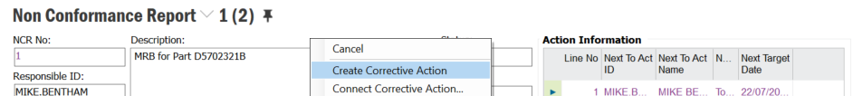

## CAPA Creation Data Mapping

Below shows the CAPA fields that require populating from the custom RMB. Some of these are mapped with data sources on the NCR, others are hardcoded inside the RMB event.

|  |  |  |  |
| --- | --- | --- | --- |
| CAPA Field  (Field on CAPA  Creation)  NCR_CORRECTIVE_ACTION | Source  NCR Field | Source  Logical Unit | CAPA Data Type  (Data Type on CAPA  Creation) |
|  |  |  |  |
| CAPA_NO | *Follow IFS logic and allow the CAPA to generate next CAPA No automatically* | | |
| NONCONFORMANCE_CODE | NONCONFORMANCE_CODE | NON_CONFORMANCE_REPORT | STRING(25)/UPPERCASE |
| SEVERITY_ID | SEVERITY_ID | NON_CONFORMANCE_REPORT | STRING(25)/UPPERCASE |
| RESPONSIBLE_PERSON_ID | RESPONSIBLE_PERSON_ID | NON_CONFORMANCE_REPORT | STRING(20)/UPPERCASE |
| TARGET_COMPLETION_DATE | TARGET_COMPLETION_DATE | NON_CONFORMANCE_REPORT | DATE/DATE |
| NCR_REFERENCE_DETAILS | NCR_REFERENCE_DETAILS | NON_CONFORMANCE_REPORT | STRING(20)/UPPERCASE |
| RAISED_BY | RAISED_BY | NON_CONFORMANCE_REPORT | STRING(20)/UPPERCASE |

## MRB & CAPA Object Connection

The final steps are to have the MRB, and associated Supplier added as objects to the created NCR and CAPA via the Connected To tab on the Non-Conformance Report and Corrective Action screens. The first Object needs to be the MRB Head and the MRB Case needs to be the MRB Case number that the RMB was actioned on. The second Object needs to be Supplier Info General, and the Supplier ID needs to be the item referenced in the NCR_REFERENCE_DETAILS field on either of the Logical Units NON_CONFORMANCE_REPORT or NCR_CORRECTIVE_ACTION.

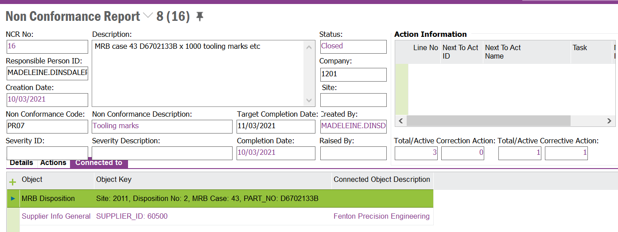

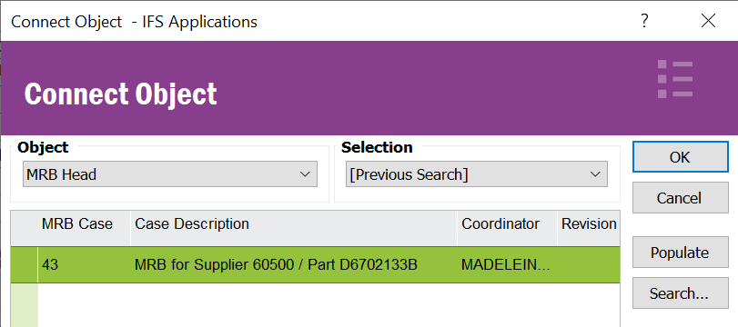

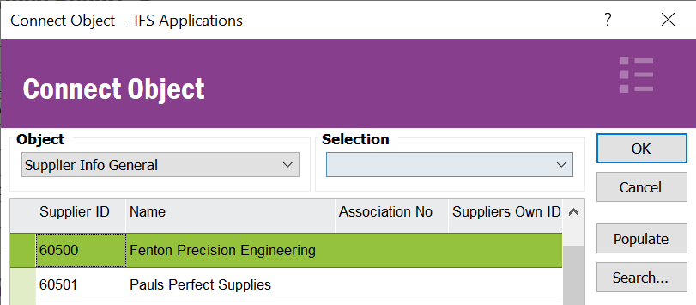

# Delimitations

The modification in this specification will be developed explicitly as written. Requests for changes in the modification necessary to fulfil (or prepare for future fulfilment of) any requirements not explicitly described in the specification, will be considered outside the scope of this modification.

Changes or extensions on Online Help (F1 Help) or e-learning material will not be included.

# Glossary/Acronyms

Commonly used IFS terms within this specification include:

|  |  |
| --- | --- |
| Term | Explanation |
| LOV | List of Values. This refers to a source list of records from which to select in a form. |
| RMB | Right Mouse Button. Commonly used abbreviation |
|  |  |

# Change log

Guidance: Delete section if no changes

## Change log for revision XX

Guidance: Describe why the change is needed (high level), and the sections of design affected by the changes. For lengthy specs, tag or mark the changed sections.

|  |  |  |
| --- | --- | --- |
| Change # | Chapter | Description of the change |
| 1 |  |  |
| 2 |  |  |
| 3 |  |  |
|  |  |  |
| n | 3.2 | <New column Z added to existing window> |

##### Detailed description of Change #1

##### Detailed description of Change #n

# Technical Details

The object connections should be defined as follows,

For LU SupplierInfoGeneral and MrbHead – NcrObjectConnection and CapaObjectConnection should be added as the service list.

# DELIVERY NOTES

**Package** - EA_SUPPLYCHAIN

**Permissions granted** – IFS_ALL

**Custom Menu - Create NCR and CAPA**

If the menu is not available in the window, RMB, custom Objects, Reload configurations.

**Custom Field – NCR created**

Note – In case the custom field is not available in the MRB Case Window, RMB, properties, layout and add the NCR created field.

