**Best Run (Epochs Up To 100):**

**Hyper Tuning Values:**

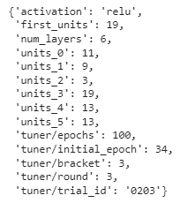

**Loss/Accuracy:**



**RMSE/R2:**



**Using Main Stats:**

**Hyper Tuning Values:**

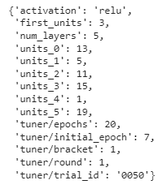

**Loss/Accuracy:**



**Using Main Stats with Year:**

**Hyper Tuning Values:**

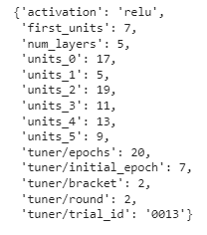

**Loss/Accuracy:**



**Using All Stats:**

**Hyper Tuning Values:**

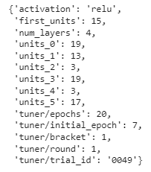

**Loss/Accuracy:**



**Comparison Table:**

|  |  |  |
| --- | --- | --- |
| **Stats Used** | **Loss (Mean Square Error)** | **Accuracy (Mean Absolute Error)** |
| **Main Stats** | 183.548 | 11.366 |
| **Main Stats + Year** | 117.787 | 8.318 |
| **All Stats** | 130.340 | 8.985 |