KNOWLEDGE MAP
Concept note | From disconnected documents to connected, source-grounded knowledge
1. Motivation: The problem, current scope/objectives
Books, PDFs and scanned documents hold valuable information across many pages and files. Search can find passages, but it cannot reliably identify key concepts, explain how ideas connect, or link related information across documents.
The goal is to organise these concepts and relationships without losing their connection to the original evidence. Otherwise, maps may contain duplicates, incorrect links or unsupported claims.
MOTIVATION, OBJECTIVES
Literature research
Methodology
Results
Conclusion, future scope, discussion
2. How we are thinking of solving it
Knowledge Map will extract and segment document content, identify and standardise concepts, discover relationships within and across documents, and store them with source references. Users can then explore a visual map, search, follow connections and ask questions grounded in their documents.
Every concept and relationship must link back to its supporting document, page and content. LLMs can assist with extraction, while validation and evidence checks help decide what enters the knowledge base.
3. Proposed processing architecture
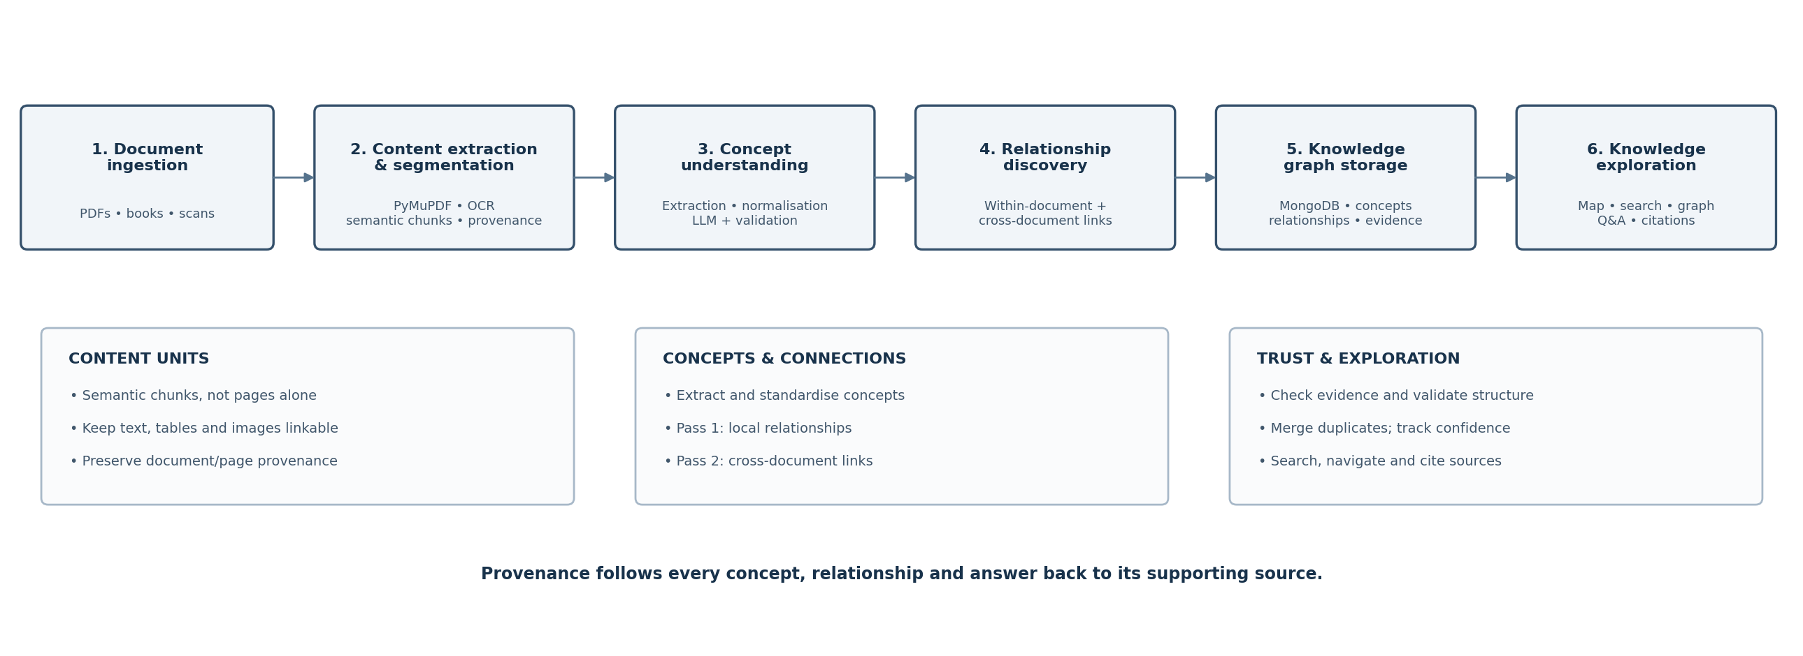
One connected workflow, with provenance and validation throughout.
4. Approaches and ideas we have learned
A. Semantic segmentation rather than page-only processing
Pages are useful source references, but not always meaningful knowledge units. We will create semantic chunks around coherent ideas while retaining page references. Text, tables, figures and images remain identifiable and linkable.
B. Two-pass concept and relationship discovery
- Pass 1 — within each document or semantic chunk, identify concepts and relationships with their local evidence.
- Pass 2 — compare concepts across documents, merge aliases and duplicates, and add evidence-supported connections.
Use labelled relationships such as defines, includes, prerequisite for and example of—not generic links.
C. LLM-assisted extraction with deterministic validation
LLMs can propose concepts and relationships, but their output needs schema checks, evidence validation, normalisation and duplicate detection before acceptance.
D. GraphRAG ideas: connect local facts to broader themes
GraphRAG extracts entities and relationships from text units, groups related entities into communities and uses these structures for broader questions. We can adopt source-linked units and higher-level groupings without copying its full infrastructure.
E. Retrieval without always generating an answer
Elastic demonstrates retrieval without generated answers: show relevant passages and citations directly. Knowledge Map can use this evidence-first approach, then call an LLM when explanation or synthesis is useful.
F. Hybrid retrieval and reranking
Combine BM25 keyword search with semantic embeddings: one finds exact terms, the other finds similar meaning. A cross-encoder reranker could improve the ordering of results; test this before adding extra infrastructure.
G. Local models and practical model selection
The CobbleAI paper is a useful reference for two-pass graph building, concept categories, embeddings and local LLMs. Treat these as ideas to evaluate, not a stack to copy. Test model quality and runtime on our hardware.
5. Desired product output
- Visual knowledge map: concepts appear as nodes and their labelled relationships as connecting edges.
- Cross-document connections: related ideas can be linked even when they appear in different books or files.
- Evidence-backed concepts: selecting a node or relationship reveals the supporting document, page and passage.
- Search by keyword or meaning, inspect passages and follow related concepts.
- Answers include source citations; if evidence is insufficient, the system should say so.
- Organise concepts as definitions, methods, entities, examples or prerequisites where the source supports it.
6. Storage and implementation direction
MongoDB will store document metadata, content units, concepts, relationships and evidence references. PDFs and image assets stay in file storage, with paths stored in MongoDB. Neo4j or a separate vector database can wait until there is a clear need.
Use embeddings for semantic search and text indexes for keyword search. Build and evaluate the concept-and-relationship pipeline first; choose models based on quality, runtime and hardware—not novelty.
7. How we will judge whether it works
Evaluate correctness using a small, manually checked set of chunks with expected concepts and relationships.
- Concept precision and recall: are concepts correct and complete?
- Relationship precision and recall: are links valid and supported?
- Duplicate handling: are aliases merged without combining different concepts?
- Evidence coverage: can each item be traced to its source?
- Retrieval quality: do passages support answers, and does the system abstain when needed?
A complete-looking graph is not proof of accuracy. Keep proposed links distinct from validated ones and flag unsupported relationships.
8. Guiding principle
Knowledge Map should reveal how ideas connect—and show the evidence behind each connection.
References informing the direction
- Microsoft GraphRAG — source-linked text units, entity and relationship extraction, community structure: https://microsoft.github.io/graphrag/
- Elastic, “RAG without ‘AG’?” — evidence-first retrieval without generated answers: https://www.elastic.co/search-labs/blog/rag-without-llms
- Chaudhari et al. (2026), “CobbleAI: Course-Grounded Adaptive Learning with Local LLM Inference, Retrieval-Augmented Generation and Automatically Constructed Knowledge Graphs” — two-pass graph construction and local-model experimentation: https://doi.org/10.20935/AcadAI8607

Possible New Approach:


