Visual Project Planning Document: Knowledge Map

Executive Summary & Overview
Knowledge Map is an AI-powered software application that transforms books, PDFs, scanned documents, images, diagrams, and notes into an interactive knowledge map. Status: Planning & Architectural Specification

Section A: Project at a Glance

1. The Problem We Are Solving
Professionals, researchers, and students accumulate thousands of scattered documents (PDFs, research books, lecture notes, scanned manuals, diagrams, and charts). Finding a specific idea requires manually searching through multiple folders or reading through long texts. Existing PDF readers only show static text, while standard AI chatbots give answers without verifying whether the source material actually contains the information, often leading to hallucinations.

2. Who Would Use This Product
- Software Engineers & System Architects: Managing technical RFCs, architecture diagrams, and system design specifications.
- Researchers & Students: Organizing academic papers, lecture notes, and textbook diagrams into interconnected topic clusters.
- Knowledge Workers & Consultants: Building searchable internal knowledge bases from messy company documents and contracts.

3. Why It Is Useful
Knowledge Map bridges the gap between raw file storage and human understanding. Instead of keeping documents in isolated silos, it automatically extracts text and visual layouts, discovers underlying concepts, connects related ideas, and allows users to converse directly with their document library with guaranteed source citations.

4. What Makes It Different from an Ordinary PDF Reader or Chatbot
- Interactive 3D-Style Knowledge Graph: Rather than flat file lists, concepts are mapped visually so users can explore how topics relate to one another.
- Cross-Modal Understanding: It does not just read text; it interprets images, diagrams, and charts by combining visual features with nearby contextual text (captions and headings).
- Strict Evidence Grounding (No Hallucinations): If uploaded documents do not contain enough information to answer a user's question, the system explicitly abstains rather than inventing an answer.

5. Concept Progression & Transformation Visual
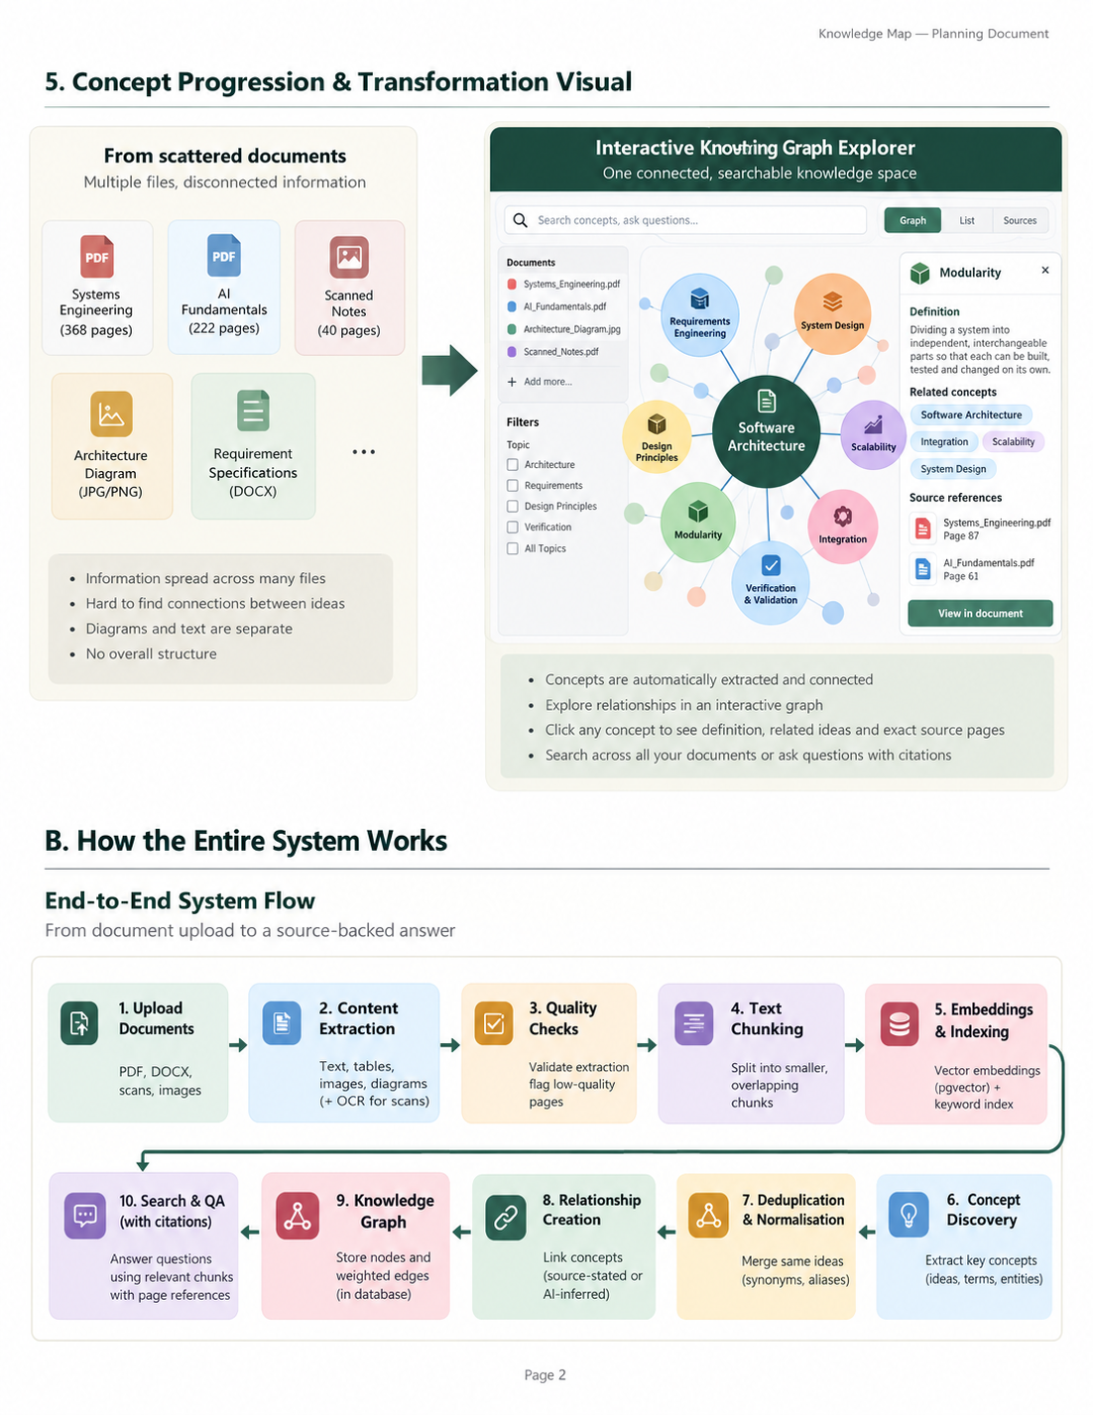

Section B: How the Entire System Works

End-to-End System Flowchart
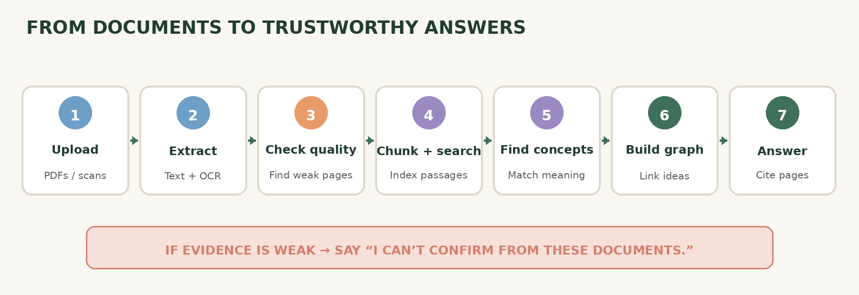

Stage-by-Stage Explanation
- Document Upload: Users upload PDFs, scanned books, DOCX files, or images into their secure workspace.
- Content Extraction: The text pipeline extracts raw text, paragraphs, tables, and headings. Scanned documents automatically route through Tesseract OCR.
- Quality Checks: The system validates extraction output, flagging low-confidence OCR passes or corrupted files for user review.
- Text Chunking: Clean text is split into overlapping chunks to preserve local sentence context.
- Embeddings & Indexing: Text chunks are converted into numerical vector embeddings via Sentence Transformers and stored in pgvector.
- Concept Discovery: AI identifies core entities, groups synonyms, and normalizes alternative names (e.g., matching "System Architecture" with "Software Architecture").
- Relationship Creation: The system links related concepts based on proximity and structural co-occurrence.
- Knowledge Graph Construction: Nodes (concepts) and edges (relationships) are indexed into the database.
- Search & Question Answering: Hybrid search combines exact keyword lookups with semantic vector matching.
- Source-Backed Results: The AI evaluates evidence sufficiency. If verified, it formulates an answer with page-level citations; if evidence is missing, it explicitly abstains.

Section D: Main Outputs of the System
Pipeline Stage | System Output Format | Example Data Item
1. Text Extraction | Structured JSON / Markdown | Page text blocks with bounding boxes and heading tags
2. Searchable Chunks | JSON / Vector Embeddings | {"chunk_id": "chk_091", "text": "Modularity separates functionality...", "page": 42}
3. Normalised Concepts | Entity Object | Canonical Name: Software Architecture (Aliases: System Architecture, Arch Design)
4. Relationships | Graph Edge Record | (Software Architecture) --[depends_on]--> (Modularity)
5. Knowledge Graph | Graph Database Records | Nodes and weighted edges renderable in React Flow
6. Search Results | Ranked JSON Array | Relevant passage snippets matched via hybrid search
7. Grounded Answers | Markdown + Citation Objects | Answer text paired with citations
8. Processing Report | Summary Audit Log | Success status, warning flags, and processing duration metrics

Section E: Important AI Logic Explained Simply
- Handling Synonyms: Two different phrases (e.g., "System Design Process" and "Architectural Design Methodology") can refer to the exact same concept. The system uses embedding similarity scores to group them under a single canonical concept node while storing alternative names as aliases.
- Preventing Over-Merging: Related concepts must not automatically merge into one. For instance, Verification and Validation are closely related software engineering practices, but merging them would destroy distinct definitions. The system enforces similarity thresholds before combining nodes.
- Source-Stated vs. AI-Inferred Relationships: Source-stated relationships are explicitly written in document text (e.g., "Modularity improves maintainability"). AI-inferred relationships are semantic links discovered by analyzing conceptual proximity across different chapters. The database clearly flags the provenance of every edge.
- Traceable Evidence: Every extracted concept and generated answer maintains a direct pointer (document ID, page number, and character offset) back to the original source text.
- Abstention Logic: If a user asks a question whose answers do not exist in the retrieved document chunks, the system's guardrail prompt detects insufficient context and outputs: "The uploaded documents do not contain enough information to answer this question reliably."
- Hybrid Search: Combines keyword search (exact matching for technical terms, class names, or error codes) with semantic search (finding ideas based on meaning rather than exact words).

Section F: The Stress-Test Plan

Stress Test Pyramid
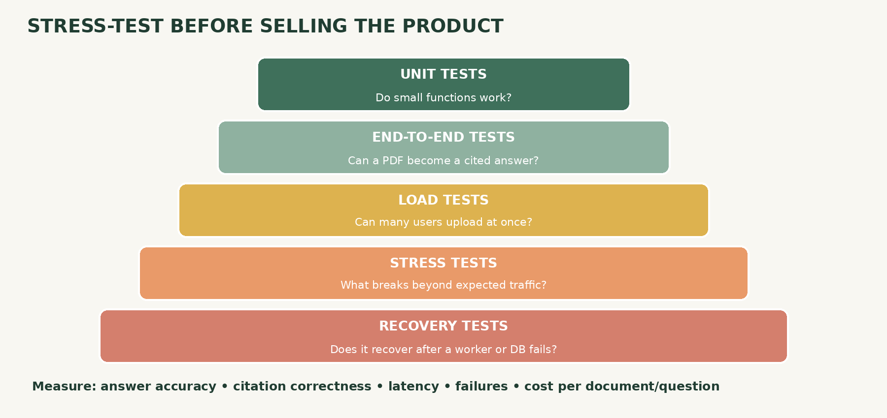

Stress Test Matrix
Test Area | What We Test | How We Test It | Success Target
Document Ingestion | Large 1,000+ page textbooks, corrupted PDFs, password-protected files. | Upload batch scripts feeding malformed files simultaneously. | Zero server crashes; graceful error messages for invalid files.
Extraction Quality | Multi-column layouts, complex tables, mathematical equations. | Process benchmark technical engineering books with known layouts. | >95% text reading accuracy; correct table formatting preservation.
Knowledge Quality | Duplicate concept generation, looping graph edges. | Inject highly repetitive documents with overlapping terminology. | Zero duplicate canonical nodes; clean hierarchical clustering.
Question Answering | Multi-document synthesis, adversarial questions with missing answers. | Automated evaluation harness testing 100 benchmark Q&A pairs. | 0% hallucinations; 100% abstention when source data is missing.
Performance | Concurrent user uploads, graph rendering speed under load. | Load testing tools (Locust / k6) simulating 100 active users. | API response time < 500ms for search; graph render < 2s.
Reliability | Background worker crashes, database connection drops. | Force-kill Celery worker nodes mid-task during heavy ingestion. | Automatic task retries via queue persistence without data corruption.
Security | Cross-tenant data leakage, malicious prompt injection inside PDFs. | Automated penetration testing scripts attempting unauthorized data access. | Zero unauthorized data access across user tenant boundaries.
Commercial Cost | Embedding API calls, vector search memory overhead, LLM token costs. | Cost tracking instrumentation per 1,000 processed pages. | Predictable unit economics ensuring positive SaaS margins.

Section G: Commercial SaaS Architecture & Transition

Hosted SaaS System Architecture
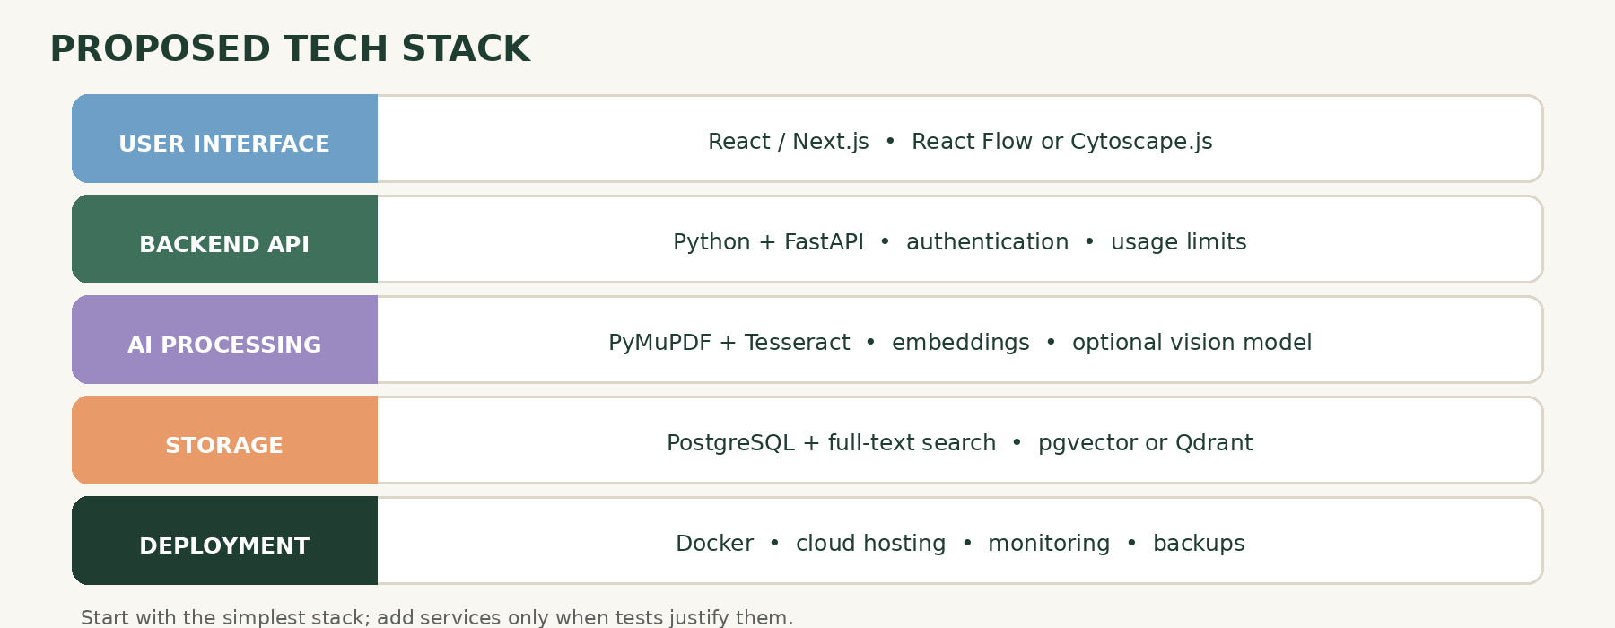

Technical Term | Simple Meaning | Relevance to Knowledge Map
Requirements Analysis | Understanding what the software must do before coding begins. | Defining user needs like PDF extraction, graph exploration, and grounded QA.
Functional & Non-Functional Requirements | Functional = what it does; Non-Functional = how well it performs (speed, security). | Functional: search documents. Non-Functional: search returns in under 500ms.
Feasibility Study & Proof of Concept | Testing if an idea is actually buildable with available technology. | Proving that PyMuPDF and Tesseract can successfully extract text from technical PDFs.
System Architecture | The high-level blueprint of how software components fit together. | Structuring the separation between React UI, FastAPI backend, vector DB, and worker queues.
Architecture Decision Records (ADRs) | Written logs explaining why specific technical choices were made. | Documenting why PostgreSQL + pgvector was chosen over dedicated graph DBs initially.
Data Modelling & API Contracts | Designing how data is stored and how frontend/backend communicate. | Defining JSON schemas for document chunks, concept nodes, and API response payloads.
Risk Analysis & Threat Modelling | Identifying what could go wrong and how to prevent it. | Mitigating risks like malicious prompt injections embedded inside uploaded PDFs.
Failure Mode and Effects Analysis (FMEA) | Systematically analyzing potential component failures and their impact. | Assessing what happens if the OCR worker crashes mid-book processing.
Performance & Capacity Planning | Calculating server and storage needs for anticipated user growth. | Estimating vector database memory requirements per 10,000 uploaded pages.
Test Strategy & Acceptance Criteria | Defining the exact conditions required to prove a feature is finished. | Ensuring 0% hallucination rate on verified test question sets.
Observability & Monitoring | Tracking system health and performance in real time. | Monitoring background worker queues, API error rates, and embedding latency.
CI/CD & Deployment Strategy | Automating testing and releasing code updates safely. | Using GitHub Actions to run unit tests and deploy Docker containers automatically.
Disaster Recovery | Procedures for restoring data after a catastrophic system crash. | Restoring PostgreSQL databases and S3 object storage from encrypted snapshots.
Technical Debt | Short-term code shortcuts that make future maintenance harder. | Recognizing when quick prototype code needs refactoring before commercial launch.
MVP & Product Roadmap | Minimum Viable Product: the simplest version that delivers user value. | Launching core extraction, graph view, and QA before adding advanced collaboration features.
Cost Analysis & Commercial Readiness | Evaluating operational expenses versus subscription revenue. | Calculating cloud GPU, LLM token, and storage costs per active paying user.

Phase | Main Tasks | Dependencies | Expected Deliverables | Verification Method | Estimated Effort | Main Risks
1. Document Extraction | Refine PyMuPDF/Tesseract extraction pipeline. | None | Extraction script with JSON output and error logs. | Manual audit of 10 complex PDF files. | 1.5 weeks | Poor OCR accuracy on scanned books.
2. Chunking & Semantic Search | Implement text chunking and pgvector embedding index. | Phase 1 | Working vector search API endpoint. | Precision/recall testing on search queries. | 2 weeks | Slow vector similarity search speeds.
3. Concept Extraction | Build entity extraction and synonym normalization logic. | Phase 2 | Concept extraction pipeline and alias tables. | Manual verification against reference texts. | 2.5 weeks | Duplicate nodes and noisy entity merging.
4. Knowledge Graph Construction | Construct graph node/edge storage and traversal queries. | Phase 3 | Relational graph database schema. | Graph traversal unit tests. | 2 weeks | Complex graph queries causing high latency.
5. Grounded QA | Build RAG pipeline with strict evidence checks and abstention. | Phase 4 | Question-answering endpoint with citations. | Automated Q&A test suite (0% hallucination target). | 2.5 weeks | LLM hallucinations or missing citations.
6. User Interface | Build React frontend with file upload, graph view, and chat. | Phase 5 | Responsive web dashboard prototype. | User workflow acceptance testing. | 3 weeks | Clunky graph rendering performance in browser.
7. SaaS Security & Billing | Add authentication, tenant isolation, and Stripe billing. | Phase 6 | Secure multi-tenant user workspace environment. | Security penetration and billing test sandbox. | 3 weeks | Security loopholes allowing cross-tenant access.
8. Stress Testing & Beta | Run load tests (Locust) and execute controlled beta. | Phase 7 | Stress test report and bug fix backlog. | Load test benchmarks passing target thresholds. | 2 weeks | Unforeseen server bottlenecks under heavy load.
9. Commercial Launch | Finalize cost controls, documentation, and go-live. | Phase 8 | Production-ready SaaS product. | Successful live commercial deployment. | 1.5 weeks | Higher-than-expected cloud operating costs.

