DOCUMENT-TO-KNOWLEDGE MAP
A simple concept and proposed workflow

The idea
Create a tool that can read books, PDFs, notes and scanned documents, understand the ideas in both text and images, connect concepts that mean the same thing or are related, and display them as an interactive knowledge map. Users can then ask questions and receive answers based on the uploaded material.
1. The initial idea
- Extract text from documents, including scanned pages.
- Use pre-trained AI models to recognise similar meanings, even when sentences use different words.
- Group related information and show how concepts connect.
- Let users ask questions about the collected knowledge.
2. How the idea developed
Text alone is not enough. Books also contain photos, diagrams, charts and illustrations that may explain an idea without containing any words. We therefore added a visual-understanding step and decided to use the text around an image—such as its caption, heading and nearby paragraphs—to help work out what the image means.
For example, two different photographs in a geography book may both show red soil. The tool should compare what is visible, read the surrounding text, and compare both with concepts already found in the book before deciding whether they belong to the same 'Red Soil' concept.

3. Proposed solution
The system processes documents in stages. Each stage has one clear job, and the information it extracts is kept with its original source so the result can be checked later.
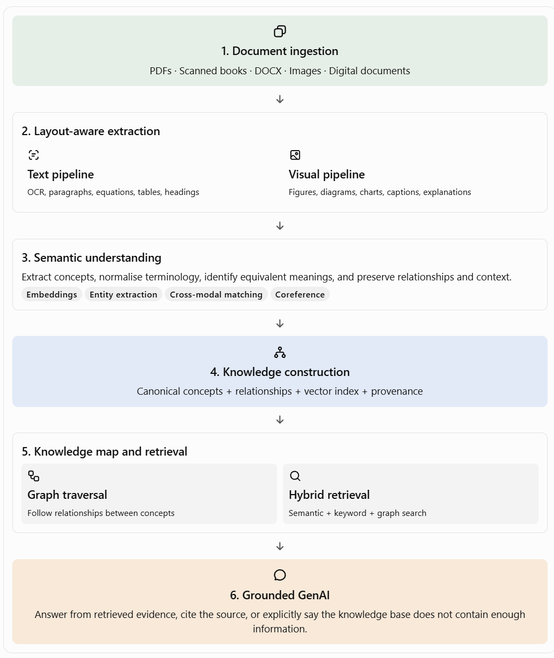
Overall workflow: from uploaded documents to a knowledge map and question-answering.

The main steps
1. Read the document: extract words, headings, tables and page details.
2. Understand the images: describe what each image shows and read any text inside it.
3. Use the surrounding context: check captions, headings and nearby pages to understand the image more accurately.
4. Find matching concepts: compare the text and images with concepts already collected.
5. Build the map: connect concepts that are the same or related, while keeping their original sources.
6. Answer questions: search the map and source material, then answer only when there is enough evidence.

4. How images will be understood
The tool will not rely on one image model alone. It will combine three clues:
- What the image looks like.
- What the book says near the image.
- What the system already knows from other pages or documents.
These clues help it decide whether two images refer to the same concept. If the evidence is unclear, it should leave the match uncertain instead of forcing the images into the same group.
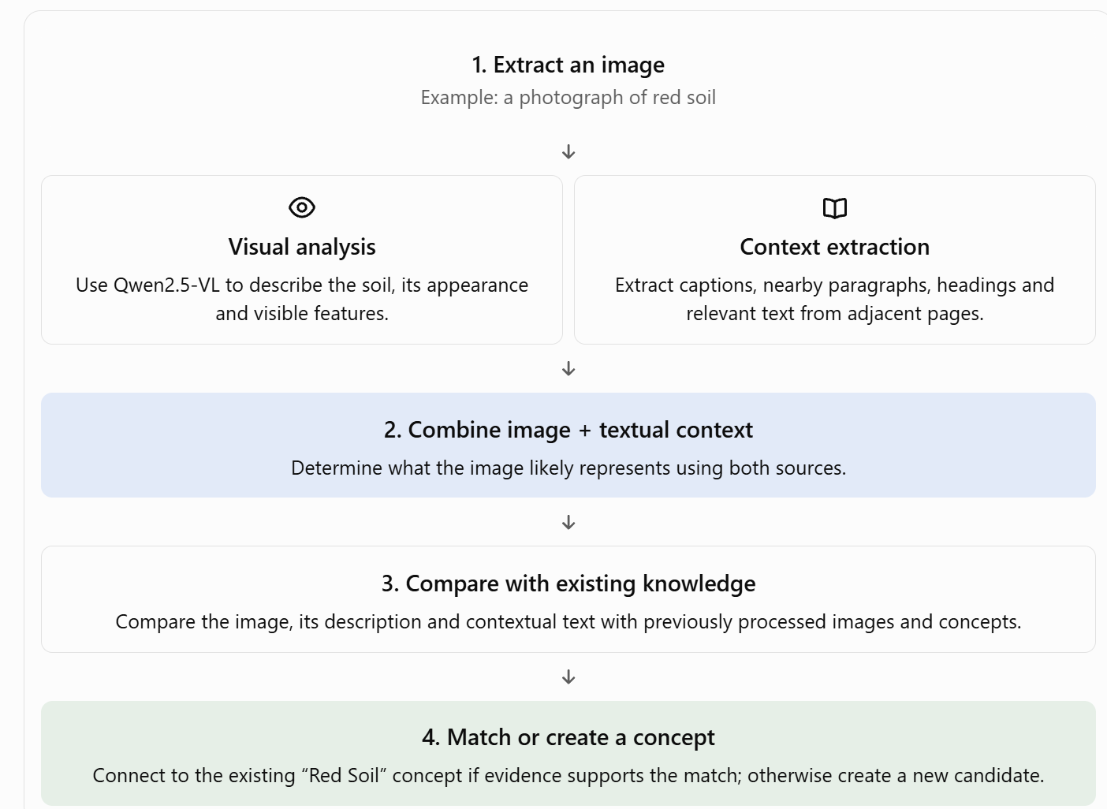
Image workflow: visual analysis and nearby text are considered together.

5. Making answers trustworthy
When a user asks a question, the tool first searches the uploaded material for relevant evidence. If it finds enough information, it answers and points to the source. If the documents do not contain enough information, it clearly says so instead of guessing.
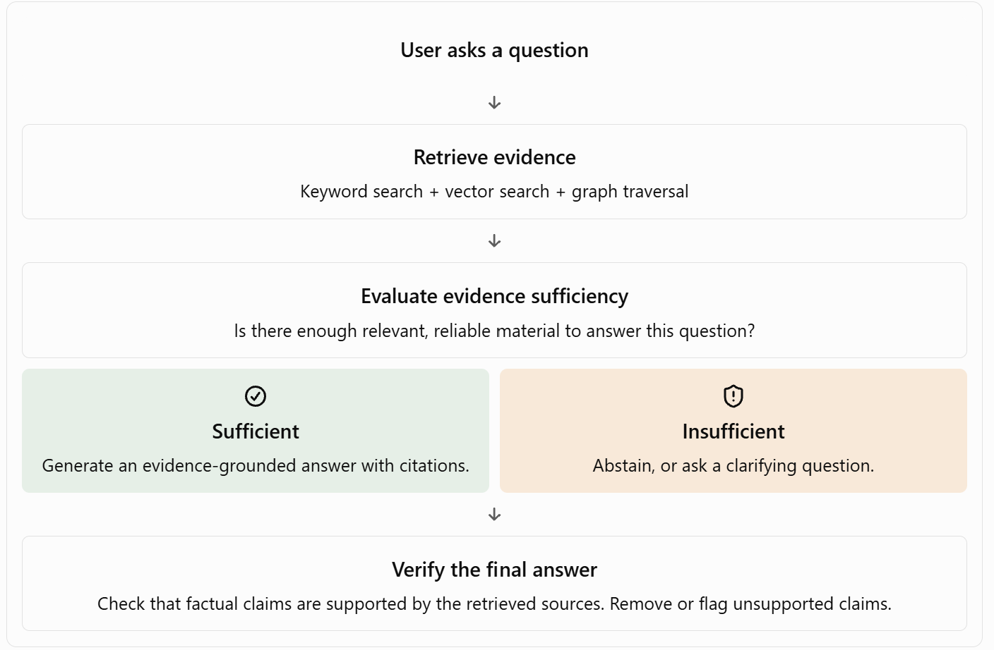
Answer workflow: check evidence first, then answer or explain that the information is missing.

6. Tools to explore
Tool | Simple purpose
Docling / OCR | Read document text, scanned pages and layout.
Qwen2.5-VL | Describe and interpret images, charts and diagrams.
Sentence Transformers | Find text passages with similar meanings.
HDBSCAN | Help group similar information.(clustering)
Neo4j | Store concepts and the links between them.
Obsidian | Display connected notes as a graph; useful for an early prototype.
RAG + an AI model | Answer questions using retrieved evidence from the documents.

.

