Parkinson's Tremor Analytics
A simple data analytics study of tremor patterns and their relationship with clinical motor severity

Project Type | Data Analytics
Dataset | UCI Machine Learning Repository – Dataset 392
Records Analyzed | 130 participants
Main Focus | Rest tremor, action/postural tremor, and UPDRS III
Tools | Python, Pandas, Matplotlib, Seaborn, SciPy

This report is written as an academic analytics project. It is not a medical diagnostic tool.

Abstract
This project looks at tremor-related measurements in a Parkinson's-related clinical dataset and uses simple data analytics to understand the patterns in the data. The analysis focuses on rest tremor, action or postural tremor, differences between body regions, and the relationship between tremor burden and the UPDRS III motor score.
The dataset contains 130 participants. After selecting the variables needed for this project, the data was cleaned and a few simple features were created, such as total rest tremor, total action tremor, upper-limb rest tremor, lower-limb rest tremor, and right-left rest tremor asymmetry.
The results show that the average action/postural tremor score was higher than the average rest-tremor score in the analyzed data. Upper-limb measurements were particularly noticeable, and both rest and action tremor showed a moderate positive relationship with UPDRS III. The correlations were 0.489 for rest tremor and 0.506 for action/postural tremor.

Introduction
Parkinson's disease can involve different types of motor symptoms, including tremor. Tremor does not necessarily appear in the same way or with the same intensity in every part of the body. Because of this, looking at individual tremor measurements can give more useful information than looking at one overall number.
The purpose of this project is not to build a complicated prediction system. Instead, the goal is to take the available clinical data, organize it, visualize it, and identify patterns that are easy to understand.

Problem Statement
The dataset contains several measurements related to tremor and motor function, but the raw values are not immediately easy to interpret. The project therefore focuses on turning these measurements into simple summaries and visualizations that can answer questions such as:
- Which tremor measurements show higher average scores?

- How do rest tremor and action/postural tremor compare?

- Which body regions show more noticeable tremor?

- Is tremor burden related to the overall UPDRS III motor score?

- Are there noticeable right-left differences in rest tremor?

Objectives
- Clean and organize the tremor-related data.

- Summarize the main tremor measurements.

- Create a few meaningful tremor features.

- Visualize tremor patterns by body region and tremor type.

- Study the relationship between tremor burden and UPDRS III.

- Present the results in simple, understandable language.

Dataset
The dataset used in this project is the UCI Machine Learning Repository dataset titled Early biomarkers of Parkinson’s disease based on natural connected speech (Dataset 392). The UCI page reports 130 instances and explains that the table contains demographic, clinical, and speech-related information. The participant code also encodes the clinical group in the original dataset.
For this project, only the variables needed for tremor analytics were selected. The analysis therefore does not attempt to use every feature in the original dataset.
Dataset source: UCI Machine Learning Repository, Dataset 392.

https://archive.ics.uci.edu/dataset/392/early+biomarkers+of+parkinson+s+disease+based+on+natural+connected+speech

Methodology

Data loading and cleaning
The CSV contains two header rows, so the second row was used as the actual variable header. Column names were cleaned to make them easier to work with in Python. Numeric variables were converted to numeric values, while participant and categorical information was kept in its original form.

Feature engineering
A small number of combined measures were created from the tremor variables. These included total rest tremor, total action/postural tremor, upper-limb rest tremor, lower-limb rest tremor, and right-left rest tremor asymmetry. These features make the analysis easier to interpret without introducing a complicated model.

Analysis
The analysis uses descriptive statistics, bar charts, a box plot, a scatter plot, and Spearman correlation. No machine-learning model is used because the purpose of this project is to understand the data rather than make a diagnostic prediction.

Dataset Overview

Measure | Result
Participants | 130
Selected variables in analysis | 17
Mean total rest tremor | 0.45
Median total rest tremor | 0.00
Mean total action tremor | 0.74
Median total action tremor | 0.00

Mean upper-limb rest tremor | 0.36
Mean lower-limb rest tremor | 0.12
Mean right-left rest asymmetry | 0.31

The output also shows 50 missing values in several clinical/tremor-related fields. These missing values are important and were retained rather than replaced with made-up values. They should be considered when interpreting the results.

Exploratory Data Analysis

Tremor score distribution
The tremor scores are concentrated around zero for many observations. A smaller number of participants have higher scores, which creates the visible outliers in the distribution plot. This means that the average alone does not tell the whole story; the spread of the values is also important.
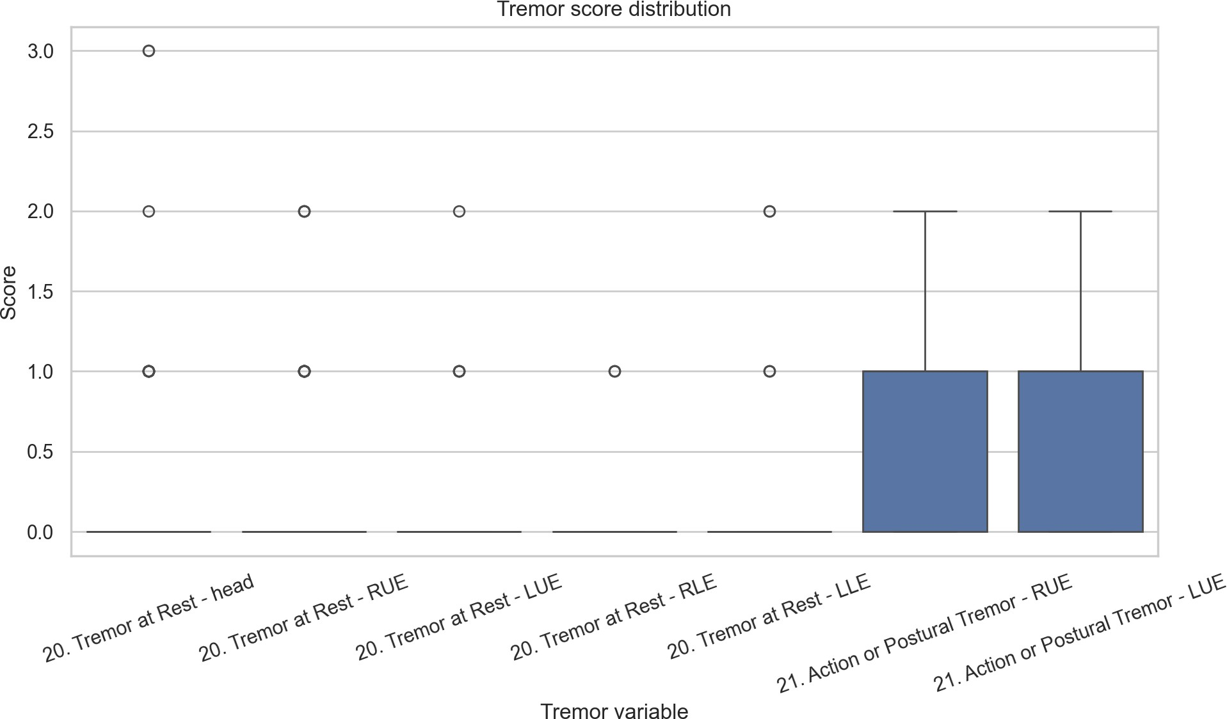

Mean tremor by body region
The body-region comparison shows that the upper limbs have the most noticeable tremor scores among the measured regions. The right and left upper limbs both show higher action/postural tremor values than their corresponding rest-tremor values. Lower-limb rest tremor is comparatively smaller in this analysis.
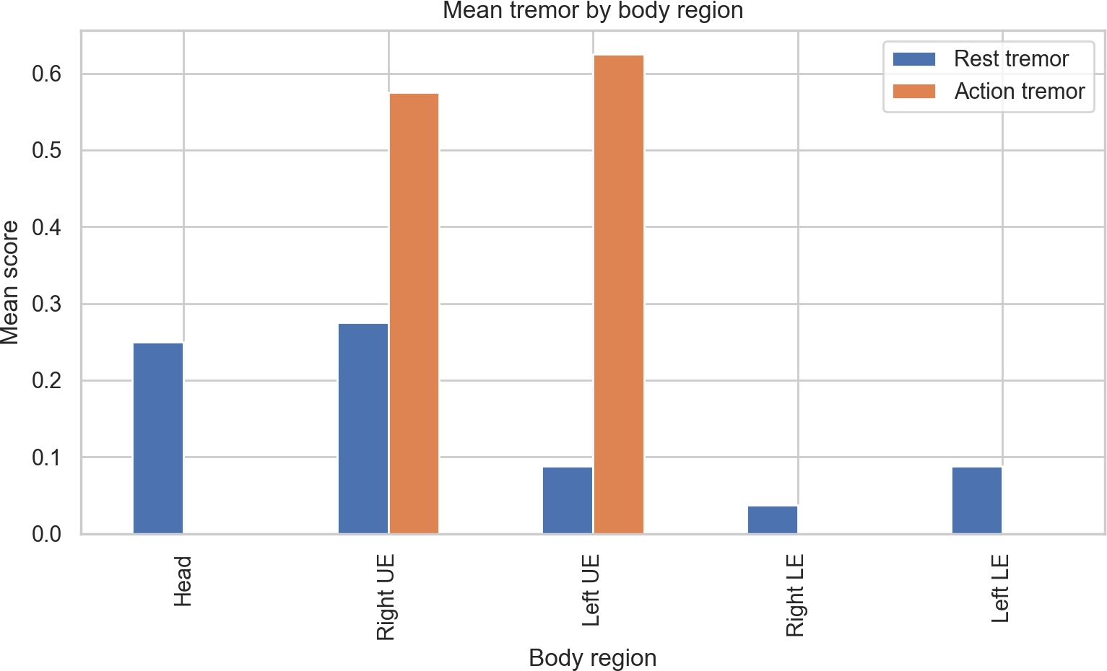

Rest tremor versus action/postural tremor
The comparison shows that the average action/postural tremor values are higher than the average rest-tremor values for the upper limbs. The mean total action tremor across the engineered measure is 0.74, compared with 0.45 for total rest tremor.
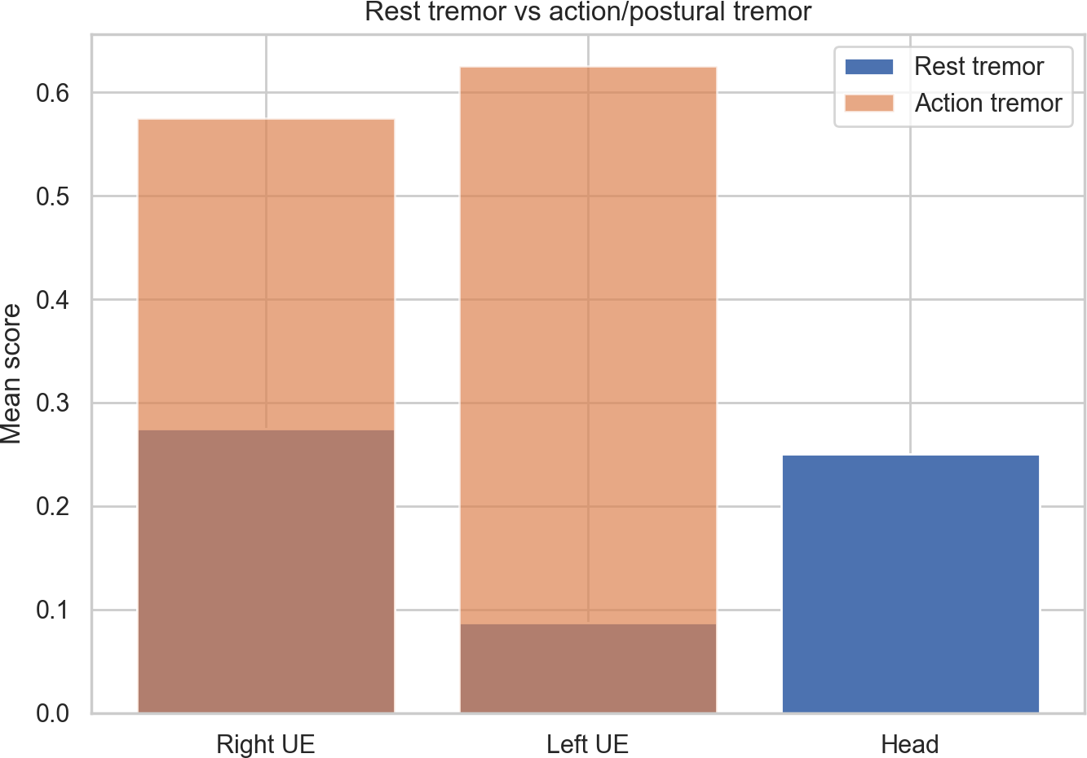

Tremor burden and UPDRS III
The scatter plot shows that higher tremor burden is generally associated with higher UPDRS III scores in the available observations. The relationship is not perfectly linear, so tremor alone does not explain all differences in motor severity.
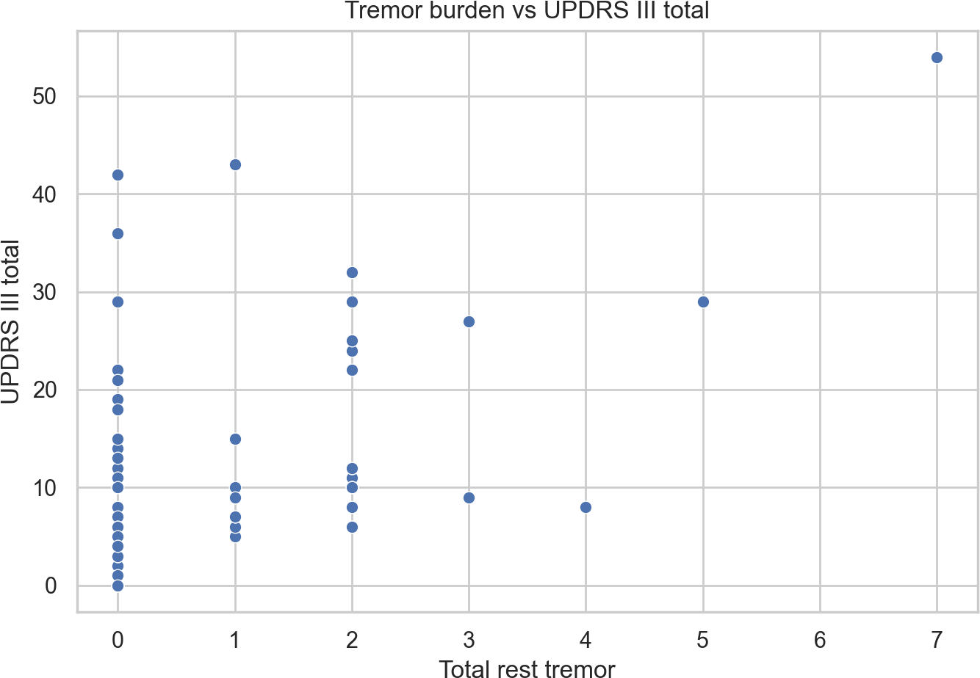

Correlation Analysis

Variables | Spearman correlation (ρ)
Total rest tremor vs UPDRS III | 0.489
Total action/postural tremor vs UPDRS III | 0.506
Both values are positive and are of moderate size. In simple terms, participants with higher tremor burden tended to have higher UPDRS III scores in the available data. The action/postural tremor relationship (0.506) was slightly stronger than the rest-tremor relationship (0.489). This is an association, not proof that one variable causes the other.

Key Findings
- Action/postural tremor had a higher average score than rest tremor in the analyzed data (0.74 versus 0.45).
- The upper limbs showed the most noticeable tremor measurements, particularly for action/postural tremor.
- Total action/postural tremor had a slightly stronger positive relationship with UPDRS III than total rest tremor (0.506 versus 0.489).

- The average right-left rest-tremor asymmetry was 0.31, showing that side-to-side differences are present in the cohort.
- Many observations have tremor scores of zero, while a smaller number have higher scores. This makes the distribution uneven and means that median and distribution should be considered alongside the mean.

Practical Insights
The main value of this analysis is that it makes the tremor information easier to read. Instead of looking at several separate columns, we can see overall rest tremor, action tremor, upper-limb involvement, and left-right differences.
For future analysis, collecting the same tremor measurements repeatedly over time could make it easier to study how an individual's tremor pattern changes. Adding more complete clinical records and a clearly documented comparison group would also allow more detailed analysis.

Limitations
- The analysis is based on a relatively small dataset of 130 participants.

- Several tremor and clinical variables contain missing values.

- The analysis describes associations within the available data and does not establish cause and effect.

- The project does not provide medical diagnosis or treatment advice.

- Only a subset of the original UCI variables was used for this project.

Conclusion
This project shows how a relatively small clinical dataset can be turned into useful and understandable information using basic data analytics. The analysis found noticeable upper-limb tremor activity, higher average action/postural tremor than rest tremor, and a moderate positive relationship between tremor burden and UPDRS III motor severity.
The project deliberately keeps the approach simple. Rather than adding a machine-learning model just for complexity, it focuses on understanding the available data and communicating the results clearly. This makes the project easier to reproduce and easier for a reader to understand.

References
UCI Machine Learning Repository, Dataset
392. DOI: 10.24432/C5W02Q.

UCI Machine Learning Repository: https://archive.ics.uci.edu/dataset/392/early+biomarkers+of+parkinson+s+disease+based+on+natural+connected+speech

