**NATIONAL INSTITUTE OF TECHNOLOGY RAIPUR**

**REPORT ON PRACTICAL TRAINING**

**SUBMITTED BY**

**K. RAGAJA(16118031)**

**T SAI PRIYANKA(16118078)**

**Introduction: -**

To meet with the pace of the competitive world, e-Procurement (electronic procurement) has developed as a progressive instrument in modern industrial sector. Our project entitled e-Procurement can be considered as the computerization of transactions of closeouts in material administration division of Vishakhapatnam Steel Plant to meet the quick handling of transactions in these Hi-tech days. This project incorporates all the provisions like client raising auctions online, supplier submitting his auctions online, Client being permitted to get to concerned information just inside a settled vacancy designated for recovering or controlling database.

**Project Description: -**

The basic function of a material management system is to check for the accessible merchandise in the store house and raise an auction in favour of producing the respective good with a set of financial, technical and other specifications which will be sent to the suppliers through a secure channel and receive their auctions in the same way. The best and idealistic one will be chosen and acknowledged.

A standout amongst the most regular activities performed by the plant user or the supplier is adding another account or updating the existing one. The client would regularly head out the distance to the plant for few information or to refresh the current would often travel all the way to the plant to request some data or to update the existing and passing on confidential data manually isn't anchor constantly. These services are now integrated in the e-procurement which will be done web based providing required security.

To guarantee that the user is ensured of high level security, the administrator provides every user with a unique set of username and password. The user is offered consent to change his password now and again. This guarantees us a high-level security. All services are accessible only on amend set of user name, phone.no and password.

The supplier can follow the technical specifications and other requirements on the auction goods, which frequently change time to time. The supplier can submit his bid amount only with in the predefined time bound and can change it as many times as he wishes with in that time. Once the dead line is crossed the latest auction will be finalized.

The consumer can analyze all the auctions submitted to him and select best and optimal one. He can check all the limitations given by individual departments and compare it with the auction to check its optimality. Once the auction is accepted, the reports will be shown.

**Benefits for the supplier:**

One of the points of interest the supplier has while utilizing this sort of facilities is that the supplier can submit or re-submit the auction at any time and at any place. This encourages the supplier to spare his opportunity and exertion and the supplier can be in contact with the industry more effectively. The high-level security will ensure the supplier about the confidentiality of his auction.

**Benefits to the firm:**

Not only benefits on behalf of the suppliers, there are also advantages to the firm like, saving their manual labour in matters like passing information to submit auctions, requesting to notice the modifications in the auction and passing the confidential data. Along these lines, introducing e-procurement services into the organization will expand the speed of the transactions.

**Brief Description of existing System:**

Purchase Department of VSP oversees procurement of any material. All the user departments of VSP offers solicitations to purchase department to procure material. Then Purchase Department sends enquiry / Invitation to Auction to enrolled Suppliers through post / courier. Suppliers then send their auctions against these enquiries. Purchase department compares and received auctions and places a PO.

**Brief Description of Proposed System:**

Proposed System computerizes all the activities right from generation of ITA to generation Acceptance to Auction (i.e. Purchase Order). A website will be designed, developed, deployed and maintained to serve this purpose. This system is a web-based application developed on three-tier architecture**.**

* Purchase department sends Enquiries / ITAs to various registered Suppliers by using this system.
* Suppliers, who receives ITA, can directly log in to system from anywhere in the world and participate in reverse auction.

* Purchase Department Users has log in to the system and generates Purchase Order / Acceptance to Auction to the successful bidder of the reverse auction.

This system implements two levels of application level security in addition to database level security as described below.

**Database Level Security:**

Database user-id and password is being maintained only the Project Manager, who is authorized by the top-level management. No other person can connect to the database directly. All the users of the system connect to the database through application only.

**Application Security:**

This security is categorized by login security. And by this all secured data is in safely placed. All the valid users are given access to use this system. In this level, System checks whether the user is authorized user or not.

**Advantages of Proposed System:**

* Since this process of raising ITA, Generating of Purchase order is done through online, the total time will be drastically reduced.
* Manual preparation of ITAs, which is a highly tedious and time taking process, is avoided.
* Tracking of any ITA is very easy.
* High level of data and application security is possible due to first level database security, two levels of application security.

**SYSTEM ANALYSIS**

**Problem Specification:**

In this e-procurement system we encounter with two different users namely

* Supplier user
* Admin user

**Supplier User:**

The only action is to submit the auction. He is the person who can raise the auction for generating ITA within the deadline.

**Admin User:**

He mainly performs two actions. One among that action is to raise the ITA with specifications from different types of portals. The other action is to accept or reject the auction submitted by the supplier.

Any user will have set of authenticated username and password. Using which we can get access to different services further. If the supplier already submitted the auction his current state can be verified which is whether accepted or rejected or still in process.

**Purpose:**

The objective of this document is to formalize the system requirement to develop a general model of e-procurement in the Material Department of Vizag Steel Plant.

To meet with pays of the world in the Industrial Sector, e-Procurement (Electronic-Procurement) has evolved as a revolutionary tool in the Industrial sector. Our Project entitled e-procurement can be considered as computerization of Auction Transactions to meet the fast processing of auction in these hi-tech days. The purpose of this computerized automation system is to increase the efficiency of online Industrial Transaction and report generation.

**Scope:**

This document is useful to system developers to understand the requirements of computerized automation system to deliver the quality of the software to any industrial system. The system is supposed to perform the online transactions of an industry. The user can access his data and get the services from any remote place. He can access or submit the corresponding data to perform an action with an authorized set of primary keys to a portal to which he/she is permitted.

**SYSTEM REQUIREMENT SPECIFICATIONS**

**User Requirements:**

* A user should have a valid account (user-id and password)
* While opening an account a valid set of user-id and password should submitted by the user. A user should access by the valid permission permitted.
* The supplier should submit the auction only within the time slot given to him/her.
* The user should specify all the required constraints to submit the auction while he is raising the auction.

**Functional Requirements:**

For the e-procurement system the function requirements are as follows:

**a)** Interface should be easier to understand and work with. The interface should guide through the server as

* + Raise the auction
  + Modify the auction
  + Generate the auction
  + Checking for the status
  + Database updates
  + Requesting for new entries
  + Reporting all the prior transactions

**b)** All the online transactions should be complete and consistent and so errors should occur even if the system crashes. A database can be used to perform and monitor the transactions which see that the transactions are done successfully even if the system crashes in the middle of the transaction.

**c)** All the suppliers/users are provided with a valid set of username and password which are confidential to authorized user.

**Hardware Requirements:**

PROCESSOR- Intel i3 or above

RAM- 2GB or above

HARD DISK- 500GB or above

MONITOR SCREEN- High color 16-bit & 800 x 600 resolutions.

**Software Requirements:**

OPERATING SYSTEM- Windows 7 or above

FRONT END- JSP platform with JavaScript

WEB SERVER (Client Side)- Default Browser

WEB SERVER (Server Side)- Apache Tomcat7.0

BACK END- MySQL version-5.6.17 and OracleXE-112

**DATABASE DESIGN**

1. /* SUPPLIERS TABLE */ Create table tblsupplier(

sup_id int(10) not null AUTO_INCREMENT, name varchar(30),

address varchar(100), phone int(30),

city varchar(30), state varchar(30), pin int(30),

email varchar(50), username varchar(30), password varchar(30),

primary key(sup_id, username));

1. /* ADMINISTRATOR USER TABLE */ Create table tbluser (

User_id varchar(30) primary key, Username varchar(30), Password varchar(30));

1. /* ITEMS TABLE */

Create table tblitem(

Item_no varchar(30) primary key, Item_desc varchar(100),

Unit int(10),

Tech_spec varchar(100), Unit_rate int(30), Qty_on_hand int(30), Remarks varchar(100));

1. /* INVITATION TO AUCTION (ITA) TABLE */ Create table tblita(

ita_no int (20) not null primary key,

ita_date date,

item_no int(30) references tblitem(item_no), item_desc varchar(100),

tech_spec varchar(100), qty_reqd int(30), est_rate int(30), dely_date date ra_start_date date ra_stop_date date remarks varchar(100));

1. /* REVERSE AUCTION (RA) TABLE */ Create table tblra (

ra_sl_no int(30) not null AUTO_INCREMENT, ita_no int(30) references tblita(ita_no),

item_no varchar(30) references tblitem(item_no), username varchar(30) references tblsupplier(username), qty_reqd int(30),

dely_date date, est_rate int(30), qty_quoted int(30), rate_quoted int(30), ra_start_date date, ra_stop_date date, applied date,

primary key(ra_sl_no));

1. /* PURCHASE ORDER (PO) TABLE */ Create table tblpo(

po_no int(20) not null AUTO_INCREMENT, po_date date

item_no varchar(30) references tblitem(item_no), username varchar(30) references tblsupplier(username), qty_ordered int(20),

dely_date date unit_rate int(20),

ra_sl_no int(20) references tblra(ra_sl_no), ita_no int(30) references tblita(ita_no));

**INPUT & OUTPUT SCREENS**

HOME PAGE

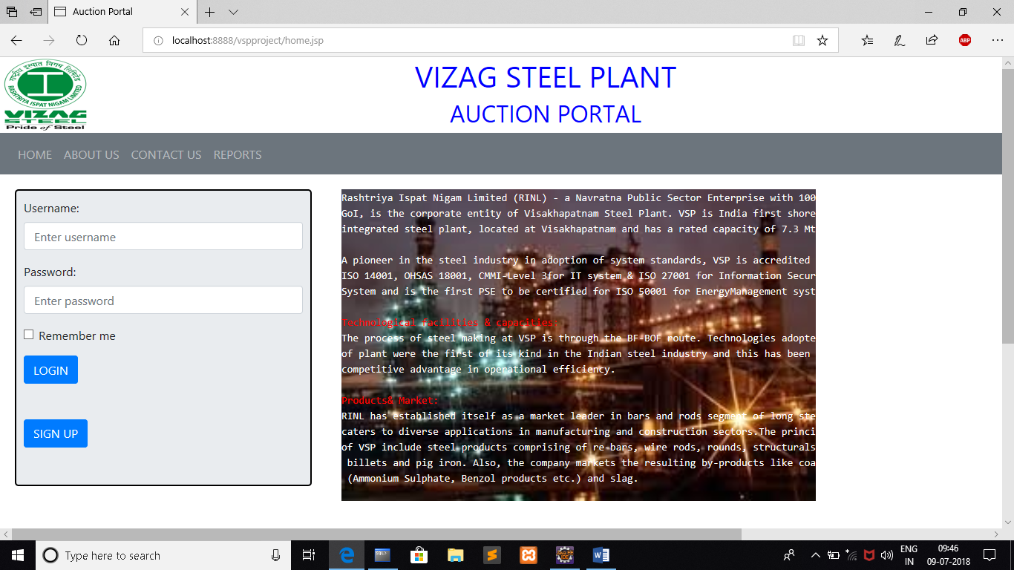

SUPPLIER’S ITEM LIST

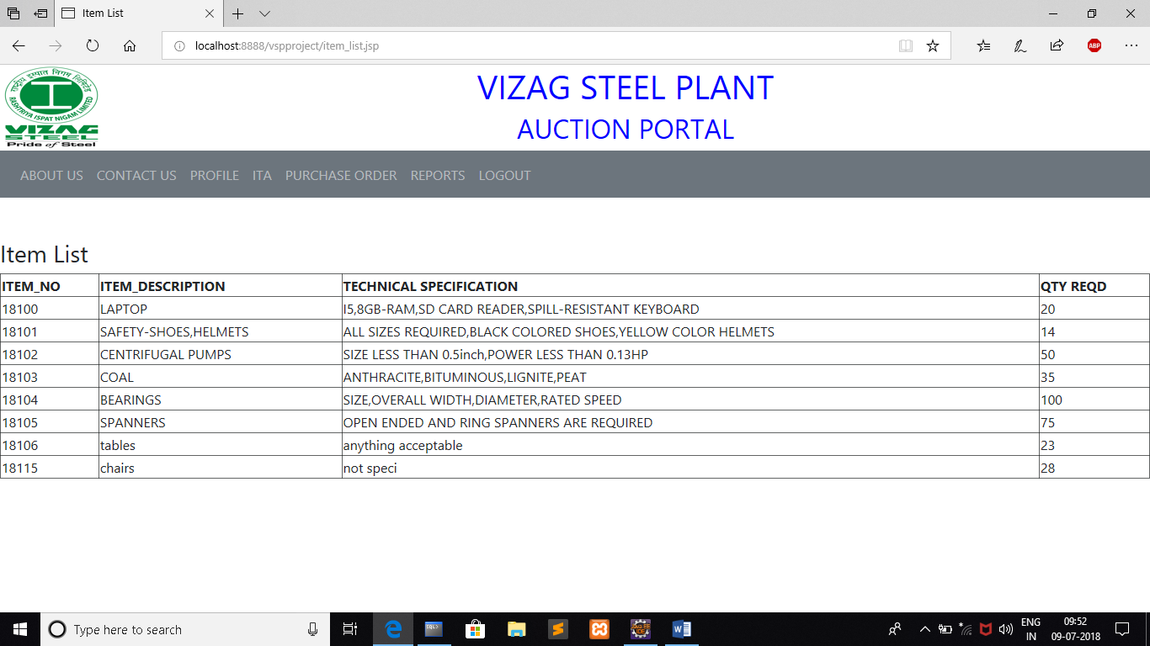

SUPPLIER’S SIDE -ITA LIST

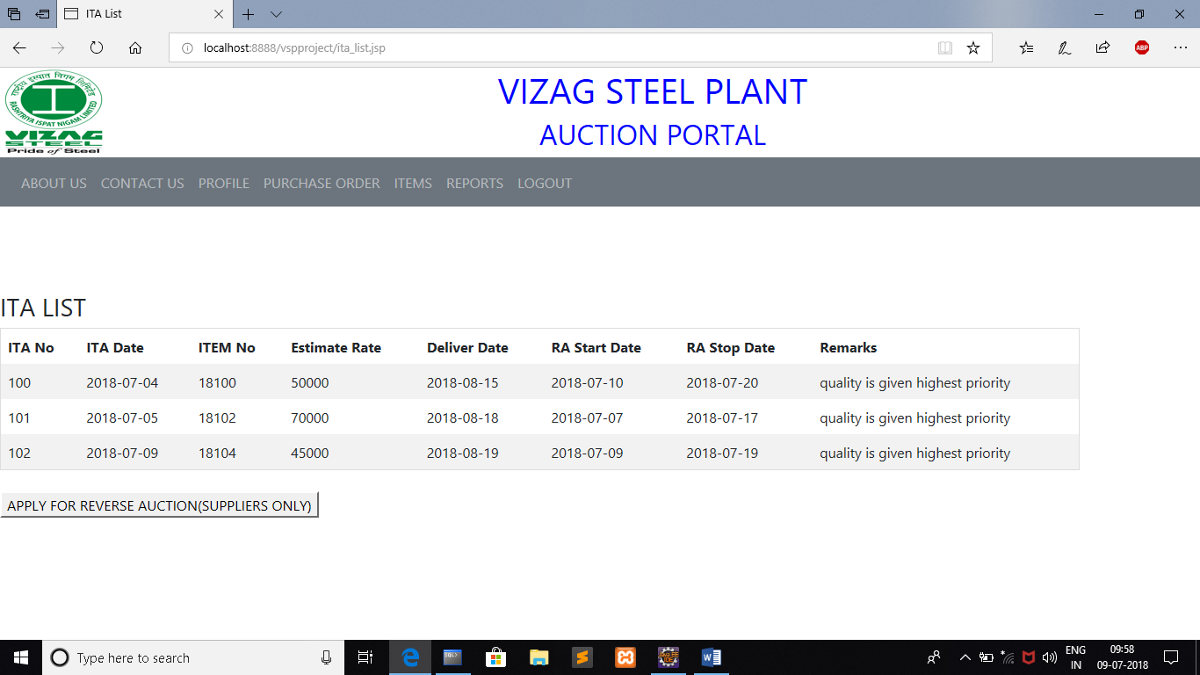

REVERSE AUCTION FORM

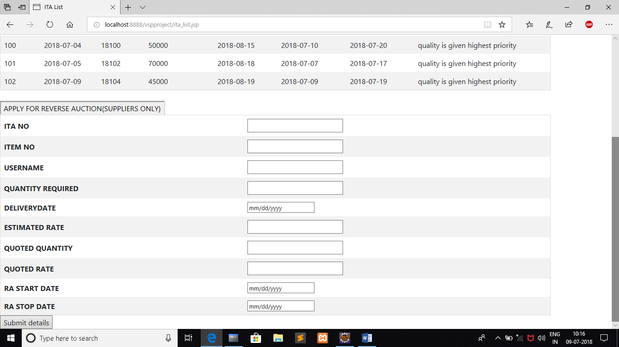

PURCHASE ORDER FORM

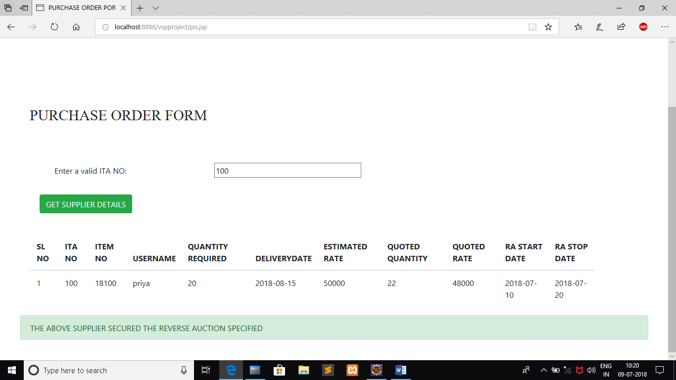

USER’S SIDE ITEM LIST

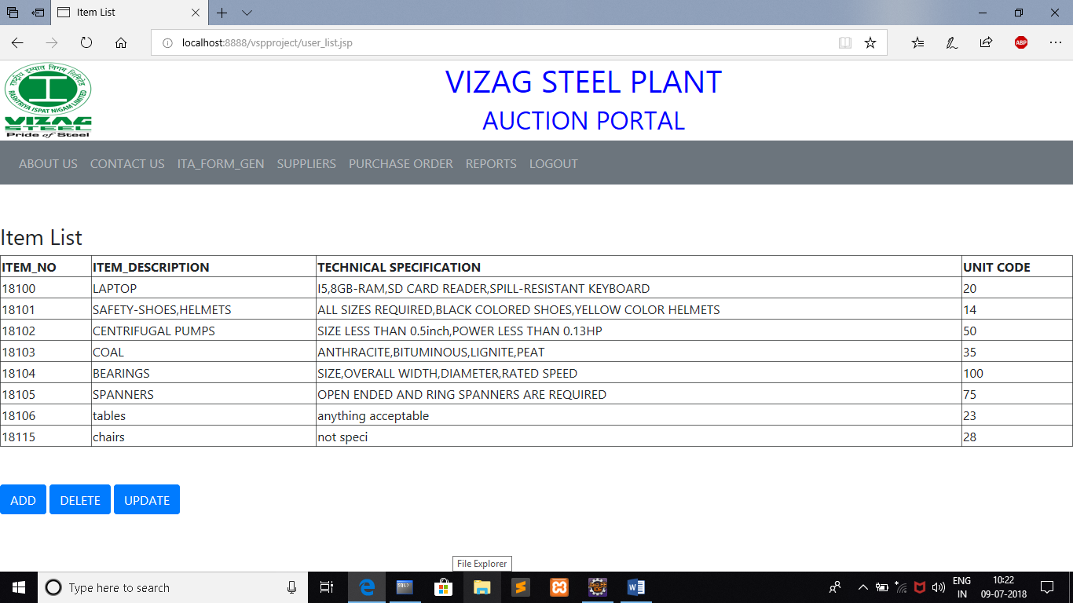

ITA GENERATION FORM

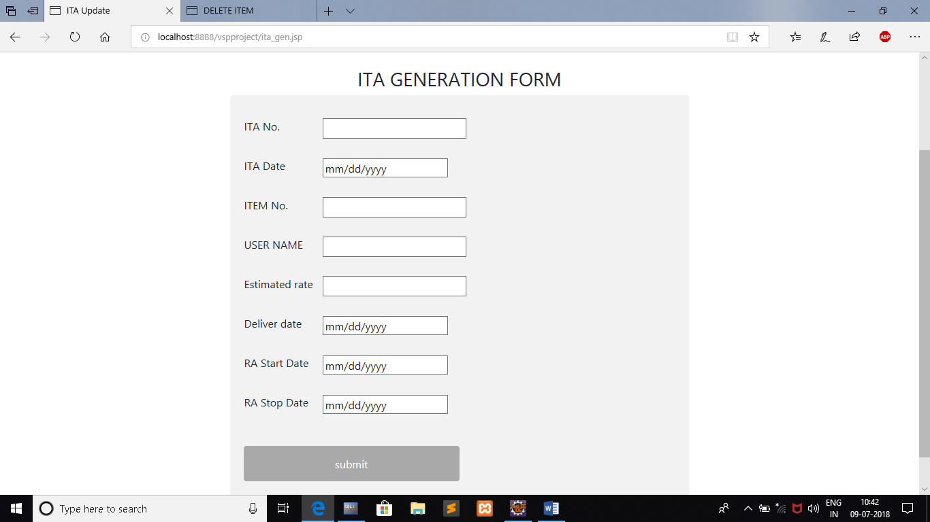

PURCHASE ORDER FORM FOR BUYERS

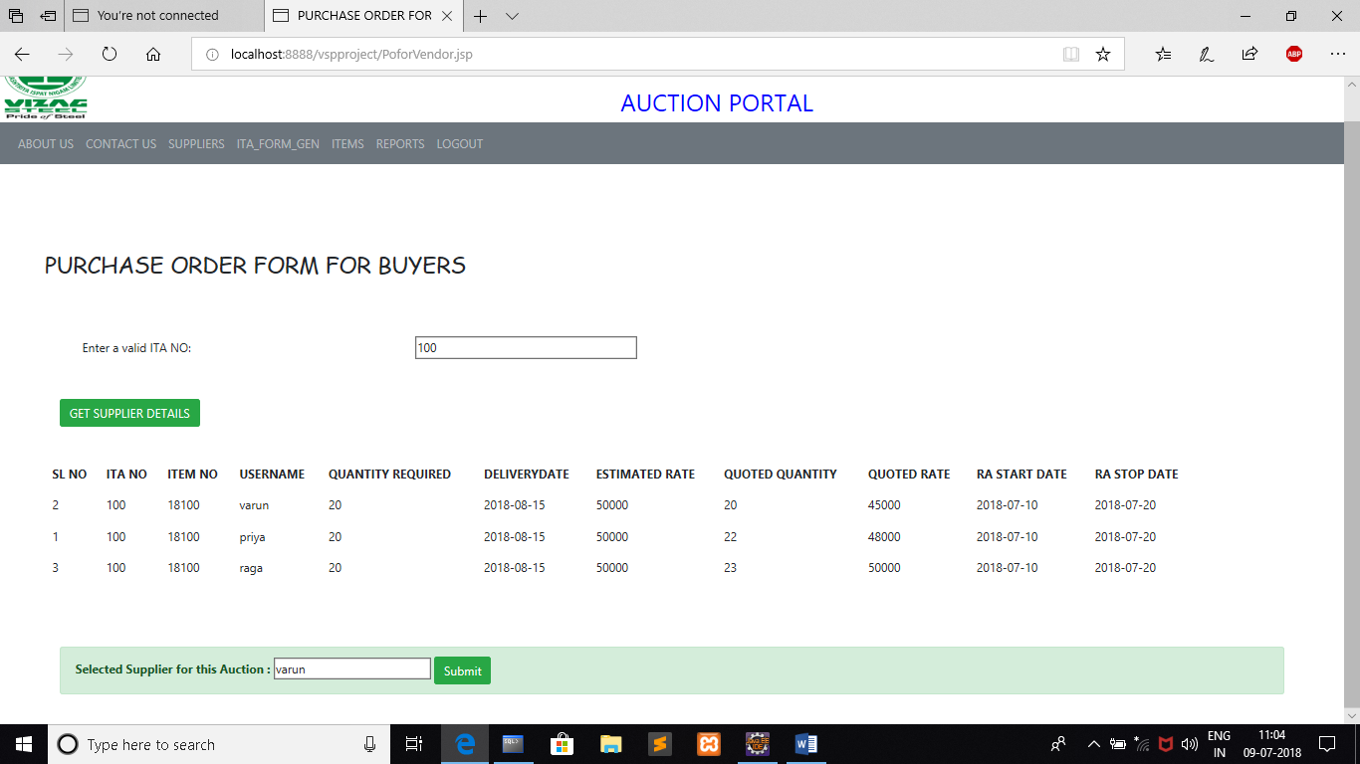

**CONCLUSION**

The project e-procurement was successfully concluded by meeting the requirements specified by the software requirements document. After careful verification and validation procedures, it has been affirmed that the system satisfies its user and system requirements.

The e-procurement can be enhanced by adding functions like,

* Use more sophisticated security mechanisms rather than user-id and password.
* Give more functionality to the administrator.
* Include the whole firm’s information.

With the emergence of new technologies, it is also possible to implement the same features in more efficient manner. This project has been successfully tested and can be implemented under any platform.

**BIBLIOGRAPHY**

**REFERENCES:**

* **JAVA EE complete reference by Herbert Schildt**
* **www.begineersbook.com**
* **www.tutorialspoint.com**
* **www.mysql.com**
* **www.w3schools.com**