Basic information about the network:

Number of nodes: 34

Number of edges: 78

Graph density: 0.13903743315508021

Is connected: True

Diameter: 5

Average shortest path length: 2.408199643493761

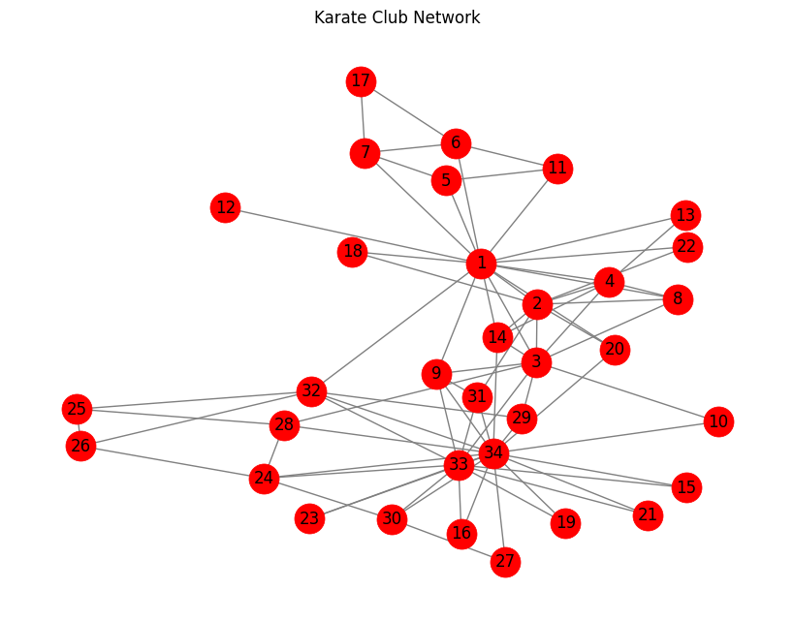

Metadata of actors in the network:

{'1': {}, '2': {}, '3': {}, '4': {}, '5': {}, '6': {}, '7': {}, '8': {}, '9': {}, '10': {}, '11': {}, '12': {}, '13': {}, '14': {}, '15': {}, '16': {}, '17': {}, '18': {}, '19': {}, '20': {}, '21': {}, '22': {}, '23': {}, '24': {}, '25': {}, '26': {}, '27': {}, '28': {}, '29': {}, '30': {}, '31': {}, '32': {}, '33': {}, '34': {}}

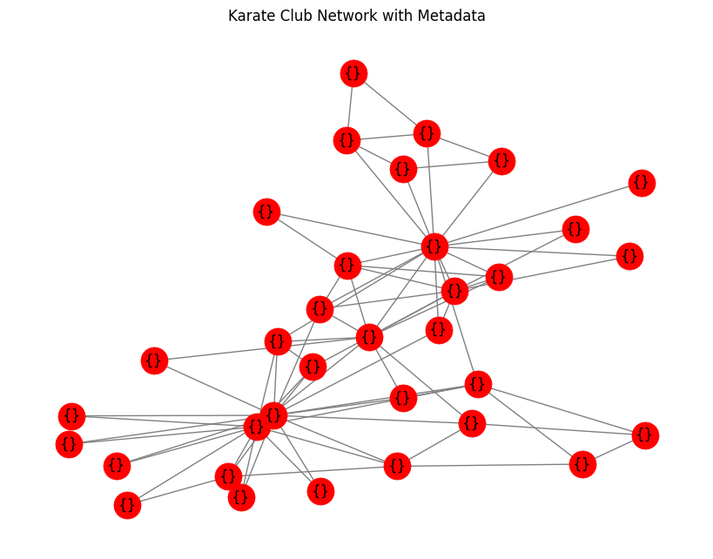

Centrality measures:

Degree Centrality: {'1': 0.48484848484848486, '2': 0.2727272727272727, '3': 0.30303030303030304, '4': 0.18181818181818182, '5': 0.09090909090909091, '6': 0.12121212121212122, '7': 0.12121212121212122, '8': 0.12121212121212122, '9': 0.15151515151515152, '10': 0.06060606060606061, '11': 0.09090909090909091, '12': 0.030303030303030304, '13': 0.06060606060606061, '14': 0.15151515151515152, '15': 0.06060606060606061, '16': 0.06060606060606061, '17': 0.06060606060606061, '18': 0.06060606060606061, '19': 0.06060606060606061, '20': 0.09090909090909091, '21': 0.06060606060606061, '22': 0.06060606060606061, '23': 0.06060606060606061, '24': 0.15151515151515152, '25': 0.09090909090909091, '26': 0.09090909090909091, '27': 0.06060606060606061, '28': 0.12121212121212122, '29': 0.09090909090909091, '30': 0.12121212121212122, '31': 0.12121212121212122, '32': 0.18181818181818182, '33': 0.36363636363636365, '34': 0.5151515151515151}

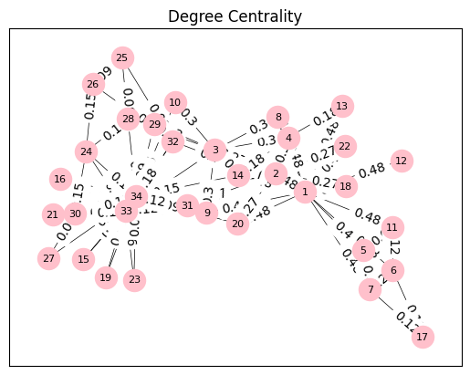

Centrality measures:

Betweenness Centrality: {'1': 0.43763528138528146, '2': 0.053936688311688304, '3': 0.14365680615680618, '4': 0.011909271284271283, '5': 0.0006313131313131313, '6': 0.02998737373737374, '7': 0.029987373737373736, '8': 0.0, '9': 0.05592682780182781, '10': 0.0008477633477633478, '11': 0.0006313131313131313, '12': 0.0, '13': 0.0, '14': 0.04586339586339586, '15': 0.0, '16': 0.0, '17': 0.0, '18': 0.0, '19': 0.0, '20': 0.03247504810004811, '21': 0.0, '22': 0.0, '23': 0.0, '24': 0.017613636363636363, '25': 0.0022095959595959595, '26': 0.0038404882154882154, '27': 0.0, '28': 0.02233345358345358, '29': 0.0017947330447330447, '30': 0.0029220779220779218, '31': 0.014411976911976909, '32': 0.13827561327561325, '33': 0.145247113997114, '34': 0.30407497594997596}

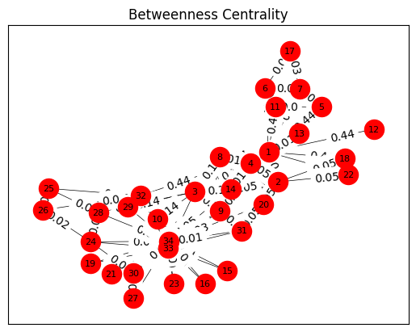

Centrality measures:

Closeness Centrality: {'1': 0.5689655172413793, '2': 0.4852941176470588, '3': 0.559322033898305, '4': 0.4647887323943662, '5': 0.3793103448275862, '6': 0.38372093023255816, '7': 0.38372093023255816, '8': 0.44, '9': 0.515625, '10': 0.4342105263157895, '11': 0.3793103448275862, '12': 0.36666666666666664, '13': 0.3707865168539326, '14': 0.515625, '15': 0.3707865168539326, '16': 0.3707865168539326, '17': 0.28448275862068967, '18': 0.375, '19': 0.3707865168539326, '20': 0.5, '21': 0.3707865168539326, '22': 0.375, '23': 0.3707865168539326, '24': 0.39285714285714285, '25': 0.375, '26': 0.375, '27': 0.3626373626373626, '28': 0.4583333333333333, '29': 0.4520547945205479, '30': 0.38372093023255816, '31': 0.4583333333333333, '32': 0.5409836065573771, '33': 0.515625, '34': 0.55}

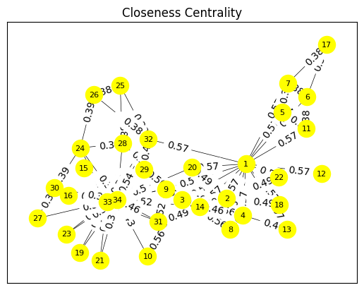

Centrality measures:

Eigenvector Centrality: {'1': 0.3554834941851943, '2': 0.2659538704545025, '3': 0.3171893899684447, '4': 0.21117407832057059, '5': 0.0759664588165738, '6': 0.07948057788594245, '7': 0.07948057788594245, '8': 0.17095511498035434, '9': 0.2274050914716605, '10': 0.10267519030637756, '11': 0.0759664588165738, '12': 0.052854169452336466, '13': 0.08425192086558085, '14': 0.22646969838808145, '15': 0.10140627846270832, '16': 0.10140627846270832, '17': 0.02363479426059687, '18': 0.09239675666845952, '19': 0.10140627846270832, '20': 0.14791134007618664, '21': 0.10140627846270832, '22': 0.09239675666845952, '23': 0.10140627846270832, '24': 0.15012328691726784, '25': 0.05705373563802805, '26': 0.059208202502790096, '27': 0.07558192219009324, '28': 0.13347932684333305, '29': 0.13107925627221215, '30': 0.13496528673866567, '31': 0.17476027834493085, '32': 0.191036269797917, '33': 0.30865104773369595, '34': 0.373371213013235}

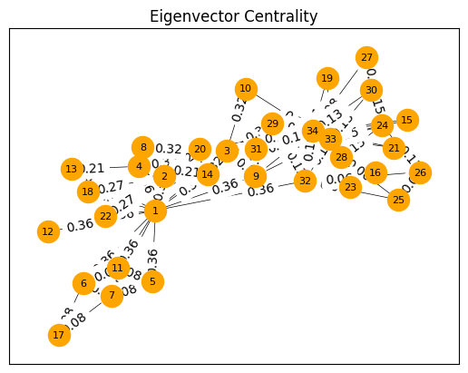

Centrality measures:

Pagerank Centrality: {'1': 0.09700181758983706, '2': 0.052878391037427, '3': 0.05707842304763673, '4': 0.035860643223064786, '5': 0.021979406974834498, '6': 0.02911334166344221, '7': 0.029113341663442205, '8': 0.02449075803950918, '9': 0.029765339186167028, '10': 0.014308950284462798, '11': 0.021979406974834494, '12': 0.009564916863537146, '13': 0.014645186487916188, '14': 0.02953631497720298, '15': 0.014535161524273824, '16': 0.014535161524273824, '17': 0.016785378110253487, '18': 0.01455885977424349, '19': 0.014535161524273824, '20': 0.01960441671193729, '21': 0.014535161524273824, '22': 0.01455885977424349, '23': 0.014535161524273824, '24': 0.03152091531163227, '25': 0.021075455001162945, '26': 0.02100562817474579, '27': 0.015043395360629753, '28': 0.025638803528350497, '29': 0.019572960509438537, '30': 0.026287262837112076, '31': 0.024589336534292478, '32': 0.037156635922679405, '33': 0.07169213006588289, '34': 0.1009179167487121}

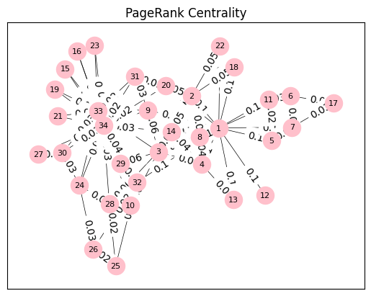

Possible k-components of the network: {4: [{'3', '31', '8', '34', '14', '2', '4', '1', '33', '9'}], 3: [{'3', '25', '31', '29', '14', '30', '20', '24', '28', '2', '33', '9', '32', '8', '34', '26', '4', '1'}, {'1', '6', '7', '5', '11'}], 2: [{'1', '22', '23', '3', '25', '31', '29', '14', '13', '10', '30', '18', '20', '24', '28', '33', '9', '32', '21', '27', '16', '8', '34', '26', '4', '15', '2', '19'}, {'1', '6', '7', '5', '11', '17'}], 1: [{'22', '23', '6', '7', '12', '3', '25', '29', '14', '10', '13', '2', '18', '30', '11', '4', '19', '5', '31', '20', '28', '24', '33', '9', '32', '21', '27', '16', '17', '8', '34', '26', '15', '1'}]}

Clustering Coefficient: 0.5706384782076823

Communities using Girvan-Newman algorithm: [({'1', '22', '6', '7', '5', '12', '11', '8', '18', '17', '14', '13', '20', '4', '2'}, {'23', '3', '25', '29', '10', '30', '19', '31', '24', '28', '33', '9', '32', '21', '27', '16', '34', '26', '15'}), ({'1', '22', '6', '7', '5', '12', '11', '8', '18', '17', '14', '13', '20', '4', '2'}, {'24', '32', '23', '3', '21', '25', '31', '16', '19', '27', '29', '34', '30', '26', '28', '15', '33', '9'}, {'10'}), ({'1', '22', '12', '8', '18', '14', '13', '20', '4', '2'}, {'24', '32', '23', '3', '21', '25', '31', '16', '19', '27', '29', '34', '30', '26', '28', '15', '33', '9'}, {'6', '7', '5', '17', '11'}, {'10'}), ({'1', '22', '12', '8', '18', '14', '13', '20', '4', '2'}, {'32', '3', '25', '29', '26', '28'}, {'6', '7', '5', '17', '11'}, {'23', '21', '27', '31', '16', '19', '34', '30', '24', '15', '33', '9'}, {'10'}), ({'1', '22', '8', '18', '14', '13', '20', '4', '2'}, {'32', '3', '25', '29', '26', '28'}, {'6', '7', '5', '17', '11'}, {'23', '21', '27', '31', '16', '19', '34', '30', '24', '15', '33', '9'}, {'10'}, {'12'}), ({'1', '22', '8', '18', '14', '13', '20', '4', '2'}, {'32', '3', '25', '29', '26', '28'}, {'6', '7', '5', '17', '11'}, {'23', '21', '31', '16', '19', '34', '30', '24', '15', '33', '9'}, {'10'}, {'12'}, {'27'}), ({'1', '22', '8', '18', '14', '20', '4', '2'}, {'32', '3', '25', '29', '26', '28'}, {'6', '7', '5', '17', '11'}, {'23', '21', '31', '16', '19', '34', '30', '24', '15', '33', '9'}, {'10'}, {'12'}, {'13'}, {'27'}), ({'1', '22', '8', '18', '14', '20', '4', '2'}, {'32', '3', '25', '29', '26', '28'}, {'6', '7', '5', '17', '11'}, {'23', '21', '16', '31', '19', '34', '30', '24', '33', '9'}, {'10'}, {'12'}, {'13'}, {'15'}, {'27'}), ({'1', '22', '8', '18', '14', '20', '4', '2'}, {'32', '3', '25', '29', '26', '28'}, {'6', '7', '5', '17', '11'}, {'23', '21', '31', '34', '33', '30', '24', '19', '9'}, {'10'}, {'12'}, {'13'}, {'15'}, {'16'}, {'27'}), ({'1', '22', '8', '18', '14', '20', '4', '2'}, {'3', '28', '29'}, {'6', '7', '5', '17', '11'}, {'23', '21', '31', '34', '33', '30', '24', '19', '9'}, {'10'}, {'12'}, {'13'}, {'15'}, {'16'}, {'26', '25', '32'}, {'27'}), ({'1', '22', '8', '18', '14', '20', '4', '2'}, {'3', '28', '29'}, {'6', '7', '5', '17', '11'}, {'23', '21', '31', '34', '30', '24', '33', '9'}, {'10'}, {'12'}, {'13'}, {'15'}, {'16'}, {'19'}, {'26', '25', '32'}, {'27'}), ({'1', '22', '8', '14', '20', '4', '2'}, {'3', '28', '29'}, {'6', '7', '5', '17', '11'}, {'23', '21', '31', '34', '30', '24', '33', '9'}, {'10'}, {'12'}, {'13'}, {'15'}, {'16'}, {'18'}, {'19'}, {'26', '25', '32'}, {'27'}), ({'1', '22', '8', '14', '20', '4', '2'}, {'3', '28', '29'}, {'6', '7', '5', '17', '11'}, {'23', '31', '34', '30', '24', '33', '9'}, {'10'}, {'12'}, {'13'}, {'15'}, {'16'}, {'18'}, {'19'}, {'21'}, {'26', '25', '32'}, {'27'}), ({'1', '22', '8', '14', '4', '2'}, {'3', '28', '29'}, {'6', '7', '5', '17', '11'}, {'23', '31', '34', '30', '24', '33', '9'}, {'10'}, {'12'}, {'13'}, {'15'}, {'16'}, {'18'}, {'19'}, {'20'}, {'21'}, {'26', '25', '32'}, {'27'}), ({'1', '22', '8', '14', '4', '2'}, {'3', '28', '29'}, {'11', '5'}, {'17', '6', '7'}, {'23', '31', '34', '30', '24', '33', '9'}, {'10'}, {'12'}, {'13'}, {'15'}, {'16'}, {'18'}, {'19'}, {'20'}, {'21'}, {'26', '25', '32'}, {'27'}), ({'1', '22', '8', '14', '4', '2'}, {'3', '28', '29'}, {'11', '5'}, {'17', '6', '7'}, {'31', '34', '30', '24', '33', '9'}, {'10'}, {'12'}, {'13'}, {'15'}, {'16'}, {'18'}, {'19'}, {'20'}, {'21'}, {'23'}, {'26', '25', '32'}, {'27'}), ({'1', '8', '14', '4', '2'}, {'3', '28', '29'}, {'11', '5'}, {'17', '6', '7'}, {'31', '34', '30', '24', '33', '9'}, {'10'}, {'12'}, {'13'}, {'15'}, {'16'}, {'18'}, {'19'}, {'20'}, {'21'}, {'22'}, {'23'}, {'26', '25', '32'}, {'27'}), ({'1', '8', '14', '4', '2'}, {'3', '29'}, {'11', '5'}, {'17', '6', '7'}, {'31', '34', '30', '24', '33', '9'}, {'10'}, {'12'}, {'13'}, {'15'}, {'16'}, {'18'}, {'19'}, {'20'}, {'21'}, {'22'}, {'23'}, {'26', '25', '32'}, {'27'}, {'28'}), ({'1', '8', '14', '4', '2'}, {'3', '29'}, {'11', '5'}, {'17', '6', '7'}, {'9'}, {'10'}, {'12'}, {'13'}, {'15'}, {'16'}, {'18'}, {'19'}, {'20'}, {'21'}, {'22'}, {'23'}, {'31', '34', '30', '24', '33'}, {'26', '25', '32'}, {'27'}, {'28'}), ({'1', '8', '14', '4', '2'}, {'3', '29'}, {'11', '5'}, {'17', '6', '7'}, {'9'}, {'10'}, {'12'}, {'13'}, {'15'}, {'16'}, {'18'}, {'19'}, {'20'}, {'21'}, {'22'}, {'23'}, {'30', '34', '24', '33'}, {'26', '25', '32'}, {'27'}, {'28'}, {'31'}), ({'2', '4', '1', '14'}, {'3', '29'}, {'11', '5'}, {'17', '6', '7'}, {'8'}, {'9'}, {'10'}, {'12'}, {'13'}, {'15'}, {'16'}, {'18'}, {'19'}, {'20'}, {'21'}, {'22'}, {'23'}, {'30', '34', '24', '33'}, {'26', '25', '32'}, {'27'}, {'28'}, {'31'}), ({'1'}, {'4', '2', '14'}, {'3', '29'}, {'11', '5'}, {'17', '6', '7'}, {'8'}, {'9'}, {'10'}, {'12'}, {'13'}, {'15'}, {'16'}, {'18'}, {'19'}, {'20'}, {'21'}, {'22'}, {'23'}, {'30', '34', '24', '33'}, {'26', '25', '32'}, {'27'}, {'28'}, {'31'}), ({'1'}, {'2'}, {'3', '29'}, {'4', '14'}, {'11', '5'}, {'17', '6', '7'}, {'8'}, {'9'}, {'10'}, {'12'}, {'13'}, {'15'}, {'16'}, {'18'}, {'19'}, {'20'}, {'21'}, {'22'}, {'23'}, {'30', '34', '24', '33'}, {'26', '25', '32'}, {'27'}, {'28'}, {'31'}), ({'1'}, {'2'}, {'3'}, {'4', '14'}, {'11', '5'}, {'17', '6', '7'}, {'8'}, {'9'}, {'10'}, {'12'}, {'13'}, {'15'}, {'16'}, {'18'}, {'19'}, {'20'}, {'21'}, {'22'}, {'23'}, {'30', '34', '24', '33'}, {'26', '25', '32'}, {'27'}, {'28'}, {'29'}, {'31'}), ({'1'}, {'2'}, {'3'}, {'4'}, {'11', '5'}, {'17', '6', '7'}, {'8'}, {'9'}, {'10'}, {'12'}, {'13'}, {'14'}, {'15'}, {'16'}, {'18'}, {'19'}, {'20'}, {'21'}, {'22'}, {'23'}, {'30', '34', '24', '33'}, {'26', '25', '32'}, {'27'}, {'28'}, {'29'}, {'31'}), ({'1'}, {'2'}, {'3'}, {'4'}, {'5'}, {'17', '6', '7'}, {'8'}, {'9'}, {'10'}, {'11'}, {'12'}, {'13'}, {'14'}, {'15'}, {'16'}, {'18'}, {'19'}, {'20'}, {'21'}, {'22'}, {'23'}, {'30', '34', '24', '33'}, {'26', '25', '32'}, {'27'}, {'28'}, {'29'}, {'31'}), ({'1'}, {'2'}, {'3'}, {'4'}, {'5'}, {'6'}, {'17', '7'}, {'8'}, {'9'}, {'10'}, {'11'}, {'12'}, {'13'}, {'14'}, {'15'}, {'16'}, {'18'}, {'19'}, {'20'}, {'21'}, {'22'}, {'23'}, {'30', '34', '24', '33'}, {'26', '25', '32'}, {'27'}, {'28'}, {'29'}, {'31'}), ({'1'}, {'2'}, {'3'}, {'4'}, {'5'}, {'6'}, {'7'}, {'8'}, {'9'}, {'10'}, {'11'}, {'12'}, {'13'}, {'14'}, {'15'}, {'16'}, {'17'}, {'18'}, {'19'}, {'20'}, {'21'}, {'22'}, {'23'}, {'30', '34', '24', '33'}, {'26', '25', '32'}, {'27'}, {'28'}, {'29'}, {'31'}), ({'1'}, {'2'}, {'3'}, {'4'}, {'5'}, {'6'}, {'7'}, {'8'}, {'9'}, {'10'}, {'11'}, {'12'}, {'13'}, {'14'}, {'15'}, {'16'}, {'17'}, {'18'}, {'19'}, {'20'}, {'21'}, {'22'}, {'23'}, {'24'}, {'26', '25', '32'}, {'27'}, {'28'}, {'29'}, {'30', '34', '33'}, {'31'}), ({'1'}, {'2'}, {'3'}, {'4'}, {'5'}, {'6'}, {'7'}, {'8'}, {'9'}, {'10'}, {'11'}, {'12'}, {'13'}, {'14'}, {'15'}, {'16'}, {'17'}, {'18'}, {'19'}, {'20'}, {'21'}, {'22'}, {'23'}, {'24'}, {'25'}, {'26', '32'}, {'27'}, {'28'}, {'29'}, {'30', '34', '33'}, {'31'}), ({'1'}, {'2'}, {'3'}, {'4'}, {'5'}, {'6'}, {'7'}, {'8'}, {'9'}, {'10'}, {'11'}, {'12'}, {'13'}, {'14'}, {'15'}, {'16'}, {'17'}, {'18'}, {'19'}, {'20'}, {'21'}, {'22'}, {'23'}, {'24'}, {'25'}, {'26'}, {'27'}, {'28'}, {'29'}, {'30', '34', '33'}, {'31'}, {'32'}), ({'1'}, {'2'}, {'3'}, {'4'}, {'5'}, {'6'}, {'7'}, {'8'}, {'9'}, {'10'}, {'11'}, {'12'}, {'13'}, {'14'}, {'15'}, {'16'}, {'17'}, {'18'}, {'19'}, {'20'}, {'21'}, {'22'}, {'23'}, {'24'}, {'25'}, {'26'}, {'27'}, {'28'}, {'29'}, {'30'}, {'31'}, {'32'}, {'34', '33'}), ({'1'}, {'2'}, {'3'}, {'4'}, {'5'}, {'6'}, {'7'}, {'8'}, {'9'}, {'10'}, {'11'}, {'12'}, {'13'}, {'14'}, {'15'}, {'16'}, {'17'}, {'18'}, {'19'}, {'20'}, {'21'}, {'22'}, {'23'}, {'24'}, {'25'}, {'26'}, {'27'}, {'28'}, {'29'}, {'30'}, {'31'}, {'32'}, {'33'}, {'34'})]

Communities using Louvain method: [frozenset({'23', '25', '31', '29', '30', '28', '24', '33', '9', '32', '21', '27', '16', '34', '26', '15', '19'}), frozenset({'22', '3', '13', '8', '14', '4', '10', '18', '2'}), frozenset({'6', '7', '5', '12', '17', '11', '20', '1'})]