**GIT GROUP ASSIGNMENT**

**GROUP – 4**

**TOPIC – CHECKOUT**



**Submitted to :- Submitted by :-**

**Mr. Sonu Mehrotra Prince Agrahari**

**Soumya Bhushan**

**Riya Kumari**

**Aditya Sahu**

**Gaurav Gupta**

**OPTIONS -**

1) By using the "--track" parameter, you can use a remote branch as the basis for a new local branch; this will also set up a "tracking relationship" between the two:

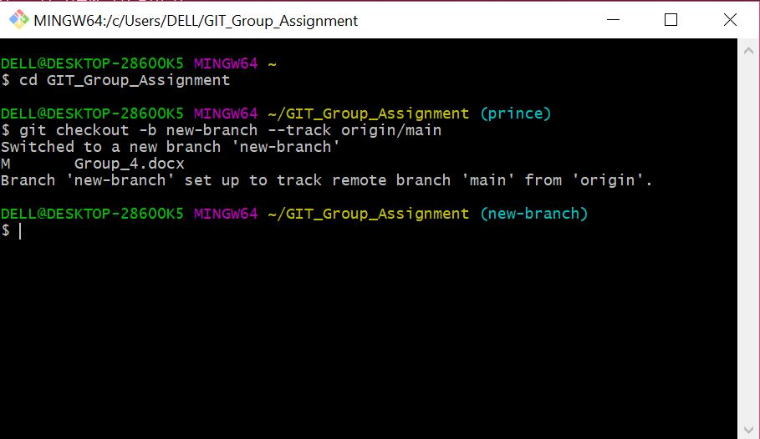

2) The below command you can used for fetching all the branches from the remote repository.

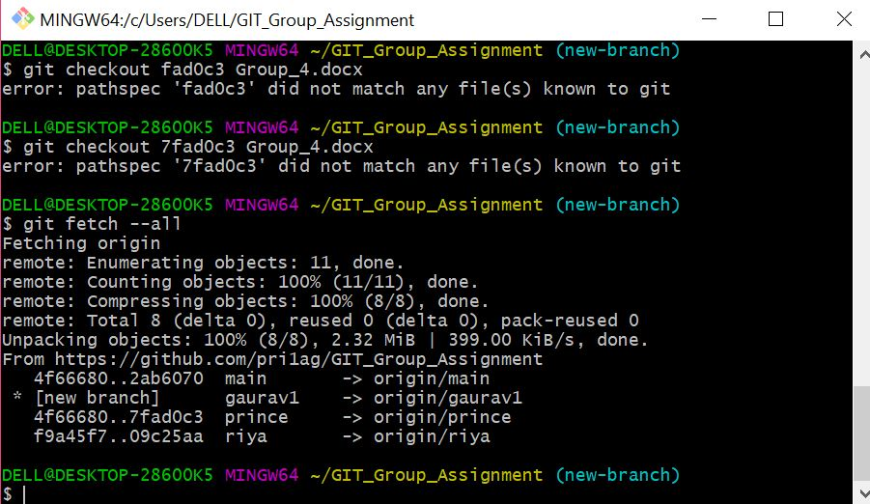

3) The following command used for the name of a commit at which to start the new branch.

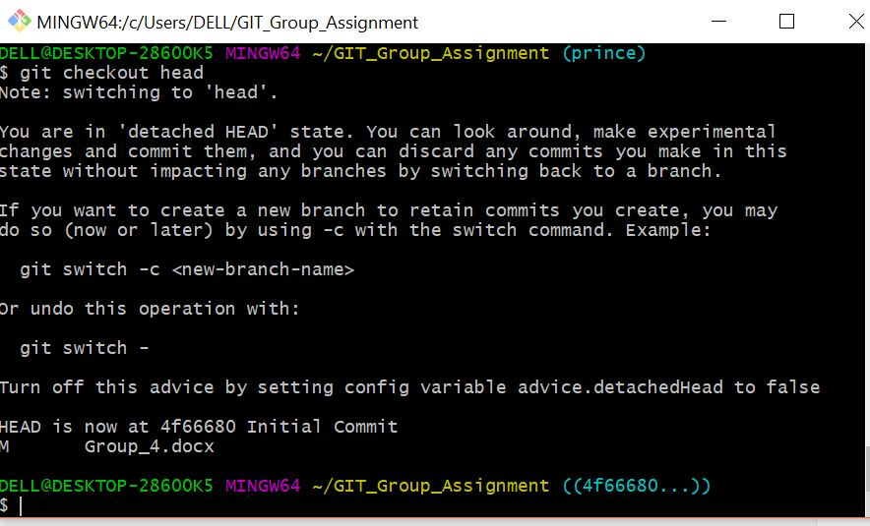

4) git checkout -q command is used to quiet, suppress feedback messages.

