

**KIP TRAINING**

Group Assignment for Git (Group 4)

Submitted by := SAUMYA

CHECKOUT :=

CHECKOUT is basically used to move (switch) from one branch to another.

SYNTAX : **git checkout <branch name>**

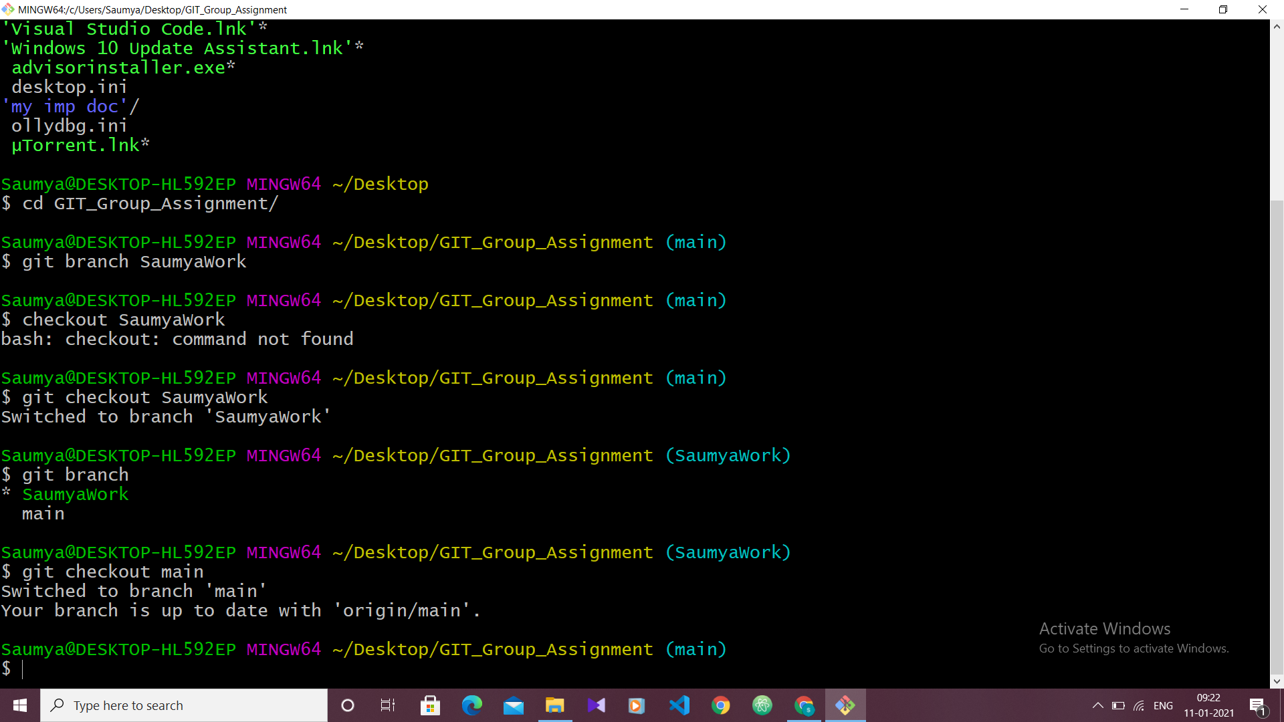

You can see from the pic that main branch has switched to SaumyaWork branch.

Create and checkout to new branch

* By adding –b with checkout we can create the new branch as well as can move to that branch.

SYNTAX := **git checkout –b <branch name>**

From the below image you can see previously there was only two branch available and the star was on **SaumyaWork** branch but now a new branch has been created and the star is now on newly created branch **SampleBranch**

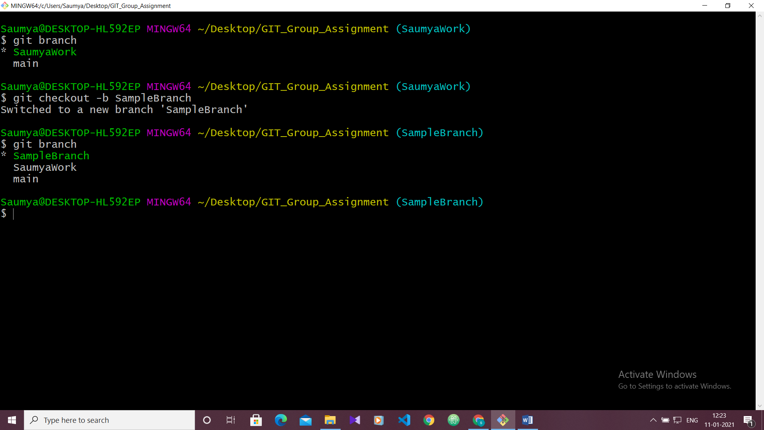

* Checkout to remote Branch

First you need to fetch all the changes from remote branch

**git fetch –all**

then you can checkout to the remote branch to see the changes of your collegues

git checkout <remoteBranch>

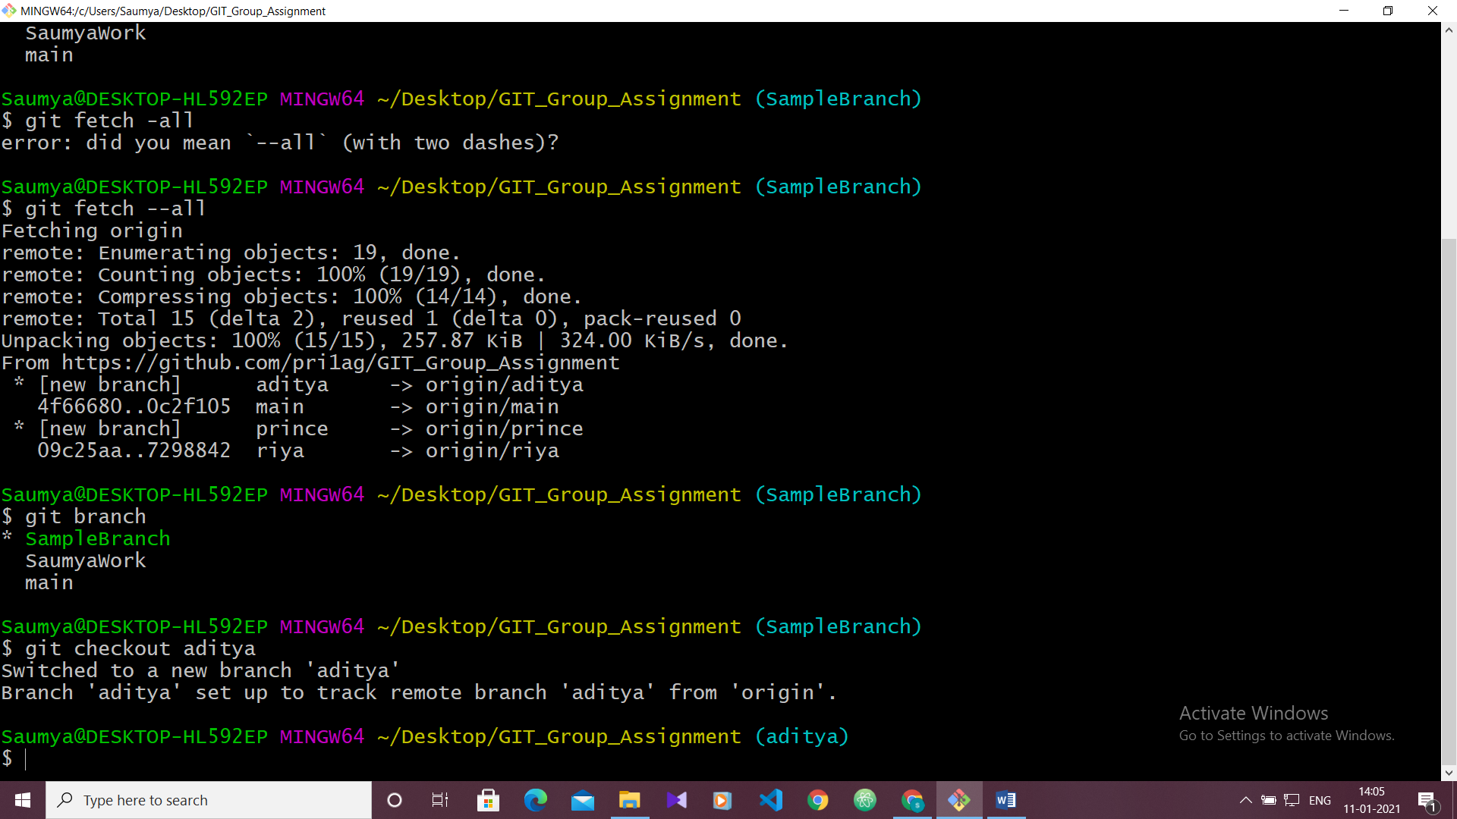

This pic shows that I have first fetched the data from remote repo and then moved to the branch of remote repo (aditya).