Narmada Watershed Delineation and Morphometric Analysis using QGIS
Author: Priyanka
Software: QGIS 3.44, GDAL

1. Introduction
This project delineates the Narmada watershed using a DEM and performs hydrological, terrain, vegetation, land use/land cover, and morphometric analyses using open-source GIS tools.

2. Study Area
Study Area: Narmada Watershed
Projection: WGS 84 / UTM Zone 44N (EPSG:32644).

3. Data Used
Dataset | Source | Resolution
SRTM DEM | USGS | 30 m
Landsat 8 Surface Reflectance | USGS EarthExplorer | 30 m
ESA WorldCover | ESA | 10 m

4. Methodology
The workflow included DEM preprocessing, sink filling, flow direction and accumulation, stream extraction, watershed delineation, slope, hillshade and contour generation, NDVI from Landsat 8, clipping ESA WorldCover to the watershed, and morphometric analysis.

5. Results

Watershed Boundary
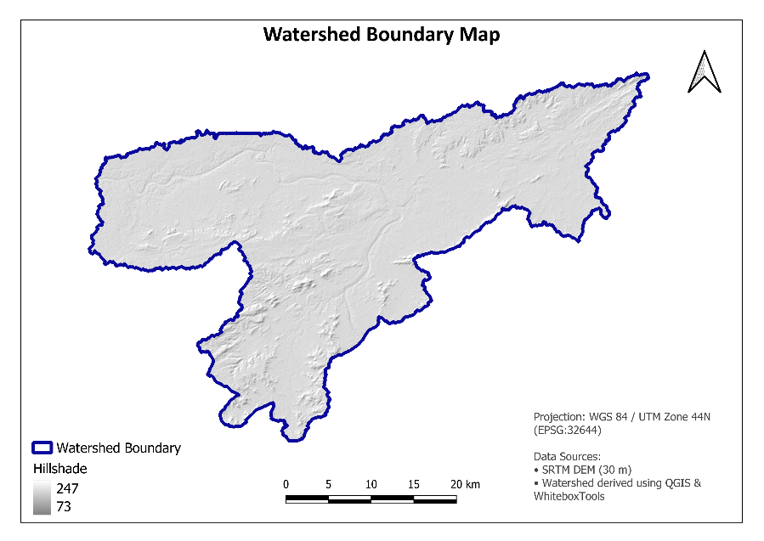

DEM

Slope
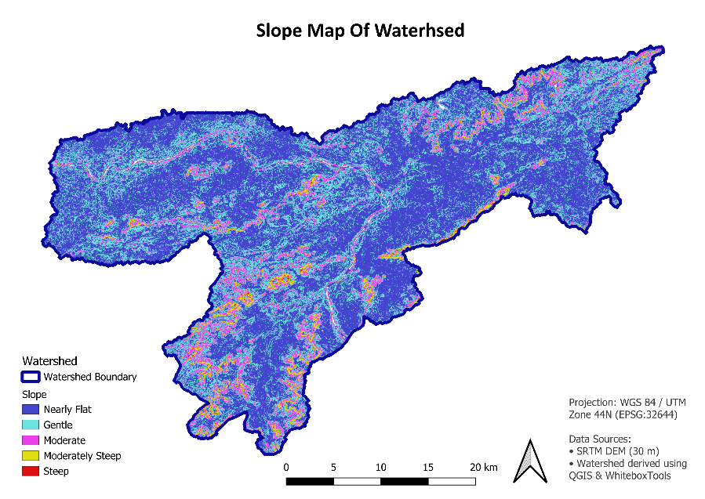

Stream Network
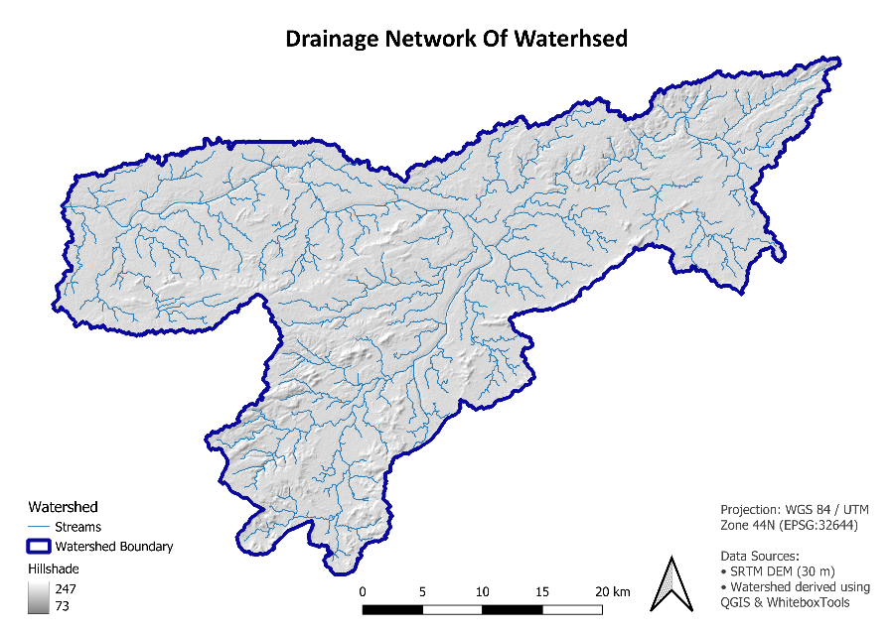

Contour Map
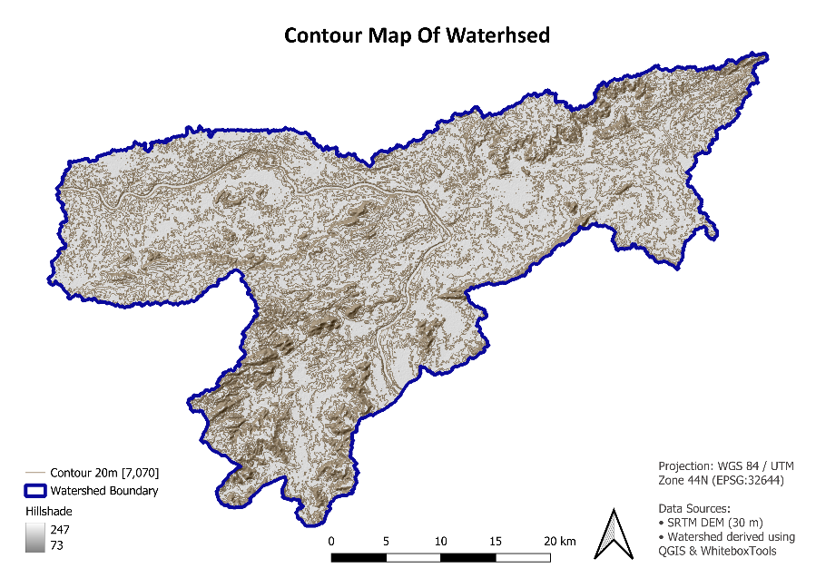

NDVI
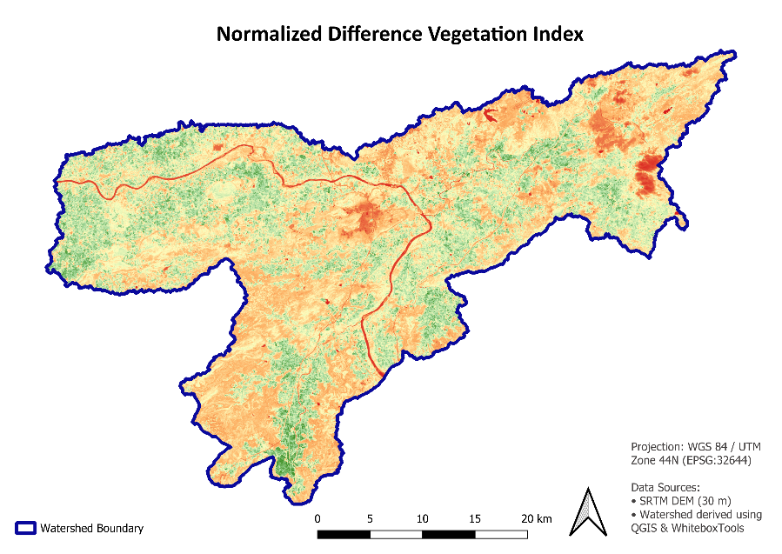

Land Use/Land Cover
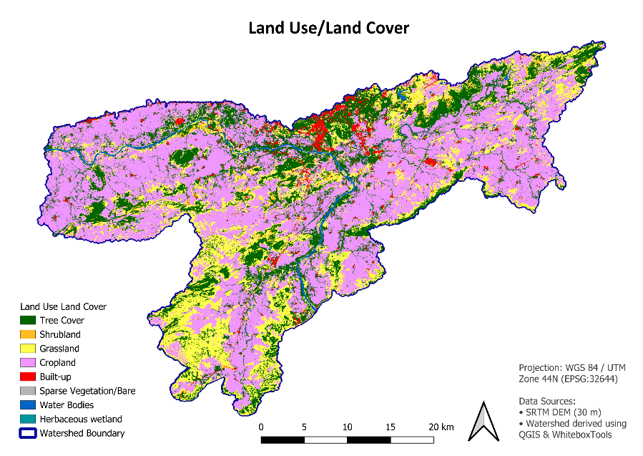

6. Morphometric Analysis
Parameter | Value
Watershed Area | 1187.59 km²
Perimeter | 367.14 km
Maximum Elevation | 641.10 m
Minimum Elevation | 330.70 m
Relief | 310.40 m
Total Stream Length | 1062.43 km
Stream Segments | 1639
Drainage Density | 0.895 km/km²
Stream Frequency | 1.38 streams/km²
The watershed exhibits a moderate drainage density and stream frequency, indicating a well-developed drainage network. Elevation and slope maps reveal terrain variability, while NDVI and ESA WorldCover provide insight into vegetation and land cover patterns.

LULC Statistics

DN | Class | Area (km²) | Percent
10 | Tree Cover | 262.11 | 22%
20 | Shrubland | 18.70 | 2%
30 | Grassland | 241.27 | 20%
40 | Cropland | 613.10 | 52%
50 | Built-up | 32.85 | 3%
60 | Bare/Sparse Vegetation | 5.95 | 1%
80 | Water Bodies | 13.40 | 1%
90 | Herbaceous Wetland | 0.02 | 0%

7. Discussion
The integrated analysis demonstrates the usefulness of DEM-based hydrological modeling combined with remote sensing products for watershed characterization and resource management.

8. Conclusion
The project successfully delineated the watershed, generated terrain and hydrological products, assessed vegetation using NDVI, mapped land use/land cover using ESA WorldCover, and computed key morphometric parameters.

9. References
1. QGIS Documentation.
2. USGS EarthExplorer.
3. ESA WorldCover User Manual.
4. NASA SRTM DEM Documentation.

