**CALCULATING FAMILY EXPENSES USING SERVICE NOW**

Submitted by

**TeamLeader**

Dharshini S (910022104007)

**Team Members**

Priyalakshmi R (910022104020)

Sivasoruba B (910022104028)

In partial fulfilment for the award of the degree

**BACHELOR OF ENGINEERING**

**in**

**COMPUTER SCIENCE AND ENGINEERING**

NAAN MUDHALVAN LAB

ANNA UNIVERSITY REGIONAL CAMPUS MADURAI-625-019

**ANNA UNIVERSITY: CHENNAI 600 025**

**NOVEMBER 2025**

Supervised by

**Dr. Srie Vidhya Janani, M.E., Ph.D.,**

**BONAFIDE CERTIFICATE**

This is to certify that the project report titled **"CALCULATING FAMILY EXPENSES USING SERVICE NOW"** is the Bonafide work of **DHARSHINI S (910022104007), PRIYALAKSHMI R(910022104020),SIVASORUBA B (910022104028)** who carried out the project work under my supervision in the Naan Mudhalvan Lab.





**SIGNATURE SIGNATURE**

**HEAD OF THE DEPARTMENT FACULTY**

Department of Computer Science and Engineering,

Anna University Regional Campus Madurai-625-019

**ACKNOWLEDGEMENT**

I extend my heartfelt gratitude to **Dr. Srie Vidhya Janani**, **M.E., Ph.D.,**Faculty Incharge of Naan Mudhalvan Lab, for her guidance and support throughout this project. I also thank my peers and family for their encouragement, without which this project would not have been possible.

I am deeply grateful to **Dr. V. Sasikala, M.E., Ph.D.,** Head of the Department, for her constant support and guidance.

I extend my sincere thanks to all teaching and non-teaching staff of the Department of Computer Science and Engineering and my peers for their support and encouragement.

Finally, I thank my family and friends, whose encouragement and patience motivated me to complete this project successfully.

**Team Leader DHARSHINI S (910022104007)**

**Team Members PRIYALAKSHMI R (910022104020) SIVASORUBA B(910022104028)**

**ABSTRACT**

The Family Expense Calculation System developed on the ServiceNow platform aims to provide an efficient and user-friendly solution for managing and tracking household expenses. The system enables users to record, categorize, and analyze daily financial transactions under various expense categories such as food, utilities, education, healthcare, and entertainment. Through its budget-setting and real-time tracking features, users can monitor their spending patterns and identify areas for financial improvement.

The system leverages ServiceNow’s powerful automation, reporting, and integration capabilities to deliver a seamless experience with accurate and timely data updates. A customized dashboard presents clear visual reports and summaries, helping users make informed financial decisions. Additionally, the project ensures data privacy, scalability, and flexibility, making it suitable for families of different sizes and financial structures.

By offering a centralized and digital platform for expense management, this project promotes financial discipline, transparency, and control over family finances. Ultimately, the Family Expense Calculation System empowers users to make smarter budgeting decisions, reduce unnecessary spending, and achieve long-term financial stability.

**ProblemStatement:**

The project aims to develop a comprehensive expense calculation system using the ServiceNow platform. This system will enable users to track and manage family expenses efficiently while offering essential features such as expense categorization, budget setting, real-time tracking, and reporting capabilities. By leveraging ServiceNow’s robust and flexible framework, the system will ensure seamless integration, a user-friendly interface, and scalability to accommodate varying family sizes and financial complexities. The ultimate goal of this project is to empower users with intelligent tools that support informed financial decision-making and promote financial well-being within the family unit.

**Objectives:**

The main objective of this project is to develop a Family Expense Management System on the ServiceNow platform that enables efficient tracking, categorization, and budgeting of household expenses. The specific objectives are as follows:

* To provide real-time monitoring and interactive dashboards for better financial visibility.
* To generate insightful analytical reports that help users make informed financial decisions.
* To ensure scalability and adaptability for families of different sizes and financial needs.
* To promote financial discipline through detailed spending analysis and budgeting tools.
* To maintain data security and integrity using ServiceNow’s built-in security features.

**Skills:**

**TASKINITIATION**

**Milestone1:SettingupServiceNowInstance**

**Activity:**SettingupServiceNowInstance

1. SignupforadeveloperaccountontheServiceNowDevelopersite “https://developer.servicenow.com”.
2. Onceloggedin,navigatetothe"PersonalDeveloperInstance"section.
3. Clickon"RequestInstance"tocreateanewServiceNow instance.
4. Fill out the required information and submit the request.
5. 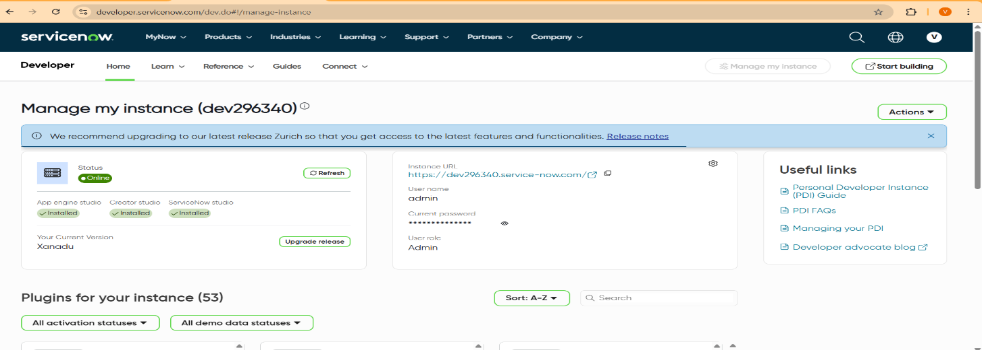You'llreceiveanemailwiththeinstancedetailsonceit'sready.
6. Logintoyour ServiceNowinstanceusingthe providedcredentials.
7. Nowyouwillnavigatetothe ServiceNow.

**Milestone2:CreationofNewUpdateSet**

**Activity:**CreationofNewUpdate Set

1. GotoAll>>InthefiltersearchforLocal Updateset>clickonNew

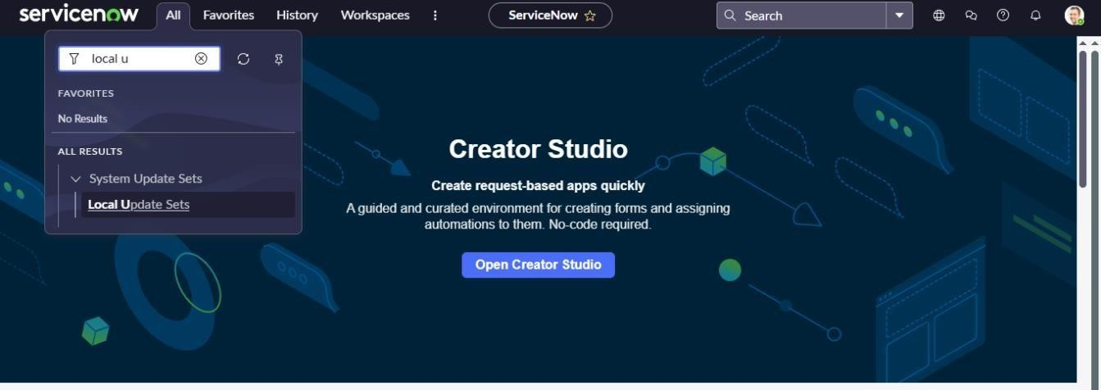

1. EntertheDetailsas:

Name:FamilyExpenses

1. Thenclick onSubmitandMake current

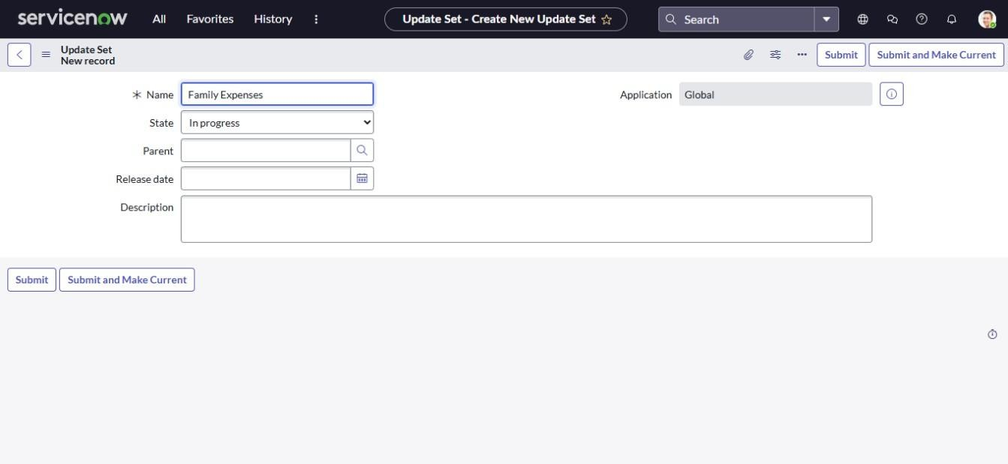

**Milestone3:CreationofTable**

**Activity:**CreationofNewUpdateSet

1. Goto All>>InthefiltersearchforLocalUpdateset>clickonNew



1. EntertheDetailsas:

Name:FamilyExpenses

1. Thenclick onSubmitandMake current.



**Milestone4:**CreationofTable

**Activity 1:** Creation of Family Expenses Table

1. GotoAll>In thefiltersearch forTables>clickonNew.
2. Enterthe Details:

Label:FamilyExpenses Name: Auto-Populated

Newmenuname:FamilyExpenditure

1. GototheHeaderandrightclickthere>>clickonSave.

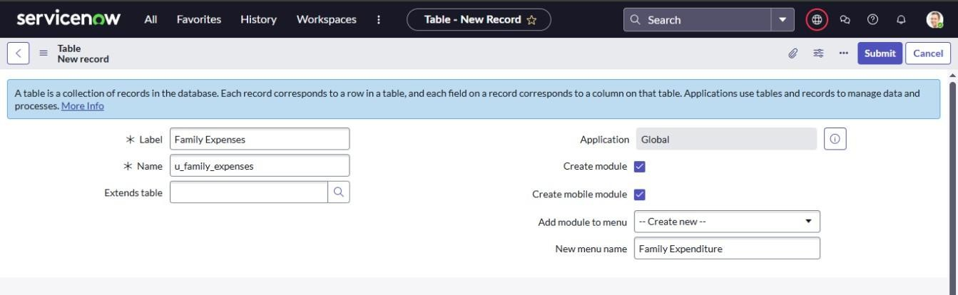

**Activity2:**CreationofColumns (Fields)

1. NearColumnsDoubleclick nearinsertanew row.

Givethedetailsas:

* 1. Columnlabel:Number
  2. Type: String

1. Double clickoninserta newrowagain

Givethedetailsas:

* 1. Columnlabel:Date
  2. Type: Date

1. Doubleclickoninserta newrowagain

Givethedetailsas:

* 1. Columnlabel:Amount
  2. Type: Integer

1. Doubleclickoninserta newrowagain

Givethedetailsas:

* 1. Columnlabel:Expense Details
  2. Type: String
  3. Maxlength:800

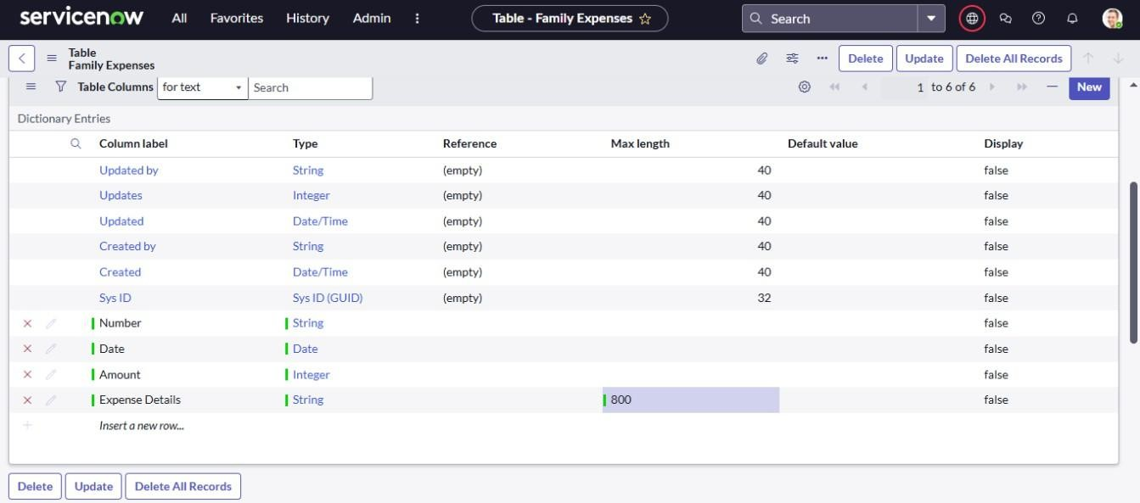

1. GototheHeaderandrightclickthere>>clickonSave.

**Activity3:** MakingNumberFieldan Auto-Number

1. Doubleclickonthe Number Field/Column.
2. GodownanddoubleclickonAdvancedview
3. InDefault Value:
   1. Usedynamic default:checkthebox
   2. Dynamicdefaultvalue:GetNextPaddedNumber
4. ClickonUpdate.

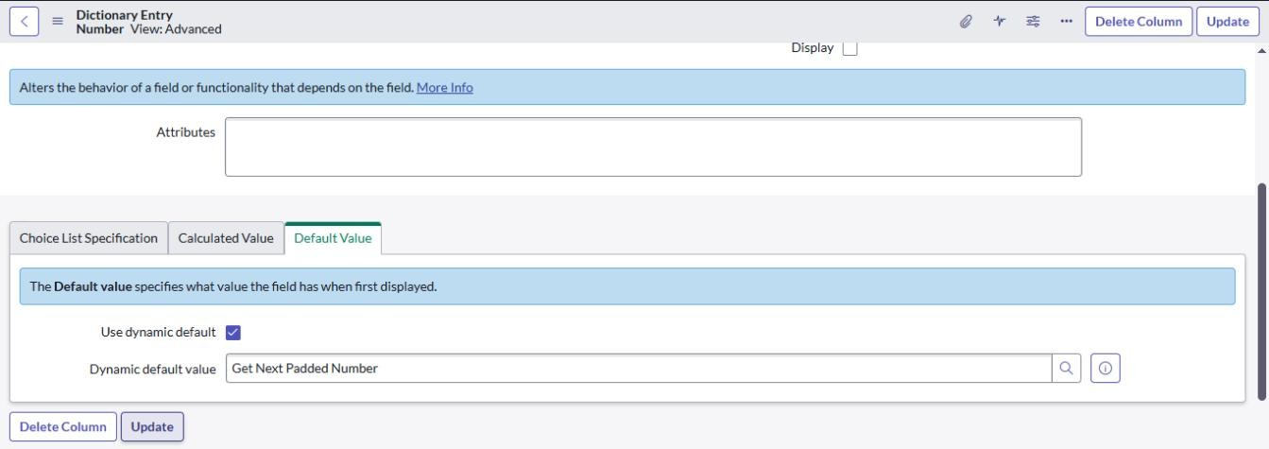

1. GotoAll>>Inthefiltersearchfor NumberMaintenance>>selectNumber Maintenance
2. ClickonNew.
3. EnterthebelowDetails:
   1. Table:FamilyExpenses
   2. Prefix:MFE

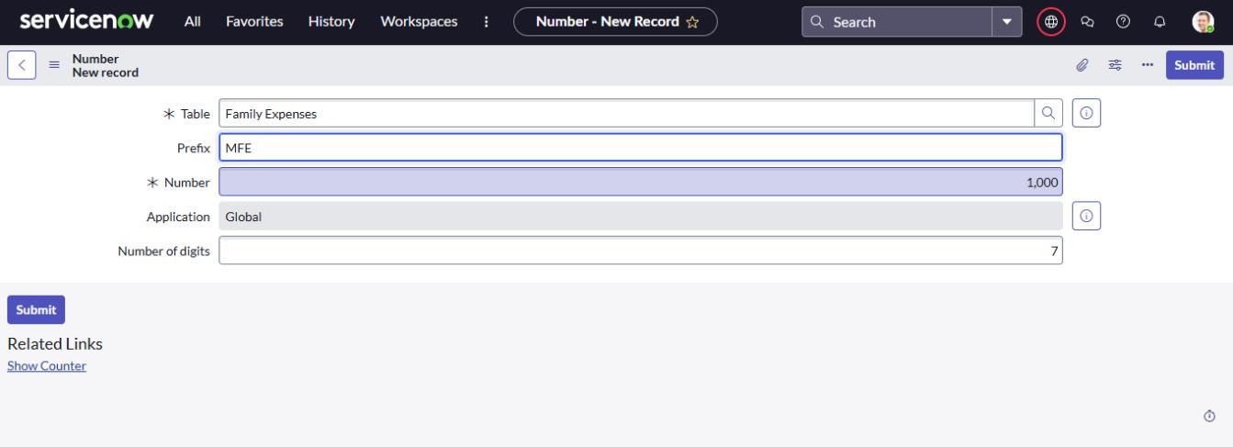

1. ClickonSubmit.

**Activity4:**ConfiguretheForm

1. GotoAll>>Inthefiltersearchfor FamilyExpenses>>OpenFamily Expenses
2. ClickonNew
3. GototheHeaderandrightclickthere>>clickonConfigure>>SelectForm Design

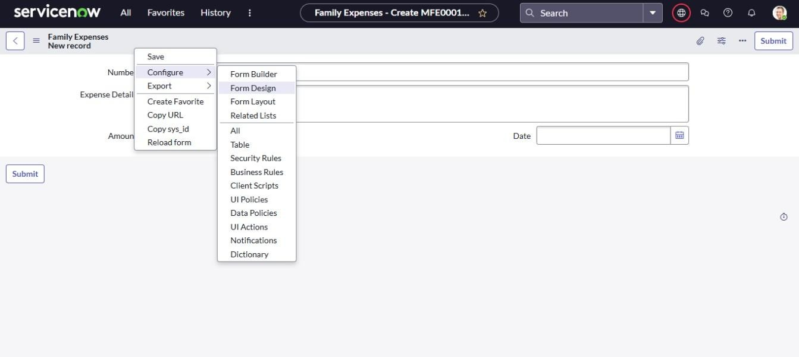

1. Customizeor DragDroptheformasperyour requirement.
2. MakeNumberRead-OnlyFieldbyclickingonthegeariconandchecking Read-Only
3. MakeDate,AmountMandatoryFieldbyclickingonthegeariconand checking Mandatory
4. ClickonSave.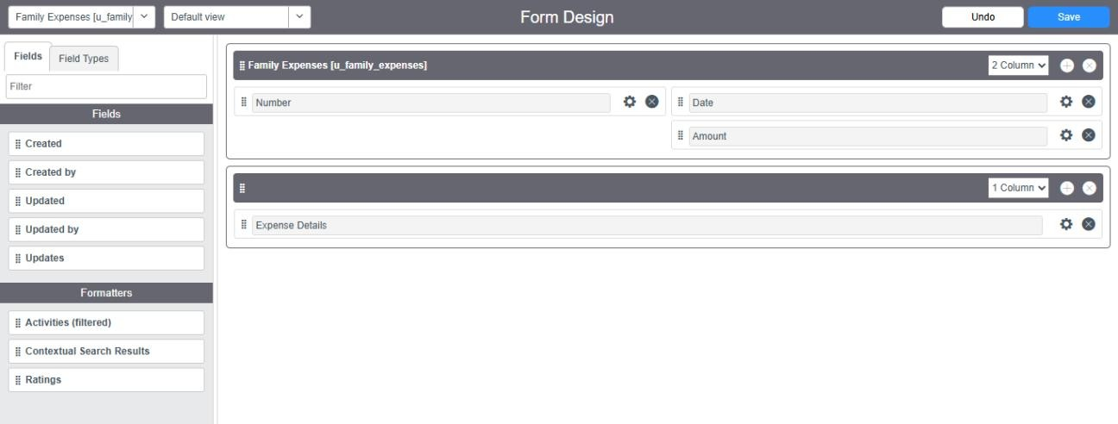

# Milestone5:CreationofTable(DailyExpenses)

**Activity1:**CreationofDailyExpenses Table

1. GotoAll>In the filtersearch forTables>clickonNew.

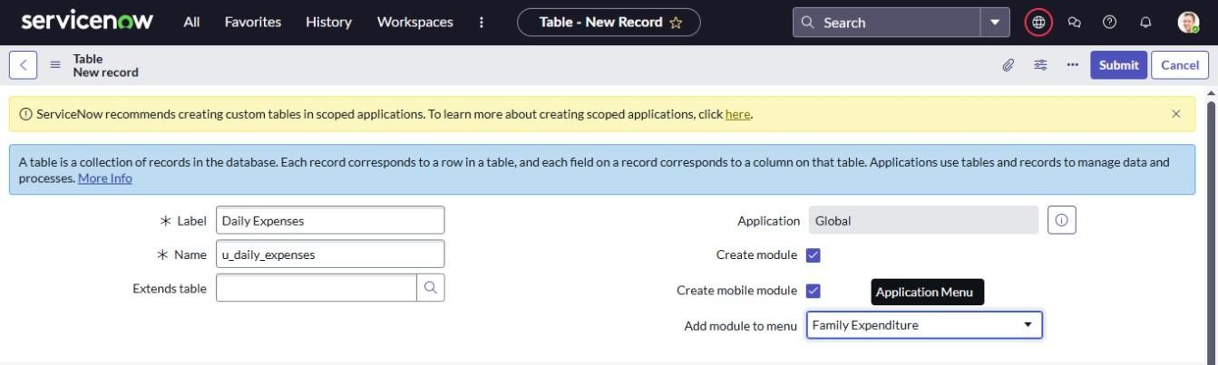

1. Enterthe Details:
   1. Label:DailyExpenses
   2. Name: Auto-Populated
   3. AddModule tomenu:FamilyExpenditure
2. Gotothe Headerandrightclickthere>>clickonSave.

**Activity2:**CreationofColumns (Fields)

1. Near Columns Double click near insert a new row.

Give the details as:

Column label: Number

Type: String

1. Doubleclickoninsertanewrowagain

Give the details as:

Columnlabel:Date Type: Date

1. Doubleclickoninserta newrowagain

Givethedetailsas:

Columnlabel:Expense Type: Integer

1. Doubleclickoninsertanewrow

Give the details as:

Columnlabel:FamilyMember Name

Type:Reference Maxlength: 800

1. Doubleclickoninsertanewrowagain Give the details as:

Columnlabel:Comments Type: String

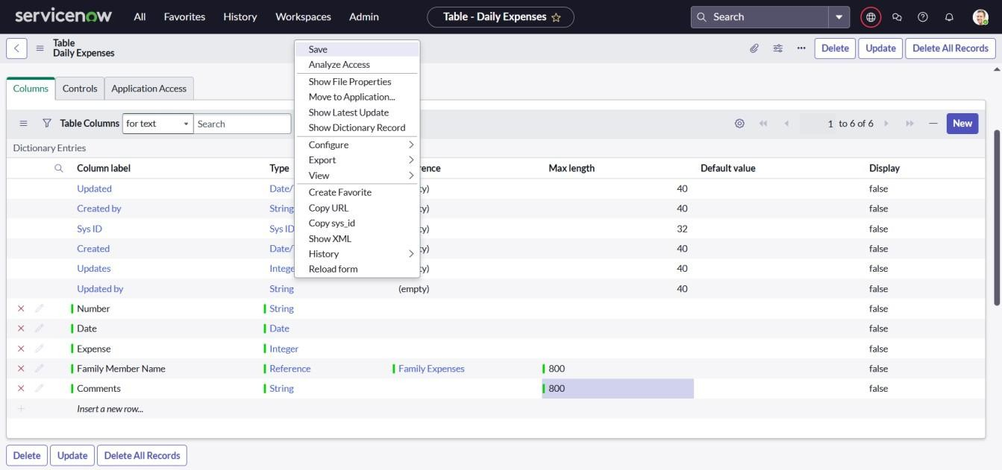Maxlength:800

1. Gotothe Headerand rightclickthere>>clickonSave.

**Activity3:**MakingNumberFieldanAuto-Number

1. Doubleclickonthe Number Field/Column.
2. GodownanddoubleclickonAdvancedview
3. InDefault Value:

Usedynamic default:checkthebox

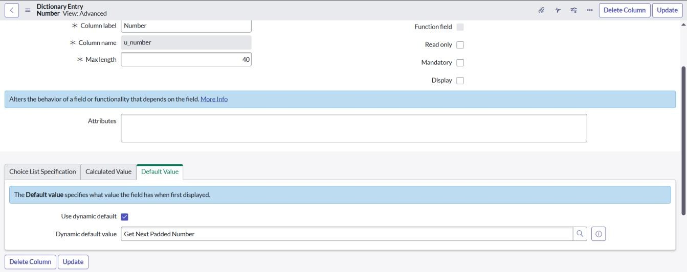Dynamicdefaultvalue:GetNextPaddedNumber

1. ClickonUpdate.
2. GotoAll>>InthefiltersearchforNumberMaintenance>>selectNumber Maintenance
3. ClickonNew.
4. Enter the below Details:

Table:Daily Expenses

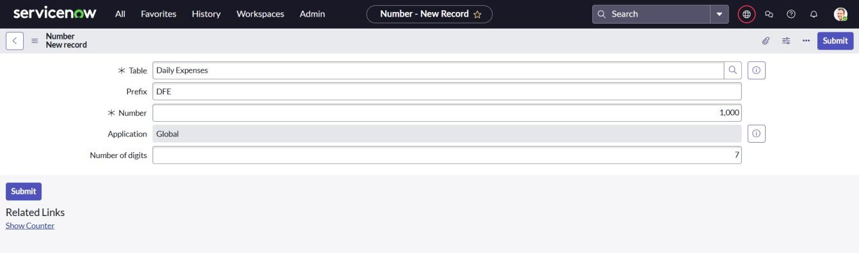Prefix:DFE

1. ClickonSubmit

**Activity4:**ConfiguretheForm

1. Goto All>>InthefiltersearchforDailyExpenses>>OpenDailyExpenses
2. ClickonNew
3. GototheHeaderandrightclickthere>>clickonConfigure>>SelectForm Design

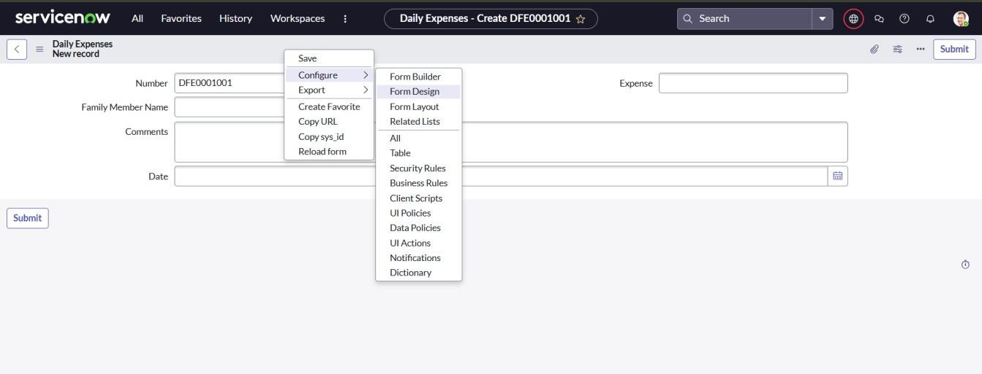

1. Customizeor DragDroptheformasperyour requirement.
2. MakeNumberRead-OnlyFieldbyclickingonthegeariconandchecking Read-Only
3. MakeDate,FamilyMemberNameMandatoryFieldbyclickingonthegear icon and checking Mandatory

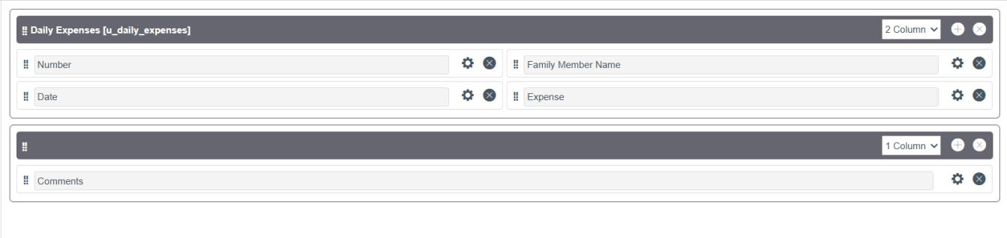

1. ClickonSave.

# Milestone6:CreationofRelationship

**Activity:**CreationofRelationshipbetweenFamilyExpensesandDaily Expenses tables.

1. GotoAll>>In thefiltersearchforRelationships>>OpenRelationships
2. ClickonNew.
3. Enterthe details:

Name:DailyExpenses

Appliestotable:SelectFamilyExpenses

Daily Expenses: Select Daily Expenses

1. ClickSave.

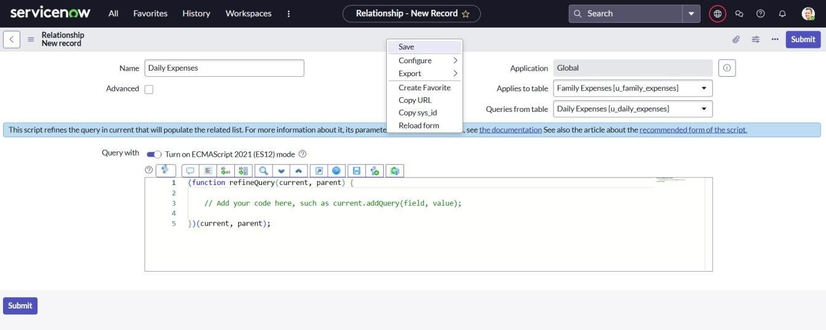

# Milestone7:ConfiguringRelatedListonFamilyExpenses

**Activity:**ConfiguringRelatedListonFamilyExpenses

1. GotoAll>>InthefiltersearchforFamilyExpenses>>OpenFamily Expenses
2. Clickon New
3. GototheHeaderandrightclickthere>>clickonConfigure>>SelectRelated Lists
4. 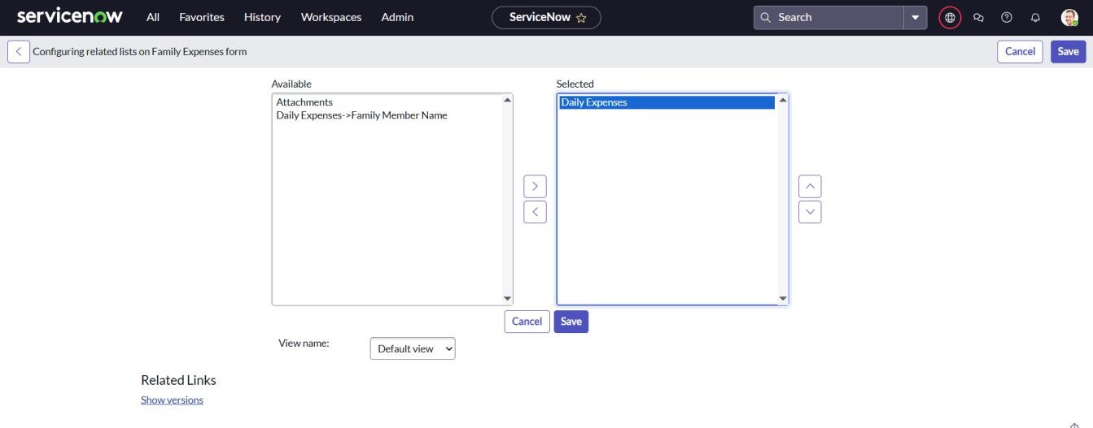AddDailyExpensestotheSelectedArea.
5. Clickon Save

# Milestone8:CreationofBusinessRules

**Activity:**CreationofBusinessRules

1. GotoAll>>InthefiltersearchforBusinessRules.
2. UnderSystemDefinitionSelectBusinessRulesthenclickonNew.
3. Enterthe Details:

Name: Family Expenses BR

Table:SelectDailyExpenses

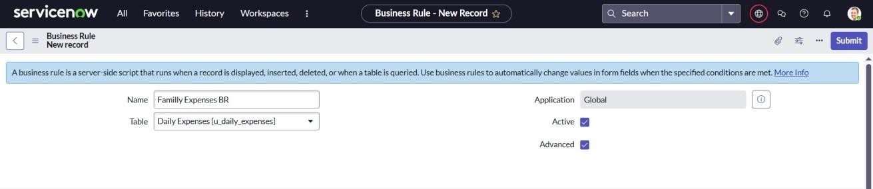Check Advanced

1. Inwhen torunCheckInsertandUpdate
2. In Advance View (wewritethecode): Writethe below

(function executeRule(current, previous /*null when async*/) { varFamilyExpenses=newGlideRecord('u_family_expenses'); FamilyExpenses.addQuery('u_date',current.u_date); FamilyExpenses.query();

if(FamilyExpenses.next())

{

FamilyExpenses.u_amount += current.u_expense; FamilyExpenses.u_expense_details+=">"+current.u_comments+":"+"Rs."

+current.u_expense+"/"; FamilyExpenses.update()

}

else

{

var NewFamilyExpenses = new GlideRecord('u_family_expenses'); NewFamilyExpenses.u_date = current.u_date; NewFamilyExpenses.u_amount = current.u_expense; NewFamilyExpenses.u_expense_details+=">"+current.u_comments+":"+

"Rs."+current.u_expense+"/-"; NewFamilyExpenses.insert();

}

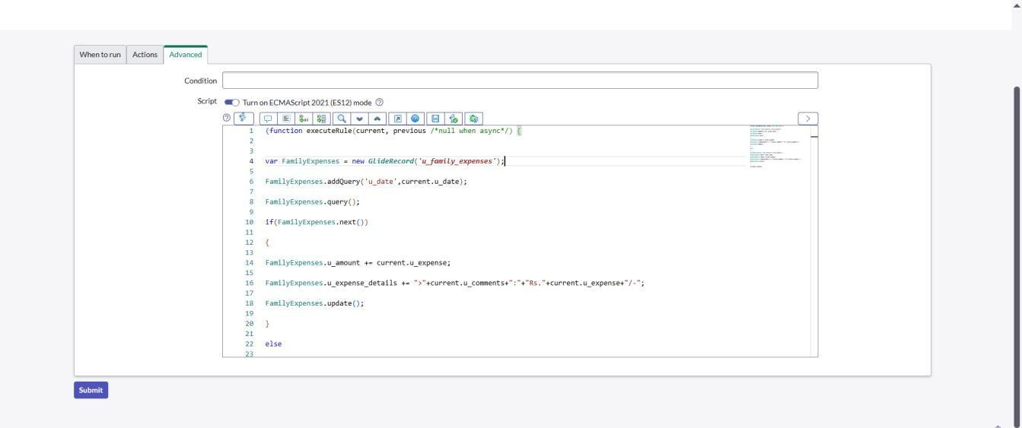})(current,previous);

1. Go to the Header and right click there>> click on Save.

# Milestone9:ConfiguretheRelationship

**Activity:**ConfiguretheRelationship

1. SearchforRelationships>>OpenRelationships.
2. In that,open DailyExpensesRelationship.
3. ForAppliestotable:SelectFamilyExpenses.
4. In Query with:writethebelow Query.

(functionrefineQuery(current,parent){

//Addyourcodehere,suchascurrent.addQuery(field,value); current.addQuery('u_date',parent.u_date)

current.query();

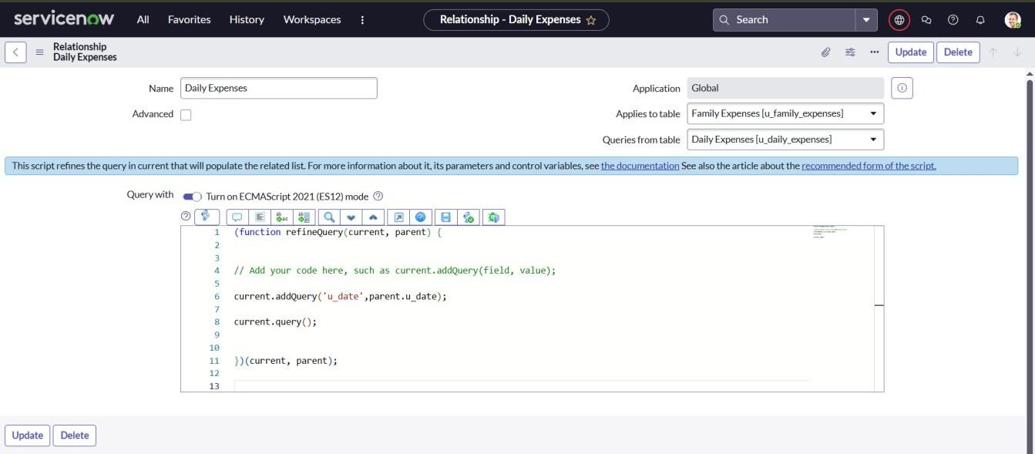})(current,parent);

1. ClickonUpdate.

**Conclusion:**

The project “Calculating Family Expenses using ServiceNow” demonstrates how technology can streamline and simplify household financial management. By leveraging the features of ServiceNow, the system provides efficient expense tracking, categorization, budgeting, and reporting while ensuring scalability, data security, and ease of use. The customized components, such as tables, forms, and business rules, enable a user-friendly and automated solution that promotes financial awareness and discipline. Overall, the project highlights the potential of ServiceNow as a versatile platform capable of supporting real-world applications beyond traditional IT service management.