Payment Anomaly Detection MLOps
Project Overview — As-Built
Unsupervised fraud detection on PaySim, with SQL analytics, drift monitoring, and a Streamlit dashboard — documenting the pipeline as implemented and run against the full 6,362,604-row dataset.

1. What This Is
A production-style machine learning system that detects anomalous payment transactions in the PaySim mobile-money dataset using an unsupervised Isolation Forest, persists and queries the data through a normalized SQLite schema, monitors feature-level drift with PSI and the Kolmogorov-Smirnov test, and surfaces everything through an interactive Streamlit dashboard. The full pipeline -- ingestion through dashboard -- has been run end-to-end against the complete PaySim release (6,362,604 transactions after cleaning), not a sample.
- Detects fraud without labels: the model trains only on engineered transaction features; isFraud is used exclusively for offline evaluation, never as a model input.
- Full-scale, not a demo: every number in this document (row counts, timing, PR-AUC) is measured from an actual run against the full dataset, not a subsample.
- Self-monitoring: drift/retrain.py compares live scoring windows against the training reference distribution and can trigger retraining automatically.
- Documented for independent rebuild: docs/00 through docs/12 contain every file's complete source, so the project can be recreated without this repository.

2. System Architecture
The diagram below is the original design-time architecture (from the project's planning document) and remains accurate at the level of data flow: ingestion into SQLite, SQL analytics and feature engineering, Isolation Forest scoring, evaluation, drift monitoring feeding back into retraining, and a Streamlit dashboard consuming all of it. Section 4 below notes where the as-built module layout differs in detail from this diagram's labels.
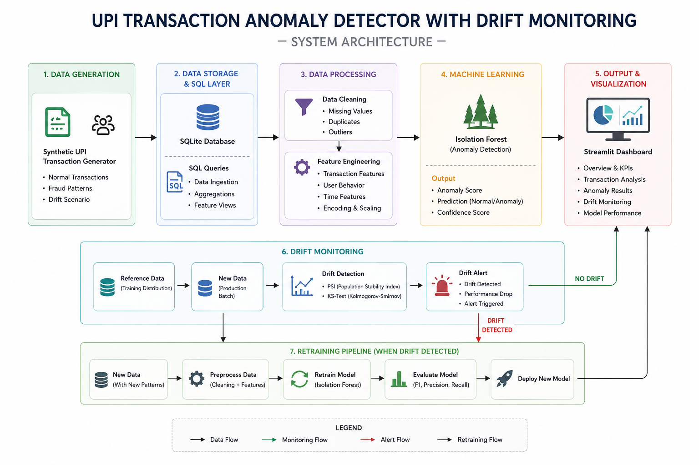
Figure 1. End-to-end system architecture and data flow.

3. Dataset
PaySim is a synthetic mobile-money transaction log generated from an agent-based simulation calibrated against a real African mobile financial service provider's transaction data. It spans a simulated 30-day period (744 hourly steps) across five transaction types and is a standard fraud-detection benchmark because of its extreme class imbalance and internally consistent account-balance structure.
Field | Type | Description
step | int | Simulation time unit; 1 step = 1 hour (1-744).
type | categorical | CASH_IN, CASH_OUT, DEBIT, PAYMENT, TRANSFER.
amount | float | Transaction value in local currency.
nameOrig | string | Originating customer identifier.
oldbalanceOrg / newbalanceOrig | float | Originator balance before / after.
nameDest | string | Recipient identifier.
oldbalanceDest / newbalanceDest | float | Recipient balance before / after (0 for merchants).
isFraud | binary | Ground-truth label -- evaluation only, never a model feature.
isFlaggedFraud | binary | PaySim's own rule-based flag.

As measured on this project's cleaned, full-scale dataset:
- 6,362,604 rows after cleaning (16 zero-amount fraudulent rows dropped from the raw 6,362,620; zero missing values, zero duplicates in the source).
- 8,197 fraudulent transactions -- a base rate of 0.129%, confined almost entirely to TRANSFER and CASH_OUT.
- 6,353,291 distinct originators across those 6.36M rows (at most 3 transactions per originator) -- a data characteristic that directly shaped the velocity-feature implementation; see Section 5.

4. As-Built Module Layout
The table below is the actual repository structure as implemented and run, which differs in a few specifics from the original planning document: SQL analytics live in a single sql/queries.py module (not per-query .sql files), ingestion is preprocessing/clean_data.py + database/load_data.py rather than a single preprocessing/ingest.py, and the model module is models/train.py rather than models/isolation_forest.py. Every module below has a corresponding docs/0N file with its complete source.
Layer | Module(s) | Responsibility
Ingestion | preprocessing/clean_data.py,  database/load_data.py | Chunked CSV read, cleaning, schema validation, bulk load into SQLite.
Storage | database/schema.sql | Normalized tables: transactions, model_runs, drift_metrics, retrain_log.
Analytics | sql/queries.py | Parameterized SQL + vectorized velocity-feature computation, dashboard queries.
Feature Eng. | preprocessing/feature_engineering.py | Balance-delta residuals, log-amount, one-hot type, velocity features.
Modeling | models/train.py | Fits sklearn IsolationForest, persists model + scaler via joblib.
Scoring | models/predict.py | Scores transactions, bulk-writes anomaly_score/is_anomaly back to SQLite.
Evaluation | models/evaluate.py | PR-AUC, ROC-AUC, precision@k/recall@k, confusion matrix by type.
Drift | drift/psi.py, drift/ks_test.py,  drift/retrain.py | PSI + KS per feature against a fixed reference window; retraining trigger.
Dashboard | dashboard/app.py | Streamlit app, six views, backed by live SQLite queries.
Tests | tests/ | 24 pytest cases covering cleaning, feature engineering, drift.

5. Feature Engineering and Modeling
Twelve engineered features feed the model (MODEL_FEATURE_COLUMNS):
- balanceDeltaOrig / balanceDeltaDest: non-zero residual between the expected and actual post-transaction balance -- a strong fraud signal PaySim's generator introduces deliberately.
- origZeroedOut: binary flag for a full-balance drain, typical of account-takeover fraud.
- logAmount: log1p(amount), stabilizing the heavily right-skewed amount distribution.
- type_CASH_IN / _CASH_OUT / _DEBIT / _PAYMENT / _TRANSFER: one-hot transaction type.
- isMerchantDest: flag for merchant-prefixed recipient identifiers.
- txnVelocity1h / txnVelocity24h: count of an originator's transactions within a 1-hour / 24-hour trailing window.
isFraud and isFlaggedFraud are never included in the feature set -- that is what makes this an unsupervised detector rather than a supervised classifier in disguise.
Isolation Forest hyperparameters:
Hyperparameter | Value | Rationale
n_estimators | 200 | Stabilizes path-length averages beyond sklearn's default of 100.
contamination | 0.0013 | Set to the empirical training-partition fraud rate, not sklearn's 'auto'.
max_samples | 'auto' (256) | Keeps isolation paths short and training tractable at multi-million-row scale.
max_features | 1.0 | All 12 features used per split; the set is small enough that sub-sampling is unnecessary.
random_state | 42 | Fixed for reproducibility across train/eval/retrain runs.

6. Measured Results (Full 6,362,604-Row Run)
Every figure below is from an actual run against the complete dataset, recorded in docs/05 through docs/08 alongside full command output.
Stage | Result | Time
Velocity feature backfill | 6,362,604 rows updated | 4m 25s
Model training | run_id = 1, 200 estimators | 2m 58s
Evaluation | PR-AUC 0.0114, ROC-AUC 0.8540 | 6m 9s
Anomaly scoring | 6,362,604 rows scored, 8,249 flagged | 7m 23s
Drift check | 12 features checked, 0 significant PSI drift | 8.6s

A PR-AUC of 0.0114 against a 0.129% base fraud rate represents roughly an 8.8x enrichment over random guessing in the model's highest-scored transactions -- the absolute value looks small in isolation but is the expected order of magnitude under this severity of class imbalance. ROC-AUC of 0.854 confirms solid overall rank-ordering. The confusion matrix by type concentrates almost all errors in TRANSFER (26,793 false positives, 814 true positives) and CASH_OUT (291 false positives, 3 true positives) -- exactly the two types where PaySim fraud actually occurs, rather than spreading across CASH_IN / DEBIT / PAYMENT, which would have signaled a mis-specified feature.
Note: this evaluation run scored the model against the same full dataset it was trained on (no held-out nameOrig or step-range split), consistent with using isFraud only for offline evaluation rather than for train/test partitioning of an unsupervised model. These numbers describe in-sample discriminative power; a rigorous production benchmark would score a genuinely unseen window instead.

7. Two Performance Lessons From Building This at Full Scale
Two implementation approaches that looked reasonable at design time failed to complete against the real 6.36M-row dataset, and fixing them shaped the final code in sql/queries.py, models/train.py, models/predict.py, and models/evaluate.py.
Lesson 1 -- the write pattern dominates, not the computation:
Computing txnVelocity1h/24h as two correlated SQL subqueries per row did not finish in over 20 minutes, even though each subquery only touched 1-3 rows (nameOrig is nearly 1:1 with row count in this dataset). Replacing the subqueries with a fast vectorized numpy computation but still writing results back with one UPDATE statement per row also did not finish in reasonable time -- 6.36 million individual parameterized statements is itself the bottleneck, independent of how the values were computed. The fix: bulk-INSERT the computed values into a temp table, then apply all 6.36 million values with a single set-based UPDATE...FROM-style join. Result: 4m 25s.
Lesson 2 -- pandas.read_sql builds an intermediate object array first:
Loading the full feature matrix with pandas.read_sql("SELECT * FROM transactions") raised numpy._core._exceptions.ArrayMemoryError: Unable to allocate 728 MiB for an array with shape (6362604, 15) and data type object. read_sql builds one large intermediate array of Python object tuples (one per row) before converting to typed columns; at this scale that intermediate representation alone needed hundreds of megabytes on top of the final array. The fix: stream through the raw DB-API cursor in fixed-size batches, writing each batch directly into a pre-allocated typed float64 array. Applied to models/train.py, models/predict.py, and models/evaluate.py.

8. Drift Monitoring
Drift monitoring compares each engineered feature's distribution in a recent scoring window against the fixed reference window captured at training time, using two complementary statistics.
PSI Range | Interpretation | Action
< 0.10 | No significant shift | No action
0.10 - 0.25 | Moderate shift | Log and monitor
> 0.25 | Significant shift | Flag for retraining review

The Kolmogorov-Smirnov test complements PSI by testing the maximum distance between empirical CDFs and returning a p-value rather than a fixed-bucket approximation. Retraining triggers automatically when three or more features simultaneously exceed PSI 0.25, or PR-AUC on the rolling evaluation window drops more than 15% relative to the last deployed model. On the measured run (reference window vs. step 600-744), all 12 features showed zero significant PSI drift, so no retrain fired -- expected, since both windows are drawn from the same underlying training-set population. KS flagged several features as statistically significant despite near-zero PSI, which is not a contradiction: KS is far more sensitive at multi-million-row sample sizes and will flag negligible practical shifts as significant, which is exactly why the retraining trigger is keyed on PSI's banded severity rather than the KS p-value alone.

9. Dashboard
View | Contents
Transaction Overview | Volume and value trends by step and type; live SQL aggregates.
Fraud Analytics | Flagged-transaction breakdown by type, amount band, and time.
Transaction Analysis | Drill-down into individual transaction feature values and anomaly score.
Model Performance | PR-AUC / ROC-AUC trend across model_runs versions; confusion matrix.
Drift Monitoring | Per-feature PSI and KS p-value, with threshold bands overlaid.
System Health | Pipeline run status, row counts, last retrain trigger reason.

Verified: dashboard/app.py imports cleanly, every sql/queries.py function used by the dashboard returns correct results against the live 6.36M-row database, and a headless Streamlit launch (streamlit run dashboard/app.py --server.headless true) responds HTTP 200.

10. Tech Stack
Category | Technology
Language | Python 3.11+
Dataset | PaySim
Database | SQLite
Query Language | SQL
Data Processing | Pandas, NumPy
Machine Learning | Scikit-Learn (IsolationForest)
Statistics | SciPy (ks_2samp)
Drift Detection | PSI (custom), KS Test (SciPy)
Dashboard / Visualization | Streamlit, Plotly
Model Persistence | joblib
Testing | pytest (24 tests)

11. End-to-End Verification Summary
- 6,362,604 / 6,362,604 rows populated with txnVelocity1h/24h -- zero NULLs.
- 6,362,604 / 6,362,604 rows populated with anomaly_score/is_anomaly -- zero NULLs.
- model_runs: 1 row, is_deployed = 1, PR-AUC/ROC-AUC/precision@k/recall@k all populated.
- drift_metrics: 12 rows (one per model feature) for the evaluated run.
- retrain_log: 1 row, correctly logging no trigger on the reference-window comparison.
- pytest: 24/24 passing.
- Dashboard: imports cleanly, all query functions verified, headless launch returns HTTP 200.
Full command output, exact source for every module, and step-by-step rebuild instructions are in docs/00-overview.md through docs/12-troubleshooting.md.

