UPI Transaction Anomaly Detector with
Drift Monitoring
Document 1: Project Overview
Version 6.0 (Final)
A production-inspired machine learning system that detects anomalous payment transactions in the PaySim mobile-money dataset using unsupervised Isolation Forest models, and continuously monitors feature drift to trigger automated retraining — covering the full lifecycle from data ingestion through SQL analytics, model evaluation, drift detection, and interactive visualization.

1. Project Objectives
- Detect anomalous / fraudulent payment transactions using an unsupervised Isolation Forest model, trained without relying on the isFraud label.
- Persist and query transaction data through a normalized SQLite schema, using SQL for feature aggregation and cohort analysis.
- Build a production-style, modular ML pipeline separating ingestion, feature engineering, scoring, evaluation, and monitoring concerns.
- Quantify feature-level distribution shift over time using the Population Stability Index (PSI) and the two-sample Kolmogorov–Smirnov (KS) test.
- Track model performance degradation against a rolling evaluation window and trigger retraining when drift or performance thresholds are breached.
- Visualize the end-to-end workflow — transactions, fraud analytics, drift status, and system health — through an interactive Streamlit + Plotly dashboard.

2. Dataset
This project uses the PaySim synthetic dataset, generated from an agent-based simulation calibrated against a one-month sample of real mobile-money transaction logs from an African mobile financial service provider. It captures five transaction types — CASH_IN, CASH_OUT, DEBIT, PAYMENT, and TRANSFER — across a simulated 30-day period (744 hourly steps), and is a standard benchmark for fraud-detection research because of its extreme class imbalance and realistic balance-consistency structure.

2.1 Schema
Field | Type | Description
step | int | Simulation time unit; 1 step = 1 hour (1–744 total).
type | categorical | Transaction type: CASH_IN, CASH_OUT, DEBIT, PAYMENT, TRANSFER.
amount | float | Transaction value in local currency.
nameOrig | string | Originating customer identifier.
oldbalanceOrg | float | Originator's account balance before the transaction.
newbalanceOrig | float | Originator's account balance after the transaction.
nameDest | string | Recipient identifier.
oldbalanceDest | float | Recipient's balance before the transaction (0 for merchants).
newbalanceDest | float | Recipient's balance after the transaction.
isFraud | binary | Ground-truth label — used only for evaluation, never as a model feature.
isFlaggedFraud | binary | Rule-based flag applied by PaySim's built-in business-rule simulator.
Table 1. PaySim schema. isFraud is withheld from the feature set to preserve the unsupervised setting and is used strictly for offline evaluation.

2.2 Class Imbalance
Fraudulent transactions represent roughly 0.13% of all records (approx. 8,213 of 6,362,620 in the full PaySim release), and are confined almost entirely to TRANSFER and CASH_OUT types. This imbalance is the central design constraint for the project: it rules out naive accuracy as an evaluation metric and motivates the choice of an unsupervised anomaly detector over a supervised classifier, since a supervised model trained on so few positive examples tends to overfit to the specific fraud patterns present in the simulation rather than generalizing to novel anomaly types.

4. System Architecture
The architecture below summarizes the complete workflow. It is intentionally modular so that each component can be developed and tested independently.
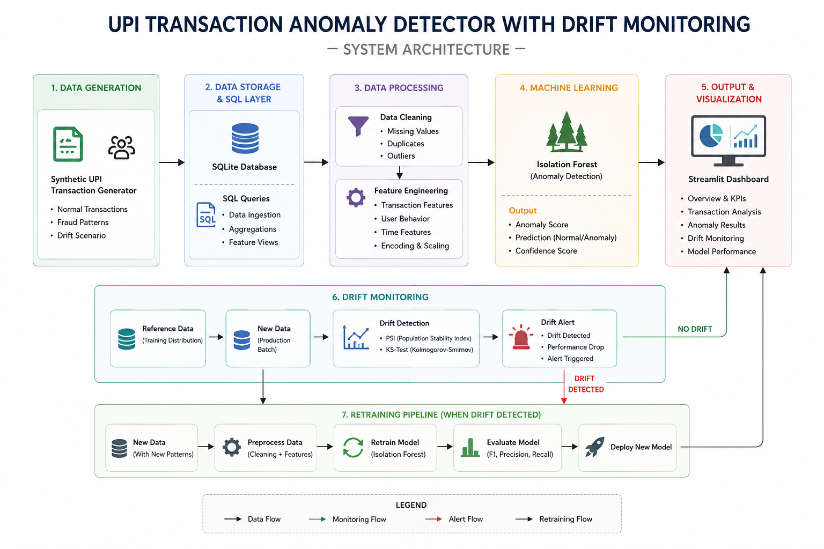

4. System Workflow
The system is organized into eight sequential stages, each implemented as an independently runnable module so that any stage can be re-executed in isolation (e.g., re-running drift monitoring without retraining the model).
┌────────────────┐
│ PaySim CSV │
└───────┬────────┘
▼
┌────────────────┐ chunked load, dtype
│ Data Ingestion │ casting, validation
└───────┬────────┘
▼
┌────────────────┐ transactions, features,
│ SQLite Store │ drift_metrics, model_runs
└───────┬────────┘ tables
▼
┌────────────────┐ aggregations, cohort &
│ SQL Analytics │ velocity queries (views)
└───────┬────────┘
▼
┌────────────────┐ balance-delta, velocity,
│Feature Engineer│ type one-hot, log-amount
└───────┬────────┘
▼
┌────────────────┐ contamination-tuned,
│ Isolation Forest│ 200 estimators
└───────┬────────┘
▼
┌────────────────┐ anomaly_score, threshold
│ Anomaly Scoring│ → binary flag
└───────┬────────┘
▼
┌────────────────┐ PR-AUC, ROC-AUC,
│Model Evaluation│ precision@k, F1
└───────┬────────┘
▼
┌────────────────┐ PSI + KS per feature,
│ Drift Monitoring│ sliding reference window
└───────┬────────┘
drift? ──► yes ──► Retrain trigger ────────────┐
│ no │
▼ │
┌────────────────────────────┐ ◄───────────────────┘
│Streamlit + Plotly Dashboard│
└────────────────────────────┘
Figure 1. End-to-end pipeline. Drift monitoring closes the loop back into retraining, making the system self-correcting rather than a one-shot batch job.

3.1 Layer Responsibilities
Layer | Module | Responsibility
Ingestion | preprocessing/ingest.py | Chunked CSV read (500k-row batches), schema validation, dtype coercion, load into SQLite via executemany.
Storage | database/schema.sql | Normalized tables: transactions, feature_snapshots, drift_metrics, model_runs; indexed on step and nameOrig.
Analytics | sql/queries/*.sql | Parameterized SQL views for per-customer velocity, balance-consistency checks, and type-level aggregates.
Feature Eng. | preprocessing/features.py | Derives balance-delta errors, transaction velocity, log-scaled amount, and one-hot transaction type.
Modeling | models/isolation_forest.py | Fits sklearn IsolationForest, persists model + scaler via joblib, versioned by training timestamp.
Evaluation | models/evaluate.py | Computes PR-AUC, ROC-AUC, precision@k, recall@k against held-out isFraud labels.
Drift | drift/monitor.py | Computes PSI and KS statistics per feature against a fixed reference window; writes to drift_metrics.
Dashboard | dashboard/app.py | Streamlit app rendering six views backed by live SQLite queries and Plotly charts.

4. Feature Engineering & Methodology

4.1 Derived Features
Raw PaySim fields are only weakly discriminative on their own; the engineered features target the specific ways fraudulent transactions violate normal account behavior:
- balanceDeltaOrig = oldbalanceOrg − newbalanceOrig − amount — a non-zero residual indicates the account balance did not move by exactly the transacted amount, a strong signal PaySim's fraud generator introduces deliberately.
- balanceDeltaDest — same residual check applied to the recipient side.
- origZeroedOut — binary flag for oldbalanceOrg > 0 and newbalanceOrig == 0, capturing full-balance drains typical of account-takeover fraud.
- txnVelocity1h / txnVelocity24h — rolling count of transactions per originator within 1-hour and 24-hour windows, computed via SQL window functions over the step column.
- logAmount = log1p(amount) — variance-stabilizing transform, since amount is heavily right-skewed (spans several orders of magnitude).
- typeOneHot — one-hot encoding of the five transaction types, since fraud is concentrated in TRANSFER and CASH_OUT only.

4.2 Model: Isolation Forest
Isolation Forest was chosen over supervised alternatives (logistic regression, gradient-boosted trees) because it does not require fraud labels at training time, and because its underlying mechanism — isolating points via random recursive partitioning — naturally assigns short average path lengths to points that are 'few and different,' which matches the profile of anomalous transactions in this dataset.
Hyperparameter | Value | Rationale
n_estimators | 200 | Stabilizes the path-length average beyond sklearn's default of 100, reducing score variance across runs.
contamination | 0.0013 (tuned) | Set to the empirical fraud rate observed in the training partition rather than sklearn's default 'auto', so the decision threshold reflects the real base rate.
max_samples | 'auto' (256) | Subsampling per tree keeps isolation paths short and training tractable at multi-million-row scale.
max_features | 1.0 | All engineered features are used per split; the feature set is small enough (9) that sub-sampling features is unnecessary.
random_state | 42 | Fixed for reproducibility across training/evaluation/retraining runs.
Table 2. Isolation Forest configuration used in models/isolation_forest.py.

5. Model Evaluation
Because fraud prevalence is under 0.2%, accuracy is not reported as a headline metric — a model predicting 'not fraud' for every transaction would score above 99.8% accuracy while catching zero fraud. Evaluation instead centers on metrics that remain meaningful under severe class imbalance:
- Precision–Recall AUC (PR-AUC) — primary metric; more informative than ROC-AUC when positives are rare, since it does not credit the model for the (trivially large) true-negative rate.
- ROC-AUC — reported alongside PR-AUC for comparability with published PaySim benchmarks.
- Precision@k / Recall@k — evaluated at k matching realistic manual-review capacity (e.g., top 0.5% of scored transactions), since in production only a limited number of flagged transactions can be reviewed per day.
- F1 at the operating threshold — the anomaly-score cutoff is chosen to balance precision and recall rather than defaulting to sklearn's raw decision_function sign.
- Confusion matrix, stratified by transaction type — surfaces whether errors concentrate in TRANSFER/CASH_OUT (expected) or elsewhere (a warning sign of a mis-specified feature).
All evaluation metrics are persisted to the model_runs table alongside the training timestamp and hyperparameters, so successive model versions can be compared over time directly from SQL rather than only from ad-hoc notebook output.

6. Data Drift Monitoring
Drift monitoring compares the distribution of each engineered feature in a recent scoring window against a fixed reference window captured at training time. Two complementary statistical tests are used because they are sensitive to different kinds of shift.

6.1 Population Stability Index (PSI)
PSI buckets each feature into deciles based on the reference distribution, then measures how much the current distribution's bucket proportions have shifted:
PSI = Σ (Actual% − Expected%) × ln(Actual% / Expected%)
PSI Range | Interpretation | Action
< 0.10 | No significant shift | No action
0.10 – 0.25 | Moderate shift | Log and monitor
> 0.25 | Significant shift | Flag for retraining review
Table 3. PSI thresholds applied per feature in drift/monitor.py, following the industry-standard bands used in credit-risk model monitoring.

6.2 Kolmogorov–Smirnov Test
The two-sample KS test complements PSI by testing the maximum distance between the empirical CDFs of the reference and current windows, and returns a p-value rather than a fixed-bucket approximation — this catches shifts within a single PSI decile bucket that PSI alone would understate. A feature is flagged as drifting if its KS p-value falls below 0.05 (i.e., the null hypothesis that both windows are drawn from the same distribution is rejected at 95% confidence).

6.3 Retraining Trigger
Retraining is triggered automatically when either (a) three or more features simultaneously exceed the PSI 0.25 threshold, or (b) PR-AUC on the rolling evaluation window drops more than 15% relative to the last deployed model's PR-AUC. This dual criterion — distributional shift and realized performance drop — avoids retraining on noisy single-feature fluctuations while still catching silent performance decay that PSI alone might miss.

7. Dashboard
View | Contents
Transaction Overview | Volume and value trends by step and type; live SQL aggregates.
Fraud Analytics | Flagged-transaction breakdown by type, amount band, and time; precision/recall at current threshold.
Transaction Analysis | Drill-down into individual transaction feature values and anomaly score.
Model Performance | PR-AUC / ROC-AUC trend across model_runs versions; confusion matrix.
Drift Monitoring | Per-feature PSI and KS p-value over time, with threshold bands overlaid.
System Health | Pipeline run status, last ingestion timestamp, row counts, last retrain trigger reason.

8. Tech Stack
Category | Technology
Language | Python 3.11
Dataset | PaySim
Database | SQLite
Query Language | SQL
Data Processing | Pandas, NumPy
Machine Learning | Scikit-Learn (IsolationForest)
Statistics | SciPy (ks_2samp)
Drift Detection | PSI (custom), KS Test (SciPy)
Visualization | Plotly
Dashboard | Streamlit
Model Persistence | joblib
Version Control | Git & GitHub

9. Project Structure

payment-anomaly-detector/
│
├── data/
│ └── paysim.csv
│
├── database/
│ ├── schema.sql
│ ├── database.db
│ └── load_data.py
│
├── preprocessing/
│ ├── clean_data.py
│ └── feature_engineering.py
│
├── sql/
│ └── queries.py
│
├── models/
│ ├── train.py
│ ├── predict.py
│ └── evaluate.py
│
├── drift/
│ ├── psi.py
│ ├── ks_test.py
│ └── retrain.py
│
├── dashboard/
│ └── app.py
│
├── notebooks/
├── reports/
├── requirements.txt
└── README.md

10. Initiate Starter Structure
This section initializes the project repository, prepares the folder structure, downloads the dataset, installs the required dependencies, and creates the first baseline commit.

Step 1. Clone the Repository
git clone https://github.com/priadarshini27/payment-anomaly-detection-mlops.git
cd payment-anomaly-detection-mlops

Step 2. Download the Dataset
Download the PaySim dataset from Kaggle:
https://www.kaggle.com/datasets/ealaxi/paysim1?resource=download
After downloading, extract the CSV file.
Example:
PS_20174392719_1491204439457_log.csv

Step 3. Create the Project Structure (Windows PowerShell)
Run the following commands inside the project directory.
mkdir data
mkdir database
mkdir preprocessing
mkdir sql
mkdir models
mkdir drift
mkdir dashboard
mkdir notebooks
mkdir reports
New-Item database\schema.sql -ItemType File
New-Item database\database.db -ItemType File
New-Item database\load_data.py -ItemType File
New-Item preprocessing\clean_data.py -ItemType File
New-Item preprocessing\feature_engineering.py -ItemType File
New-Item sql\queries.py -ItemType File
New-Item models\train.py -ItemType File
New-Item models\predict.py -ItemType File
New-Item models\evaluate.py -ItemType File
New-Item drift\psi.py -ItemType File
New-Item drift\ks_test.py -ItemType File
New-Item drift\retrain.py -ItemType File
New-Item dashboard\app.py -ItemType File
New-Item requirements.txt -ItemType File
New-Item README.md -ItemType File

Step 4. Copy the Dataset
Move the downloaded CSV file into the data directory.
payment-anomaly-detection-mlops/
│
├── data/
│ └── paysim.csv
You may rename the downloaded file to paysim.csv for consistency.

Step 5. Update requirements.txt
Populate requirements.txt with the initial project dependencies.
pandas
numpy
scikit-learn
scipy
matplotlib
plotly
streamlit
joblib
sqlalchemy
jupyter
ipykernel
Install the dependencies:
pip install -r requirements.txt

Step 6. Commit the Initial Project Structure
git add .
git commit -m "Initialize project structure and baseline dependencies"
git push origin main

11. Further Study
Concept | Learning Resource
Feature Engineering | https://www.kaggle.com/learn/feature-engineering
Isolation Forest | https://scikit-learn.org/stable/modules/generated/sklearn.ensemble.IsolationForest.html
Model Evaluation Metrics | https://scikit-learn.org/stable/modules/model_evaluation.html
Drift Detection (KS Test) | https://docs.scipy.org/doc/scipy/reference/generated/scipy.stats.ks_2samp.html
Streamlit Dashboard | https://docs.streamlit.io
Plotly Charts | https://plotly.com/python/
Git & GitHub | https://guides.github.com/introduction/git-handbook/

