**MB1040-000 Ultrasonic sensor:**

Name: **MB1040 LV-MaxSonar-EZ4**

Working Principle:

Ultrasonic sensors emit short, high-frequency sound pulses at regular intervals. These propagate in the air at the velocity of sound. If they strike an object, then they are reflected back as echo signals to the sensor, which itself computes the distance to the target based on the time-span between emitting the signal and receiving the echo.

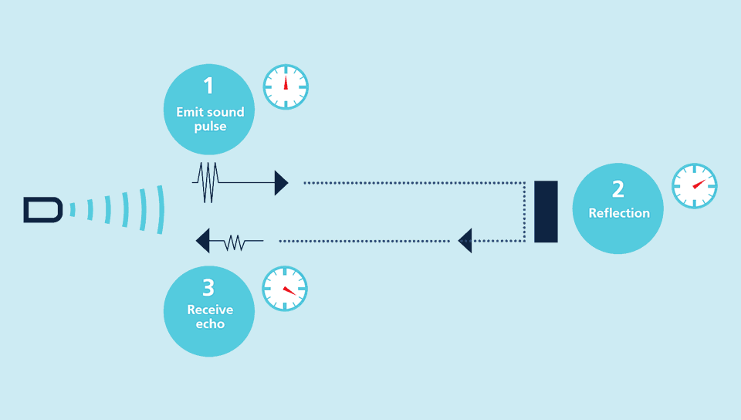

As the distance to an object is determined by measuring the time of flight and not by the intensity of the sound, ultrasonic sensors are excellent at suppressing background interference.

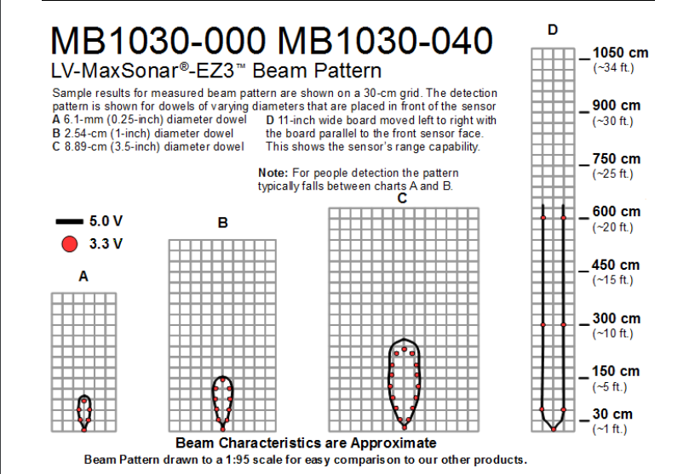

Circuit Diagram:

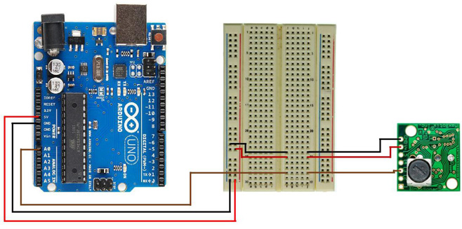

Arduino Code:

int sonarPin = A0;

int inchesAway;

void setup() {

Serial.begin(9600);

}

void loop() {

inchesAway = analogRead(sonarPin)/2;

Serial.print(inchesAway);

Serial.println(" in");

delay(1000);

}

Application Areas:

1. Landing flying objects
2. Used with battery power
3. Autonomous navigation
4. Educational and hobby robotics

Advantages:

1. Low power consumption
2. Easy to use interface
3. Large object detection

Disadvantages and things to take care of while using this sensor:

There is a problem with ultrasonic sensors. It detects all the objects on its sides(Not in front) within a range of 2ft. Also, senor should be as perpendicular to the obstacle surfare as possible.

References:

<https://www.maxbotix.com/Ultrasonic_Sensors/MB1040.htm>

<https://www.maxbotix.com/Arduino-Ultrasonic-Sensors-085/>

Capacitive Moisture Sensor:

Name: Capacitive Soil Moisture Sensor V1.2

Working Principle:

The electrical component known as a capacitor consist of three pieces. A positive plate, a negative plate and the space in-between the plates, known as the dielectric. The physical form and construction of practical capacitors vary widely and many capacitor types are in common use. Most capacitors contain at least two electrical conductors often in the form of metallic plates or surfaces separated by a [dielectric](https://en.wikipedia.org/wiki/Dielectric) medium.

A capacitive moisture sensor works by measuring the changes in capacitance caused by the changes in the dielectric. It does not measure moisture directly (pure water does not conduct electricity well), instead it measures the ions that are dissolved in the moisture These ions and their concentration can be affected by a number of factors, for example adding fertilizer for instance will decrease the resistance of the soil. Capacitive measuring basically measures the dielectric that is formed by the soil and the water is the most important factor that affects the dielectric.

Capacitive measuring has some advantages, It not only avoids corrosion of the probe but also gives a better reading of the moisture content of the soil as opposed to using a resistive soil moisture sensor. Since the contacts (the plus plate and the minus plate of the capacitor) are not exposed to the soil, there is no corrosion of the sensor itself.

The capacitance of the sensor is measured by means of a [555](https://en.wikipedia.org/wiki/555_timer_IC) based circuit that produces a voltage proportional to the capacitor inserted in the soil. We then measure this voltage by use of an Analog to Digital Converter which produces a number that we can then interpret as soil moisture.

Circuit Diagram:

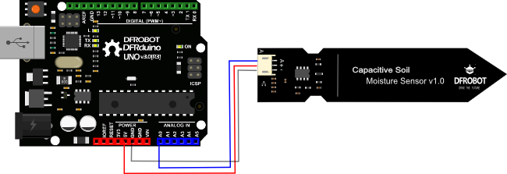

Arduino Code:

float an;

void setup() {

// put your setup code here, to run once:

Serial.begin(9600);

}

void loop() {

an=analogRead(0);

Serial.println(an);

// put your main code here, to run repeatedly:

}

Advantages:

➨Simple method of measurement.

➨It delivers the results immediately.

➨Watermark sensors and tensiometers are very low in cost.

➨Offers accurate results.

➨Watermark sensors offer larger moisture reading range from 0 to 200 cb or kpa.

Disadvantages:

There is a circuit on the top of the sensor. Whenever watering plants when in contact with wet soil the circuit should not get wet or else sensor will be damaged.

****

Average readings in normal atmosphere : ~640

Reading in a glass full of water: ~280

****

References:

<https://www.instructables.com/id/Arduino-Soil-Moisture-Sensor/>

Applications:

### Agriculture

### Landscape irrigation

1. Research

### Simple sensors for gardeners

3) Ambient light sensor temt6000:

Name: sparkfun BOB-08688 Ambient Light Sensor Breakout

Image:

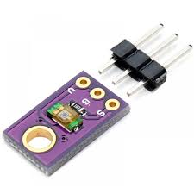

Working Principle:

The TEMT6000 Light Sensor will detect the brightness of its surroundings. While there are many properties of light that can help us categorize its brightness, the TEMT6000 measures [illuminance](https://en.wikipedia.org/wiki/Illuminance): brighter = more current, darker = less current.

Circuit Diagram:

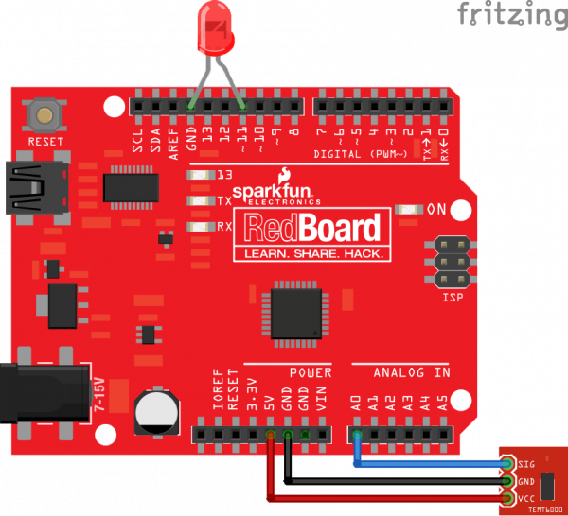

Arduino Code:

float an;

void setup() {

// put your setup code here, to run once:

Serial.begin(9600);

}

void loop() {

an=analogRead(0);

Serial.println(an);

// put your main code here, to run repeatedly:

}

Advantages:

➨It is easy to integrate with lighting system such as automatic lighting system.

➨It is used for energy consumption or energy management by automatic control of brightness level in mobile phones and auto ON/OFF of street lights based on ambient light intensity.

➨LDR (i.e. photoresistor) based light sensors are available in different shapes and sizes.

➨Light sensors need small voltage and power for its operation.

➨Photoresistors are lower in cost, bi-directional and offer moderate response time.

➨Phototransistors are very fast and provide immediate output compare to photoresistors.

Disadvantages:

➨Resistance varies continously (analog) in photoresistor and are rugged in nature.

➨Photodiodes are temperature sensitive and are uni-directional unlike photoresistors.

➨Phototransistors can not withstand voltages above 1000 volts..

****

In normal conditions reading: ~40(30-60)

In dark reading: 0 (0-2)

Under flash or full bright readings: ~600

****

References:

<https://learn.sparkfun.com/tutorials/temt6000-ambient-light-sensor-hookup-guide/all>

4) Ambient light and proximity sensor:

Name: **APDS 9930 Ambient Light Sense**

Working Principle:

Same as temt6000

It works on I2C

Things to take care of while using this sensor:

**Important**

There is the library made by sparkfun company at <https://github.com/Depau/APDS9930>

Just clone the library and run examples.

The sensor temt6000 does a better job.

Advantages:

Does proximity sensing with ambient light sensing

Disadvantages:

Not so great accuracy

Communicate via I2C.

Complex code