**Breakthroughs, Stumbles and Victories**

Technology Design Studio

**By:**

**Rachel Han**

**Priyanka Panjwani**

# Contents

1. **Introduction**
2. **Technology Used**

**2.**1. Makey Makey Board Connection

2.2. The Code

**3. Initial Thoughts and Breakthroughs**

**4. Stumbles**

**5. Victories**

# 

# 1. Introduction

Our project is called “Stamp Music”. It all started with an idea of wanting to create something that will help people have fun when they draw by combining art with music. Our drawing board will not only bring out the creative artist in people, but also and give them an experience that is a memorable one.

We have created a drawing board that plays music using the Makey Makey circuit board. There are rubber stamps with different shapes connected to the alphabet keys on the circuit board. Each stamp has a sound effect attached to it. On stamping the paper, the sound effects connected to the stamp are played and animated artworks are displayed on the computer screen simultaneously.

The welcome screen lets the user select a genre of music of their liking (e.g.: pop, rock, country, etc.). Based on the genre selected, the screen will play a background music and each stamp will play a unique musical note when stamped on paper. The same stamp shape will be converted to an animation on screen and will appear on the digital artboard.

# 

# 

# 

# 

# 2. Technology Used

## 2.1. Makey Makey Board Connection

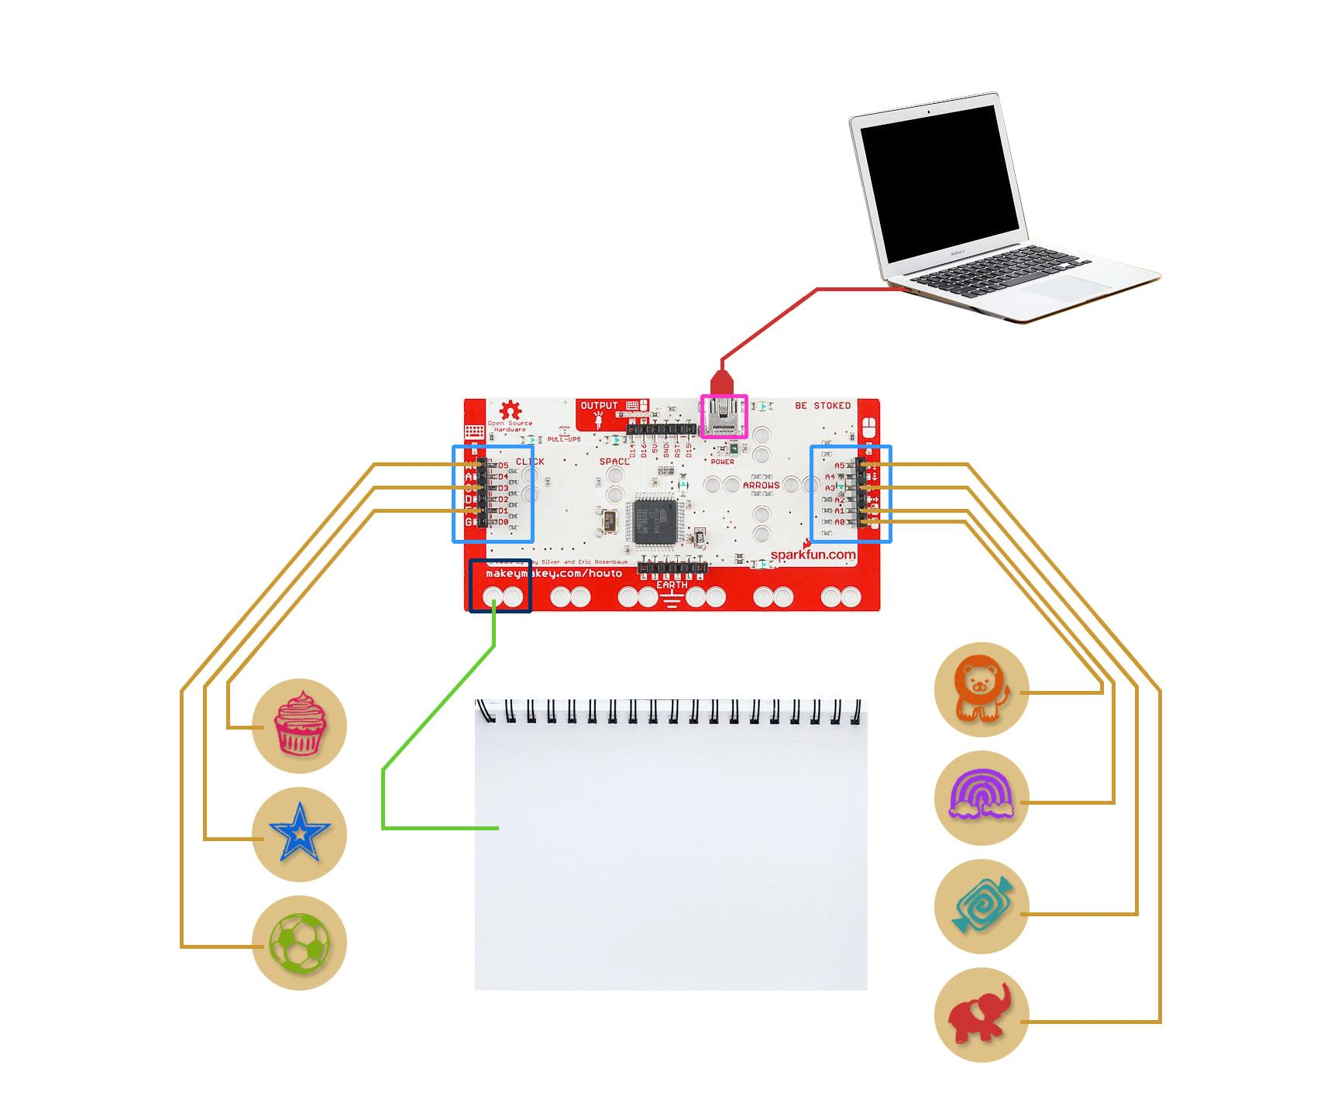

## 

We used a Makey Makey Classic Board and connected rubber stamps to it. Each rubber stamp had an aluminium strip attached to it which was connected to an alligator clip. These alligator clips were then connected to the alphanumeric keys to the back of the Makey Makey circuit board. The circuit board’s pre-set keys were remapped (using [www.makeymakey.com/remap](http://www.makeymakey.com/remap)) to the alphabets used in the code. Finally, the Earth connection was made by connecting and alligator clip to an aluminium sheet.

## 2.2. The Code

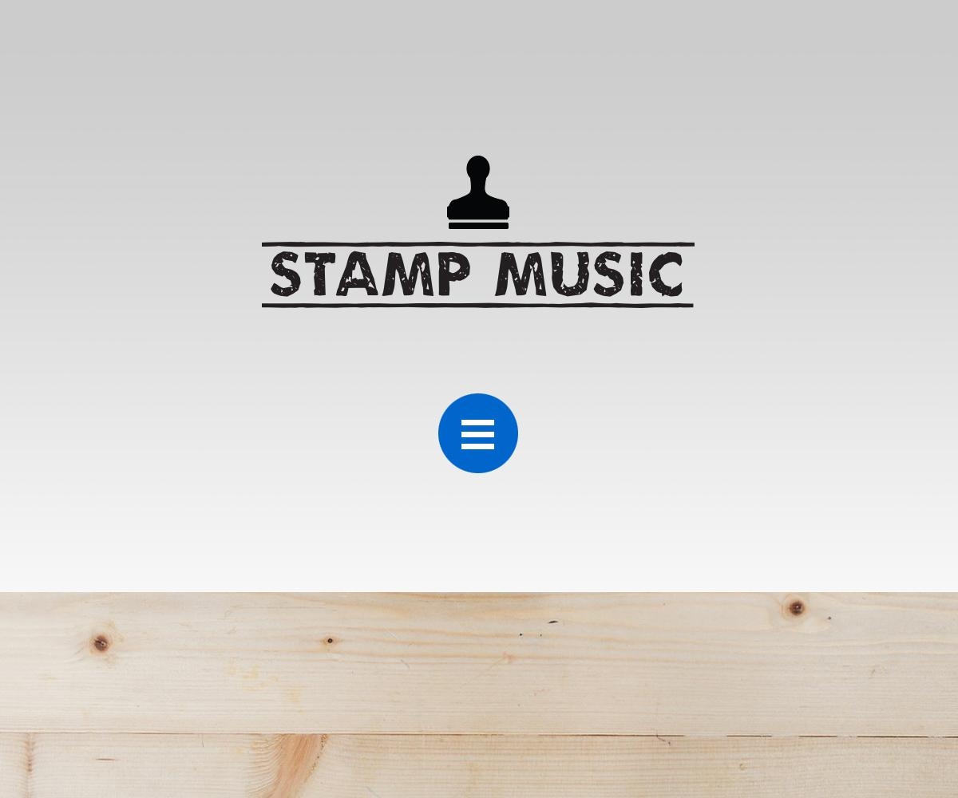 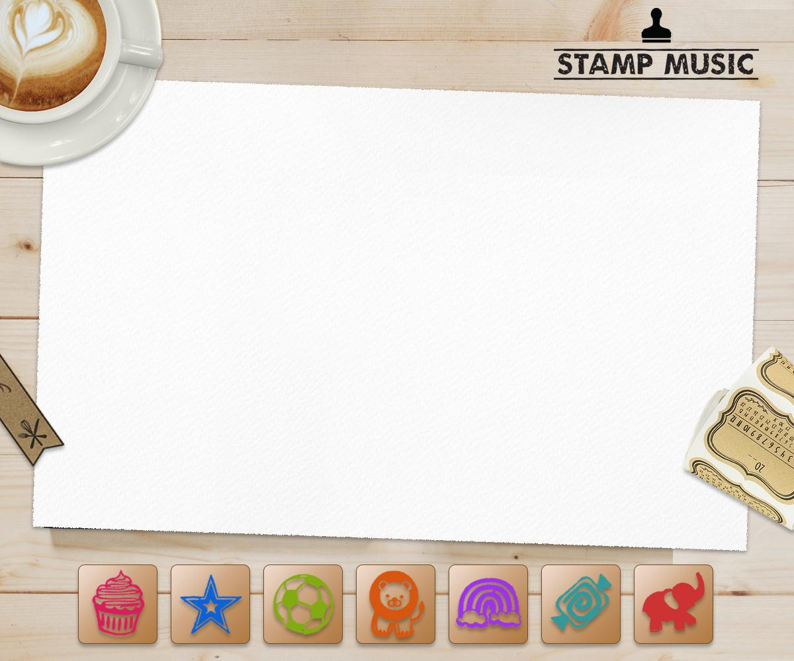

The digital drawing board with the stamp buttons was made in HTML and CSS. The navigation button was made with JavaScript. Each screen played a different genre of music using the HTML5 <audio> tag. The rubber stamp animations on screen were created using CSS. The animations would appear in random locations on the screen.

The code for the rubber stamp’s music was written in JavaScript. Each rubber stamp had a “keypress” Event Listener attached to it. A “switch” statement would recognize the key type and play the music connected to it and call the assigned CSS animation simultaneously. A div would be created for the CSS animation in random x and y coordinates of the digital drawing board.

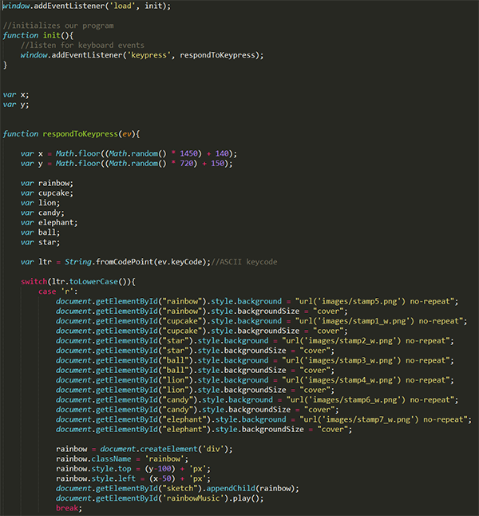

**The JavaScript Code**

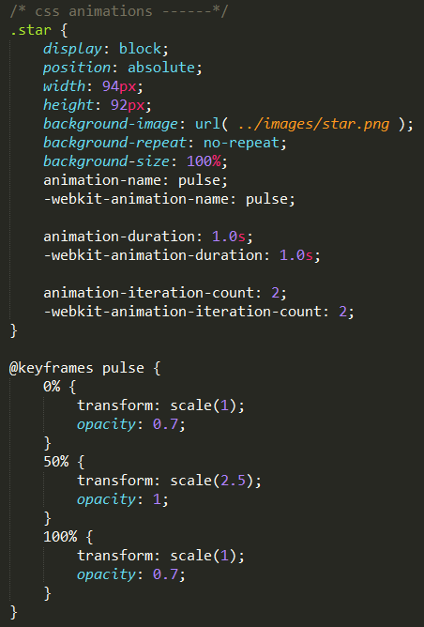

**The CSS Animation Code**

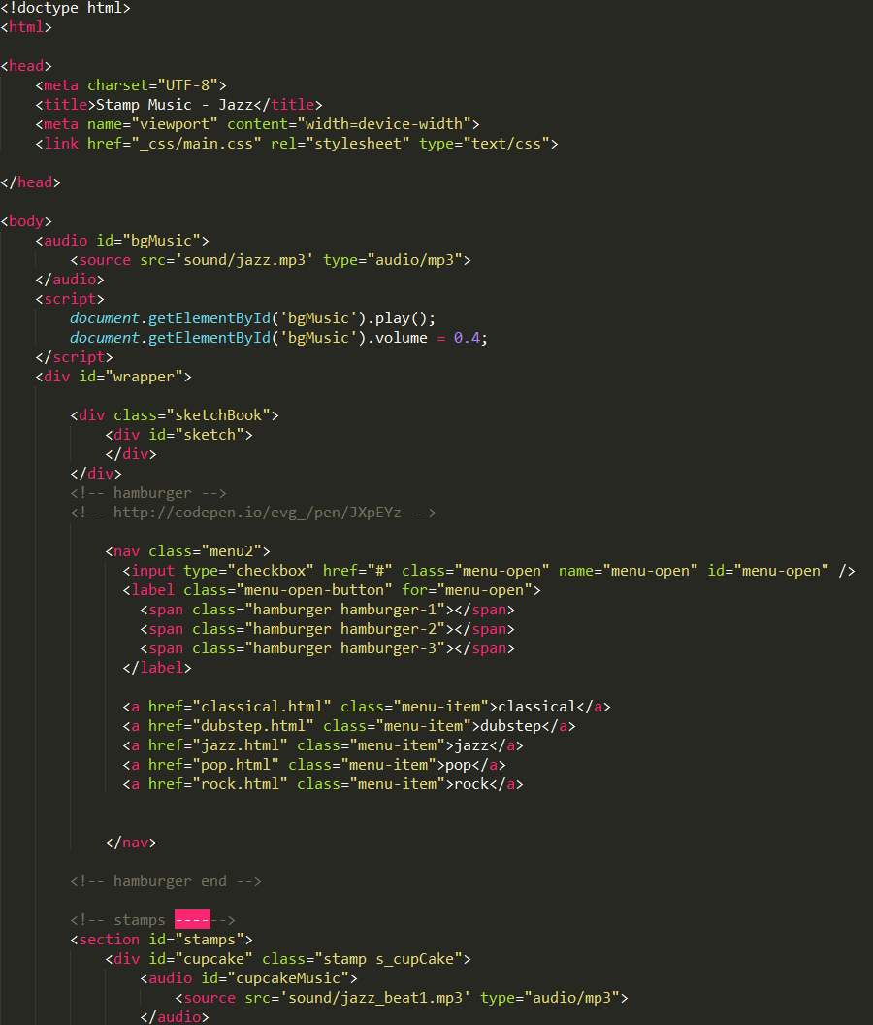

**The HTML Code**

# 3. Initial Thoughts and Breakthroughs

The initial idea was to create a simple wooden drawing board that would be connected to the Makey Makey board and would play music using different stamp shapes. Each stamp shape would have a music note connected to it. We realized that we could also create digital art at the same time on the computer screen. The user would be able to create artwork on paper as well as random animations on the computer screen, which would look similar to what they had created on paper. This would be a major enhancement to the existing idea.

To make the experience more fun, we also thought about presenting the user with the option of selecting a background music of their choice. It could be pop, jazz, classical or rock. On selecting the music type, the music notes connected to the stamps would also change. For example, rock music would have guitar sounds connected to the stamps.

# 4. Stumbles

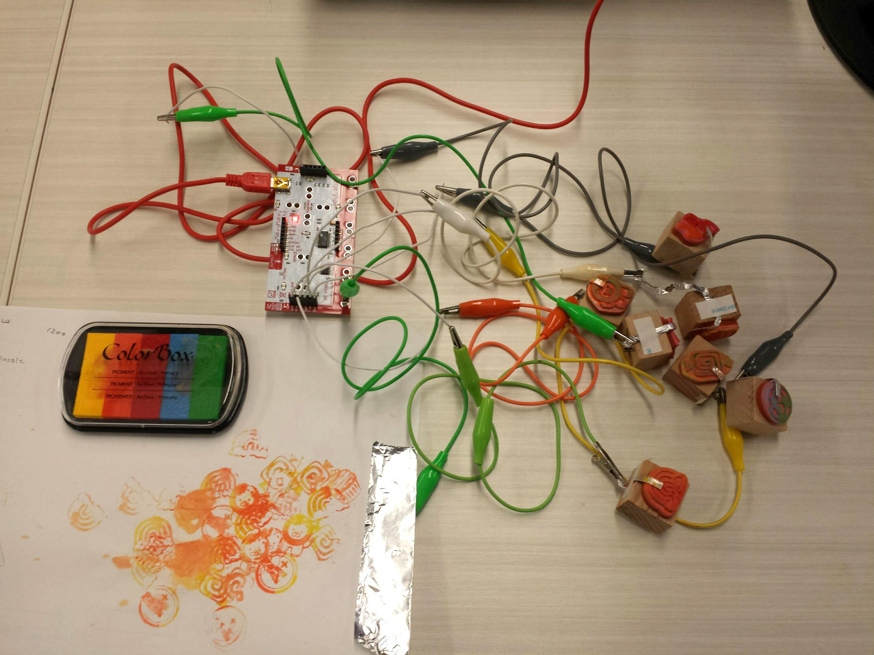

The earth alligator clip was connected to an aluminium sheet and a sheet of paper was kept over it. Being an insulator, the sheet of paper would act like a barrier between the stamps and the aluminium foil. We could not eliminate the drawing paper because the whole idea was to present the user with their artwork after they finished playing with the stamp music board. We thought of various ways to make the paper conductive. One of the options was to spray some water over the sheet of paper or to dip the stamps in a water-ink based solution. This solution worked but the artwork looked messy. The other option was to paint the paper with a conductive glue made from graphite powder and a paint thinner. This would make the paper black (because of the graphite powder) and would be slightly more expensive.

Another problem that we experienced while building this project was that the stamps would not be able to recognise the mouse coordinates on paper. The synchronisation between the rubber stamps position on the artboard and the digital board was broken. We had to re-code the x and y coordinates of the digital board stamps and make them appear at random positions on the screen.

# 5. Victories

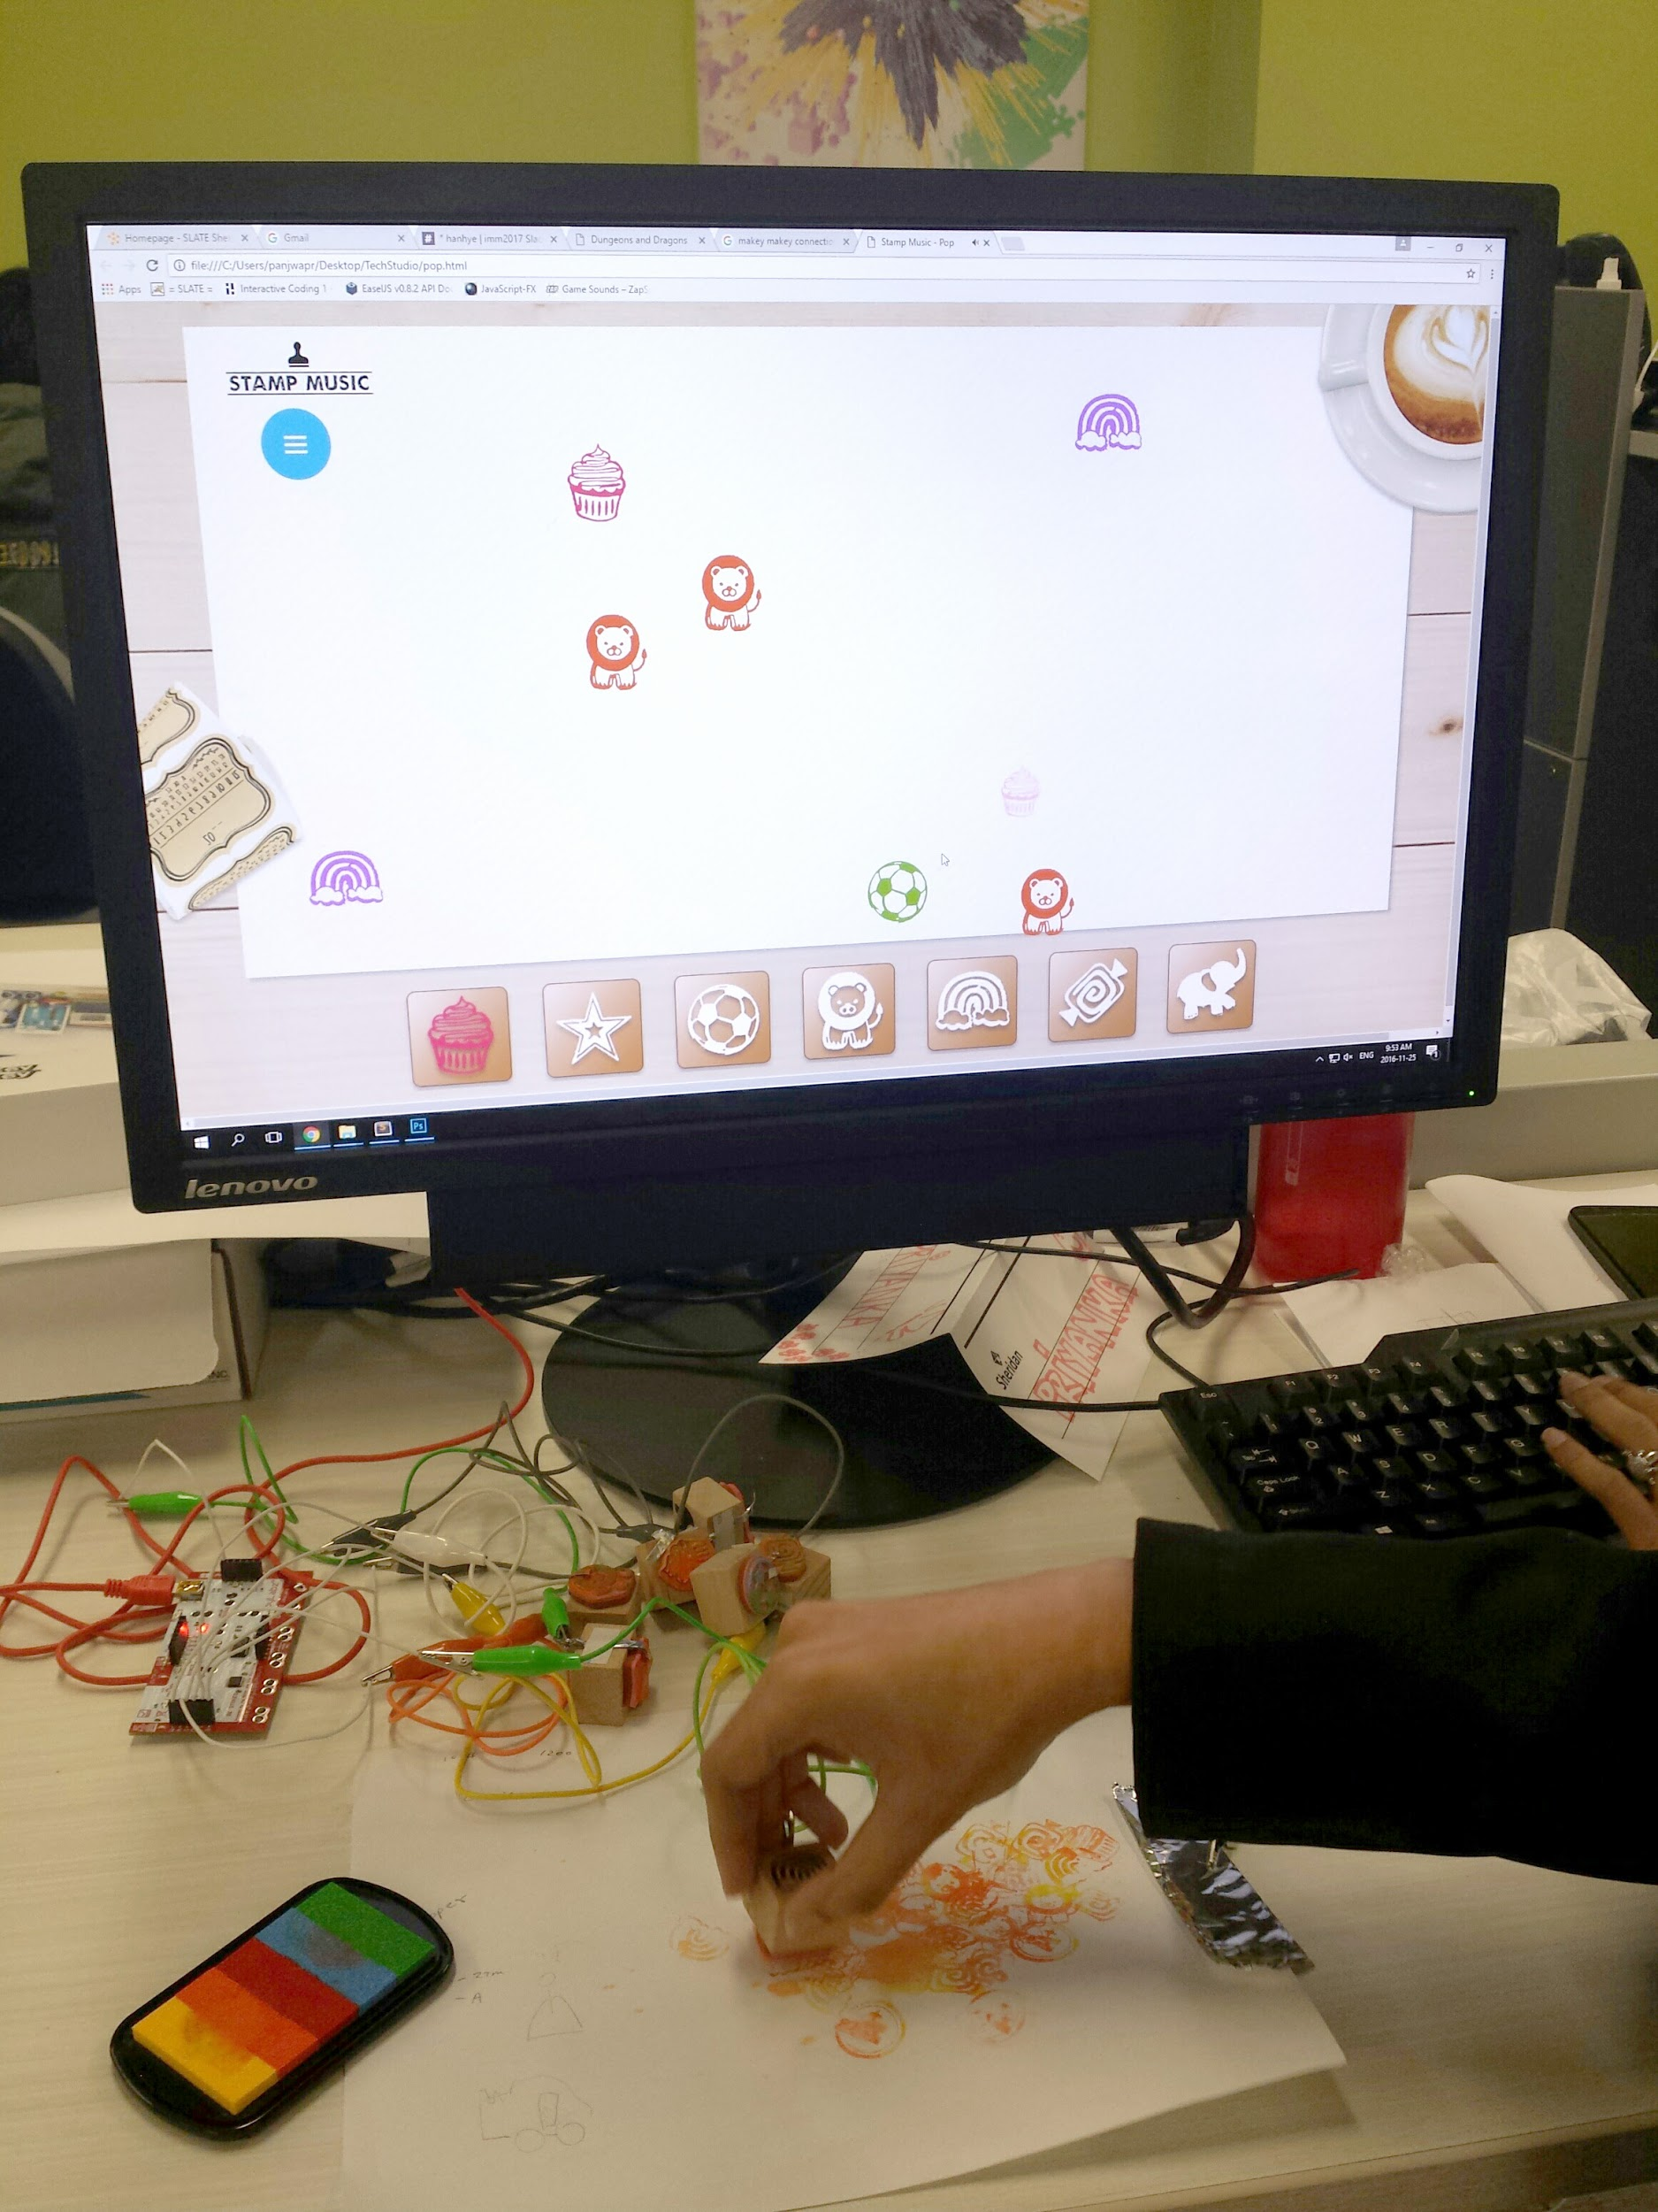

We made a saltwater solution and sprayed it on the drawing sheet of paper. A small quantity of salt added to water makes it highly conductive. Now the circuit was complete.

We also downloaded royalty free music and added different genres of music so that everyone can have a background track that suits their taste. Sound effects of various musical instruments for each genre were added so that they blended well into the background track. The on-screen animations for each stamp were flashy, fun and different. The overall user interface for the digital board looks beautiful. We hope that everyone will have an enjoyable experience using our musical drawing board!